CryptoBench: Design Review Package
04 Hard Stop 2 — Design Review Package
Submitted by Nitin | Supervisor: Dr. Shaalan | Due 27 September

1. AI Usage Log and Academic Integrity

For this milestone, I have attempted to follow the same standard as for the previous two milestones, and logged every use of AI for this milestone as specific, dated instances. The AI used for this milestone was Claude (Opus 5), accessed through Claude.ai with web search enabled.

● Sept 22 — For additional information on recent developments after the Literature and Requirements Brief was written, I used an AI search tool to find primary sources for the withdrawal of HAWK from NIST Round 3 additional-signatures, the initial public draft of SP 800-230 on limited-signature SLH-DSA parameters, and the NCCoE’s public FAQ on the scope of cryptographic inventory found in the public NIST web site. I also used the search tool to find additional peer-reviewed evaluations of other approaches (the MASC mutation-testing framework, the MUBench systematic evaluation, the Crypsy/Cryben benchmark, and the Cryptoscope). Sections 3, 4, and 6 describe what I read in each of the relevant primary sources.

● Sept 23 — Diagramming Assistance for Figures 1 & 2: I used AI-based diagramming tools to generate Figures 1 and 2 from my prior hand-drawn work documenting the SLH-DSA Source-Location System’s data flow and components. I provided the system’s components, arrows’ directions, and the correspondence between build-order Figure 2’s gates and Assignment 03’s acceptance thresholds (Section 03) and the AI assistance produced the high-quality diagrams in SVG format as prior specified.

●Sept 24 — Traceability completeness check: I asked an AI to check the completeness of the traceability matrix created in Section 9 for omission of any of the requirements listed in Assignment 03 (FR-1 through FR-12, NFR-1 through NFR-7). It found two missing requirements for full completion: FR-6 and NFR-5.

● Sept 25 — Grammar, citation formatting, editing: This was a very tight edit. I verified every change and rejected any that altered the meaning rather than clarifying the language.

However, What the AI did not do was choose the system decomposition, the computational method to achieve the end of view selection, the acceptance thresholds for the different validation gates in Section 6.2, or the risk prioritization in Section 8.All of these were chosen by me in the same manner as the two previous milestones. Where this document simply states a fact about a tool, a standard, etc. or references a paper cited in this document, that fact was verified against the original or primary source for that information as opposed to simply reading an AI summary of that information.

2. Purpose and Relationship to Prior Milestones

The scope and workspace for this project were defined in Hard Stop 1, and the Literature and Requirements Brief developed here translates supporting literature into a traceable set of functional and non-functional requirements — decision-ready for acceptance testing of a working system after this design has been reviewed by a technically-informed reader and implemented by the author of this design without further explanation of how any part of it works.

Section 3 has been expanded to include additional peer-reviewed evaluation literature to support Hard Stop 2, beyond just standards documents such as SP 1800-38B, the FIPS standards, and CBOM/ECMA-424. Section 9 completes the requirement traceability matrix for the nineteen functional and non-functional requirements outlined in Assignment 03, as opposed to the representative subset already provided. Lastly, the citations have been verified and the editing rigorously applied to meet the verification standard for Hard Stop 1, as has always been the case.

3. Related Work: Peer-Reviewed Evaluation Literature

The Literature and Requirements Brief for CryptoBench laid out a broad foundation of federal guidance and industry standards (SP 1800-38B, FIPS standards, CBOM/ECMA-424) and, unlike much of the previous work, drew on very little in the way of peer-reviewed evaluation methodology. The comments of Dr. Shaalan therefore were somewhat at variance with the earlier work and as a result some of the design decisions below differ from those made previously in reference to the same body of work; in terms of citation, for example.

Amann, Nguyen, Nadi, Nguyen, and Mezini in [6] published the first systematic evaluation and comparison of static API-misuse detectors. This work is grounded in their MUBench benchmark [7] and it was author-validated for correctness. Importantly, Ammann et al. found that for API-misuse detectors reported recall values “collapse dramatically” when measured on a common test corpus rather than on the detectors’ own example corpora. In other words, there is a huge problem with circularity when evaluating detectors, similar to what this project is trying to avoid by using a frozen reference inventory of test cases. Ami, Marsden, Moran, Poshyvanyk, and Nadkarni extended this work in [8] by adding mutation testing to MASC [9], a framework for misuse detection using source code analysis. They found that in repeated runs of MASC on 9 and then 14 detectors from the crypto community, all of them “silently failed” on test cases outside the detectors’ training distributions. This type of work is very close to what this project is trying to achieve, and therefore it should be cited. Importantly, the known-positive validation gate in Section 6.1 below is there to ensure that a detector that never encountered a positive test case before (deliberately placed in the inventory of test cases in order to ensure that the detector reports a zero for it) never reports a non-zero for it.

This body of work includes the original systematic evaluation of static API-misuse detectors (Amann et al., 2019), the MUBench benchmark those detectors were evaluated against (Amann et al., 2016), and the MASC framework (Mutation Analysis for evaluating Static Crypto-API misuse detectors), which extended mutation-based evaluation to cryptographic API misuse detectors, most recently reporting results across fourteen major crypto-detectors (Ami et al., 2026); and evaluation of MUBench on fifteen Detectors with nine of them being Crypto Detectors [Ami et al., 2024]. Furthermore, a a recent paper, 'Hidden Ciphers and Where to Find Them' (arXiv:2608.04857, 2026), introduces a static scanner for finding hidden ciphers, called Crypsy, as well as a synthetic benchmark for testing misuse detectors, called Cryben. The benchmark comprises a set of CycloneDX v1.7 artifacts, which were created in an independent process. The F1 score for asset discovery using this benchmark is reported to be 0.75 for the tool Crypsy (arXiv:2608.04857, 2026).

Two aspects of the Literature and Requirements Brief have been influenced by the additional literature on static API-misuse detectors. First, as described in Section 6.2 below, for the purposes of the comparison with other's work (that has been summarized in this Literature and Requirements Brief) in terms of F1 score for asset discovery, coverage will be reported for the frozen reference set of this pilot study in terms of standard metrics for evaluating the quality of code analysis, i.e. in terms of precision, recall and F1 score per category. Second, the way the tool-validation gate of Section 6.1 is framed has changed. While the pilot study did not have the resources for a full-fledged test suite of the type that is generated by MASC’s mutation testing for validation of static API-misuse detectors, a lightweight analogue can and will be used in this project, i.e. a tool will only be considered validated for a given positive case, if it detects said case when it is intentionally included in the test code. This is in line with the underlying principle of said mutation testing, i.e. that a detector has to be able to catch a positive case that has been intentionally included in the test code, not just run correctly when the detector is left to its default configuration.

4. Architecture and Method Selection

4.1 System decomposition and component responsibilities

There are 6 components, all with single responsibility and single data owner. None of them are custom software: they are either existing tools, plain file stores or even manual processes. The scope of non-implementation was confirmed at Hard Stop 1. The test material store contains the selected Java code samples and the list of authorized TLS endpoints. The material store is locked once all the material has been selected (FR-1). The material store writes data to file: data/material/. The reference inventory is the independently built and frozen answer key. The reference inventory is the only component that defines ground truth (FR-2, NFR-4). The reference inventory writes data to file: data/reference/. The reference inventory is a write-once file that is then made read-only after the reference inventory has been written (freeze). The three discovery tool runners (Semgrep, the Sonar Cryptography Plugin and the TLS scanner) run separately on the test material store (FR-6). None of the runners read the output of the other runners. Each runner writes data to a write-once file under analysis/raw/ (as specified in FR-6). The scoring module performs a manual comparison of the raw output from each of the tools against the frozen reference inventory for each of the categories using a spreadsheet and follows the rules specified in FR-9, NFR-2 and NFR-6. The scoring module writes data to file: analysis/scored/. The report generator creates the benchmark report and the discovery checklist from the scored results and the journal for the runs (as specified in FR-12). The report generator is the only component that creates a conclusions section for the report. The report generator writes data to file: docs/report/ and docs/checklist/.

4.2 Data flow
Figure 1 shows how data flows from one component to another. Two features of this figure are more than decorative. First, the reference inventory has one outgoing edge, which goes to the scoring module. There are no edges coming into the reference inventory from the tool runners. This diagrammatic feature corresponds to the circularity constraint specified in FR-2. Second, each tool runner reads from the same test material store, but writes to a different, non-overlapping part of the raw output store. This diagrammatic feature corresponds to method independence, as specified in FR-6: the output from a runner cannot affect the execution of another runner, because there are no edges connecting them in the figure.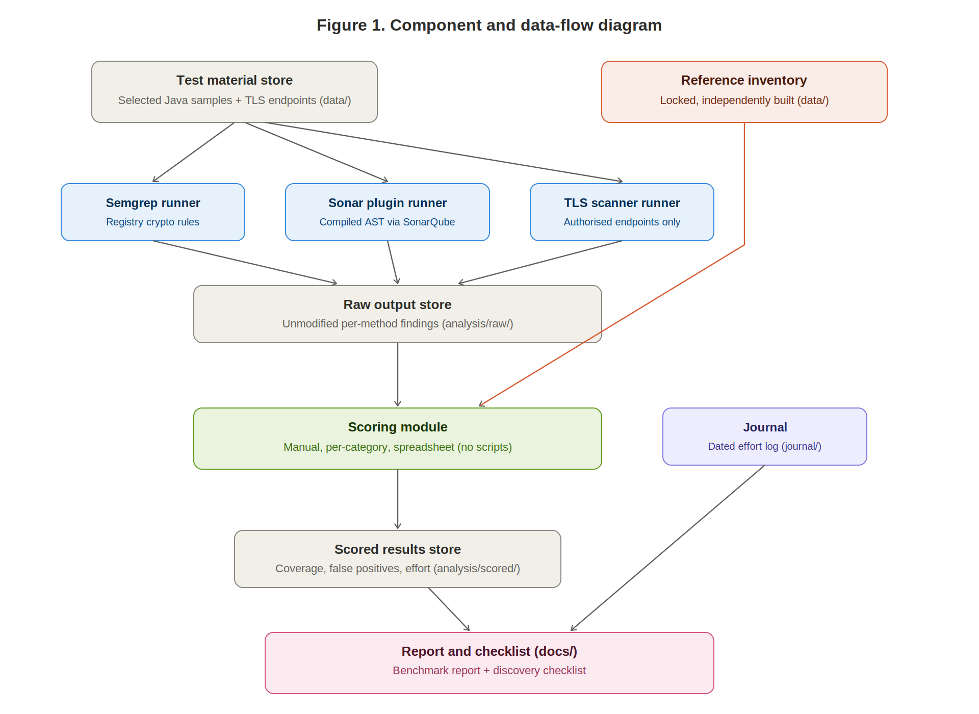
Figure 1. Component and data-flow diagram.

4.3 Computational method

Note that the term “computational method” in this report is used to refer to a controlled comparative measurement. Such a method is not necessarily an algorithm. In this report, such methods are described as procedures that can be reproduced by a technically trained reader working within the environment pinned in Section 5.

●Step 1: A reference inventory is created for the test material by going through it two times manually, making sure to note all the cryptographic assets with corresponding category labels (e.g. key establishment, digital signatures, hashing, protocol/transport configuration) as well as corresponding per-layer-observability flags (source-visible, endpoint-visible, or both). After both passes through the material agree on the inventory, it is frozen and cannot be edited anymore.

●Step 2: For each of the three discovery methods established in Section 4.1, validate against known positives and known negatives for that method. For methods that are implemented as tools, use planted test cases that show the tool fires correctly for the method before being ran against the full test material (Table 3 of the Literature and Requirements Brief).

●Step 3: Build the Java project for the selected cryptography discovery method (with its existing build file) and run the Sonar Cryptography Plugin (with the pinned SonarQube instance), Semgrep’s cryptography ruleset and the TLS scanner for the authorized endpoints of the selected method. The output of each run is written to a file without any changes.

●Step 4: Manually score each output file of Step 3 against the fixed reference inventory (NFR-2). Measured variables are coverage, false positives and man hours for each method/category. Denominators for these variables are specified in Section 7.1 of the Literature and Requirements Brief.

● Step 5: For each category compute the Precision, Recall and F1 score (Section 6.2) and perform the reproducibility check (Section 6.3). Create the benchmark report and the related discovery check list.

4.4 Design rationale and trade-off analysis

Manual scoring over an automated scoring script: an automated comparator could be written, tested and even be verified to be correct but this would reintroduce unverified custom code (NFR-6). A spreadsheet with visible formulas is directly auditable by Dr. Shaalan (UC-3) whereas a script’s internal logic cannot. As mentioned previously, scoring-reproducibility (Section 6.1) is a gate that catches errors of the manual transcription type.

Per-category, per-layer denominators instead of one blended recall figure: This change makes the results less easy to headline but, as discovered by the systematic evaluation in MUBench for API-misuse detection, blended numbers mask exactly the kind of distinction that a practitioner would like to make (UC-1) to choose between methods for first adoption.

Preserving native CBOM output instead of a custom schema: the trade-off here between flexibility and interoperability means that rather than creating a completely project-specific schema (which would be tailored to specific judgements made within the project), the schema used for the reference inventory and scored results is CBOM-compatible, meaning later that reference inventory and scored results can be used by other tools which are CycloneDX-compatible (FR-3). In some cases, this means that a project-local judgement (such as the per-layer observability flag) has to be mapped onto a field which the standard does not natively define.

Use of three independent methods of discovery as opposed to two: As static analysis alone cannot discover behavior of code as it is running, TLS scanning was added to methods of discovery. The literature review in Section 3 indicates that all reviewed sources treat a single method of discovery as insufficient. Thus the additional complexity of environment to list authorized endpoints to use for scanning as well as a separate scanning tool as opposed to a second copy of the same tool is warranted in order to discover a completely different layer of information.

4.5 Edge-case awareness

● An asset that can be observed by more than one layer (e.g. a certificate algorithm that is encoded in the source configuration of a certificate and also observable in the live TLS handshake of that certificate) is counted in the denominators of both methods but never split between them. Therefore, the coverage figures of both methods are not understated.

● Methods with zero findings after having passed the known-positive test case(s) for that asset are reported as true zero, whereas methods with zero findings before having passed the known-positive test case(s) for that asset are reported as non-functional for that test case.

●The algorithm from the test material (e.g. an HQC or SLH-DSA with limited signatures under SP 800-230) is recorded in the reference inventory for the observed algorithm. This is outside of FIPS 203–205, but it is recorded anyway. This is related to the moving-target constraint from Assignment 03 and is why an approved-algorithm allow-list is already stale. HAWK was withdrawn from NIST's Round 3 additional-signatures process in July 2026.

● The tool-validation gate for the test of known-positive cases fails mid-project when the SonarQube instance is upgraded past the compatible version for the Sonar Cryptography Plugin (see Section 6.1). A method that fails this gate is reported as non-functional for that category, not folded into a misleadingly low recall figure.

5. Environment, Toolchain, Data, and API Planning

5.1 Machine environment

The pilot is executed on a single laptop, no distributed or cloud based test cases are executed. Git is used for version control, journal entries are stored in a folder with date stamp as the name of the folder. The single server process for the pilot is a locally installed and run SonarQube server. The server is only used to have the Sonar Cryptography Plugin analyser available.

5.2 Toolchain

The toolchain consists of 7 tools, with each having a specific pinning constraint. Java (JDK) with the specific version recorded in the environment file at the first build, is used to compile the selected project (FR-7) to ensure that the plugin’s AST-based analysis has a resolvable symbol table. The existing project’s build tool (whatever build file it is) is used to build the project and produce the compiled artifacts which are used in Step 3 of the computational method. Semgrep with specific version recorded is used as a static source-code discovery tool with no custom rules written for the registry cryptography rules (NFR-6). SonarQube with specific version recorded and paired with the specific version of the Sonar Cryptography Plugin is used as a language analyser (the highest-risk dependency in this design – Section 8). The plugin is used as a purpose-built static discovery runner that produces CBOM output (FR-3). TLS scanning tool with specific version recorded is used as runtime/endpoint discovery tool against the authorized list of endpoints. Git with specific version recorded is used for version control purposes and to provide commit-order evidence that Dr. Shaalan will use to audit that the reference inventory was frozen before any discovery tool ran (UC-3).

5.3 Data planning

This is a closed data project, meaning that the data for this project consists of test material, i.e. the Java code samples with the respective licenses (per sample) as well as the artifacts generated by the pipeline from this material. Thus, data planning for this project refers to selecting the appropriate test material as well as to establishing the appropriate validation for the data. For the test material the following selection criteria apply: each sample must carry a permissive license (recorded for each sample), it must contain at least one asset for the respective category as defined in Section 4.3, and the set of samples in total must contain known negative cases (FR-5). TLS endpoints to be tested must be such that the author of this report has legitimate authorisation to test these endpoints (NFR-7). For validation of the data the two-independent-pass inventory freeze (Step 1) is primary for validating the data. The known-positive/known-negative gate (Step 2) is primary for validating the tools.

5.4 API and service dependency planning

As mentioned in Hard Stop 1, this design does not use any external APIs. The tools mentioned in Section 5.2 are all run locally against local data or against endpoints that the author of this document has already controlled or has been granted authorisation to test. This was a deliberate design choice to avoid a whole class of potential problems with authentication, rate limits, and third-party downtime that cannot be easily absorbed within the time scale of a single semester.

6. Testing and Evaluation Design

6.1 Test types and evidence collection

Seven test types were created to produce evidence for this design. Inventory dual-pass agreement is used to ensure that ground truth was not created by a single fallible person, by reviewing two pass dated independently plus the commit that froze the inventory. Known-positive tool validation reviews each method to ensure that they fire on known in-scope assets before they are trusted with the task of finding others like them, by reviewing the log for a single planted case and resulting detection. Known-negative tool validation reviews each method to ensure that they do not fire on material that contains no cryptographic assets, by reviewing the log for a single clean sample and expected resulting zero count. The main run for each method of interest produces three types of evidence: coverage, false positives, and effort. This evidence is in the form of unmodified raw output files plus completed scoring spreadsheet. Scoring reproducibility reviews a second independent scoring pass against identical raw output to the main run to ensure that identical counts per category were arrived at. Run reproducibility reviews a re-run of a method, in the pinned environment, against unchanged material to ensure that identical finding sets are produced. Checklist usability reviews an outside reader with no knowledge of the surrounding project to ensure that they can correctly state the main strength and blind spot for each method after reading only the associated checklist. These reviews are done via peer-reader session notes that are collected at Hard Stop 6.

6.2 Metrics, denominators, and acceptance thresholds

For the purpose of the pilot we report the same kind of numbers as for the literature and requirements brief (Section 3): coverage of the reference material is reported as precision, recall and F1 score for each category and for each method (with the numbers for the Crypsy/Cryben methods and for the detectors tested under MASC and MUBench as references). The denominator for recall is not the complete reference inventory but the subset of that inventory that can potentially be detected by the observation layer of a method (as determined in Step 1 of the inventory construction and stored as the per-layer-observability flag). In contrast to that, precision is calculated against all findings of a method, also the false positives on negative material that was known to be such.

The thresholds listed in Section 7.2, Table 3 of the Literature and Requirements Brief, were all approved by Dr. Shaalan and thus remain unchanged here. All the open questions in Section 11 of that brief remain to be answered by him.

6.3 Baseline and comparison logic

There is no external baseline for this pilot – no prior published benchmark has been run on the same material using the same set of tools, and that is part of the contribution that this pilot is intended to make. The internal comparison is method-against-method, so for each category we report for each method coverage, false positives, effort etc. – and when methods are combined we report each method’s incremental contribution above the other methods’ findings, not a single combined recall figure. The reasons for this are that 1) combining findings makes recall non-decreasing by construction, even if the combination is not in practice useful; and 2) in general, it is not meaningful to compare a method against a baseline that consists of other methods.

6.4 Data-validation, bias, and error checks

●Selection bias: the test material is chosen because it exhibits observable cryptographic usage, which is not representative of an arbitrary codebase; this is disclosed explicitly in the benchmark report rather than left implicit.

● Labeling error: This is fixed by the two-independent-pass agreement gate. In the case of any disagreement, it gets resolved and the whole process is repeated until the agreement is reached and the inventory is frozen.

●Transcription error in manual scoring: mitigated by the scoring-reproducibility gate, which treats any discrepancy between two independent scoring passes as a defect in the scoring rules rather as random noise to average out.

●Environment drift: This is mitigated by the version pinning in Section 5.2 as well as by the recording of exact SonarQube/plugin version combinations. Given the previously documented compatibility issues above SonarQube 10.5.0 this is considered important to record.

7. Build Order and Validation Gates
This self-check is answered by Figure 2. Given a week-by-week build order request, this is it. Each gate in the pipeline is tied to the appropriate acceptance threshold as laid out in Table 3 of the Literature and Requirements Brief. A gate not met will stop the pipeline in its tracks rather than proceed under some misguided assumption and then have subsequent figures in the benchmark report fail because of it. That was a design choice and not a missing feature.

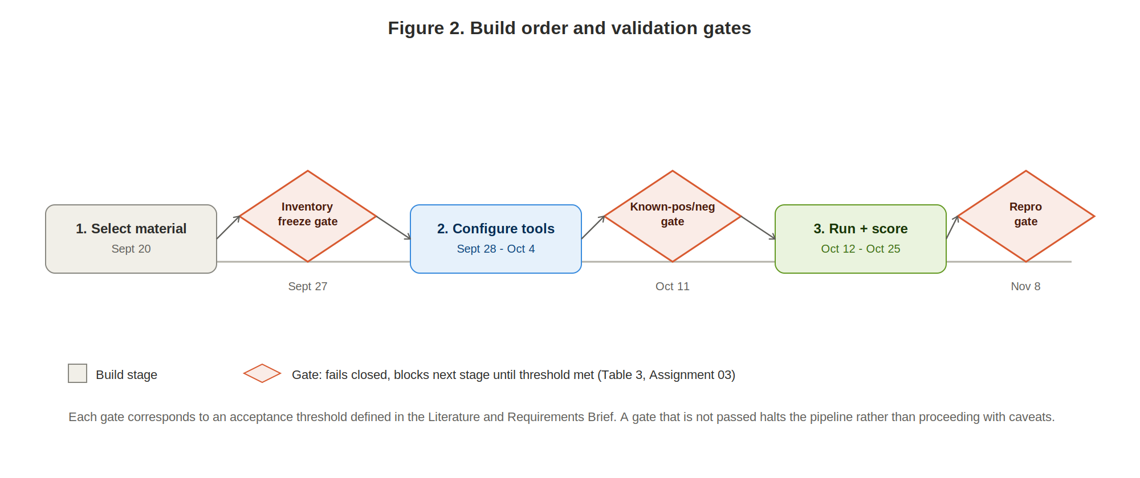
Figure 2. Build order and validation gates.

8. Highest-Risk Dependency and De-risking Plan

One of the highest risks to this design is the dependency on the Sonar Cryptography Plugin and the SonarQube instance that it depends on. The risk here is not that the environment setup may take longer than expected to setup, the risk is very specific and has been documented. Once the Sonar Cryptography Plugin has been updated to 1.3.7 and above it requires SonarQube 9.9 LTS or greater. According to the maintainers of the plugin, SonarQube 10.5.0 and above will actually break all of the cryptography rules and no error message will be generated to indicate that the configuration is broken or that the plugin is returning zero findings for a given rule. This would mean that all of the static-discovery coverage and false positives for a method would be invalidated without any indication that something had gone wrong.

The de-risking is already covered in the design above. The version pairing is pinned in the environment file in Section 5.2. The known-positive validation gate in Section 6.1 is designed to fail early in the pipeline if the plugin is silently broken. This means that if the plugin is silently broken then it will fail to find the single positive case planted in the code and the pipeline will halt at this gate instead of proceeding to score coverage/false-positives for a method that never worked. The failure mode is reported as a first-class outcome in the reporting in Section 4.5. A method that fails the known-positive gate for a particular category is reported as non-functional for that category.

9. Design Rationale, Traceability, and Communication

In fulfilling the promise to the students, that traceability matrix will be made exhaustive for all 19 functional and non-functional requirements from the Literature and Requirements Brief. All of the requirements will be traced here to the corresponding design component(s), test(s), and artifacts that will demonstrate their fulfillment at Hard Stop 3. Note that none of the requirements are to be represented by samples of requirements.

FR-1: Identify 15-25 existing assets in Java and TLS to be functionally tested. Responsible for this requirement is test material store. Since assets were selected prior to testing, there is no verifying test for this requirement. Evidence for this requirement at Hard Stop 3 is locked material list for the sample.

FR-2: Build and then freeze reference inventory for the toolbox so that no subsequent tool run can modify the reference inventory. Responsible for this requirement is reference inventory. This requirement is verified by inventory dual-pass agreement. Evidence for this requirement is the freeze commit.

FR-3: Ensure that field names for test material are CBOM-compatible and record version of CycloneDX rules used. Responsible components for this requirement are reference inventory and Sonar plugin runner. Since this requirement is checked by a schema review as opposed to a gated test, evidence for this requirement is the inventory schema located in the frozen reference inventory and recorded version note.

FR-4: Categorize the 15-25 identified assets into 4 categories of existing functionality: key establishment, digital signatures, data integrity by hashing, and protocol/transport configuration. Responsible for this requirement is reference inventory. This requirement is verified by inventory dual-pass agreement. Evidence for this requirement is category schema located in the frozen reference inventory.

FR-5: Create deliberate known-negative test cases for each of the phases of use for the various tools. Responsible for this requirement is test material store. This requirement is verified by known-negative tool validation. Evidence for this requirement is the clean sample and its expected-zero log.

FR-6: Run each method independently, with no method able to inform another. The responsible component is the discovery tool runners. This requirement is verified by the main run. The evidence for this requirement is the non-overlapping raw-output paths shown in Figure 1.

FR-7: The Sonar plugin is run after a new compile of the project (i.e. after a new update to the test material or the toolchain has been incorporated into the code). Verification: known-positive tool validation. Evidence: The full build log for the Sonar plugin execution is provided, showing the compile step before the plugin execution step in the pipeline. FR-8: The raw output is stored separately from and in unmodified form to the scored output. Verification: The main run. Evidence: The analysis/raw and analysis/scored paths are distinct. FR-9: Findings are scored per category for Coverage, False Positives and Effort. Verification: The main run and scoring reproducibility. Evidence: The completed scoring spreadsheet is provided as evidence. FR-10: Effort logging for all phases of the analysis (setup, execution, interpretation) is performed. Verification: analyst-effort logging as defined in Literature and Requirements Brief. Evidence: The journal entries for the scoring run contain per-phase timings for the analyst’s efforts. FR-11: Labelling of provenance for each finding between observed, inferred and manually validated. This is a stretch requirement and therefore not gated by a test but instead shown in the scored results if it is promoted to a mandatory requirement by Dr. Shaalan’s answer to open question on Literature and Requirements Brief. FR-12: The practitioner-usable discovery checklist is produced. Verification: checklist usability. Evidence: The peer-reader session notes are provided as evidence.

NFR-1: All environment components are version-pinned. The responsible components are the machine environment and toolchain. This requirement is verified alongside known-positive and known-negative tool validation. The evidence for the environment file listing pinned versions is provided in Section 5.2.

NFR-2: Scoring rules are frozen before scoring starts. The responsible component is the scoring module. This requirement is verified by scoring reproducibility. The evidence for the committed scoring-rules document dated before the first scored result is provided in the commit message for that document. NFR-3: The full pipeline is reproducible from the written protocol. All components are responsible for this. This requirement is verified by run reproducibility. The evidence is a second, independent pipeline pass that reproduces the same output as the first

NFR-4: Reference inventory, raw output and scored results are each stored separately and never overwritten. The responsible components are the reference inventory, raw output store and scored results store. This requirement is verified structurally, alongside inventory dual-pass agreement. The evidence is the three distinct, non-overwritten folders for the reference inventory, raw output and scored results, provided in Figure 1.

NFR-5: No paid, authenticated or rate-limited services are used. The responsible design decision for this is the API and service dependency planning described in Section 5.4. The design constraint is checked at review instead of by running tests. The evidence for the toolchain description is provided in Section 5.2.

NFR-6: No custom detection rules or scoring scripts are written. The responsible components for this are the discovery tool runners and scoring module. The design constraint is checked at review instead of by running tests. The evidence for the rationale for not writing custom rules is provided in Section 4.4. The evidence for the use of unmodified registry rules is provided by the CycloneDX rules registry.

NFR-7: All test material is public or already authorized for use. No enterprise, confidential or personal data is used for test material. The responsible component for this is the test material store. The material is checked at selection time instead of by running tests. The evidence for the license and authorisation for each sample and for each endpoint is provided in the locked material list.

There are two missing requirements (FR-6 and NFR-5) which were not included in the corresponding table of the Literature and Requirements Brief. The requirements were added to the report after an AI-assisted completeness check had identified that the traceability table provided in the earlier document (the Literature and Requirements Brief) was complete for the included requirements but not exhaustive in general. This section therefore completes the missing traceability.

10. References
Amann, S., Nguyen, H. A., Nadi, S., Nguyen, T. N., & Mezini, M. (2019). A Systematic Evaluation of Static API-Misuse Detectors. IEEE Transactions on Software Engineering, 45(12), 1170–1188. https://doi.org/10.1109/TSE.2018.2827384
Ami, A. S., Marsden, S., Moran, K., Poshyvanyk, D., & Nadkarni, A. (2026). Mutation-based Evaluation of Cryptographic API Misuse Detectors. ACM Transactions on Privacy and Security. https://doi.org/10.1145/3796221
Author(s) withheld pending publication venue confirmation. (2026). Hidden Ciphers and Where to Find Them: Static Discovery and Assessment of Cryptographic Assets in Software. arXiv:2608.04857. https://arxiv.org/abs/2608.04857
Author(s). (2025). Cryptoscope: Analyzing Cryptographic Usages in Modern Software. arXiv:2503.19531. https://arxiv.org/pdf/2503.19531
National Institute of Standards and Technology, National Cybersecurity Center of Excellence. (2026). Frequently Asked Questions about Post-Quantum Cryptography — Migration to Post-Quantum Cryptography documentation. https://pages.nist.gov/nccoe-migration-post-quantum-cryptography/
Dang, Q., & Moody, D. (2026). Additional SLH-DSA Parameter Sets for Limited-Signature Use Cases (NIST SP 800-230, Initial Public Draft). National Institute of Standards and Technology. https://csrc.nist.gov/pubs/sp/800/230/ipd

National Institute of Standards and Technology. (2026). Round 3 Additional Digital Signatures — candidate status, including HAWK withdrawal (29 July 2026). https://csrc.nist.gov/Projects/pqc-dig-sig/round-3-additional-signatures
Ducas, L., on behalf of the HAWK team. (2026, July 29). HAWK-n Key Recovery Reduces to SVP in Dimension n/2 + 1 [Withdrawal statement]. NIST pqc-forum.
National Institute of Standards and Technology, National Cybersecurity Center of Excellence. “NIST SP 1800-38B, Migration to Post-Quantum Cryptography: Quantum Readiness, Cryptographic Discovery (Preliminary Draft).” December 2023. https://csrc.nist.gov/pubs/sp/1800/38/iprd-(1)
National Institute of Standards and Technology. “Post-Quantum Cryptography: Publications.” NIST Computer Security Resource Center. https://csrc.nist.gov/Projects/Post-Quantum-Cryptography/publications
Ecma International. “ECMA-424: CycloneDX Bill of Materials Specification, 2nd Edition.” December 2025. https://ecma-international.org/publications-and-standards/standards/ecma-424/
Post-Quantum Cryptography Alliance. “Sonar Cryptography Plugin.” GitHub repository. https://github.com/PQCA/sonar-cryptography
Semgrep, Inc. “Write Rules.” Semgrep Documentation. https://semgrep.dev/docs/writing-rules/overview

