Therapist User Flow
Therapy Session Monitoring & Clinical Support Platform
Client BEST
Prepared by TBR Consulting
Source PRD version 3.0, Section 7.2
Date 14 October 2026

1. Purpose
This document sets out the therapist user flow for the platform: the dashboard, running a session, completing the session summary, and the session statuses. It matches Section 7.2 of PRD version 3.0.

2. Dashboard
The therapist dashboard shows today’s sessions, sessions with an upload pending, summaries waiting to be confirmed, and notes or tasks from the supervisor.

3. Running a Session
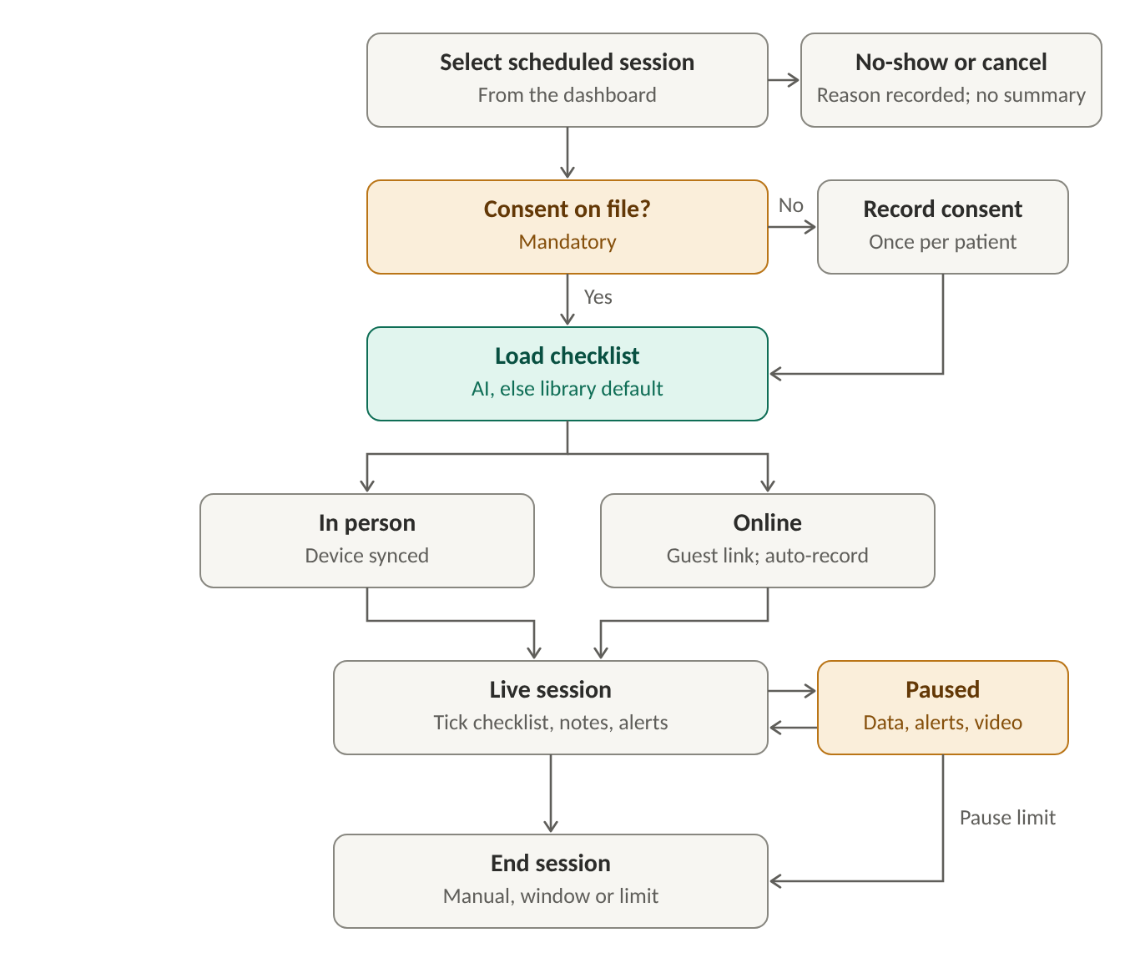
Figure 1. Therapist: running a session
- Select a scheduled session from the dashboard. A session can instead be marked as a no-show or cancelled, with a reason; nothing is sent to the AI service for it
- Consent is mandatory. If the patient has no consent on file, the therapist records it once per patient, with the signed form uploaded. No session can start without consent. If consent is withdrawn, the therapist or Organization Admin records the date and no further sessions can start. Consent does not expire
- The session checklist is loaded. For a patient with history, the checklist is received from the external AI service. For a new patient, or if the AI service does not respond, the default checklist for the client profile is taken from the platform library
- In person: the wearable is synced to the session. If the device is not connected, the therapist is warned and can continue
- Online: the platform emails the parent a one-time guest link to join; no account is needed. The session is recorded automatically. Live soft alerts are not used in online sessions
- During the live session, the therapist ticks checklist items as they are completed; each tick is time-stamped. Items cannot be added or removed. An optional reason can be given for items not completed
- Indicators show trends and the age of their data. If the device drops, the indicator shows no data, the gap is recorded, and the session continues
- Soft alerts (in person only) appear from the notification queue; the therapist acknowledges them. Notes and markers can be added at any time
- The therapist can pause and resume the session. While paused, device data, soft alerts and video are paused. In online sessions, the recording can also be paused and resumed on its own while the call continues
- If the browser is closed or the connection is lost, the session keeps running and resumes when reopened
- The session ends when the therapist ends it, when the scheduled window closes, or when the pause limit is reached (configurable by the BEST Platform Admin). Unacknowledged alerts expire

4. Completing the Session Summary
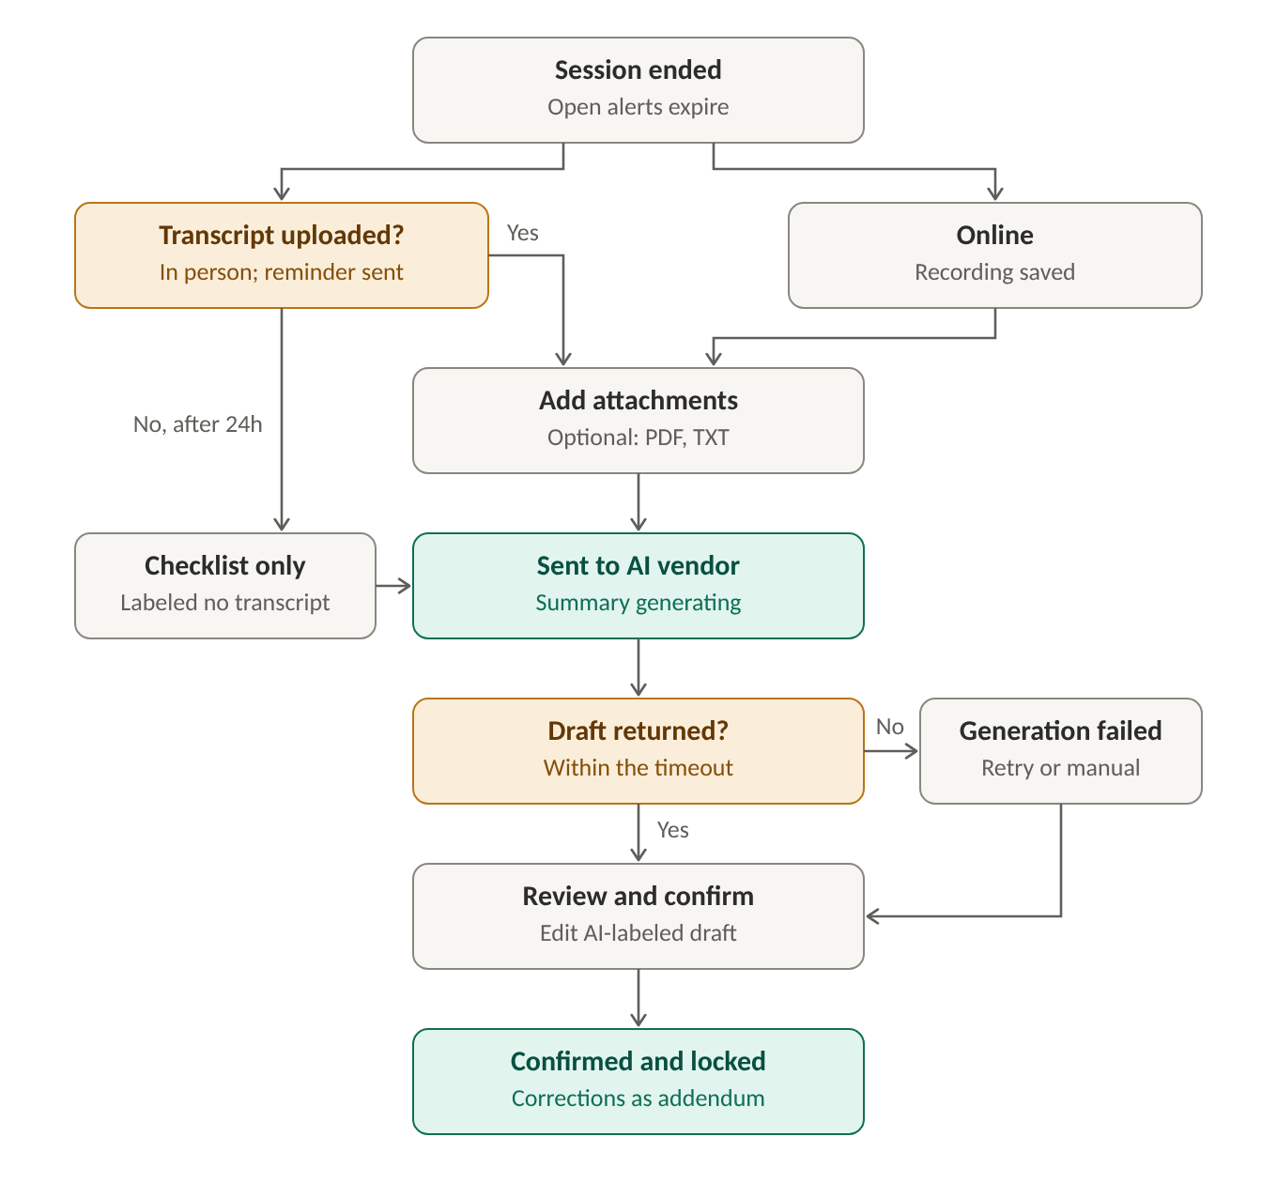
Figure 2. Therapist: completing the session summary
- In person: the therapist uploads the session transcript produced by an external transcription tool (TXT, PDF or DOCX; formats configurable). The transcription tool itself is outside the platform
- If the transcript is not uploaded, the session shows Upload pending and a reminder is sent. If no transcript is uploaded within the configured time (default 24 hours), only the checklist is sent to the AI service and the summary is labeled as having no transcript
- Online: the session recording is saved automatically; no upload is needed
- The therapist can add optional attachments (PDF, TXT) after the session; attachments cannot be added during the session. File size limits are configurable
- Session data is sent to the external AI service: device data, the checklist, notes and markers, the transcript or recording, and attachments. The screen shows that the summary is being generated
- If a draft is returned, it is shown labeled as AI-generated for the therapist to review
- If generation fails or times out, the therapist can retry (no limit) or write the summary manually
- The therapist edits and confirms the summary
- The confirmed summary is saved to the session record, locked, and becomes visible to the supervisor; unconfirmed drafts are never shown to supervisors. Later corrections are added as a dated addendum; the original is never overwritten

5. Session Statuses
- Scheduled, In progress, Paused, Ended, Upload pending, Summary generating, Draft ready, Generation failed, Confirmed
- No-show and Cancelled are set instead of running the session

