DRAFT
Functional Specification Document (FSD)
User Creation and Login
Therapy Session Monitoring & Clinical Support Platform

Client | BEST
Prepared by | TBR Consulting
Version | 0.3 — Draft for review
Date | 28 October 2026
Based on | PRD version 3.1; user creation and login flow (draft, 21 October 2026); review meeting of 22 October 2026; role-first user creation and master data decisions (27 October 2026)
Audience | BEST Product Team; TBR Consulting design, development and QA teams
Status | Draft. Items awaiting BEST confirmation are tagged PENDING CLIENT CONFIRMATION
Classification | Confidential
Document control
Table 1 — Version history
Version | Date | Author | Description
0.1 | 22 October 2026 | TBR Consulting | Initial draft for review
0.2 | 26 October 2026 | TBR Consulting | Updated after the 22 October review: active-user limit replaces seats; optional MFA for non-admin users; password re-entry for critical admin actions; view-only access with a grey screen for an inactive license; US formats as configurable lists; wireframes in the agreed colours and font
0.3 | 28 October 2026 | TBR Consulting | Role-first user creation: permissions are set on the role, not per user (BR-07); new S12 Roles list; S3 shows a read-only role summary instead of a permission grid; S4 can copy an existing role and is used to edit custom roles; editing a role updates all its users; a role in use cannot be retired; one role per user; several certifications per user; clinic fields can apply to chosen roles; aligned with PRD version 3.1

Table 2 — Approvals
Name | Role | Organization | Signature | Date
 | Product owner | BEST
 | Product manager | TBR Consulting
 | Delivery lead | TBR Consulting

Table 3 — Distribution
Name / group | Organization | Purpose
BEST Product Team | BEST | Review and approval
Design team | TBR Consulting | Screen design
Development team | TBR Consulting | Build
QA team | TBR Consulting | Test planning and execution

Contents
At a glance 4
1. Introduction 5
1.1 Purpose 5
1.2 Scope 5
1.3 Definitions 5
2. Actors and Permissions 6
2.1 Actors 6
2.2 Modules and permissions of predefined roles 6
2.3 Permissions for actions in this flow 7
3. Process Flow 8
4. Screen Specifications 12
4.1 S1 — Users list 12
4.2 S2 — Create user: details 13
4.3 S3 — Create user: role 14
4.4 S4 — Create or edit role (pop-up) 15
4.5 S5 — Login 16
4.6 S6 — Set new password 17
4.7 S7 — Email code 18
4.8 S8 — Forgot password 18
4.9 S9 — Deactivate and reactivate (pop-ups) 19
4.10 S10 — Home screen states 19
4.11 S11 — Confirm password (pop-up) 20
4.12 S12 — Roles list 20
5. Business Rules 22
6. User Account Statuses 23
7. Emails 24
8. Error and Information Messages 25
9. Configurable Settings 26
10. Audit Log Events 27
11. Acceptance Criteria 28
12. Traceability to the PRD 31
At a glance
This page summarises the specification. Details follow in Sections 1 to 12.
Table 4 — Summary of the specification
Topic | Summary
What it covers | The Org Admin optionally sets up roles, then creates clinic users by choosing one role for each; users receive a welcome email and log in
Actors | Organization Admin, clinic user, System
Screens | S1 Users list · S2 Create user: details · S3 Create user: role · S4 Create or edit role · S5 Login · S6 Set new password · S7 Email code · S8 Forgot password · S9 Deactivate and reactivate · S10 Home screen states · S11 Confirm password · S12 Roles list
Key rules | One role per user; permissions are set on the role, not on the user · editing a role updates all its users · login ID is the email address · a user counts towards the active-user limit from creation · temporary password valid 72 hours · new password required at first login · email code at every login for admin access, optional for other users · password re-entry for critical admin actions · lockout after 5 failures · view-only access with a grey screen when the license is not active
Account statuses | Invited, Invite expired, Active, Locked, Deactivated
Key settings | Password policy, email code validity, lockout threshold, reset-link validity and inactivity logout, all set by the BEST Platform Admin
Not covered | Editing a user after creation, clinic onboarding, BEST back-office login
Size of the specification | 12 screens · 25 business rules · 20 messages · 15 audit events · 34 acceptance criteria

1. Introduction

1.1 Purpose
This document specifies how clinic users are created by the Organization Admin and how they log in to the platform. It defines the screens, fields, validations, business rules, statuses, emails, messages, settings, audit events and acceptance criteria needed to design, build and test this part of the platform.

1.2 Scope
In scope
- Setting up roles (optional): viewing the predefined roles, creating a custom role from blank or by copying an existing role, editing a custom role, and retiring it when no user holds it
- Creating a user by choosing one role, predefined or custom
- Active-user limit check against the clinic’s license
- Optional MFA for non-admin users, set by the Org Admin
- Password re-entry for critical admin actions
- Welcome email with login ID, temporary password and login link
- First login: temporary password, setting a new password, and email code for users with admin access
- Second and later logins, including forgot password, lockout, deactivated accounts and restricted mode
- Deactivating and reactivating a user
- Re-sending the welcome email
Out of scope for this document
- Editing a user’s details or role after creation
- Clinic onboarding and creation of the first Organization Admin by BEST (covered in the clinic onboarding FSD)
- Login to the BEST back office (separate portal)

1.3 Definitions
Table 5 — Definitions
Term | Meaning
Organization Admin (Org Admin) | Clinic user who manages users, roles and clinic settings
Role | The set of permissions a user has. Each user holds exactly one role, and permissions are set on the role, not on the user
Predefined role | Role supplied and maintained by BEST: Therapist, Supervisor, Organization Admin. Clinics cannot edit them; changes by BEST apply to all clinics
Custom role | Role created by the Org Admin for the clinic, with a name, description and module permissions, from blank or as a copy of another role
Combined custom role | Custom role for a person with both clinical and admin duties. Replaces the Supervisor / Org Admin view switch of PRD version 3.0
Admin access | Any role with View or Edit permission on the Users & roles or Clinic settings module
Active user | A user with status Invited, Active or Locked. Each counts towards the active-user limit in the clinic’s license; deactivated users do not
Temporary password | System-generated password sent in the welcome email; valid for a limited time and usable once
Email code | Six-digit one-time code sent by email at login to users with admin access, and to other users whose MFA the Org Admin has turned on
Restricted mode | View-only access, including client personal details, applied to all clinic users when the clinic’s license has expired or is suspended; the screen turns grey

2. Actors and Permissions

2.1 Actors
Table 6 — Actors
Actor | Role in this flow
Organization Admin | Sets up custom roles, creates users by choosing a role, deactivates and reactivates users, re-sends welcome emails
Clinic user (new or existing) | Receives the welcome email, logs in, sets and resets their password
System | Checks the active-user limit, creates accounts, sends emails, validates credentials and codes, applies lockout and restricted mode

2.2 Modules and permissions of predefined roles
Each module can be set to None, View or Edit. The table shows the permissions of the predefined roles, which are maintained by BEST. Permissions belong to the role and cannot be changed for one user PENDING CLIENT CONFIRMATION ; a clinic that needs different access copies a role or creates a custom one (S4).
Table 7 — Permissions of predefined roles
Module | Therapist | Supervisor | Org Admin
Dashboard | View | View | View
Sessions | Edit | View | None
Clients | View (assigned only) | View | Edit
Assessments | Edit | Edit | None
Summaries | View | View | None
Reports | None | View | View
Consent | Edit | View | Edit
Users & roles | None | None | Edit
Clinic settings | None | None | Edit
Audit log | None | None | View

The Org Admin has no access to clinical session data by default (PRD version 3.1, Section 16.2).
The full list of permissions, with the default access of each predefined role, is in the Clinic User Permissions Catalogue (Excel, 28 October 2026). Two points there await BEST’s confirmation: whether S4 sets access per module, as shown here, or per individual permission, and whether the Supervision, Devices and Support access modules are added PENDING CLIENT CONFIRMATION .

2.3 Permissions for actions in this flow
Table 8 — Permissions for actions in this flow
Action | Who can perform it
View the user list | Any user with View or Edit on Users & roles
Create a user | Any user with Edit on Users & roles
View roles (S12) | Any user with View or Edit on Users & roles
Create, copy, edit or retire a custom role | Any user with Edit on Users & roles
Deactivate or reactivate a user | Any user with Edit on Users & roles
Re-send the welcome email | Any user with Edit on Users & roles
Log in, reset own password | Every clinic user whose account is not deactivated

3. Process Flow
The flow is shown in three diagrams, with one lane per actor. Ovals mark start and end points, rectangles are steps, parallelograms are user inputs, diamonds are decisions, the wavy-bottom shape is an email, a rectangle with side bars is a sub-process, and a circle links one page to the next.
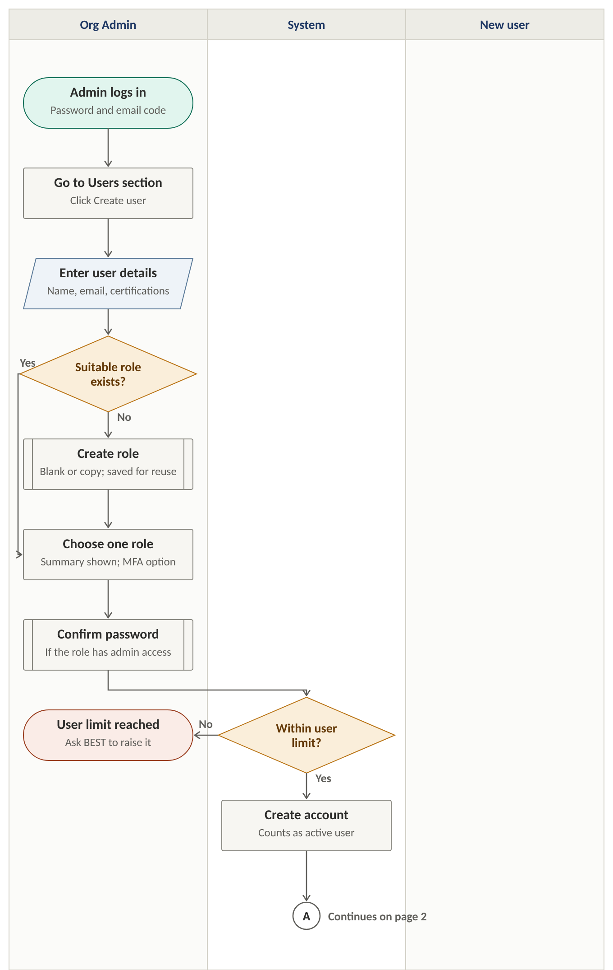
Figure 1. Org Admin creates the user

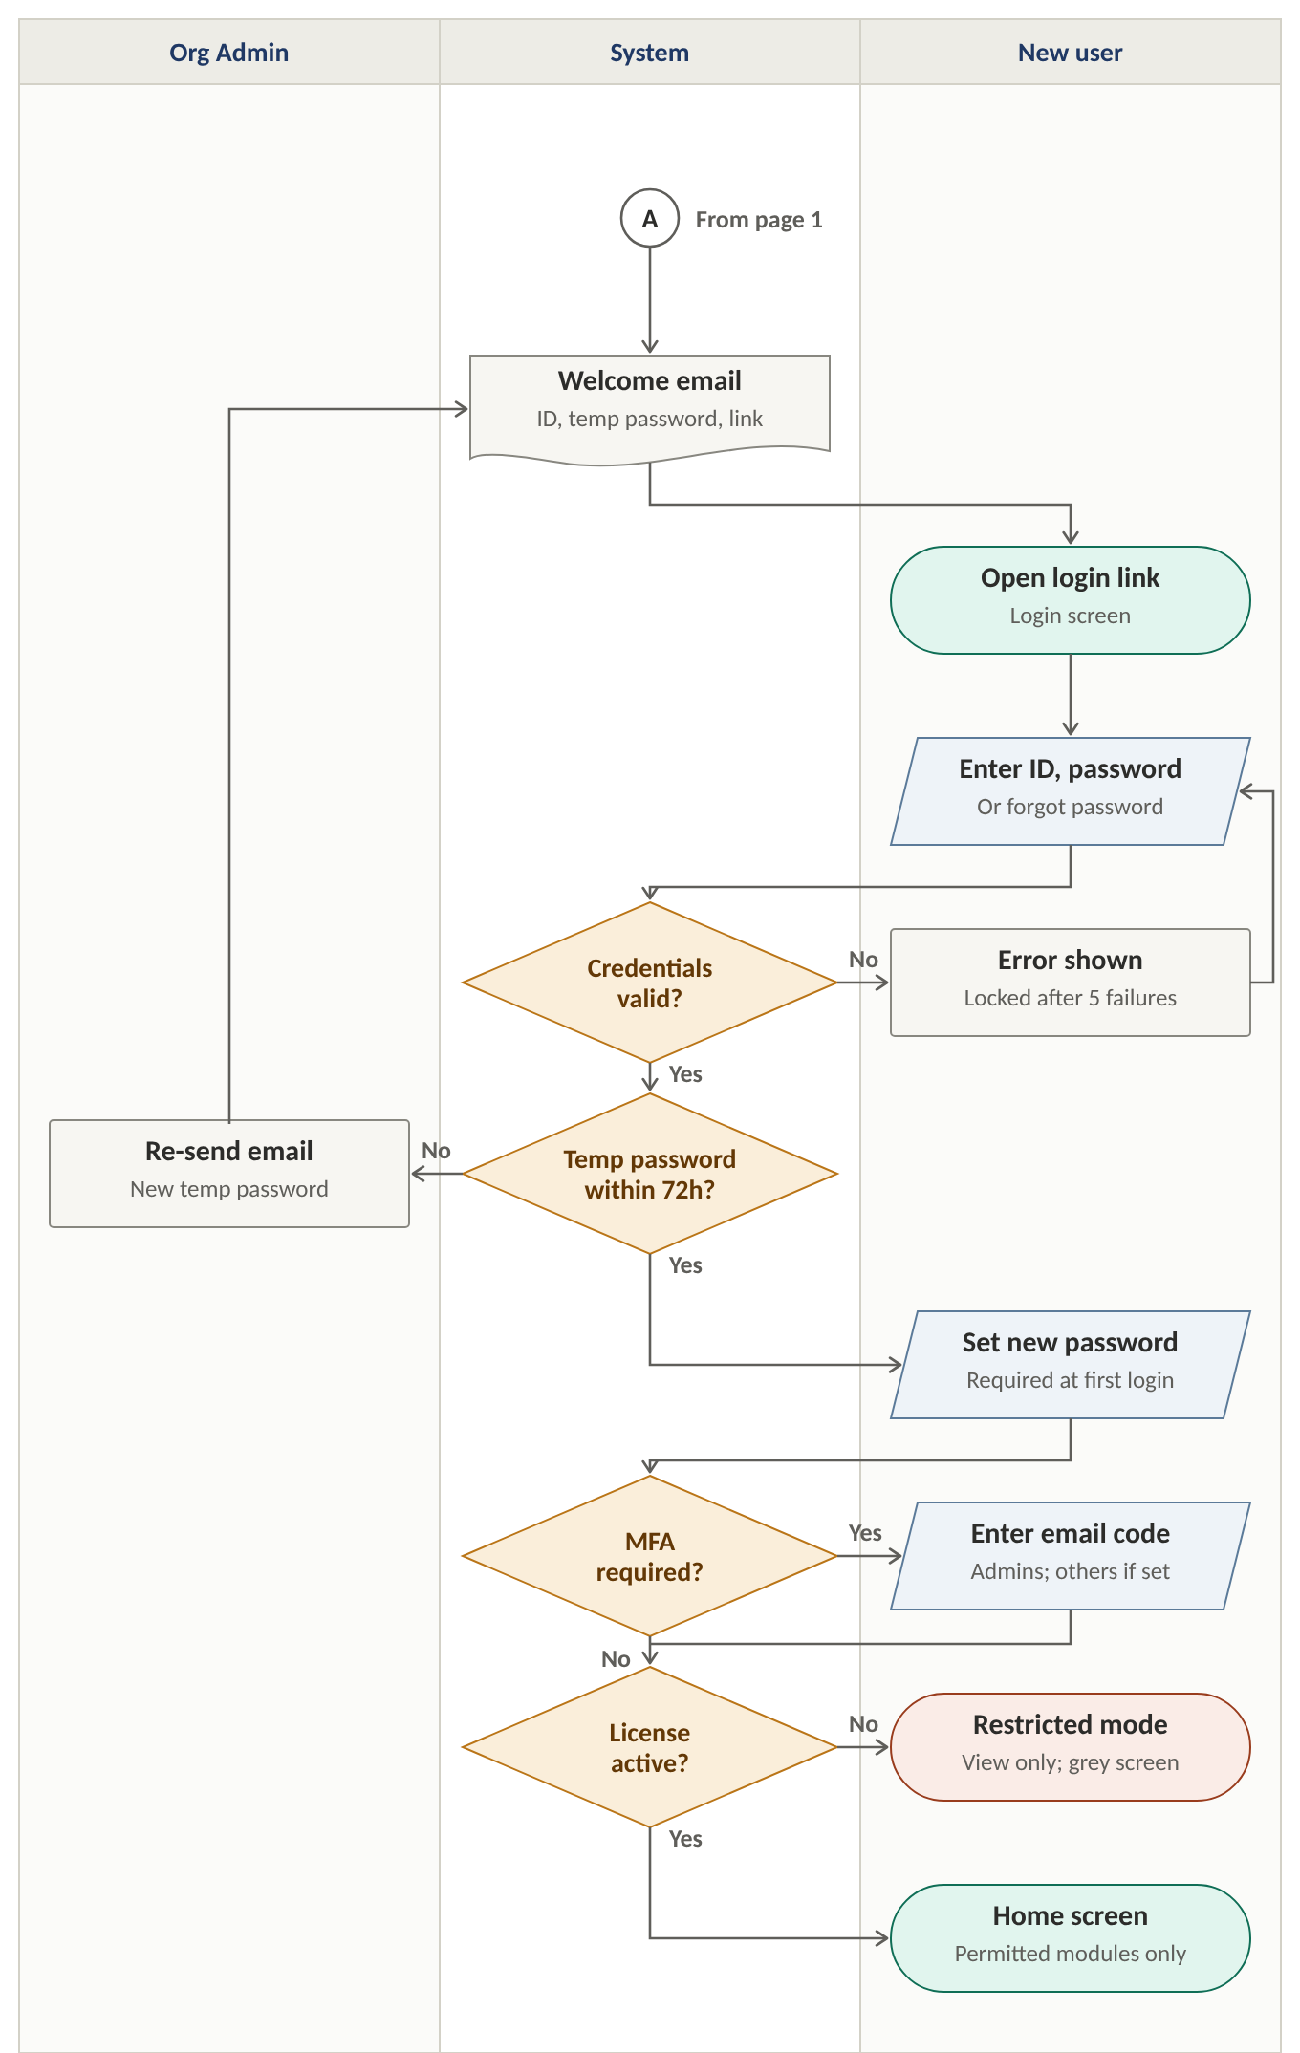
Figure 2. First login

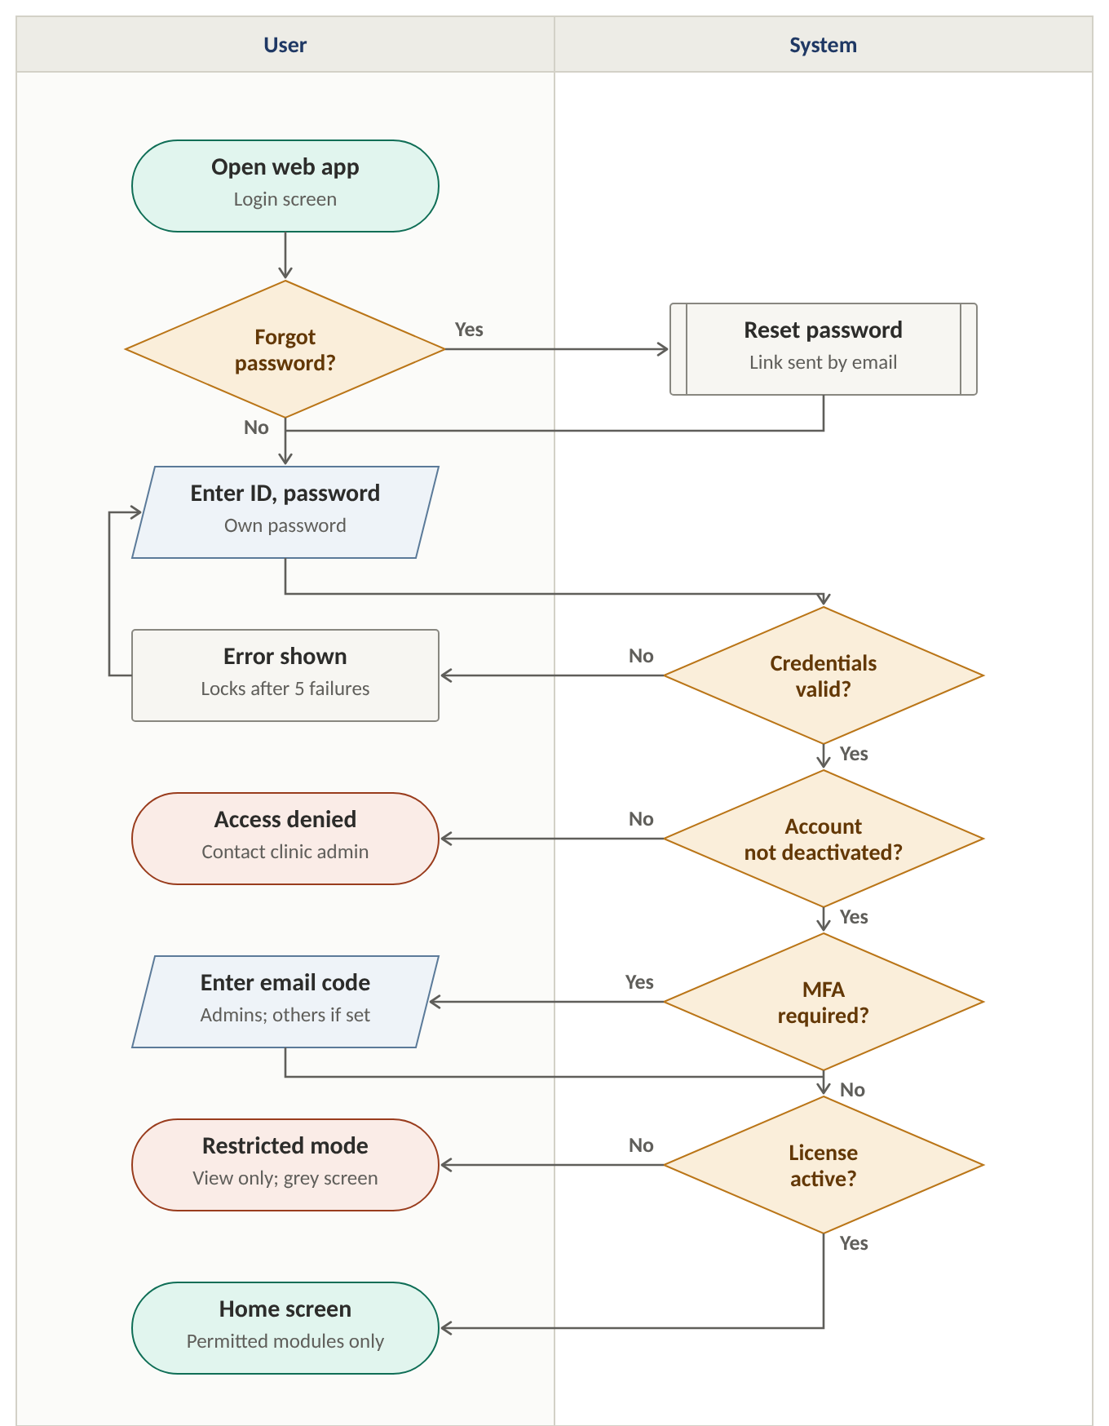
Figure 3. Second and later logins

4. Screen Specifications
Each screen is shown as a low-fidelity wireframe that sets out layout and content only; visual design follows separately. The box under each screen lists the business rules (BR), messages (M) and acceptance criteria (AC) that apply to it.

4.1 S1 — Users list
Purpose: shows all users of the clinic and is the starting point for creating, deactivating and reactivating users. Opened from the Users section of the clinic console.
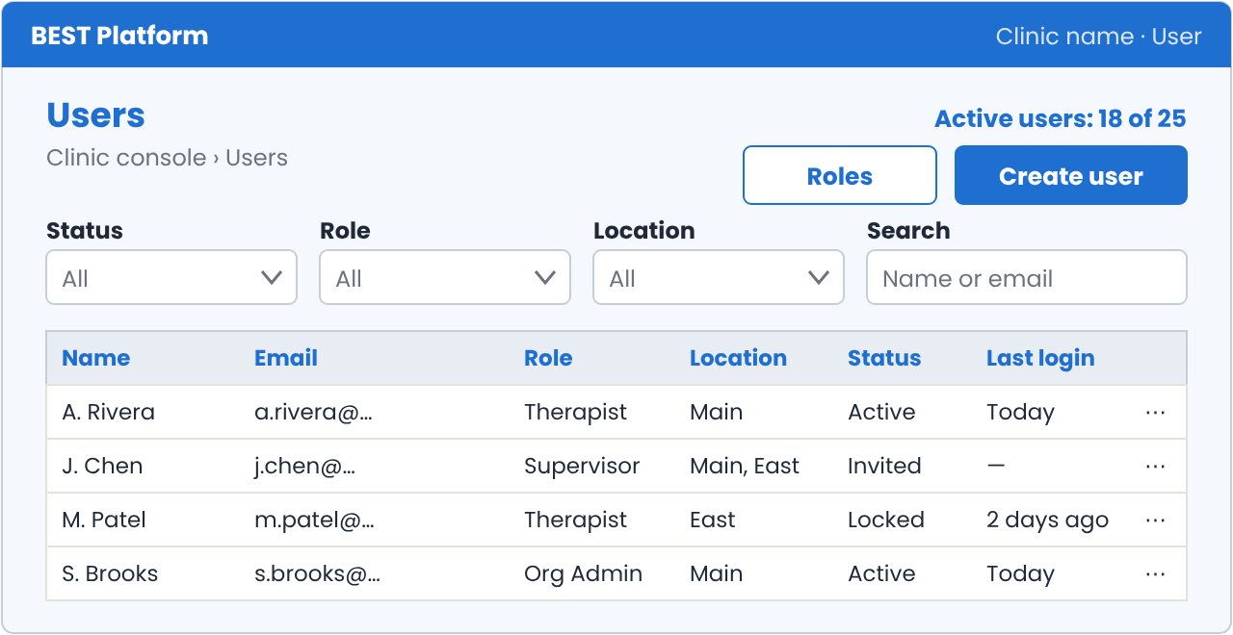
Figure 4. S1 — Users list (wireframe)
Table 9 — S1 Users list: elements
Element | Description
Active-user counter | “Active users: X of Y”, from the clinic’s license
Columns | Name, Email, Role, Location(s), Status, Last login
Filters | Status, Role, Location; search by name or email
Roles button | Opens S12, where roles can be set up before users are created (optional)
Create user button | Opens S2. Disabled with a tooltip when the active-user limit is reached (message M-04)
Row actions | Deactivate (Active or Locked users); Reactivate (Deactivated users); Re-send welcome email (Invited or Invite expired users)

Related: BR-01, BR-03, BR-04, BR-08, BR-09 · M-04 · AC-02, AC-08, AC-17, AC-19

4.2 S2 — Create user: details
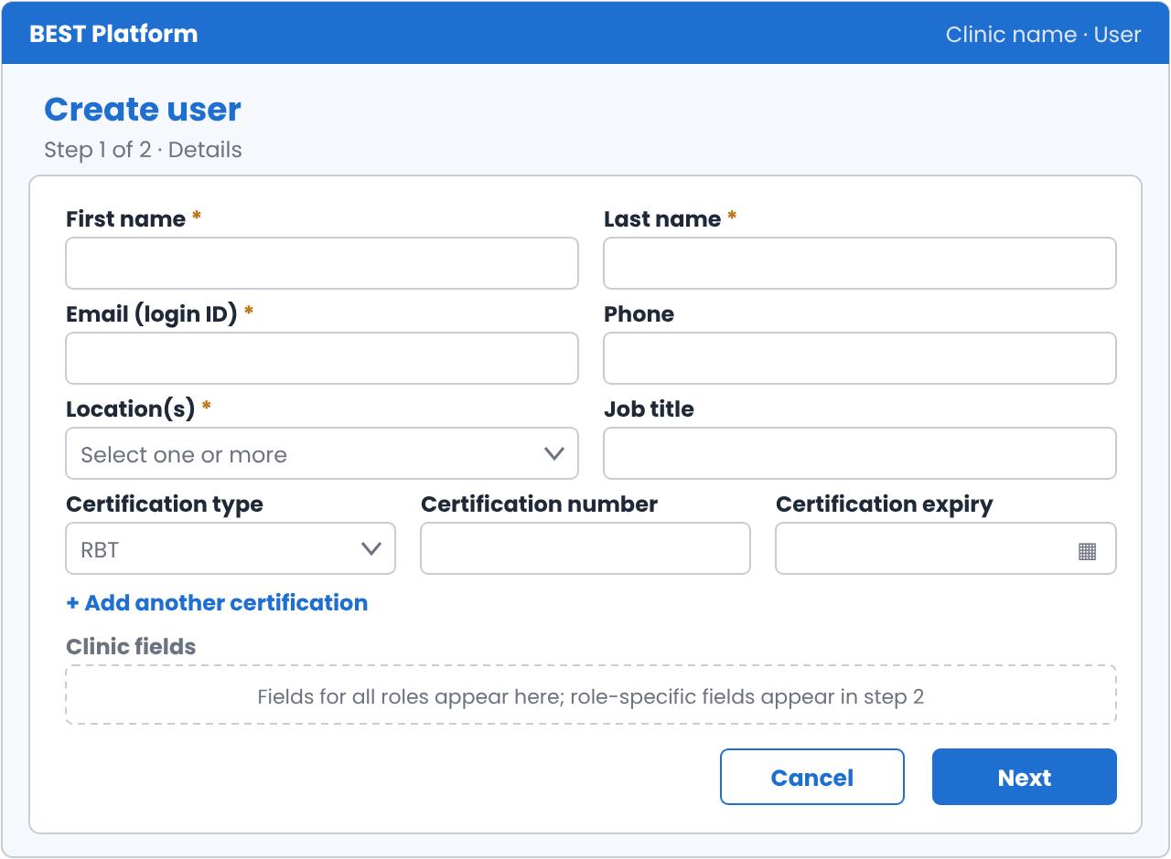
Figure 5. S2 — Create user: details (wireframe)
Table 10 — S2 Create user: details fields
Field | Type | Mandatory | Validation and rules
First name | Text | Yes | 1–50 characters; letters, spaces, hyphens, apostrophes
Last name | Text | Yes | 1–50 characters; letters, spaces, hyphens, apostrophes
Email (login ID) | Email | Yes | Valid email format; not case-sensitive; must not belong to any existing account on the platform (M-01)
Phone | Phone | No | US phone number format (configurable list of formats)
Location(s) | Multi-select | Yes | At least one of the clinic’s locations
Job title | Text | No | Up to 100 characters
Certifications | Repeatable group | No | Any number. “+ Add another certification” adds a row of the three fields below
Certification type | Dropdown | Yes, in each row | RBT or BCBA (configurable list)
Certification number | Text | Yes, in each row | Up to 30 characters
Certification expiry | Date | Yes, in each row | Future date. Recorded only; no effect on access in this version
Clinic fields | As defined | As defined | Fields set up by the Org Admin in Clinic settings that apply to all roles: text, number, date or dropdown, each optional or mandatory. Fields limited to chosen roles appear on S3

Buttons: Next (validates the fields and opens S3), Cancel (discards the entries after confirmation).
Related: BR-02, BR-25 · M-01 · AC-01, AC-03, AC-34

4.3 S3 — Create user: role
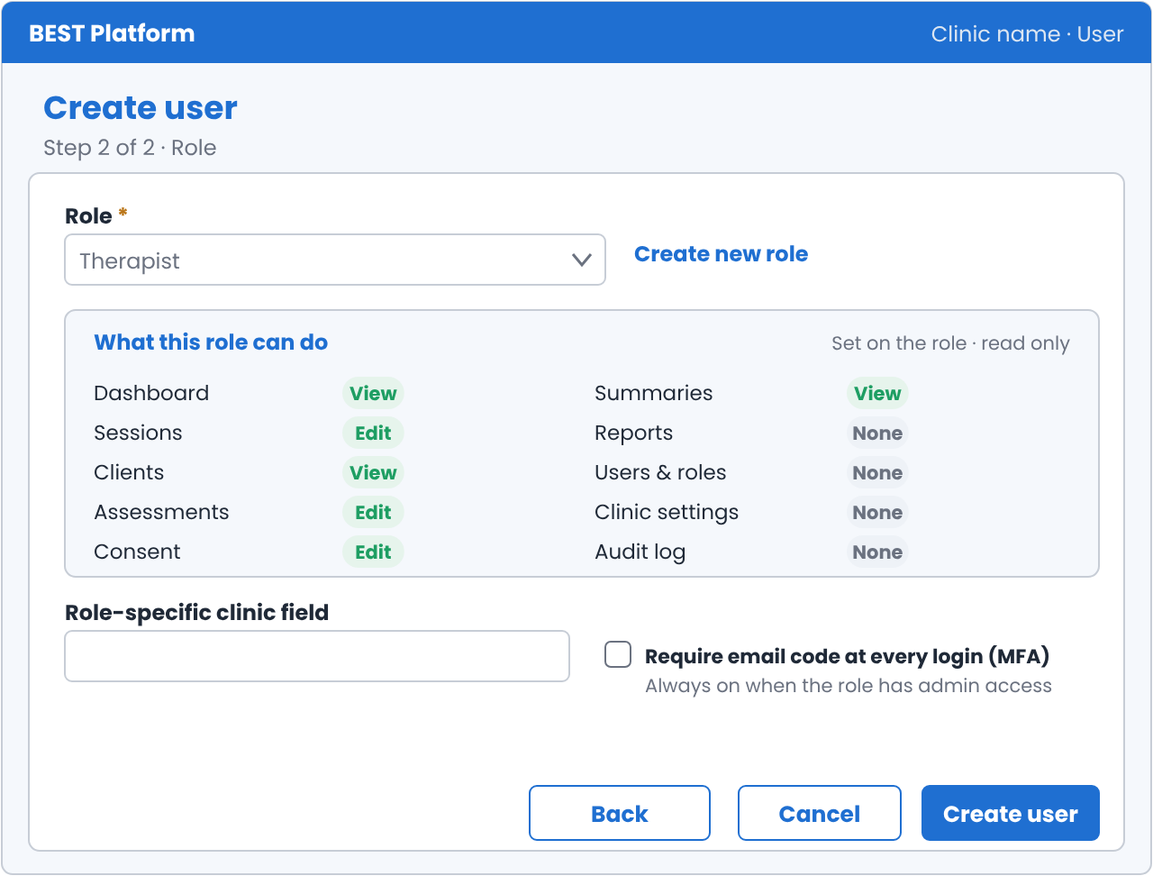
Figure 6. S3 — Create user: role (wireframe)
Table 11 — S3 Create user: role fields
Field | Type | Mandatory | Validation and rules
Role | Dropdown (single choice) | Yes | Lists predefined roles, then the clinic’s custom roles. Retired roles are not listed. One role per user
Create new role | Link | — | Opens S4. The saved role is selected here
What this role can do | Read-only summary | — | Shows each module and the role’s access (None, View or Edit). It cannot be changed for this user PENDING CLIENT CONFIRMATION
Role-specific clinic fields | As defined | As defined | Clinic fields limited to chosen roles, shown when one of those roles is selected
Require email code (MFA) | Checkbox | No | Off by default. When the role has admin access, it is turned on and cannot be changed
Admin access indicator | Read-only label | — | Shown when the role has View or Edit on Users & roles or Clinic settings: “This user will enter an email code at every login”

Buttons: Back (returns to S2 with entries kept), Create user (runs the active-user limit check, asks the Org Admin to re-enter their password in S11 when the user is given admin access, and creates the account), Cancel.
Related: BR-03, BR-07, BR-11, BR-18, BR-20, BR-25 · M-04, M-16 · AC-01, AC-05, AC-24, AC-26, AC-33

4.4 S4 — Create or edit role (pop-up)
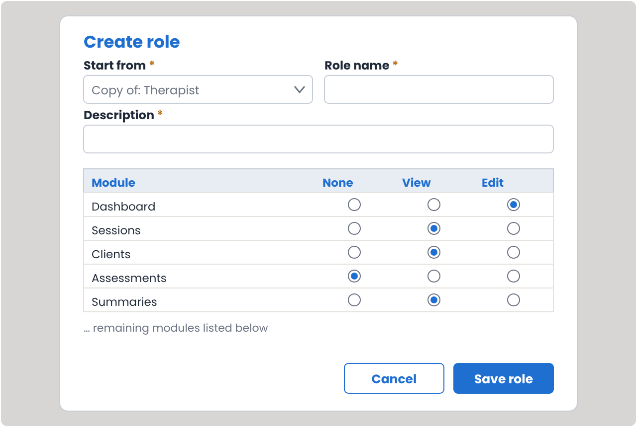
Figure 7. S4 — Create role (wireframe)
Opened from S3 (Create new role) or from S12 (Create role, Copy or Edit).
Table 12 — S4 Create role: fields
Field | Type | Mandatory | Validation and rules
Start from | Dropdown | Yes, for a new role | Blank, or a copy of any predefined or custom role. A copy loads that role’s permissions into the grid. Hidden when editing
Role name | Text | Yes | 2–50 characters; unique within the clinic and different from predefined role names (M-02)
Description | Text area | Yes | Up to 250 characters
Module permissions | Grid: module × None / View / Edit | Yes | At least one module must be View or Edit (M-03)

Buttons: Save role (asks the Org Admin to re-enter their password in S11 when the role includes Users & roles or Clinic settings; saves the role to the clinic and, when opened from S3, selects it there), Cancel (returns without saving).
When editing a custom role that users hold, Save role first shows M-20 with the number of users affected; after saving, M-19 is shown.
Related: BR-06, BR-18, BR-21, BR-22, BR-23 · M-02, M-03, M-19, M-20 · AC-04, AC-28, AC-29, AC-32

4.5 S5 — Login
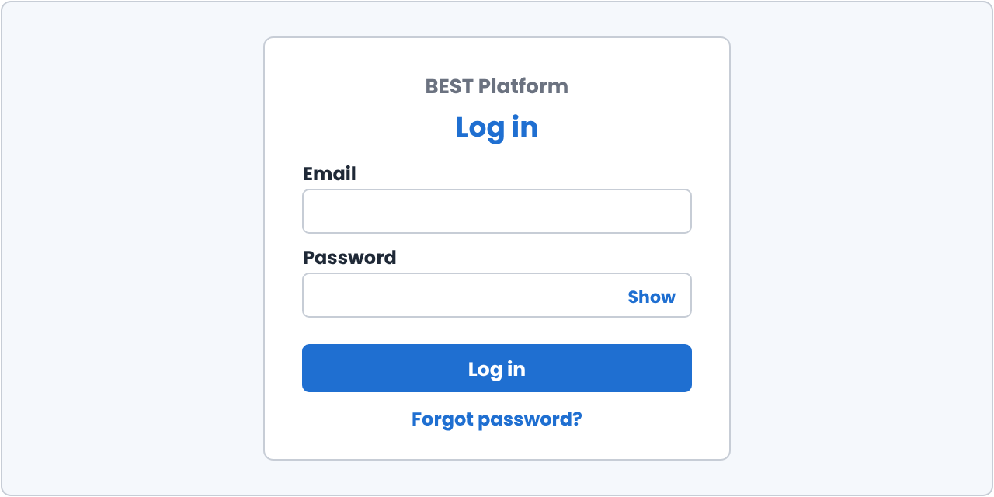
Figure 8. S5 — Login (wireframe)
Table 13 — S5 Login: fields
Field | Type | Mandatory | Validation and rules
Email | Email | Yes | Not case-sensitive
Password | Password (masked, with show/hide) | Yes | Temporary password at first login; own password afterwards

Links and buttons: Log in, Forgot password? (opens S8). The login page does not ask for a user type; the role is read from the account.
Related: BR-12, BR-13, BR-14 · M-05, M-06, M-13, M-14 · AC-06, AC-07, AC-12, AC-16

4.6 S6 — Set new password
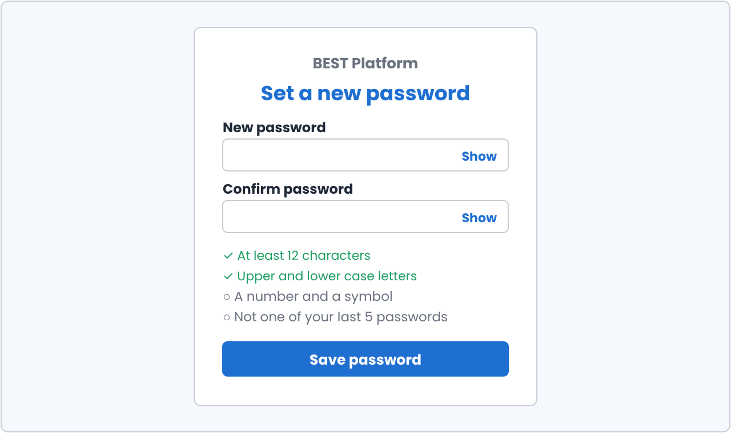
Figure 9. S6 — Set new password (wireframe)
Shown after a successful first login with the temporary password, and when a user opens a valid password-reset link.
Table 14 — S6 Set new password: fields
Field | Type | Mandatory | Validation and rules
New password | Password | Yes | Meets the password policy (Section 9); not one of the user’s last 5 passwords; not the temporary password (M-08)
Confirm password | Password | Yes | Must match New password (M-09)

A checklist under the field shows each password rule turning complete as it is met. Button: Save password.
Related: BR-10, BR-16, BR-17 · M-08, M-09, M-15 · AC-06, AC-13, AC-15, AC-22

4.7 S7 — Email code
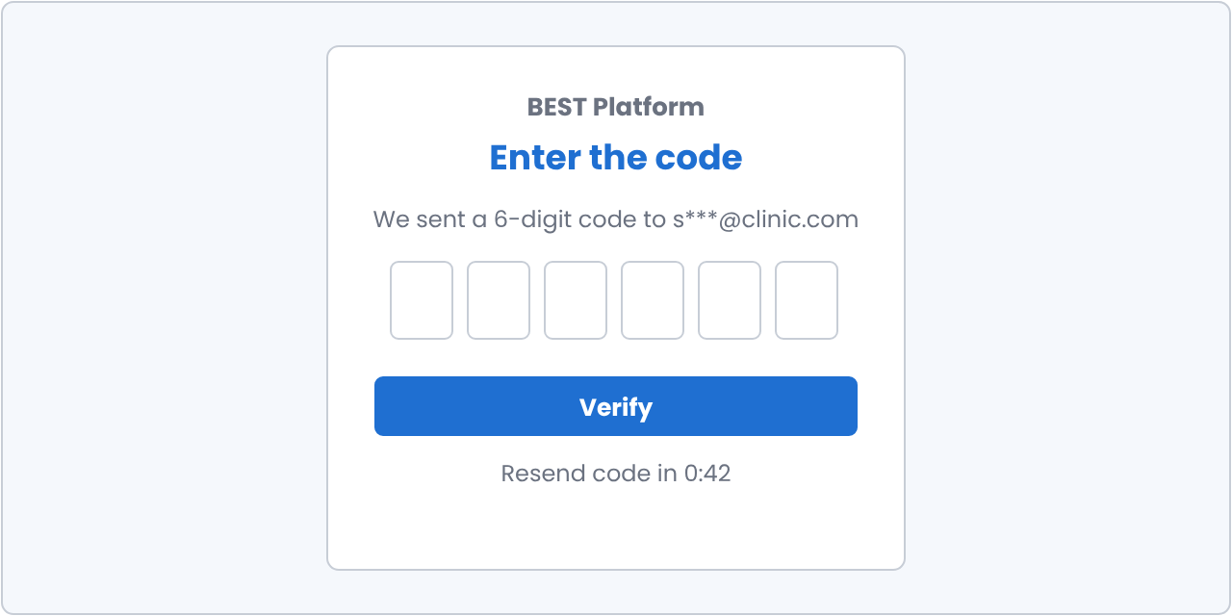
Figure 10. S7 — Email code (wireframe)
Shown at every login to users with admin access, and to other users whose MFA is turned on, after the password step (and after S6 at first login).
Table 15 — S7 Email code: field
Field | Type | Mandatory | Validation and rules
Code | 6-digit number | Yes | Matches the latest code sent and is within its validity (M-10, M-11)

The screen shows the email address the code was sent to, partly masked. Buttons: Verify, Resend code (available after 60 seconds; a new code replaces the old one).
Related: BR-11 · M-10, M-11 · AC-09, AC-10, AC-11, AC-24

4.8 S8 — Forgot password
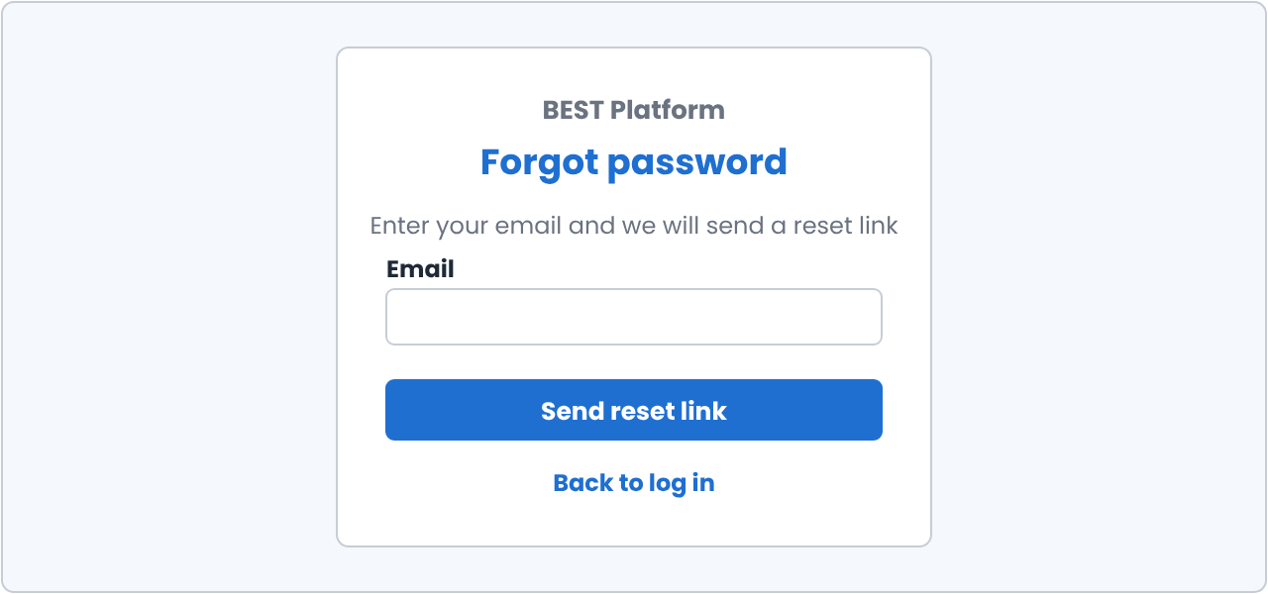
Figure 11. S8 — Forgot password (wireframe)
Table 16 — S8 Forgot password: field
Field | Type | Mandatory | Validation and rules
Email | Email | Yes | Valid email format

Button: Send reset link. The same confirmation (M-12) is shown whether or not the email belongs to an account, so the screen cannot be used to find out which emails are registered. Opening a valid link leads to S6.
Related: BR-16, BR-17 · M-12 · AC-13, AC-14

4.9 S9 — Deactivate and reactivate (pop-ups)
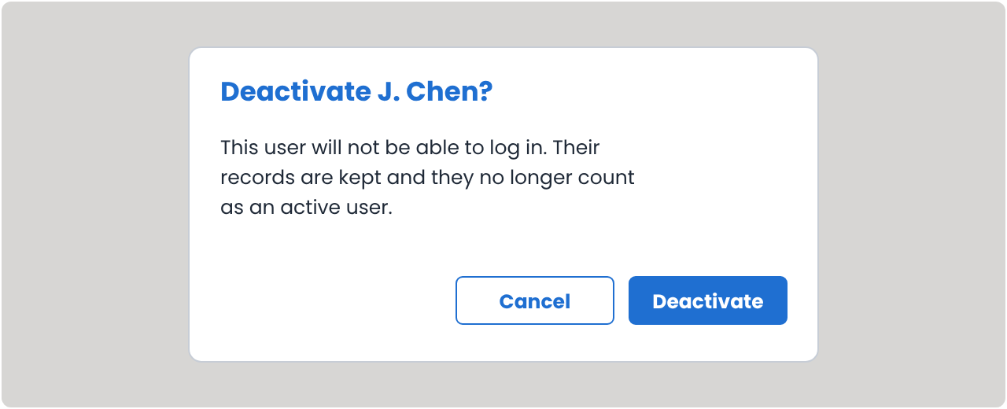
Figure 12. S9 — Deactivate (wireframe)
- Deactivate: confirmation pop-up with the user’s name and the text: “This user will not be able to log in. Their records are kept and they no longer count as an active user.” Buttons: Deactivate, Cancel. After Deactivate, the Org Admin re-enters their password in S11
- Reactivate: confirmation pop-up. Runs the active-user limit check; if the limit is reached, M-04 is shown. On success the user can log in with their existing password
Related: BR-04, BR-05, BR-13, BR-18 · M-04, M-07 · AC-17, AC-18, AC-19, AC-25

4.10 S10 — Home screen states
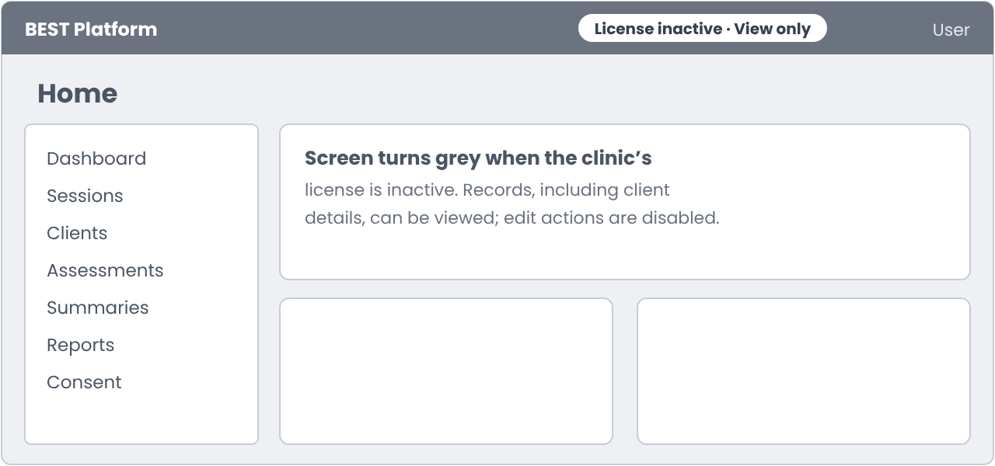
Figure 13. S10 — Home screen with an inactive license (wireframe)
- Normal: the home screen for the user’s role, showing only modules with View or Edit permission
- Restricted mode (license inactive): the screen turns grey and a “License inactive · View only” label appears in the header. Users can view all records, including client personal details. All Edit actions are disabled
Related: BR-14, BR-15 · AC-10, AC-20, AC-21

4.11 S11 — Confirm password (pop-up)
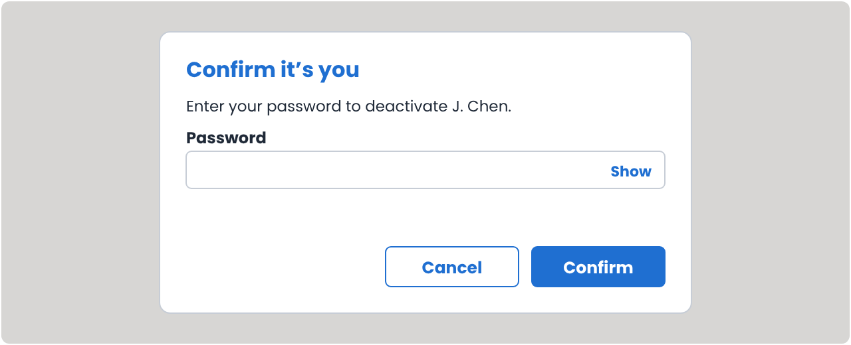
Figure 14. S11 — Confirm password (wireframe)
Shown before a critical admin action is completed: deactivating a user, creating a user with admin access, and saving a role that includes Users & roles or Clinic settings.
Table 17 — S11 Confirm password: field
Field | Type | Mandatory | Validation and rules
Password | Password (masked, with show/hide) | Yes | The Org Admin’s own current password (M-17). Each wrong entry counts towards the account lockout (BR-12)

The pop-up names the action being confirmed. Buttons: Confirm (completes the action), Cancel (returns without completing it).
Related: BR-12, BR-18 · M-17 · AC-25, AC-26, AC-27

4.12 S12 — Roles list
Purpose: shows the roles available in the clinic, and is where roles are set up before users are created (optional). Opened from the Roles button on S1.
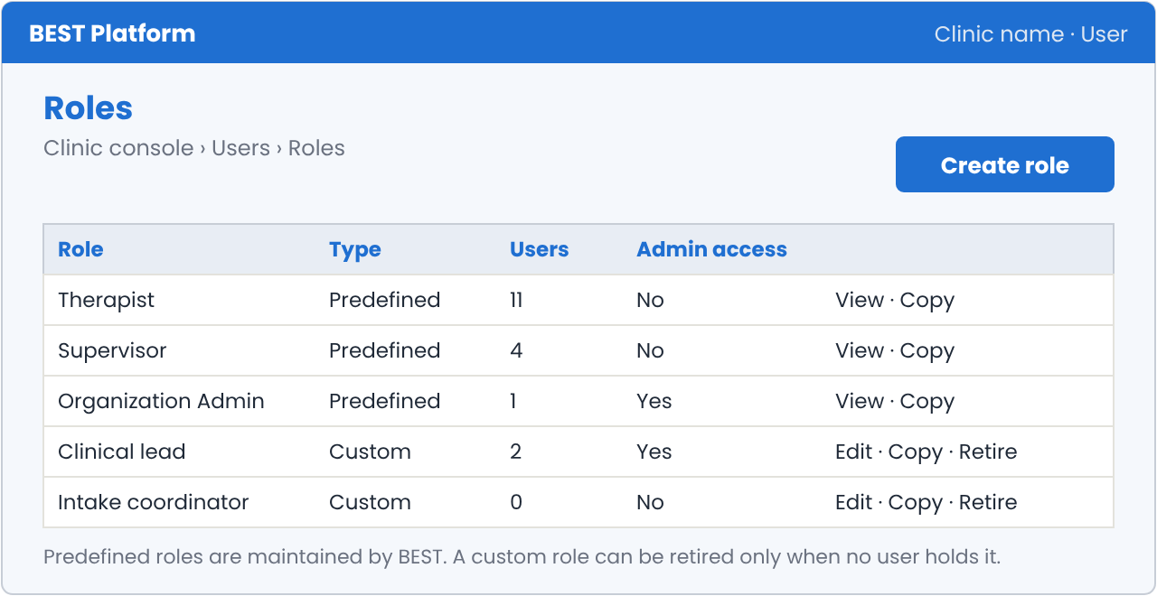
Figure 15. S12 — Roles list (wireframe)
Table 18 — S12 Roles list: elements
Element | Description
Columns | Role, Type (Predefined or Custom), Users (number holding the role), Admin access (Yes or No)
Create role button | Opens S4 with Start from set to Blank
Row actions: predefined roles | View (opens the role read-only), Copy (opens S4 as a copy)
Row actions: custom roles | Edit (opens S4 for that role), Copy, Retire. Retire is blocked while any user holds the role (M-18)

Related: BR-01, BR-21, BR-23, BR-24 · M-18 · AC-29, AC-30, AC-31

5. Business Rules
Table 19 — Business rules
ID | Rule
BR-01 | Only users with Edit permission on Users & roles can create, deactivate or reactivate users and create, copy, edit or retire custom roles.
BR-02 | The login ID is the user’s email address. Each email can belong to only one account on the platform. Email comparison is not case-sensitive.
BR-03 | A user counts towards the active-user limit of the clinic’s license from creation (status Invited). A user can be created only if the limit has not been reached.
BR-04 | A deactivated user does not count towards the limit. Reactivating a user is allowed only if the limit has not been reached.
BR-05 | A clinic must always have at least one active user with Edit on Users & roles. The last such user cannot be deactivated (M-07).
BR-06 | Custom roles belong to one clinic and are not visible to other clinics. Role names must be unique within the clinic.
BR-07 | Permissions belong to the role and cannot be changed for one user. To give a user different access, the Org Admin chooses another role or creates a custom role. PENDING CLIENT CONFIRMATION
BR-08 | On creation, the system generates a temporary password and emails it with the login ID and login link. The temporary password is valid for 72 hours (configurable) and can be used once.
BR-09 | Re-sending the welcome email generates a new temporary password and makes the previous one invalid. It is available only for users who have not completed first login.
BR-10 | At first login the user must set a new password before reaching any other screen.
BR-11 | Users with admin access (View or Edit on Users & roles or Clinic settings), including custom roles, must enter an email code at every login. For other users, the Org Admin can turn this on for each user; it is off by default.
BR-12 | After 5 consecutive failed login attempts the account is locked. It stays locked until the user resets the password through Forgot password. A successful login resets the failure count.
BR-13 | A deactivated user cannot log in, cannot reset their password, and receives M-06. Their records are kept.
BR-14 | If the clinic’s license has expired or is suspended, all clinic users get view-only access after login. They can view all records, including client personal details, but cannot make changes or start sessions. The screen turns grey and a “License inactive · View only” label is shown.
BR-15 | A user is logged out automatically after 15 minutes without activity (configurable). A warning is shown 2 minutes before.
BR-16 | Password-reset links are valid for 30 minutes and can be used once. Requesting a new link makes earlier links invalid.
BR-17 | A completed password reset unlocks a locked account.
BR-18 | Before deactivating a user, creating a user with admin access, or saving a new or edited role that includes Users & roles or Clinic settings, the Org Admin must re-enter their password (S11). The action is completed only after the password is confirmed.
BR-19 | Phone numbers and certification types follow US formats in this version. Both are configurable lists maintained by the BEST Platform Admin, so other regions can be added later.
BR-20 | Each user holds exactly one role. A person with both clinical and admin duties is given a combined custom role; there is no view switch.
BR-21 | Predefined roles are maintained by BEST and cannot be edited or retired by a clinic. A change made by BEST applies to every clinic. A clinic can copy a predefined role to make a custom role.
BR-22 | A new custom role starts blank or as a copy of any predefined or custom role. A copy is independent: later changes to the original do not change it.
BR-23 | Editing a custom role changes access for every user who holds it, from their next action. If the edit gives the role admin access, the Org Admin re-enters their password (S11), and those users must enter an email code from their next login.
BR-24 | A custom role can be retired only when no user holds it (M-18). A retired role is no longer offered in S3 and stays in the audit history.
BR-25 | A user can have any number of certifications. A clinic field can apply to all roles (shown on S2) or to chosen roles (shown on S3 when one of those roles is selected).

6. User Account Statuses
Table 20 — User account statuses
Status | Meaning | Moves to
Invited | User created; first login not yet completed; temporary password still valid | Active (first login completed); Invite expired (72 hours pass); Deactivated
Invite expired | Temporary password expired before first login | Invited (welcome email re-sent); Deactivated
Active | User has completed first login and can log in | Locked (5 failed attempts); Deactivated
Locked | Login blocked after 5 failed attempts | Active (password reset completed); Deactivated
Deactivated | Login blocked by the Org Admin; no longer counts as an active user; records kept | Active (reactivated, if the active-user limit allows and first login was completed); Invited (reactivated before first login, with a new welcome email)

7. Emails
Table 21 — Emails
Email | Trigger | Recipient | Content
Welcome email | User created (BR-08) or welcome email re-sent (BR-09) | New user | Clinic name; login ID (email); temporary password; login link; validity (72 hours); note that a new password must be set at first login
Email code | Password step completed by a user with admin access, or whose MFA is turned on | That user | Six-digit code; validity (10 minutes); note to ignore the email if they did not try to log in
Password reset link | Forgot password submitted for an existing, not deactivated account | That user | Reset link; validity (30 minutes); note to ignore the email if they did not ask for it

8. Error and Information Messages
Table 22 — Error and information messages
ID | Condition | Message shown
M-01 | Email already belongs to an account | An account with this email already exists.
M-02 | Role name already used in the clinic or matches a predefined role | A role with this name already exists. Choose a different name.
M-03 | New role has no module set to View or Edit | Give this role access to at least one module.
M-04 | Active-user limit reached when creating or reactivating a user | Your license’s active-user limit has been reached. Ask BEST to raise it.
M-05 | Wrong email or password | Email or password is incorrect. X attempts left before your account is locked.
M-06 | Login by a deactivated user | Your account is not active. Please contact your clinic admin.
M-07 | Attempt to deactivate the last user with Edit on Users & roles | This user cannot be deactivated. The clinic needs at least one user who can manage users.
M-08 | New password does not meet the policy or reuses a recent password | Your password does not meet the requirements shown.
M-09 | Passwords do not match | Passwords do not match.
M-10 | Wrong email code | The code is incorrect. Check the latest email and try again.
M-11 | Email code expired | This code has expired. Request a new code.
M-12 | Forgot password submitted | If an account exists for this email, we have sent a password reset link.
M-13 | Temporary password expired | Your temporary password has expired. Ask your clinic admin to send a new one.
M-14 | Account locked | Your account is locked after too many attempts. Use Forgot password to reset it.
M-15 | Reset link expired or already used | This link has expired. Request a new password reset link.
M-16 | User created | User created. A welcome email has been sent to [email].
M-17 | Wrong password in S11 | Password is incorrect. Try again.
M-18 | Retiring a custom role that users hold | This role is held by X users. Move them to another role before retiring it.
M-19 | Edited role saved | Role saved. X users with this role now have the updated access.
M-20 | Saving an edit to a role that users hold | This change applies to X users who hold this role. Continue?

9. Configurable Settings
Table 23 — Configurable settings
Setting | Default | Set by
Temporary password validity | 72 hours | BEST Platform Admin
Password: minimum length | 12 characters | BEST Platform Admin
Password: required characters | Upper case, lower case, number, symbol | BEST Platform Admin
Password: previous passwords not reusable | Last 5 | BEST Platform Admin
Password expiry | None | BEST Platform Admin
Email code length and validity | 6 digits; 10 minutes | BEST Platform Admin
Failed attempts before lockout | 5 | BEST Platform Admin
Password-reset link validity | 30 minutes | BEST Platform Admin
Inactivity logout | 15 minutes | BEST Platform Admin
Clinic fields on Create user, and the roles each applies to | None | Org Admin (Clinic settings)
MFA for non-admin users | Off | Org Admin, per user
Phone number formats | US | BEST Platform Admin
Certification types | RBT, BCBA | BEST Platform Admin

10. Audit Log Events
Every event records the date and time, the clinic, and the IP address. Passwords, temporary passwords and email codes are never written to the audit log.
Table 24 — Audit log events
Event | Actor | Details recorded
User created | Org Admin | New user’s email, role, locations, certifications, MFA setting
Custom role created | Org Admin | Role name, description, module permissions; role copied from, if any
Custom role edited | Org Admin | Role name; permissions before and after; number of users affected
Custom role retired | Org Admin | Role name
Welcome email sent or re-sent | System / Org Admin | Recipient email
User deactivated / reactivated | Org Admin | User’s email; active-user count after the change
Password re-entry succeeded / failed | Org Admin | Action being confirmed
Login succeeded | User | User’s email
Login failed | User | Email entered; failure count
Account locked / unlocked | System | User’s email; reason
Email code sent / verified / failed | System / User | User’s email
Password set or reset | User | User’s email; first login or reset
Password-reset link requested | User | Email entered
Logged out (manual or inactivity) | User / System | User’s email; reason
Restricted mode applied at login | System | User’s email; license status

11. Acceptance Criteria
Table 25 — Acceptance criteria
ID | Given | When | Then
AC-01 | The Org Admin has Edit on Users & roles and the active-user limit has not been reached | They complete S2 and S3 with valid data and select Create user | The user is created with status Invited, counts towards the active-user limit, the welcome email is sent and M-16 is shown
AC-02 | The active-user limit has been reached | The Org Admin opens the Users list | Create user is disabled and M-04 is shown on hover
AC-03 | An account with the same email already exists (in any letter case) | The Org Admin enters that email in S2 | M-01 is shown and the user cannot proceed
AC-04 | The Org Admin is on S3 | They choose Create new role and save a valid name, description and permissions | The role is saved to the clinic, selected for the user, and its summary is shown
AC-05 | The Org Admin has chosen a role on S3 | They look at the role summary | The permissions are read-only, cannot be changed for this user, and only one role can be selected
AC-06 | A user has status Invited and the temporary password is within 72 hours | They log in with it | S6 is shown and no other screen is reachable until a valid new password is saved
AC-07 | The temporary password is older than 72 hours | The user tries to log in with it | M-13 is shown and the status is Invite expired
AC-08 | A user has status Invite expired | The Org Admin re-sends the welcome email | A new temporary password is emailed, the old one no longer works, and the status is Invited
AC-09 | A user’s role includes View or Edit on Users & roles or Clinic settings | They enter a correct password | S7 is shown and access is granted only after a valid email code
AC-10 | A user has no admin access and their MFA is off | They enter a correct password | No email code is asked and the home screen is shown
AC-11 | An email code is older than 10 minutes | The user enters it | M-11 is shown
AC-12 | A user has 4 failed attempts | They enter a wrong password again | The account is locked and M-14 is shown
AC-13 | A user is locked | They complete a password reset through Forgot password | The account is Active and they can log in with the new password
AC-14 | Any email is entered in S8 | The user selects Send reset link | M-12 is shown; an email is sent only if an active or locked account exists
AC-15 | A reset link is older than 30 minutes or already used | The user opens it | M-15 is shown
AC-16 | A user is deactivated | They try to log in | M-06 is shown and no session starts
AC-17 | The Org Admin deactivates an Active user | They confirm in S9 | The status is Deactivated, the active-user count drops by one, and any open session of that user ends
AC-18 | Only one active user has Edit on Users & roles | The Org Admin tries to deactivate that user | M-07 is shown and the user stays active
AC-19 | A Deactivated user and the active-user limit has been reached | The Org Admin reactivates the user | M-04 is shown and the user stays Deactivated
AC-20 | The clinic’s license has expired | A clinic user logs in | The screen turns grey, the “License inactive · View only” label is shown, records including client details can be viewed, and all Edit actions are disabled
AC-21 | A user is logged in | There is no activity for 15 minutes | A warning appears at 13 minutes and the user is logged out at 15 minutes
AC-22 | A new password reuses one of the last 5 passwords | The user saves it in S6 | M-08 is shown and the password is not saved
AC-23 | Any of the events in Section 10 occurs | The Org Admin opens the Audit log | The event is listed with date, time, actor and details, and no password or code appears
AC-24 | The Org Admin turned on MFA for a user without admin access | That user enters a correct password | S7 is shown and access is granted only after a valid email code
AC-25 | The Org Admin selects Deactivate for a user | They confirm in S9 | S11 is shown and the user is deactivated only after the Org Admin’s correct password
AC-26 | The Org Admin creates a user whose permissions include Users & roles or Clinic settings | They select Create user | S11 is shown and the account is created only after the correct password
AC-27 | S11 is shown | The Org Admin enters a wrong password | M-17 is shown, the action is not completed, and the failure counts towards lockout
AC-28 | The Org Admin is on S4 for a new role | They choose Start from “Copy of: Therapist” and save | The grid loads the Therapist permissions, a new custom role is saved, and later changes to Therapist do not change it
AC-29 | A custom role is held by 3 users | The Org Admin edits it, confirms M-20 and saves | All 3 users have the new access from their next action, M-19 is shown, and the before and after permissions are in the audit log
AC-30 | A custom role is held by at least one user | The Org Admin selects Retire | M-18 is shown and the role stays available
AC-31 | A custom role is held by no user | The Org Admin retires it | The role is no longer offered in S3 and its history stays in the audit log
AC-32 | An edit to a custom role gives it admin access | The Org Admin saves the role | S11 is shown, and every user holding the role is asked for an email code at their next login
AC-33 | A clinic field applies to the Supervisor role only | The Org Admin chooses Supervisor on S3 | The field is shown on S3; it is not shown for other roles
AC-34 | The Org Admin is on S2 | They add two certifications and complete the user | Both certifications are saved on the user

12. Traceability to the PRD
The table below links each part of this specification to the PRD version 3.1 sections it details.
Table 26 — Traceability to PRD version 3.1
Part of this FSD | PRD version 3.1 section
User creation and roles (S1–S4, S12; BR-01 to BR-07, BR-20 to BR-25) | 7.4 Organization Admin / Clinic Manager; 8.9 Organization Administration; 16.2 Role and Permission Matrix
Active-user limit on creation and reactivation (BR-03, BR-04) | 8.11 License Management
Login, passwords, email code, password re-entry and lockout (S5–S8, S11; BR-08 to BR-13, BR-15 to BR-18) | 7.1 Signing in and routing; 8.1 Authentication & Access; 13.2 Security Controls
Restricted mode (S10; BR-14) | 7.1 Signing in and routing; 8.11 License Management
Audit log events (Section 10) | 13.3 Access Governance
Acceptance criteria (Section 11) | 16.3 Rollout Acceptance Criteria

