Product Requirements Document (PRD)
Therapy Session Monitoring & Clinical Support Platform
Client BEST
Prepared by TBR Consulting
Version 3.1 — Consolidated draft for BEST review
Supersedes PRD version 3.0 (9 October 2026)
Date 28 October 2026
Phase MVP / Pilot (Web App)
Audience BEST Product Team, Clinical Operations, Leadership; TBR Consulting delivery team
Marking Items awaiting BEST confirmation are tagged PENDING CLIENT CONFIRMATION

Contents
1. Purpose & Background
2. Product Vision
3. Scope Overview
4. Target Users
5. Clinical Guidelines
6. Platform
7. Core User Flows
8. Functional Requirements (MVP)
9. Wearable & Sensor Data Format
10. MVP Release Scope
11. Out of Scope
12. Data Strategy & Existing BEST Data Usage
13. HIPAA Compliance & Security Model
14. Data Infrastructure
15. Governance, Assumptions & Risks
16. Administration and Back-Office Rollout Requirements
17. Telehealth Sessions (Remote Session Modality)
18. Environments & Deployment
Appendix A. Changes in version 3.1

1. Purpose & Background
Therapy sessions involve continuous observation of child engagement, stress, and environmental factors. Currently, therapists rely heavily on subjective judgment, manual notes, and post-session recall. While wearable and sensor data exists, it is fragmented, unstructured, and not aligned to therapy workflows.
This product aims to support clinical workflows by providing contextual awareness during and after sessions, without replacing clinical judgment or introducing diagnostic or treatment logic.
The rollout also includes organization administration, client access governance, license management, and a secure BEST back-office console for customer and platform operations.

2. Product Vision
Build a clinical support system that:
- Enhances therapist awareness during sessions
- Supports supervisors with objective session context
- Structures manual and device data into usable insights
- Maintains strict clinical guidelines
- Enables organization administrators to manage users, client access, licenses, and organization settings
- Provides BEST back-office teams with secure visibility into customer organizations, licenses, system health, logs, and errors

3. Scope Overview

In Scope (MVP / Pilot)
- Web application
- Therapist and Supervisor workflows
- Session-based monitoring with live trend indicators
- Manual + device data combination
- Soft in-app alerts, delivered through a notification queue
- Post-session summaries generated by an external AI service from session data, including session audio or the call recording
- Role management with predefined and clinic-defined custom roles
- Assessment records (VB-MAPP, ABLLS-R, Vineland) linked to each client PENDING CLIENT CONFIRMATION
- Telehealth sessions (Section 17)
- Organization administration and client access governance
- Client lifecycle management, including add, edit, archive, and restore
- Consent records for each client
- License management through a maintained licensing table
- BEST back-office console for customer administration, platform monitoring, logs, errors, and incidents
- DEV, UAT and PRODUCTION environments with a three-branch deployment strategy (Section 18)

Out of Scope (MVP)
- Clinical decision making of any kind
- Medical diagnosis or treatment recommendations
- Payment processing, payment verification, invoicing, and billing
- Building, hosting, or training the AI model used for summaries
- SpO₂ capture
- Routine BEST back-office access to identifiable clinical records
- Self-onboarding by clinics PENDING CLIENT CONFIRMATION
- Insurance-related features, including session creation by insurers PENDING CLIENT CONFIRMATION

4. Target Users

Primary Users
- Therapist (BT) – runs therapy sessions
- Supervisor / BCBA – oversees sessions and therapists
- Organization Admin / Clinic Manager – governs users, roles, client access, consent records, organization settings, and active users on the license
- Scheduler – creates and manages session schedules PENDING CLIENT CONFIRMATION
Clinics can also define custom roles from the permission catalogue (Section 8.9). Each user holds one role.

Internal Platform Users
- BEST Platform Administrators – manage customer organizations, the licensing table, entitlements, and platform configuration; review clinic onboarding requests
- BEST Key Account Managers – share onboarding links and submit onboarding requests on behalf of clinics
- BEST Engineering / SRE – manage infrastructure, capacity, security events, and deployments
- BEST Operations and Support – monitor service health, incidents, integrations, logs, and support cases

Non-Users
- Children (the child wears the device but does not use the platform)
- Insurance providers

5. Clinical Guidelines

5.1 Clinical Positioning
- All vitals and signals are reference-based and informational
- No diagnosis, treatment, or clinical recommendations
- Therapist and supervisor judgment remains primary

5.2 Interpretation Rules
- Age-aware reference ranges only
- Trend-based interpretation (not absolute thresholds)
- Session context only
- Persistence-based alert escalation
- All interpretation thresholds are configurable parameters (Section 8.13)

5.3 Language Rules
These rules apply to every system-generated label, alert, and displayed AI summary.

Allowed:
- “Elevated”
- “Lower than usual”
- “Change from baseline”
- “Trend observed”
- “Check-in suggested”

Never allowed:
- Diagnostic terms
- Emergency language
- Medical instructions
- Terms that imply an emotional or clinical state, such as “stress” or “distress”

6. Platform
- Web application, used on desktop and tablet browsers
- Design: primary colours blue, white and green; font Poppins; dashboards show trends by default, with exact values on hover
- Regional formats: US phone numbers and certification types in this version, kept as configurable lists so other regions can be added
- Database: MongoDB (Section 14)

7. Core User Flows
This section shows how each user moves through the platform. Decision points are shown in amber; system-driven steps in green.

7.1 Signing in and routing

Signing in
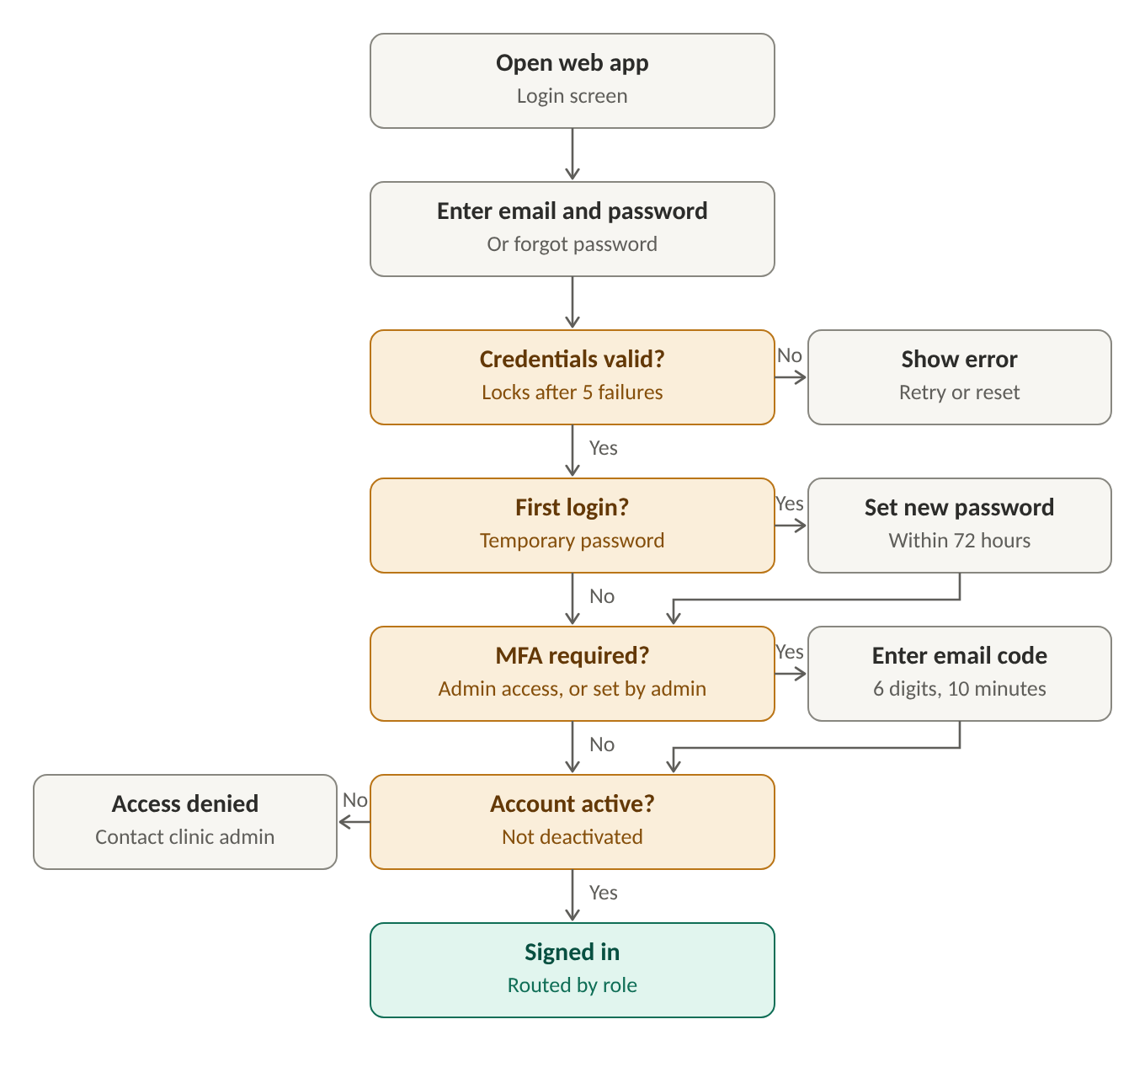
Figure 1. All users: signing in
- The user opens the web app. The login screen asks for email and password only; there is no user-type choice, because the role comes from the account
- Forgot password sends a reset link by email, valid for 30 minutes
- If the credentials are invalid, an error is shown. The account locks after 5 consecutive failures until the password is reset
- At first login, the user signs in with the temporary password from the welcome email (valid 72 hours, configurable) and must set a new password: at least 12 characters with upper case, lower case, a number and a symbol, not one of the last 5
- MFA: a 6-digit email code, valid 10 minutes, is required at every login for any role with admin access (Users & roles or Clinic settings) and for BEST roles. For other users it is optional and switched on per user by the Organization Admin
- If the account has been deactivated, access is denied and the user is asked to contact their clinic admin
- The user is signed in. After 15 minutes without activity the user is logged out, with a warning 2 minutes before

Routing to the home screen
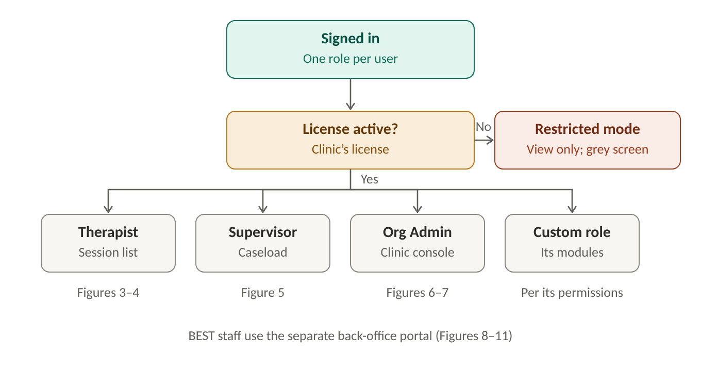
Figure 2. All users: routing to the home screen
- For clinic users, the platform checks the organization’s license. If it has expired or is suspended, users get view-only access, including client personal details: the screen turns grey, a “License inactive · View only” label is shown, and no changes or new sessions are possible
- Users are routed by role: Therapist to the session list, Supervisor to the caseload, Organization Admin to the clinic console, and a custom role to the modules its permissions allow. BEST staff use the separate back-office portal
- Each user holds one role. A person with both clinical and admin duties is given a combined custom role; the Supervisor/Organization Admin view switch of version 3.0 is removed

7.2 Therapist
PENDING CLIENT CONFIRMATION This section reflects the latest therapist flow shared with BEST (drafts of 15, 18 and 22 October 2026). Appendix A lists what changed from version 3.0.

Dashboard
The therapist dashboard shows today’s sessions, summaries ready, assessments due, and notes or tasks from the supervisor.

Running a session
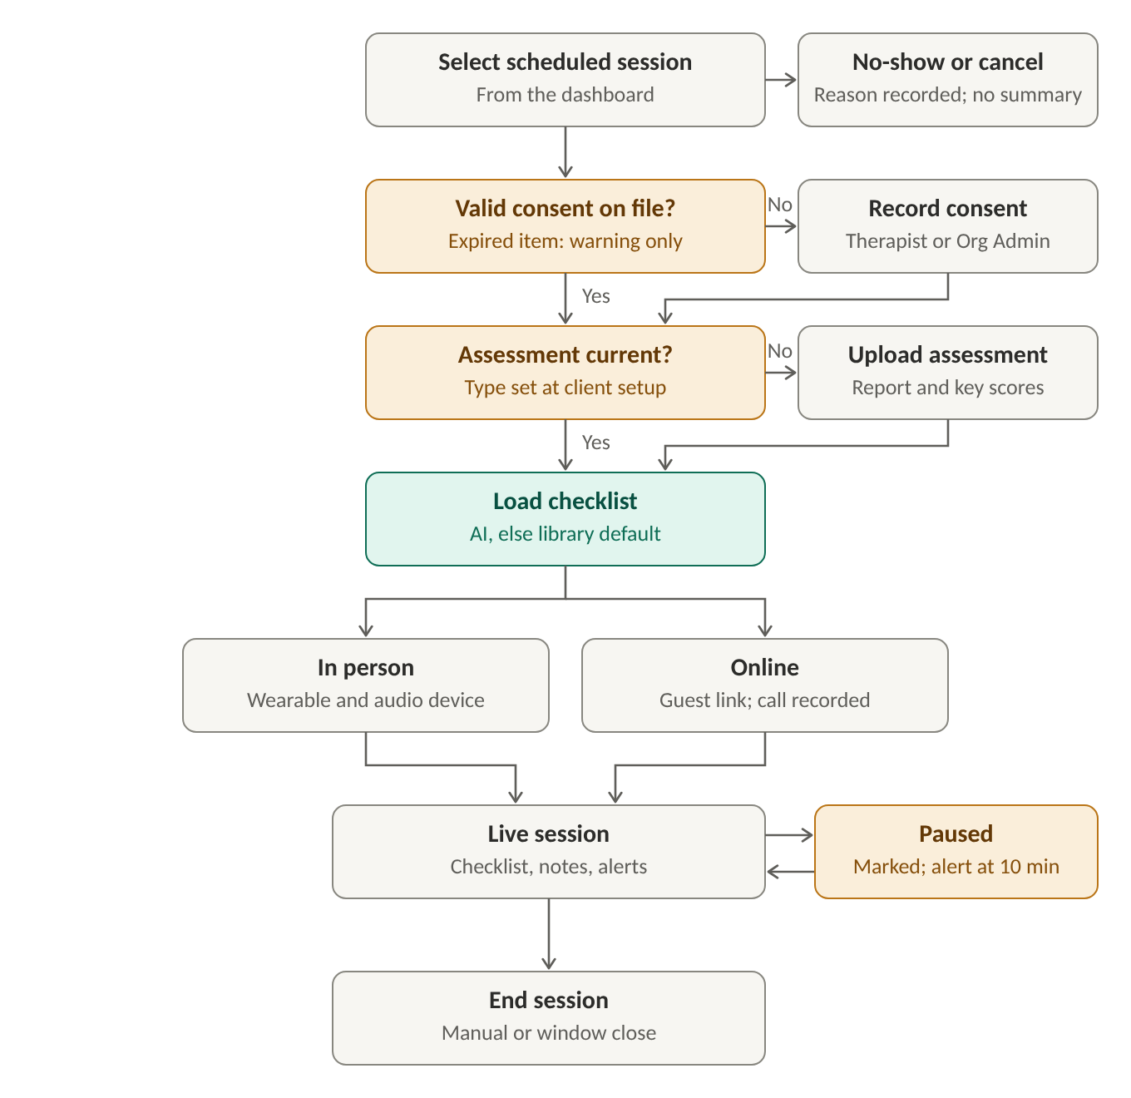
Figure 3. Therapist: running a session
- Select a scheduled session from the dashboard. Sessions are created by a Scheduler or BCBA PENDING CLIENT CONFIRMATION . A session can instead be marked as a no-show or cancelled, with a reason; nothing is sent to the AI service for it
- The platform makes one check: valid consent on file. Each consent item has its own validity period, set by BEST for each clinic. If no consent is on file, the therapist or Organization Admin records it with the signed form. If an item has expired, a warning is shown, the session continues and renewal is flagged. If consent is withdrawn, no further sessions can start
- A current assessment is required: VB-MAPP, ABLLS-R or Vineland, done within 6 months (configurable). The assessment type is chosen at client setup. If it is missing or out of date, the therapist or supervisor uploads the score report and key scores before the session can start; a warning appears 30 days before it lapses
- The session checklist is loaded: from the external AI service, based on the client’s history and assessment, or for a new client or no response, the default checklist for the client profile from the platform library
- In person: the wearable and the room audio device are linked to the session. If a device is not connected, the therapist is warned and can continue
- Online: the platform emails the parent a one-time guest link; no account is needed. The call is recorded automatically and the therapist can pause the recording. Live soft alerts are not used in online sessions
- During the session the therapist ticks checklist items (time-stamped; items cannot be added or removed; an optional reason for items not done), types notes and markers on screen, and acknowledges soft alerts (in person). Indicators show trends and the age of their data; a device drop is recorded and the session continues
- Pause is marked on the timeline. Device data, alerts and video continue. The therapist is alerted after 10 minutes paused (configurable); the session does not end on its own because of a pause
- If the browser is closed or the connection is lost, the session keeps running and resumes when reopened
- The session ends when the therapist ends it or when the scheduled window closes. Unacknowledged alerts expire

Completing the session summary
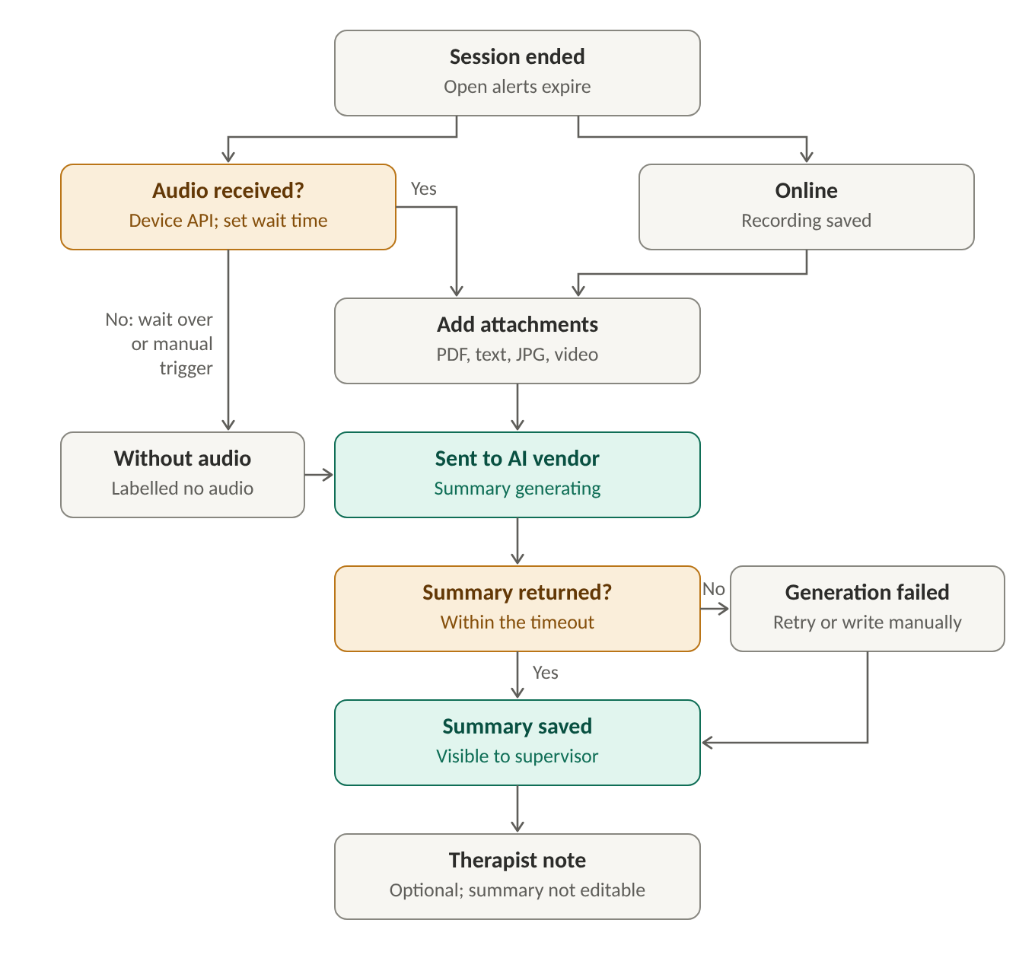
Figure 4. Therapist: completing the session summary
- In person: the room audio device sends the session audio to the platform through its API, after the session and asynchronously. The platform waits for a configurable time
- If the audio is missing, corrupted or late, the data is sent without it when the wait is over or when the therapist uses the manual trigger; the summary is labelled as having no audio. If audio consent was not given, any audio received is discarded
- Online: the call recording is used
- The therapist can add attachments after the session: PDF, text, JPG or video (size limits configurable)
- Session data is sent to the external AI service with surrogate IDs: device data, the checklist, notes and markers, the audio or call recording, and attachments. The screen shows that the summary is being generated
- The returned summary is saved, labelled as AI-generated, and visible to the supervisor straight away. The therapist cannot edit it and can add their own note
- If generation fails or times out, the therapist can retry (no limit) or write the summary manually; a manual summary is labelled as written by the therapist

Session statuses
- Scheduled, In progress, Paused, Ended, Awaiting audio, Summary generating, Summary ready, Generation failed
- No-show and Cancelled are set instead of running the session

7.3 Supervisor
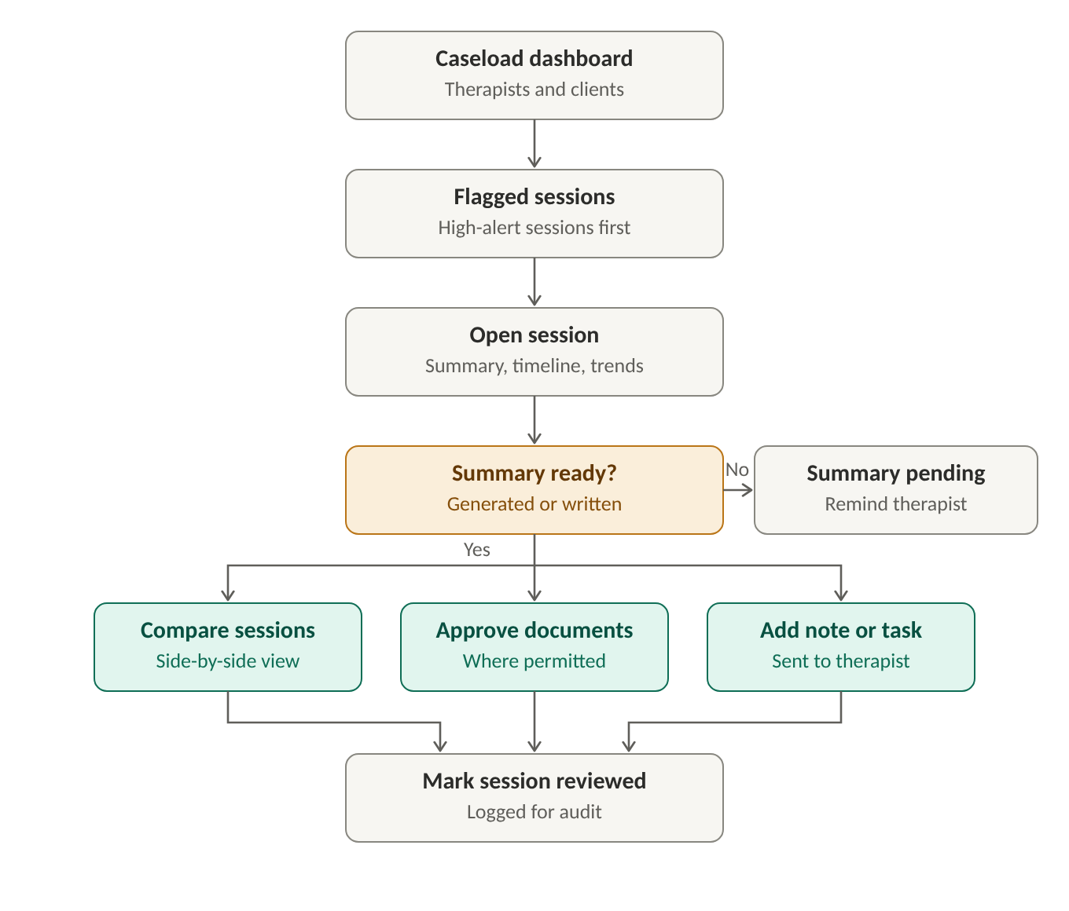
Figure 5. Supervisor: reviewing sessions
- Open the caseload dashboard showing assigned therapists and clients
- Work through flagged sessions: sessions with alerts, most alerts first
- Open a session to see its summary, timeline, and trends
- If the summary is not ready yet, the session shows as summary pending and the supervisor can send the therapist a reminder
- When the summary is ready, the supervisor can, in any order: compare sessions side by side; approve documentation where permitted (scope to be confirmed); add a review note or follow-up task, which appears in the therapist’s pending tasks
- Mark the session as reviewed; this is logged for audit

7.4 Organization Admin / Clinic Manager

Roles
Users are created by choosing a role. The clinic starts with the predefined roles (Therapist, Supervisor / BCBA, Organization Admin). Before adding users, the Organization Admin can optionally create custom roles by setting permissions from the permission catalogue, starting blank or by copying an existing role. Permissions are set on the role, not on each user PENDING CLIENT CONFIRMATION . Changing a role updates every user who holds it; a role in use cannot be retired. When BEST updates a predefined role, the change applies to all clinics.

Adding a user
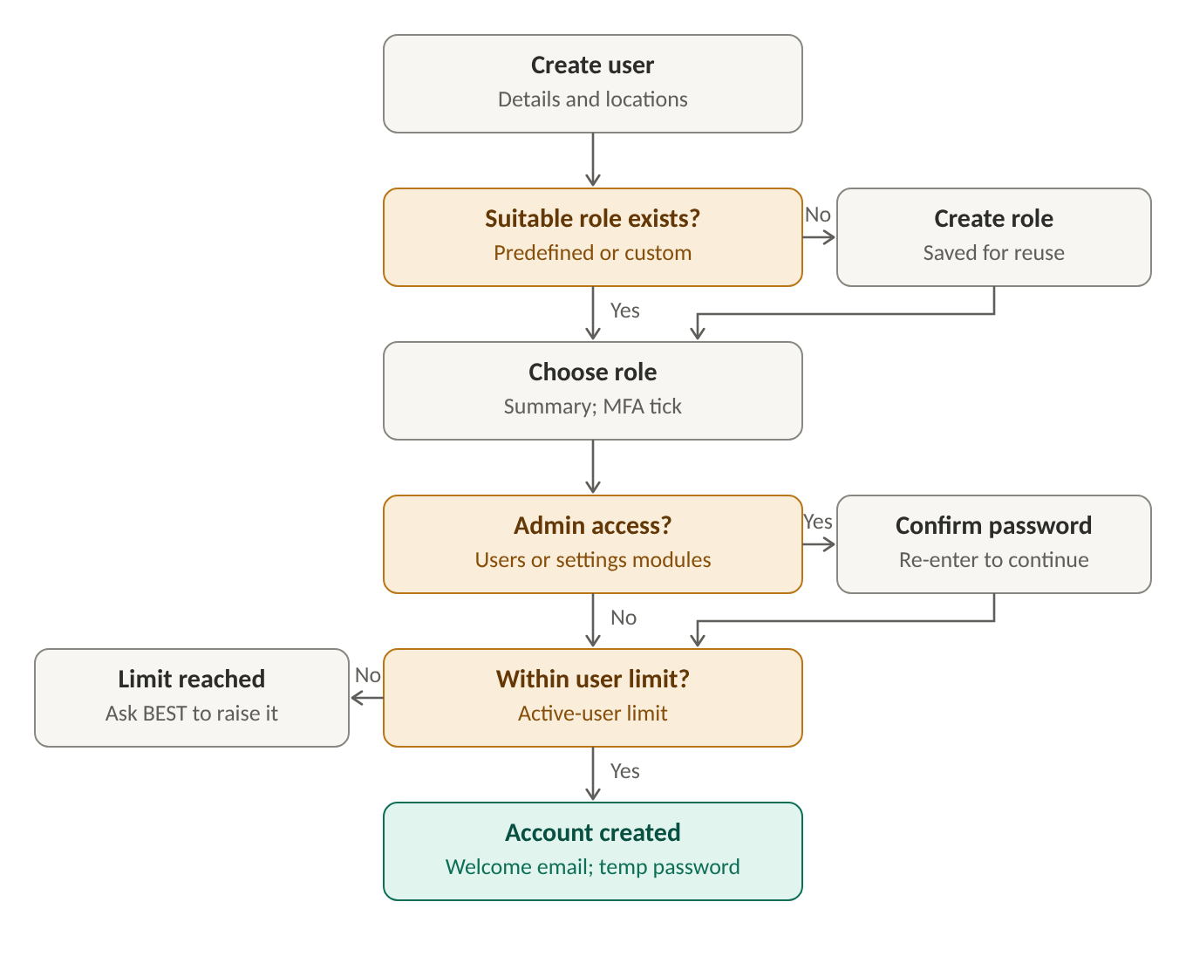
Figure 6. Organization Admin: adding a user
- Enter the user’s details: name, email (the login ID), US phone number, locations, certifications (any number), and any custom fields the clinic has set up for that role
- If no suitable role exists, the admin creates one (optional) and it is saved for reuse
- Choose one role. The screen shows a summary of what the role can do. MFA can be ticked for the user; it is always on when the role has admin access
- If the role has admin access (Users & roles or Clinic settings), the admin re-enters their own password to continue
- The platform checks the active-user limit on the license. Every user counts from creation (Invited, Active or Locked); deactivated users do not count. If the limit is reached, the admin asks BEST to raise it
- The account is created with status Invited, and a welcome email is sent with a temporary password valid for 72 hours (configurable). The admin can re-send it, which issues a new temporary password

Adding a client
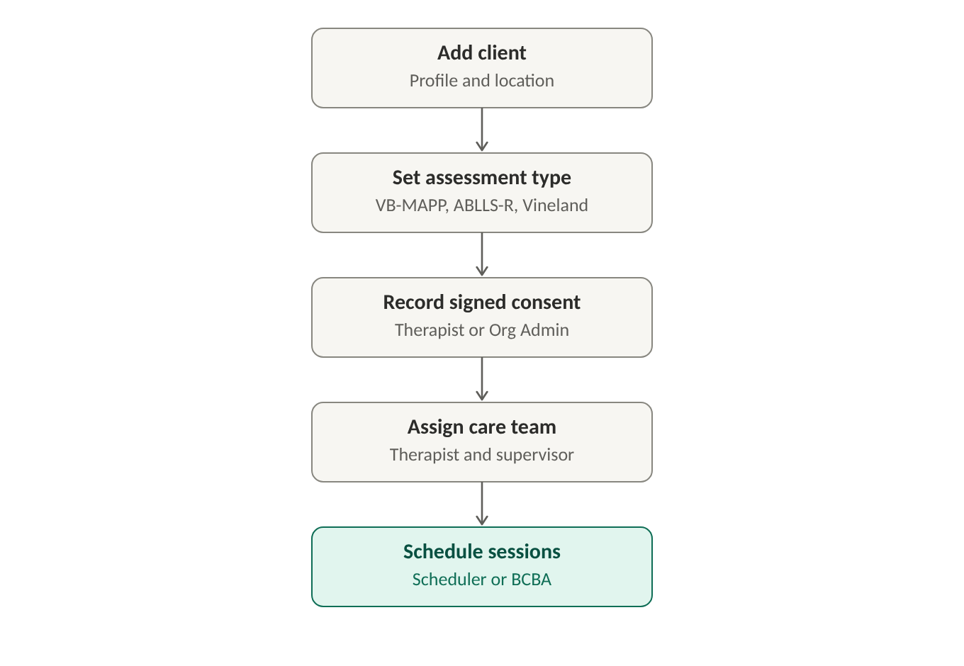
Figure 7. Organization Admin: adding a client
- Add the client profile and location
- Set the assessment type: VB-MAPP, ABLLS-R or Vineland PENDING CLIENT CONFIRMATION
- Record the signed consent. Consent is recorded or renewed by the therapist or the Organization Admin, with the signed form attached. Without wearable consent, sessions are manual only; without telehealth consent, telehealth sessions cannot start; without audio consent, audio is discarded
- Assign the care team: therapist and supervisor
- Sessions are scheduled by a Scheduler or BCBA, in-app or by CSV import PENDING CLIENT CONFIRMATION
Deactivating a user stops them counting towards the active-user limit. Archiving a client hides them from active workflows. Withdrawing consent makes later sessions manual only and blocks telehealth.

7.5 BEST Back Office

Clinic onboarding: request and approval
PENDING CLIENT CONFIRMATION Onboarding is done by the BEST Key Account Manager only; self-onboarding by clinics is not in Phase 1.
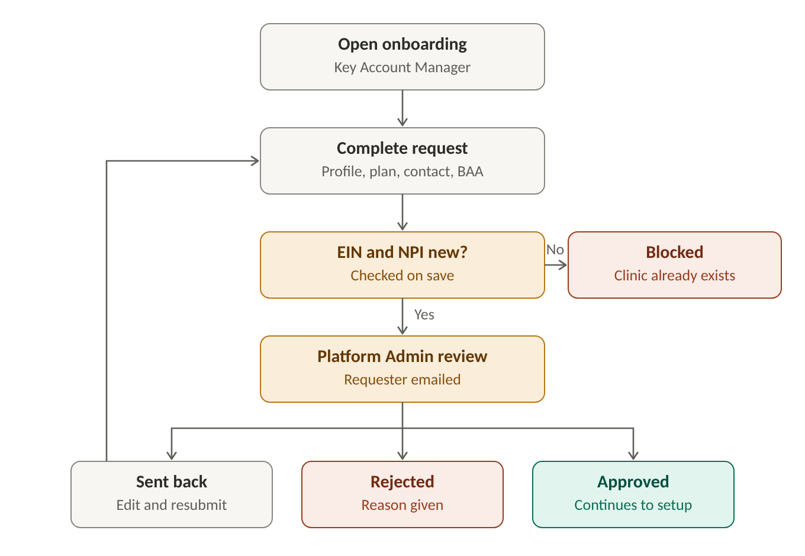
Figure 8. Clinic onboarding: request and approval
- The BEST Key Account Manager opens a new onboarding request for the clinic
- The request can be saved as a draft and completed later
- Mandatory details: legal name, EIN, NPI, address, time zone, contact person, at least one location, and the chosen plan
- Mandatory documents: signed Business Associate Agreement (BAA) and service agreement. Optional documents: W-9, state license, and proof of insurance
- A request is blocked if the EIN or NPI already belongs to an existing clinic
- The request is submitted for review by the BEST Platform Admin, who can approve it, reject it with a reason, or send it back for changes
- When sent back, the reviewer's comments are shown on the request; it can be edited and resubmitted with no limit
- The Key Account Manager is emailed on each outcome

Clinic onboarding: setup and go-live
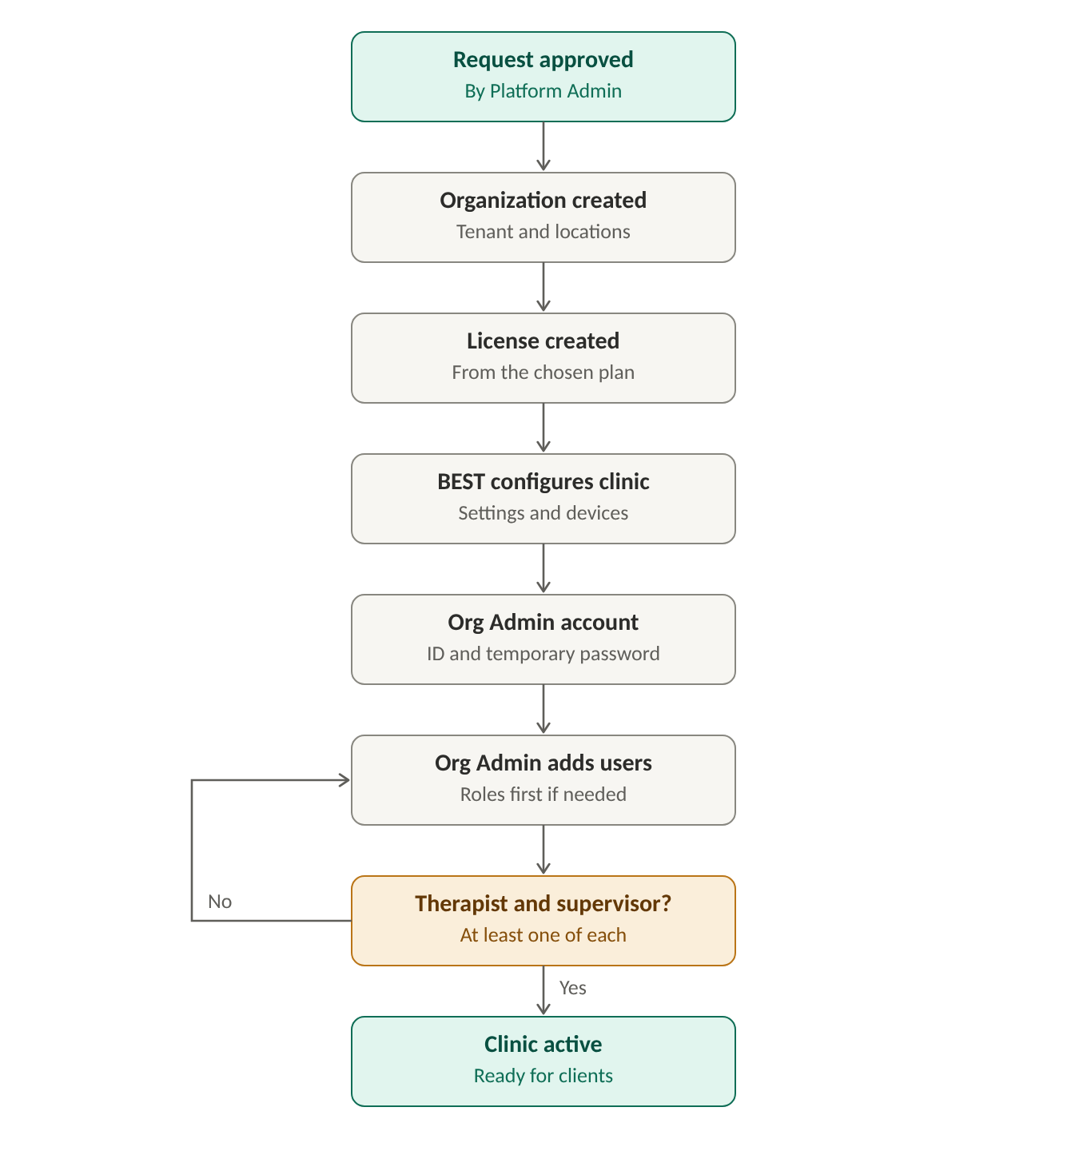
Figure 9. Clinic onboarding: setup and go-live
- On approval, the organization (tenant) and its locations are created
- The license is created from the chosen plan; Platform Admin can adjust the active-user limit and dates
- BEST configures the clinic: telehealth on or off, consent validity periods, and the clinical parameter values. Wearable and audio devices are supplied by BEST and registered to the clinic
- The Organization Admin account is created for the contact person named on the request. Its login ID and a temporary password are sent by email; MFA is mandatory for this account
- The Organization Admin signs in, sets a new password, uploads the clinic's consent form template, reviews roles (optional), and adds the clinic’s users. Users are created by the clinic, not by BEST
- The clinic becomes active once it has at least one therapist and one supervisor. Until then the clinic stays Approved

Clinic statuses
- Draft, Submitted, Sent back, Rejected, Approved, Active
- Suspended and Expired follow the license (Figure 10)

License lifecycle
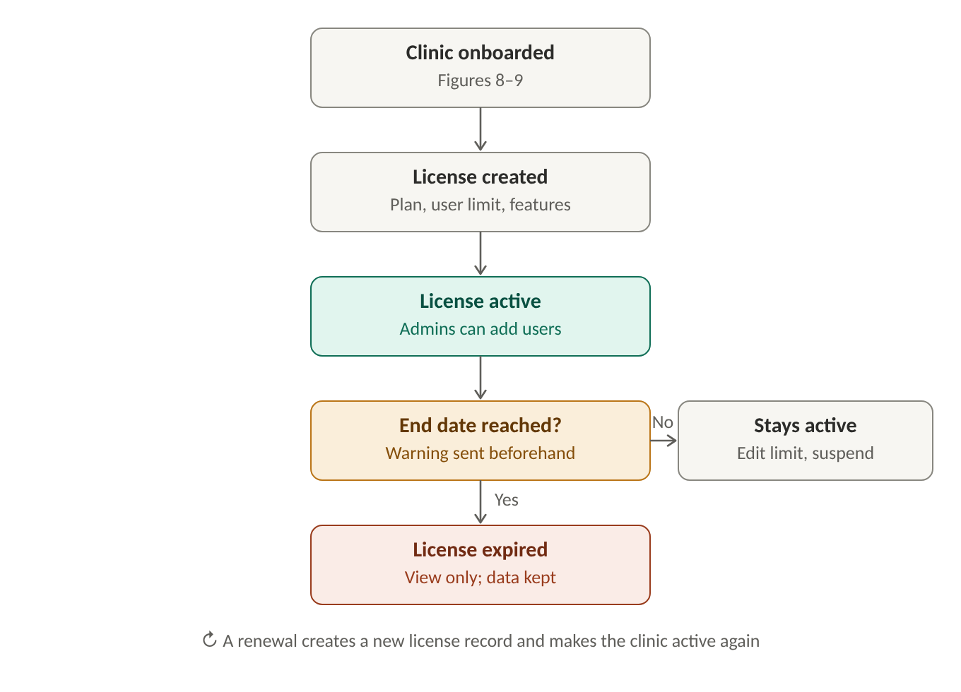
Figure 10. BEST Platform Admin: license lifecycle
- The customer organization is onboarded and approved (Figures 8 and 9)
- Its license is created from the chosen plan: plan, active-user limit, dates, and enabled features. Platform Admin can adjust the limit and dates
- While the license is active, Organization Admins can add users; Platform Admin can edit the limit or features, or suspend the license
- Organization Admins receive a warning before the license end date (configurable; default 30 days)
- When the end date is reached, the license expires: users can still log in and view records, including client details, on a grey view-only screen; no changes or new sessions are possible, and no data is deleted. A suspended license has the same effect
- A renewal creates a new license record and makes the clinic active again. The license history is kept, and only one license is active at a time

Time-bound support access to clinical data (break-glass)
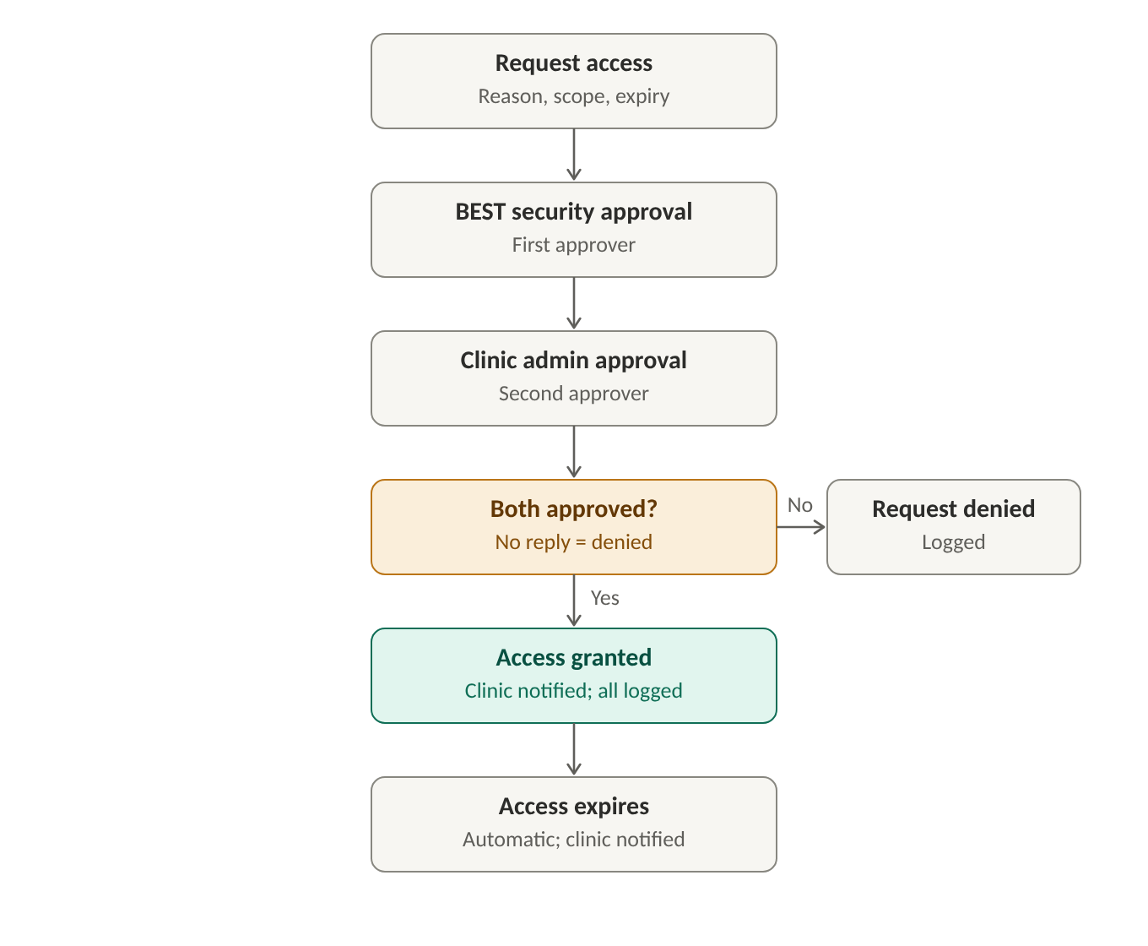
Figure 11. BEST Back Office: break-glass access
- A BEST staff member requests access, stating the reason, scope, and expiry
- A designated BEST security approver approves first
- The customer’s Organization Admin approves second
- Both must approve. If either declines, or does not respond within the set time, the request is denied and logged
- Access is granted, the clinic is notified, and every action is logged
- Access expires automatically after the configured maximum duration, and the clinic is notified

8. Functional Requirements (MVP)

8.1 Authentication & Access
Detailed requirements are in the Functional Specification “User Creation and Login” (version 0.3).
- Login with email and password; logout
- First login with a temporary password (valid 72 hours, configurable), followed by a mandatory new password
- Password rules: at least 12 characters with upper case, lower case, a number and a symbol; not one of the last 5
- Account lockout after 5 consecutive failed attempts; unlocked by password reset
- Password reset by email link, valid 30 minutes
- MFA by 6-digit email code is mandatory for any role with admin access and for BEST Back-Office roles; for other users it is optional and set per user by the Organization Admin
- Critical admin actions require the admin to re-enter their password
- Session timeout after 15 minutes of inactivity, with a warning 2 minutes before
- Role-based access: each user holds one role, predefined or custom, and permissions are set on the role
- Organization and tenant scope enforced on every request
- Administrative access comes only from a role that includes the Users & roles or Clinic settings modules
- Role changes, client assignments, login events, and configuration changes are auditable
- Separation of duties between support, platform administration, and engineering / SRE

8.2 Client & Session Management
- Client profile creation, editing, archiving, restoration, and status management
- Authorized client assignment and reassignment to therapists and supervisors
- Session scheduling: sessions are created in-app by a Scheduler or BCBA, with bulk CSV import PENDING CLIENT CONFIRMATION
- Assessment records: the assessment type is set per client; a current assessment (within 6 months, configurable) is required before a session starts, with a warning 30 days before it lapses
- No-show and cancelled sessions are recorded with a reason
- Manual or automatic session start/stop
- Monitoring restricted to the session window
- A session cannot start without consent on file (Section 8.12)
- Client removal uses archive or deactivate by default; permanent deletion is blocked when retention obligations apply
- Client access changes take effect promptly and record the actor, reason, timestamp, previous value, and new value
- Archived clients are hidden from active workflows but remain available to authorized users for permitted historical review

8.3 Manual Data Capture
- Session notes, typed on screen
- Manual observations
- Session markers (important moments)
- Session checklist: items ticked with a time stamp; items cannot be added or removed; optional reason for items not done
- Attachments after the session: PDF, text, JPG or video
- Task and follow-up creation

8.4 Wearable & Sensor Integration (Vendor-Agnostic)

Capabilities Required
- Read-only data access
- Consent-based authentication
- Heart rate, activity, and environmental noise
- Periodic sync (not real-time streaming); the sync interval and maximum acceptable data age are configurable parameters (Section 8.13)
- Incoming readings follow the data format in Section 9

Product Responsibilities
- Normalize vendor data into the format in Section 9
- Store raw and processed data
- Handle sync failures gracefully

Device Selection
- BEST and TBR decide internally the category of wearable used before integration begins
- Wearable vendors must be HIPAA-eligible and sign a BAA (Section 13.1)
- Shortlisted devices are tested with a small group of children at a BEST clinic, covering comfort, wear time, data gaps, and sync interval
- Selection criteria: BAA, API data access, sync interval, child comfort and wear time, data quality, and cost

8.5 Live Session Monitoring
- Visual indicators for:
  - Heart rate trends
  - Activity changes
  - Environmental noise changes
- No raw medical values emphasized
- Trend indicators: rising / stable / settling
- Each indicator shows when its data was last received; data older than the configured maximum age is visibly marked as delayed

8.6 Alerts & Notifications

Alert rules
- In-app alerts only
- Soft, non-intrusive presentation
- Triggered only after sustained trends; the “sustained” window is a configurable parameter (Section 8.13)
- Alert throttling to prevent fatigue; the throttling window is a configurable parameter
- No forced actions or instructions
- Alerts are rule-based and are not raised on delayed or stale data

Notification signal queue
When an alert rule fires, the platform writes a notification signal to a notification queue / table. The application UI consumes signals from this queue and shows them to the therapist running that session.
- Each signal records: signal ID, organization, session, client (surrogate ID), signal type (for example, heart rate elevated), trend direction, display text from the allowed language (Section 5.3), and created time
- Signal status moves through: pending → delivered → acknowledged, or expired
- Delivery and acknowledgment record the user and timestamp
- Signals expire when the session ends; undelivered signals are not shown after the session
- The queue / table is tenant-scoped and audit-logged

8.7 Dashboards

Therapist Dashboard
- Assigned clients
- Active session indicators
- Pending tasks
- Alerts summary

Supervisor Dashboard
- Caseload overview
- High-alert sessions
- Trend summaries
- Objective session data

Organization Admin / Clinic Manager Dashboard
- Organization summary with active users, active clients, locations, and pending actions
- Users and their status (Invited, Active, Locked, Deactivated), roles, and custom roles
- Client lifecycle status, consent status, and therapist or supervisor access assignments
- Active users against the license limit, license end date, and entitlement status
- Organization settings, notification preferences, and approved feature configuration
- Administrative audit activity and access-change history

BEST Back-Office Dashboard
- Customer organization status, onboarding stage, contacts, licenses, and entitlements
- System load, availability, latency, job queues, integration health, and service dependencies
- Application, audit, security, and integration logs with PHI masking and correlation identifiers
- Error rates, failed jobs, incident alerts, ownership, status, and resolution history
- Tenant-scoped settings and feature controls with approval and rollback history
- Support case context and approved, time-bound access without default visibility into identifiable clinical data

8.8 Post-Session Review and AI Summary

AI summary
Session summaries are generated by an external AI service through an API. The platform does not build, host, or train the AI model; it sends session data to the service and displays the result.
- When a session ends, the platform sends the session data to the AI summary API using surrogate IDs in place of direct identifiers: device data, the checklist, notes and markers, the session audio (in person) or call recording (online), and attachments PENDING CLIENT CONFIRMATION
- In-person audio is sent by the room audio device through its API after the session. The platform waits for a configurable time; when the wait is over, or when the therapist uses the manual trigger, the data is sent without audio and the summary is labelled accordingly
- The returned summary is saved to the session record, labelled as AI-generated, and visible to the supervisor straight away. The therapist cannot edit it and can add their own note PENDING CLIENT CONFIRMATION
- While the summary is being generated, the screen shows its status; if the API fails or times out, the therapist can retry or write the summary manually, labelled as written by the therapist
- The summary covers: heart rate trends, environmental disruptions, checklist progress, and marked moments
- Displayed summaries follow the language rules in Section 5.3

Review tools
- Session timeline view, aligning device data with notes and markers
- Comparison across sessions (Supervisor): side-by-side session view

8.9 Organization Administration
- Administrative access is given by a role that includes the Users & roles or Clinic settings modules; there is no separate elevation step
- Manage roles: use the predefined roles, or create, copy, edit and retire custom roles from the permission catalogue. Each user holds one role; a person with both clinical and admin duties is given a combined custom role
- Create, edit, deactivate, reactivate, and re-send the welcome email to users within the administrator’s organization
- Clinic master data: certification types, custom user fields (which can apply to chosen roles), and locations
- Create, edit, archive, and restore clients; prevent permanent deletion when clinical or legal retention requirements apply
- Record, renew and withdraw consent for each client (Section 8.12)
- Assign and reassign clients to therapists and supervisors individually or in bulk, with immediate enforcement and audit history
- Configure organization profile, locations, time zone, session defaults, notification rules, and approved feature settings
- View active users against the license limit (Section 8.11)

8.10 BEST Back-Office Administration and Operations
- Use separate permission profiles for platform administration, operations and support, and engineering or SRE functions
- Onboard, edit, suspend, reactivate, and close customer organizations without deleting retained records
- Maintain the licensing table and entitlements (Section 8.11)
- Monitor infrastructure and application health, load, latency, background jobs, queues, integrations, capacity, and tenant-level service status
- Search logs and errors using tenant, service, time, severity, request, and correlation identifiers while masking PHI and secrets
- Create and track incident records, ownership, priority, customer impact, workaround, resolution, and post-incident actions
- Apply tenant-scoped configuration and feature changes with approval, audit history, and rollback capability
- Export operational reports for customer status, licenses, entitlements, system health, and incidents

Time-Bound Support Access to Clinical Data (“Break-Glass”)
- Every request records a reason, scope (organization, client, data type), and expiry
- Requires dual approval: a designated BEST security approver and the customer’s Organization Admin, subject to what the customer’s BAA allows
- The customer organization is notified when access is granted and when it ends
- Access expires automatically at the end of a configurable maximum duration and cannot be extended without a new approval
- All actions taken under support access are fully audit-logged and reviewed

8.11 License Management
Licenses are managed through a licensing table maintained by BEST Platform Administrators. Each renewal creates a new license record, so the history is kept; only one license per organization is active at a time. Payment verification is not part of the platform.

Licensing table
Field | Description
License ID | Unique identifier
Organization | Customer organization the license belongs to
Plan name | Name of the plan or package
Active-user limit | Maximum number of users the organization can hold
Users counted | Users with status Invited, Active or Locked (calculated); deactivated users are not counted
Enabled features | Entitlements switched on for the organization, such as telehealth
Start date / end date | License validity period
Status | Active, suspended, expired, or superseded by a renewal
Notes | Free text for internal reference
Last updated by / at | User and timestamp of the latest change

Maintenance capability
- BEST Platform Administrators can create, edit, renew, suspend, and reactivate licenses
- Every change records the user, timestamp, previous value, and new value
- A user cannot be created when the organization has reached its active-user limit
- Features not enabled on the license are hidden from that organization’s users
- When a license expires or is suspended, users have view-only access, including client details, on a grey screen labelled “License inactive · View only”; no new sessions or changes are possible until renewal; existing data is retained

8.12 Consent Management
- Before monitoring begins, the client’s parent signs a consent form with clinic staff
- The therapist or the Organization Admin records the signed consent in the platform: consent type, date signed, recorded by, and the signed form
- Consent types: wearable data collection during sessions, session audio, and telehealth sessions (Section 17.6)
- Each consent item has its own validity period, set by BEST for each clinic PENDING CLIENT CONFIRMATION . When an item expires, a warning is shown at session start, the session can continue, and renewal is flagged
- Consent can be withdrawn; staff record the withdrawal date, and it takes effect for all later sessions
- The platform blocks the related activity when consent is missing or withdrawn (no session start without consent on file, no wearable data collection, no telehealth session start; audio received without consent is discarded)
- All consent records and changes are audit-logged

8.13 Configurable Clinical Parameters
Interpretation thresholds are configurable parameters rather than fixed values, so they can be set and tuned without code changes.
Parameter | Used in | Default value
Sustained-trend window | 8.6 Alerts | Set by BEST clinical lead
Alert throttling window | 8.6 Alerts | Set by BEST clinical lead
Wearable sync interval | 8.4, 8.5 | Set from device test results
Maximum acceptable data age for live indicators | 8.5, 8.6 | Set by BEST clinical lead with device test results
Age-aware reference ranges | 5.2, 8.5 | Source specified by BEST clinical lead
Pause alert time | 7.2 | 10 minutes
Audio wait time | 7.2, 8.8 | Set by BEST
Assessment validity and warning | 7.2, 8.2 | 6 months; warning 30 days before
Consent validity per item | 8.12 | Set by BEST for each clinic

- Default values are signed off by BEST’s clinical lead before the pilot starts
- Parameters are tuned during the pilot; every change is approved and audit-logged

9. Wearable & Sensor Data Format
Data received from each wearable vendor is converted into one common format and stored in a dedicated wearable data table, linked to its organization, session, and client. The vendor’s original data is kept separately (Section 12.3). The table’s structure will be defined during design.

10. MVP Release Scope
- Core therapist and supervisor workflows (web application)
- Session-based monitoring with live trend indicators
- Soft in-app alerts through the notification signal queue
- AI-generated post-session summaries from the external AI service, visible once generated, with an optional therapist note PENDING CLIENT CONFIRMATION
- Assessment records and the session checklist
- Telehealth sessions
- Consent management and configurable clinical parameters
- Organization Admin dashboard, role and user management, client access assignment, and client lifecycle controls
- License management through the licensing table
- BEST back-office dashboard for customer organizations, licenses, entitlements, system health, logs, errors, and incidents
- DEV, UAT, and PRODUCTION environments

11. Out of Scope
- Medical diagnosis
- Treatment recommendations
- Clinical decision making of any kind
- Emergency response
- Continuous monitoring outside sessions
- Payment processing, payment verification, invoicing, and billing
- Building, hosting, or training the AI model used for summaries
- Self-onboarding by clinics (Phase 1) PENDING CLIENT CONFIRMATION
- Per-user permission changes outside the user’s role PENDING CLIENT CONFIRMATION

12. Data Strategy & Existing BEST Data Usage

12.1 Existing Data Sources at BEST
The platform will leverage BEST’s existing structured clinical and operational data to enhance session awareness and post-session reflection. Confirmed data sources include:
- Structured historical session notes
- Session schedules and durations
- Therapist–client assignment history
- Incident and escalation notes
- Organization, user, role, permission, and client-assignment metadata
- License and entitlement metadata
- Operational metrics, audit logs, application logs, error events, and incident records
PENDING CLIENT CONFIRMATION Session audio (in person, from the room audio device) and telehealth call recordings are received and sent to the AI summary service, subject to consent. Version 3.0 excluded all audio and video; BEST to confirm the retention period for audio and recordings.

12.2 Data Usage Principles
- Data is used only to support therapist and supervisor awareness
- No data is used for diagnosis, treatment, or automated decision making
- All processing remains within session or supervisory context
- Historical data is used for baseline creation, comparison, and trend analysis only
- Collection of a client’s wearable data follows the consent recorded for that client (Section 8.12)

12.3 Data Lifecycle
- Raw data (manual notes, wearable data, session audio, call recordings, attachments) is stored securely
- Processed data (summaries, trends) is derived and linked to sessions
- Historical data is retained by BEST’s internal data retention policy
- Operational logs must exclude or mask direct identifiers, credentials, and authentication tokens
- License metadata is retained separately from clinical session content

13. HIPAA Compliance & Security Model

13.1 PHI Handling
The platform handles Protected Health Information (PHI) and must comply with HIPAA regulations. All vendors, infrastructure providers, and development partners must:
- Be HIPAA-eligible
- Sign a Business Associate Agreement (BAA)
This includes, at minimum, the cloud provider, the wearable vendor(s), the telehealth video vendor, and the external AI summary service. The AI summary service must not retain session data or use it to train its models.

13.2 Security Controls
Mandatory security measures include:
- Encryption at rest and in transit
- PHI de-identification using cryptographically secure random UUIDs in place of direct identifiers for analytics, logs, and data sent to the AI summary service; re-identification mappings are stored separately with tightly restricted access
- Role-based access enforcement
- Session-scoped data visibility
- Audit logging for key user actions
- Secure authentication and session management
- Tenant isolation across data storage, APIs, caches, exports, queues, and administrative tools
- MFA and least-privilege access for privileged roles
- PHI, secrets, and authentication tokens excluded or masked in operational logs
- Key management, rotation, backup, incident response, vulnerability management, and access-review procedures
- UUID replacement does not by itself authorize unrestricted data use; de-identification must follow the approved HIPAA method and organizational policy

13.3 Access Governance
- Therapists access only assigned clients
- Supervisors access assigned caseloads
- Admin access is restricted and auditable
- No cross-organization data visibility for clinic users; tenant isolation is enforced at rollout
- Organization Admins manage users, roles, client access, consent records, and settings only within their own organization
- Organization Admins do not have access to clinical session data by default; a person with both duties holds one combined custom role and sees only what that role allows
- BEST Back-Office roles access operational metadata according to function and do not receive routine access to identifiable clinical records
- Any exceptional support access to PHI follows the break-glass process in Section 8.10
- Role, permission, client-assignment, consent, license, configuration, and support-access changes are logged

14. Data Infrastructure

14.1 Infrastructure Requirements
- All workloads run within a HIPAA-eligible cloud (AWS, Azure, or GCP)
- No external API that receives PHI is used without HIPAA eligibility and a signed BAA
- Separate DEV, UAT, and PRODUCTION environments (Section 18)
- Database: MongoDB, with shared collections and an organization ID on every clinic document; indexes enforce tenant scope

14.2 Data Separation
- Raw data stored separately from derived data
- Identifiers separated from analytical datasets
- Random UUIDs used as surrogate identifiers in analytical, logging, operational workflows, and AI summary requests
- Re-identification mapping stored separately from analytical and operational datasets
- Organization boundaries enforced in storage, processing, search indexes, caches, queues, logs, and exports
- Access logged and auditable

15. Governance, Assumptions & Risks

15.1 Key Assumptions
- BEST owns and controls all historical data
- Therapists and supervisors (BTs/BCBAs) remain the primary decision makers
- AI-generated summaries are saved as generated and labelled; the therapist can add a note but does not edit or confirm them PENDING CLIENT CONFIRMATION
- Wearable integrations remain read-only
- The category of wearable is decided internally by BEST and TBR
- BEST provides a named clinical lead to sign off clinical parameters and language

15.2 Identified Risks & Mitigations
Risk | Mitigation
Misinterpretation of AI-generated summaries | Clear labeling, language rules, therapist note, and supervisor review
AI summary service unavailable | Generation status shown; retry and manual summary available
Alert fatigue | Alert throttling and configurable parameters
Over-reliance on wearables | Manual observations remain primary
Delayed device data makes live indicators stale | Data-age display; no alerts on stale data; sync interval tested before device selection
Children do not tolerate the device, or readings are unreliable | Device test at a BEST clinic before selection; manual observation remains primary
Regulatory classification of in-session features | Clinical language rules, rule-based soft alerts, and internal decision on wearable category
Compliance risk | Strict HIPAA controls and audits
Unauthorized administrative privilege escalation | Admin access only through roles, mandatory MFA, password re-entry for critical actions, least privilege, and audit review
Incorrect client access assignment | Immediate enforcement, confirmation, change history, periodic access review, and rapid revocation
License or entitlement configuration error | Active-user limit enforcement, audit of licensing table changes, and reconciliation
Back-office exposure to PHI | Masked operational data by default and break-glass access when required
Monitoring or incident-detection gap | Centralized metrics, logs, traces, alert ownership, escalation rules, and tested runbooks

16. Administration and Back-Office Rollout Requirements

16.1 Rollout Access Model
Each clinic user holds one role. Administrative access comes only from a role that includes the Users & roles or Clinic settings modules; a person with both clinical and admin duties holds a combined custom role. BEST back-office access is separate from clinic access and is divided by operational function.

16.2 Role and Permission Matrix
Role | Data Scope | Key Permissions
Therapist | Assigned clients and own sessions | Run sessions, record consent, notes and markers, add attachments and a note to the AI-generated summary, and complete tasks
Supervisor / BCBA | Assigned caseload | Review sessions and trends, supervise therapists, approve permitted clinical documentation, and manage assigned work
Organization Admin / Clinic Manager | Own organization (no clinical session data by default) | Manage users, roles, client access, client lifecycle, consent records, and settings; view active users against the license
BEST Operations / Support | Cross-organization operational metadata | Monitor service health, integrations, logs, errors, incidents, and support cases; no default identifiable clinical access
BEST Platform Admin | Platform configuration and licensing | Manage tenant lifecycle, the licensing table, entitlements, and feature configuration; approve, reject, or send back clinic onboarding requests; co-approve break-glass requests where designated
BEST Key Account Manager | Onboarding requests for assigned clinics | Create, save, and submit onboarding requests on behalf of a clinic; no clinical data access
Custom role (clinic-defined) | Own organization, as its permissions allow | Any combination of permissions from the catalogue, set by the Organization Admin
BEST Engineering / SRE | Technical operations | Manage infrastructure, capacity, deployments, and security events; no default identifiable clinical access

16.3 Rollout Acceptance Criteria
- An authorized Organization Admin can create and deactivate users, create custom roles, assign roles, and grant or revoke client access within the organization
- A user whose role has no admin access cannot manage users, roles, licenses, or organization-wide client access
- Client add, edit, archive, restore, assignment, and reassignment actions are enforced within the correct tenant and appear in the audit history
- The active-user limit and feature entitlements match the licensing table; creating a user beyond the limit is blocked
- Licensing table changes require the correct permission and produce an auditable before-and-after record
- A session cannot start without consent on file, cannot collect wearable data without wearable consent, and a telehealth session cannot start without telehealth consent
- Alert signals are written to the notification queue and shown only to the therapist of that session
- The AI-generated summary is saved labelled and visible to the supervisor; the therapist cannot edit it PENDING CLIENT CONFIRMATION
- Wearable batches that do not match the data format (Section 9) are rejected and logged
- BEST back-office users can monitor customer status, system load, logs, errors, integrations, and incidents without routine exposure to identifiable clinical data
- Break-glass access requires a reason, dual approval, defined scope, automatic expiry, customer notification, and a complete audit record
- All critical administrative and back-office flows pass role, tenant-isolation, negative-access, and audit-log tests in UAT before production release

16.4 Operational Readiness
- Production dashboards, alerts, on-call ownership, incident severity definitions, and escalation paths are documented and tested
- Backup, restoration, configuration rollback, and tenant suspension or reactivation procedures are verified
- Administrative help content, permission guidance, and back-office operating procedures are available to assigned teams
- A release checklist confirms security review, access review, entitlement validation, observability coverage, training, and support readiness

17. Telehealth Sessions (Remote Session Modality)

17.1 Purpose
Telehealth sessions enable therapists to conduct remote therapy sessions while preserving the platform’s core principles of:
- Session-scoped monitoring
- Therapist-led observation
- Post-session reflection
- Non-prescriptive AI assistance
Telehealth does not introduce new clinical logic or decision making. It represents an alternate session execution modality within the existing session framework.

17.2 Clinical Positioning (Telehealth)
Telehealth sessions follow the same clinical positioning defined in Section 5.
- Telehealth sessions are observational and supportive in nature
- No diagnosis, treatment, or clinical recommendations are generated
- Therapist and supervisor judgment remains primary
- AI-generated summaries are review-only and produced after the session
Telehealth does not alter the interpretation of physiological, behavioral, or environmental data.

17.3 Scope of Telehealth Sessions (MVP)

In Scope
- Secure, real-time remote therapy sessions
- Session-scoped monitoring and manual observation
- AI-generated post-session summaries
- Supervisor visibility and review

Out of Scope
- Real-time AI prompts or guidance
- Live soft alerts during telehealth sessions
- Emergency response or escalation workflows
PENDING CLIENT CONFIRMATION The call is recorded automatically and the therapist can pause the recording; the recording is used for the AI summary. Version 3.0 listed recording as out of scope.

17.4 Telehealth Session Characteristics
Telehealth sessions are treated as standard sessions with the following attributes:
- Explicitly tagged as telehealth
- Time-bounded and session-scoped
- Subject to the same monitoring window rules
- Included in historical comparisons and trend analysis

17.5 Telehealth Functional Capabilities (MVP)
The platform must support the following telehealth capabilities:
- Secure, session-bound video connection through a HIPAA-eligible vendor that has signed a BAA
- Manual session start and end by therapist
- One-time guest link emailed to the parent; no account needed
- Automatic call recording, which the therapist can pause PENDING CLIENT CONFIRMATION
- Live manual notes and session markers
- Optional read-only signal overlays (if a wearable is in use at the client’s location)
- Graceful handling of connectivity disruptions
- Full audit logging of access and session events
All functionality remains consistent with existing Session Management and Manual Data Capture requirements defined in Section 8.

17.6 Consent & Governance
- Signed telehealth consent is required prior to participation, recorded through consent management (Section 8.12)
- Consent must be timestamped, auditable, and role-linked
- Consent has a validity period and does not imply ongoing monitoring
- Sessions cannot be initiated without recorded consent

17.7 AI Usage in Telehealth Sessions
- Telehealth sessions receive AI-generated post-session summaries in the same way as in-person sessions (Section 8.8)
- AI does not operate during live telehealth sessions
- AI does not provide guidance, recommendations, or instructions, and does not alter therapist inputs

17.8 Telehealth Data Handling

Data Sources
- Manual notes and session markers
- Session timing and duration
- Wearable data (read-only), where available
- Call recording PENDING CLIENT CONFIRMATION

Data Restrictions
- Call recordings are stored and used only for the session summary; retention period to be confirmed PENDING CLIENT CONFIRMATION
- No continuous monitoring outside session windows
Telehealth data is processed identically to in-person session data and follows the lifecycle defined in Section 12.3.

17.9 Telehealth Safety Guardrails
The platform must enforce the following safeguards:
- No prescriptive or causal language
- No live prompts or alerts
- No automated intervention logic
- Recording only within the session, with consent PENDING CLIENT CONFIRMATION
- Full audit logging of access and actions

17.10 Telehealth Dependencies
Item | Requirement
Video vendor | HIPAA-eligible, signs a BAA; selected before telehealth build begins
Wearable at the client’s location | Signal overlays are optional; device placement instructions are provided outside the platform
Consent | Telehealth cannot start without recorded consent (Section 8.12)
Connectivity | Graceful reconnection and clear marking of data gaps

17.11 Telehealth Success Indicators (Non-Clinical)
Telehealth effectiveness will be evaluated using non-clinical signals only, including:
- Telehealth session completion rate
- Therapist adoption and repeat usage
- Post-session summary utilization
- Supervisor review engagement
- Qualitative therapist feedback
No clinical outcomes or behavioral scoring are captured or inferred.

18. Environments & Deployment

18.1 Environments
Environment | Purpose | Data | Access
DEV | Development and integration testing by the TBR team | Synthetic test data only; no PHI | TBR development team
UAT | User acceptance testing and sign-off by BEST | Synthetic or de-identified data only; no PHI | TBR team and BEST testers
PRODUCTION | Live use by customer organizations | Real data, including PHI | End users; restricted operational access for BEST and TBR

18.2 Three-Branch Deployment Strategy
Each environment is deployed from its own branch. Code moves forward only through reviewed merges.
Branch | Deploys to | Merged from | Gate before merge
dev | DEV | Feature branches | Code review and passing automated tests
uat | UAT | dev | DEV testing complete; release notes prepared
production | PRODUCTION | uat | BEST UAT sign-off and release checklist (Section 16.4)

18.3 Rules
- Each environment has its own database, configuration, credentials, and integration keys
- PHI is never copied from PRODUCTION into DEV or UAT
- Hotfixes branch from production, are verified in UAT, and are merged back into uat and dev
- Every production deployment is recorded with its version, date, and approver, and can be rolled back

Appendix A. Changes in version 3.1
Version 3.1 brings this PRD in line with the decisions taken since version 3.0: the therapist flow drafts (15, 18 and 22 October), the clinic onboarding review, the 22 October review of the user creation and login specification, the role-first user creation model, and the master data decisions. Items marked PENDING CLIENT CONFIRMATION are shown as currently proposed and await BEST’s sign-off.

A.1 Settled
Topic | Version 3.0 | Version 3.1
Licensing unit | Seats; an account used a seat when active | Active-user limit; every user counts from creation (Invited, Active or Locked)
MFA | Mandatory for Organization Admin and BEST roles | Mandatory for any role with admin access and BEST roles; optional per user for others, set by the Organization Admin
Critical admin actions | Not specified | Admin re-enters their password
First login | Invite link; user sets a password | Welcome email with a temporary password valid 72 hours; new password set at first login
Roles | Fixed roles; Organization Admin as an elevated permission set | Predefined and custom roles; one role per user; permissions set on the role
Supervisor / Organization Admin view switch | Available to a person holding both | Removed; a combined custom role is used instead
Inactive license | No new sessions; view records | View-only including client details; grey screen with a “License inactive · View only” label
License renewal | License extended | Renewal creates a new license record; history kept; one active at a time
Consent recording | Clinic staff | Therapist or Organization Admin
Design and formats | Not specified | Blue, white and green; Poppins; trends with values on hover; US formats as configurable lists
Database | Not specified | MongoDB with shared collections and an organization ID on every clinic document

A.2 Pending client confirmation
Topic | Current proposal
Therapist flow | Consent check, assessment check, checklist, in person or online, pause alert, audio from the room device, attachments (Section 7.2)
AI summary | Saved as generated and visible to the supervisor straight away; therapist cannot edit it and can add a note
Audio and call recording | Session audio and telehealth call recordings are used for the summary, subject to consent; retention period to be set
Consent validity | Each consent item has its own validity period, set by BEST for each clinic; an expired item gives a warning only
Assessments | VB-MAPP, ABLLS-R or Vineland, set at client setup; required within 6 months before a session
Session creation | Scheduler or BCBA
Clinic onboarding | Key Account Manager only; Organization Admin account with login ID and temporary password; clinic adds its users; active once it has a therapist and a supervisor
Permissions per user | None outside the role; changes are made by editing the role or creating a new one
Supervisor approval of documentation | Scope of what a supervisor approves

