Clinic Onboarding Flow
Therapy Session Monitoring & Clinical Support Platform
Client BEST
Prepared by TBR Consulting
Source PRD version 3.0, Section 7.5
Date 14 October 2026

1. Purpose
This document sets out how a clinic is onboarded to the platform: the onboarding request and its approval by BEST, setup and go-live, and the clinic statuses. It matches Section 7.5 of PRD version 3.0.

2. Request and Approval
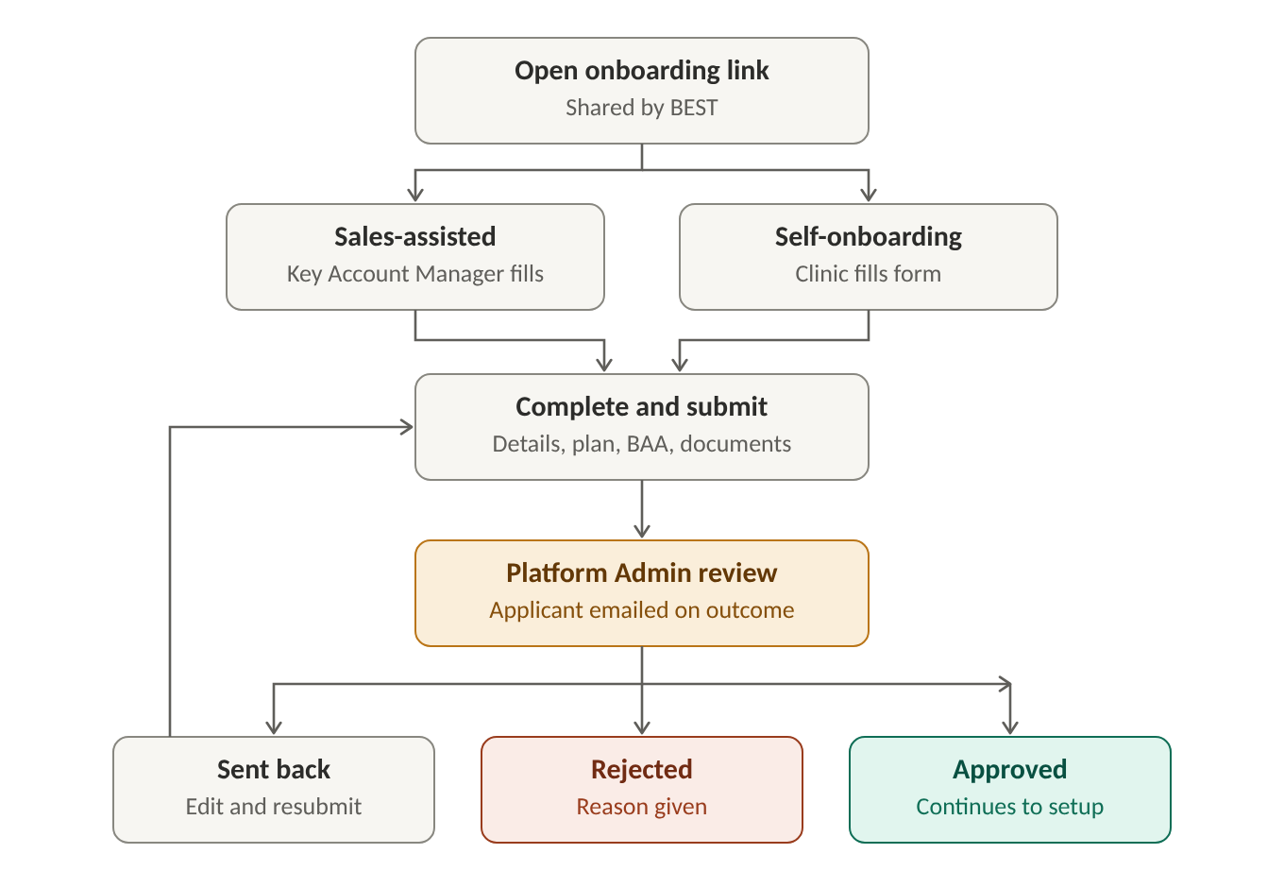
Figure 1. Clinic onboarding: request and approval
- The BEST team shares an onboarding link with the clinic. Each link belongs to one clinic, is valid for 14 days, and can be re-sent by BEST
- The onboarding type is selected: Sales-assisted, where the BEST Key Account Manager fills the form on behalf of the clinic, or Self-onboarding, where the clinic fills the form itself
- The form can be saved as a draft and completed later
- Mandatory details: legal name, EIN, NPI, address, time zone, contact person, at least one location, and the chosen plan
- Mandatory documents: signed Business Associate Agreement (BAA) and service agreement. Optional documents: W-9, state license, and proof of insurance
- A request is blocked if the EIN or NPI already belongs to an existing clinic
- The request is submitted for review by the BEST Platform Admin, who can approve it, reject it with a reason, or send it back for changes
- When sent back, the reviewer's comments are shown on the form; the request can be edited and resubmitted with no limit
- The applicant is emailed on each outcome

3. Setup and Go-Live
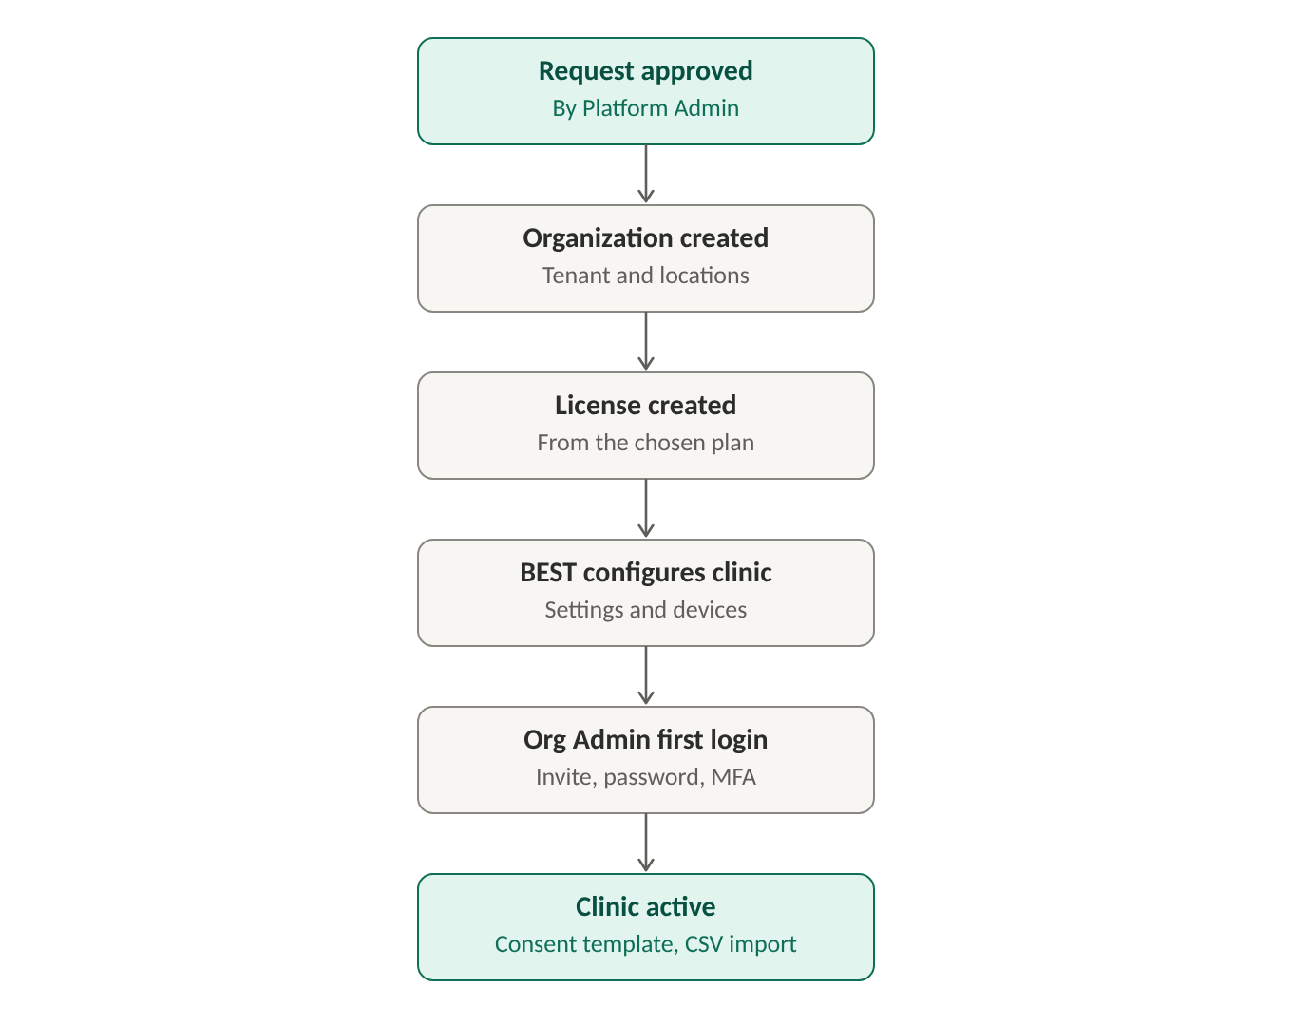
Figure 2. Clinic onboarding: setup and go-live
- On approval, the organization (tenant) and its locations are created
- The license is created from the chosen plan; Platform Admin can adjust seats and dates
- BEST configures the clinic: telehealth on or off and the clinical parameter values. Wearable devices are supplied by BEST and registered to the clinic
- The contact person named on the form is invited as Organization Admin and uses one license seat. The invite expires after 7 days and can be re-sent by BEST
- The Organization Admin sets a password and MFA at first login, and the clinic becomes active. Until then the clinic stays Approved
- The Organization Admin uploads the clinic's consent form template and can import staff and clients by CSV (optional)

4. Clinic Statuses
- Draft, Submitted, Sent back, Rejected, Approved, Active
- Suspended and Expired follow the license (see the license lifecycle in PRD version 3.0, Section 7.5)

