Glenn Marks & Pat Young, Silicon Image 09-09-2002

Backplane Design Guide for SATAII Signal Integrity Requirements

Introduction
This section will address the general design considerations for backplanes for use with SATAII signal levels. The scope of this design guide will be limited to maximizing the signal integrity of the SATA busses by minimizing losses. Key aspects of the general SATAII electrical specifications and typical FR4 circuit board substrate shall be used in the analysis. The goal will be to estimate the loss that should be expected as the SATA signals traverse from a controller through a backplane to a disk drive over 18 inches of low cost FR4 substrate.

Signal Distortions
The SATA signals will be distorted by attenuation, impedance mismatch reflections, crosstalk, and differential skew.

Attenuation
FR4 backplane has much greater losses compared to a standard SATA cable. The higher losses will cause relatively large signal attenuation over much shorter distances. Attenuation will be mostly caused by dielectric absorption and skin effect losses.

Impedance Mismatch Reflections
Impedance mismatches will cause reflections resulting in additional signal loss. The primary impedance distortions will be connectors, discrete components, and any vias used on the SATA traces.
The Metral connector specified for use as the controller interface is well matched for 100 Ohm, differential use. It is important to insure the disk drive interface connector, (if not direct SATA type), is also suitable for 100 Ohm, differential use.
If the SATA traces include any discrete components, use the smallest package size possible and remove the ground plane directly under the component’s pads to reduce the impedance discontinuity caused by the effectively wider trace, (this technique can also be used at surface mount connector pads when the pad width is significantly larger than the trace).

Cross-Talk
Etch and connector crosstalk will degrade the signal at random places depending on the aggressor signal relationship.
Far end crosstalk tends not to be much a significant problem on FR4 signals because the capacitive and inductive induced crosstalk have opposite polarities and tend to cancel each other out.
Near end crosstalk is the main problem encountered and is mainly controlled by adding distance to aggressor signals as the crosstalk reduces with the square of the distance. Also, if the source is not terminated, the near end crosstalk will reflect off the low impedance source and travel to the far end with opposite polarity.

Differential Skew
Differential skew is caused by differences in signal transmission times between differential pairs. The high-speed edge rates of SATAII signals will require tight etch length matching. A 5 mil maximum difference in length is a reasonable design goal. The eye-pattern will close with additional skew. See section 2.6 for additional considerations for trace length calculation.

Trace Geometry

There is a range of different trace geometries applicable for use with SATA busses. The term tightly coupled refers to a direct coupling of the differential pairs. This geometry requires strict mechanical control of a small space between the pairs and is best suited to mostly cable environments. This is because tightly coupled traces are by design much narrower and closer together and are far more susceptible to losses from the smaller trace width and from impedance variation due to width tolerance. Also the required spacing variations between the traces to interface with connectors and ICs cause large impedance errors and are therefore more distorting. Note that in planar PCBs this coupling geometry is actually medium coupling at best because a significant amount of return current will use the adjacent ground plane. A true tightly coupled geometry would require either a huge space to the ground plane or a ridiculously small trace and trace-to-trace spacing.

Loosely coupled trace geometries are better coupled to the ground plane or shield than the signal pairs are coupled to each other. This means the ground plane or shield will supply a significant portion of the return current path. This type of trace geometry is more suitable for a circuit board environment with multiple interconnects, components, vias, and long traces.

Tightly Coupled Trace Geometry
Trace geometries relying on direct trace-to-trace coupling are referred to as tightly coupled. The SATA standard relies on a more loosely coupled transmission line, also the hot plugging of SATA interfaces rely on common mode current paths to prevent problems during hot-swap operations. For these reasons tightly coupled traces are NOT recommended for SATA applications.

Loosely Coupled Trace Geometry
In a backplane environment the long trace lengths are highly susceptible to impedance errors from multiple connectors and normal trace width variations. To reduce this problem traces should be arranged much closer to the ground plane than to each other. This has the added benefit of allowing wider traces that reduce skin-effect loss.

- Wider trace geometries have less skin effect loss
- Distance to ground plane is better controlled than trace width
- Trace spacing variations caused by trace tolerance have less effect on impedance
- Trace space variations forced by chip or connector interfaces have less effect on impedance
- Vias used on SATA traces have less effect on impedance
- Distortions caused by large mechanical structures such as connectors or discrete components are easier to compensate for
- Traces can have deviate spacing for matching trace lengths with far less effect on the impedance

It is extremely important that the ground planes used to reference the signal in loosely coupled geometries is unbroken and directly below the SATA trace. Since a loosely coupled geometry uses essentially two common mode return paths, and since EMI is the result of the common mode loop size, any deviation of the return path will corrupt the impedance control and substantially increase EMI emissions.

Micro strip
Since a significant portion of the loss at higher frequencies is attributed to dielectric absorption, it is highly recommended that surface trace or micro-strip traces be used to minimize this effect. This additional loss will be especially significant at SATAII frequencies.

Strip Line
The Strip line traces are routed side by side on an inner layer and can be tightly or loosely coupled. Strip line geometry is not recommended with small tightly coupled trace geometries because of the higher dielectric loss. Also the spacing between the pins on the FCI Metral 4000 controller interface connector cannot support traces wider than .009” in a side by side strip line configuration. This type of configuration additionally places the traces closer to the connector pins, which will degrade the impedance control.

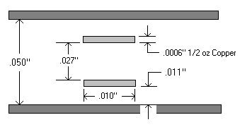
Broadside-Coupled Strip Line
The broadside-coupled strip line arranges the signal pairs vertically between a pair of surrounding ground planes. While this configuration can be routed as loose or tightly coupled, a loosely coupled configuration is recommended for SATA signals.
An example 100 Ohm, broadside-coupled strip line geometry is .010” trace width separated vertically by .027” with a total distance between the surrounding ground planes of .050”. This stack-up was computed using the Polar Impedance Calculator assuming a dielectric constant of 4.5 and used ½ oz copper for the signal layers and will be used in the example loss calculations in section 3. The resulting propagation delay is 179.7ps/inch.
As with the conventional strip line configuration, this buried trace geometry will suffer from more dielectric loss compared to a surface trace. Also, even when routed as loosely coupled traces, (as in the example geometry), any deviation between the vertical alignment of the signal pairs will create an impedance discontinuity. This makes equalizing trace lengths difficult without causing additional impedance errors.

Trace to Trace Spacing

The minimum distance from one signal pair to the next depends on the trace geometry. For micro strip traces the distance should be 5 times the center-to-center distance between the pairs or the distance to the ground plane, (whichever distance is greater).
For broadside coupled strip line traces, use 5 times the distance to the ground plane. If signal pair traces are any closer together the level of crosstalk will become a significant additional loss.

Trace Length Calculation
The trace length must be matched to within .005 over the entire bus from chip to chip. Most PCB layout tools handle trace length as a simple two-dimensional entity on a single PCB. This will NOT suffice for SATA signals. In addition to adding the trace length from all the PCBs in the signal path, the offset created by the connectors and the way the traces enter and exit these connectors must be considered, (see Figure 1). Lastly if the differential pairs are arranged on separate layers, such as in the broadside-coupled strip line geometry, the distance between the layers must be factored into the signal path length.

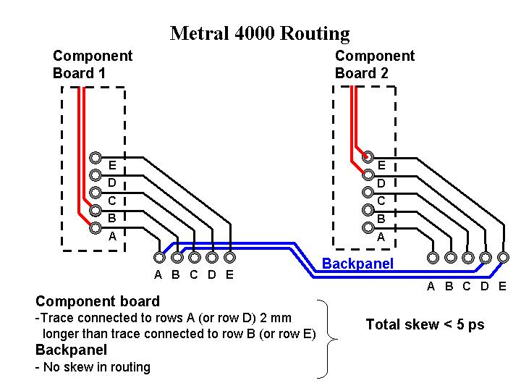
Figure 1 Metral 4000 Row Offsets

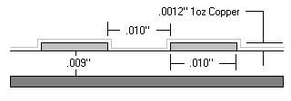Recommended Trace Geometry
A coated micro-strip configuration with a nominal trace width of .010”, a space of .010” between the pairs, and a distance of .009” to the ground plane, is the recommended trace geometry and will be used in the example loss calculations in section 3. This geometry was selected using the Polar Impedance Calculator assuming 1 oz copper for the surface, (signal) layer with a typical FR-4 dielectric constant of 4.5. The impedance was calculated at 100.1 Ohms with a delay of 153.5ps/inch.

Notes on Through-hole Connectors
For practical considerations when using the high pin density Metral 4000 connectors, the optimal trace geometry may be broad side coupled strip line, however, because of the higher dielectric loss, the buried traces should be avoided or kept to a minimum length. If the disk interface connectors on a given backplane design are also through hole and enough surface routing channels are not available, the use of broad side coupled strip line for short trace lengths may have less dielectric loss than the distortion loss from two sets of vias required to access the surface layers. If the disk interface connector is surface mount, route on the surface layers, or bring the SATA signals to the surface as soon as possible to reduce the dielectric loss. In general use surface mount components and micro-strip trace geometries wherever possible.

Vias On SATA Traces
Smaller vias will impart less distortion to the SATA signal. For this reason blind or buried vias are preferred. However due to the cost increase for these vias, an RF type via may be used as a minimum. An RF via is the minimum diameter drill available from the selected board house and will increase in size with board thickness. Boards .062” thick and under can use drill sizes as small as .010”, boards .125” will usually use .014” etc. The pad used on these vias should be as small as possible.
The other important aspect of a high frequency via is the extra large clearance, (.090” typical), to the surrounding power or ground planes. Also when the SATA signal changes layers through a via, and if the ground plane used to reference the SATA signal is no longer the same, add one or two standard vias next to the SATA signal vias for the ground return path. Also it is best to only connect the two ground layers used to reference the signal and leave any other ground layers unconnected.

Estimating PCB Signal Loss
The overriding signal distortion will be attenuation caused by dielectric absorption and skin effect losses. This section concentrates on calculating the expected signal attenuation at the SATAII fundamental carrier frequency. The loss will be calculated for both example trace geometries: micro-strip and broad side coupled strip-line.

Note on Compounding Signal Losses
All signal losses in a system must be combined to solve for the total signal loss. Summing the individual losses can be used to approximate the total signal loss for low losses. As losses increase the accuracy of this approximation declines.

Example, for etch loss of 1.2% per inch, the approximate loss over 3 inches using summation:
1.2% Loss + 1.2% Loss + 1.2% Loss = 1.2% • 3 = 3.6% Loss

The summation approximation method falls apart with larger signal losses:

40% Loss + 80% Loss = 120% Loss

Obviously, there cannot be more loss than available signal. The correct solution compounds the losses. First the signal is reduced 40% of the original signal. Next, the remaining signal is further reduced 80%.

Reducing a signal by X% is the same as keeping (100% - X%) of the signal, most of the loss compounding formulas will contain a term of (1 - X / 100).

Remaining signal after 40% Loss + 80% Loss =
Signal • (1 - 40 / 100) • (1 - 80 / 100) =
Signal • 0.6 • 0.2 = 0.12 Signal

Only 12% of the original signal remains, which means the combined loss in percent is:

100% - 12% = 88% (not the 120% of the summation approximation)

To directly solve for combined signal loss use the following formula format:

100 • (1 - (1 - PERCENT_LOSS_1 / 100) • (1 - PERCENT_LOSS_2 / 100))
100 • (1 - (1 - 40 / 100) • (1 - 80 / 100)) = 88%

Recalculating our first example that approximated 3.6% loss using the summation method:
100 • (1 - (1 - 1.2 / 100) • (1 - 1.2 / 100) • (1 - 1.2 / 100)) =
100 • (1 - (1 - 1.2 / 100) ^ 3) = 3.557% Loss

SATA Differential Voltage Levels and Acceptable Attenuation

Since it is not desirable to burden the disk drive with excessive transmit and receive capability beyond the standard PC cable based environment, the SATA specification defines a different set of values for host, (controller PHY) and device (disk PHY). There is an extended capability host PHY proposal for selectively extending the host device capability further, herein referred to as high drive. The relevant minimum and maximum loss values and PHY voltages are given in table 1, expressed in mVp-p. (These voltages are measured at the connectors in the SATAI specification, for SATAII these measurements are specified at the PHY boundary.)

Minimum  PHY Voltage p-p | SATA I DEVICE |  | SATA II HOST |  |  | SATA II HOST  high drive
Minimum  PHY Voltage p-p | Rx 325 | Tx 400 | Rx 240 |  | Tx 500 | Rx 240 | Tx 800
Max loss for  SATA II HOST | 35%  (-3.74dB) | 40%  (-4.44dB) | 52%  (-6.375dB) |  |  | 52%  (-6.375dB) | 70%  (-10.46dB)
Max loss for  SATA II HOST high drive | 59.4%  (7.82dB) | 40%  (-4.44dB) | 70%  (-10.46dB) | 52%  (-6.375dB) |  | 70%  (-10.46dB)

Table 1

The original SATA transmit and receive levels of 400mV and 325mV respectively must be supported at the disk drive interface. If a SATAI disk drive is directly connected to a SATAII host controller the maximum loss acceptable transmitting to the disk drive is:

500mV transmit minimum to 325mV minimum at the receiver
% (db) Loss Allowed Host to Device = 100 • ( 1 - (325mV / 500mV) ) = 35% (-3.74db)

Maximum allowable loss receiving from the disk drive is:

400mV transmit minimum to 240mV minimum at the receiver
% (db) Loss Allowed Device to Host = 100 • ( 1 - (240mV / 400mV) ) = 40% (-4.44db)

The worst-case acceptable loss for a direct connection to the SATA drive is 35%. This is difficult to accomplish using 18 inches of trace on a standard FR-4 substrate. Since the system must be designed to operate with first generation SATA disk drives, this problem may be overcome in multiple ways:

- Use a buffer IC at the disk interface, this may initially be a SATA to IDE converter, or simply a dual path multiplexer used to convert a single path SATA device into a dual path device. (This is done to provide a redundant data path to each disk drive for use in high availability systems and can be used to maintain direct compatibility with traditional fibre channel architectures). This type of device isolates the SATA drive and creates a matched network with extended drive capability.
- Use SATAII devices with high drive capability. This can be selectively enabled for the longest, (highest loss), traces.
- Use lower loss materials, wider or shorter traces, or a combination of all three.
- Use a SATA cable from a small controller interface PCB to the disk drive. (Note: This is a single path solution and adds another connector loss to the signal path).

In the following example loss analysis, we will assume a standard SATAII to SATAII direct backplane connection: The minimum transmit voltage is 500mV, the minimum valid receiver voltage is 240mV. This yields a total signal loss budget of:
% (db) Loss Allowed Specification Minimum = 100 • ( 1 - (240mV / 500mV) ) = 52% (-6.375db)

Skin Effect and Dielectric Absorption
The following chart estimates skin effect and dielectric absorption losses in % per inch:

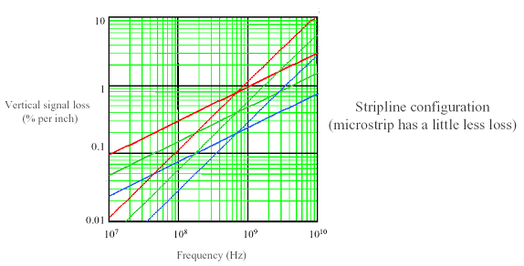
Dielectric loss tan = .02
Dielectric loss tan = .01
Dielectric loss tan = .005

skin effect W=.006
skin effect W=.012
skin effect W=.024

SATAII Loss Analysis

1500 MHz Sine Wave
Because of the serious attenuation at the higher edge rate frequencies, the SATAII receiver must function close to an actual sine wave at the maximum SATAII effective frequency of 1.5GHz, (period is twice the length of the data rate). It turns out that that many receivers are designed to work at 240mVp-p with the lower 1.5GHz fundamental sine wave with the higher frequency odd harmonics stripped out (or removed by attenuation). Designing in additional loss margin will provide an effectively higher frequency signal at the receiver.

Dielectric Absorption
Assuming:

- A typical dielectric loss tangent for buried strip line traces in FR-4 is .0167. The trace delay of the recommended strip line trace geometry is 179.7ps/inch using the Polar Impedance calculator.

- A typical dielectric loss tangent for a coated micro strip trace in FR-4 is about 90% of the buried trace value or .015. The trace delay of the recommended micro-strip trace geometry is 153.5ps/inch using the Polar impedance calculator.

The dielectric loss in percent-signal-loss per inch of trace can be calculated by the following formula:

100 • π • F • LOSS_TANGENT • TRACE_DELAY =
for buried strip line:
100 • π • 1.5GHz • .0167 • 179.7ps/inch = 1.41% per inch
for micro strip:
100 • π • 1.5GHz • .015 • 153.5ps/inch = 1.08% per inch

The loss chart shows slightly over 1% for a .010” trace, which matches the calculated loss per inch.

Expected dielectric absorption loss for an 18 inch trace:

100 • (1 - (1 - PERCENT_LOSS / 100)^ETCH_LENGTH)
buried strip line:
18 Inch Etch Loss = 100 • (1 - (1 - 1.41 / 100) ¹⁸) = 22.55%
micro strip:
18 Inch Etch Loss = 100 • (1 - (1 - 1.08 / 100) ¹⁸) = 17.75%

Skin Effect Loss
The Skin Effect loss is proportional to the SQRT (F)/ETCH_EDGE_LENGTH, (etch_edge_length is the length of the perimeter of a cross section of the etch). This value in percent-signal-loss per inch of trace can be estimated by the following formula:

R(skin) = 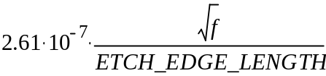

.010” 1 oz Copper micro strip:
R(skin) = 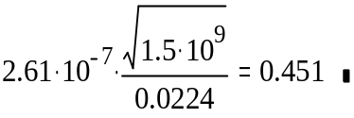

.010” 1/2 oz Copper strip line:
R(skin) = 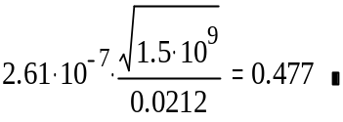
Loss % per inch = 

.010” 1 oz Copper micro strip:

Loss % per inch = 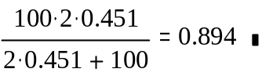% per inch

.010” 1/2 oz Copper strip line:

Loss % per inch = 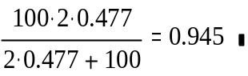% per inch

Skin effect loss from the chart is .85% signal loss per inch. The charts value is reasonable based on the calculated .894% estimate for a .010” wide trace.

Skin effect losses are not additive, they compound over the etch length. The expected skin effect loss for an 18 inch trace:

100 • (1 - (1 - PERCENT_LOSS / 100) ETCH_LENGTH)

.010” 1 oz Copper micro strip:

18 Inch Etch Loss = 100 • (1 - (1 - .894 / 100) ¹⁸) = 14.9%

.010” 1/2 oz Copper strip line:

18 Inch Etch Loss = 100 • (1 - (1 - .945 / 100) ¹⁸) = 15.7%

Note: The difference in the skin effect loss is a function of the difference in cross sectional perimeter length of the trace. The difference in this length is because internal signal layers typically use ½ oz copper, and surface traces are usually 1oz copper.

Combined Dielectric Absorption and Skin Effect Loss
Unfortunately the dielectric absorption and skin effect losses combine:

100 • (1 - (1 - PERCENT_LOSS_1 / 100) • (1 - PERCENT_LOSS_2 / 100))
Buried strip line:
100 • (1 - (1 - 1.41 / 100) • (1 - .945 / 100)) = 2.34%
Micro strip:
100 • (1 - (1 - 1.08 / 100) • (1 - .894 / 100)) = 1.96%

Notice that the combined loss for the buried strip line is well over 2% per inch!

Expected dielectric absorption and skin effect loss for an 18 inch trace:

100 • (1 - (1 - PERCENT_LOSS / 100)^ETCH_LENGTH)
Buried Strip Line:
18 Inch Etch Loss = 100 • (1 - (1 - 2.34 / 100) ¹⁸) = 34.7%

[This results in nearly a 35% loss before any other losses are added]

Micro strip:
18 Inch Etch Loss = 100 • (1 - (1 - 1.96 / 100) ¹⁸) = 29.9%

Connector Losses

Source of Connector Losses
The main connector losses will be impedance mismatch reflections and crosstalk interference.

Backplane Controller Interface Connector
The Controller interface to the backplane is a FCI Metral 4000 connector.

Disk Interface Connectors
The Disk interface is not defined, as an example for this study; a Molex SCA-2 type connector will be used as the drive connection for backplane compatibility with fibre channel.

Impedance Losses

Resistance Losses
The mated connectors have a contact resistance of about .02 ohms. This low level of contact resistance is small enough compared to the 100 ohms differential impedance that it can be ignored.

Impedance Losses
The controller, backplane, and disk interface impedances are typically controlled to 100 Ohms ±10%. Leading to an impedance range of 90 to 110 ohms.

The FCI Metral 4000 has an impedance variation of 85 to 105.

The Molex SCA-2 connector's differential impedance specification range is 90 to 105 ohms.

The worse case signal loss due to connector reflections occurs when the controller and backplane impedances are high (110 ohms) and the connector impedances are low (85 and 90 ohms).

% Reflection from the Controller PCB to FCI Metral 4000 connector =
abs(100 • (Zconnector – ZController_PCB) / (Zconnector + ZController_PCB)) =
abs(100 • (85 - 110) / (85 + 110)) = 12.8%

% Reflection from FCI Metral 4000 to backplane =
abs(100 • (Zbackplane - Zmetral) / (Zbackplane + Zmetral)) =
abs(100 • (110 - 85) / (110 + 85)) = 12.8%

% Reflection from backplane to Molex SCA=
abs(100 • (Zmolex - Zbackplane) / (Zmolex + Zbackplane)) =
abs(100 • (90 - 110) / (90 + 110)) = 10.0%

Total worst-case reflection losses:
100 • (1 - (1 - 12.8 / 100) • (1 - 12.8 / 100) • (1 - 10.0 / 100)) = 31.6%

Combining Impedance Losses With Etch Losses
Combining the impedance losses with the etch losses (backplane, controller, and disk interface):

100 • (1 - (1 - PERCENT_LOSS_ETCH / 100) • (1 - PERCENT_LOSS_REFLECTION /100))
Buried strip line:
18 Inch Etch Loss = 100 • (1 - (1 – 34.7 / 100) • (1 - 31.6 / 100)) = 55.3%
Micro strip:
18 Inch Etch Loss = 100 • (1 - (1 – 29.9 / 100) • (1 - 31.6 / 100)) = 52%

Crosstalk
The Molex connector specifies crosstalk will be approximately 10%. The multiactive crosstalk for the FCI Metral 4000 connector is 4% with 100ps rise time. Even though the signal loss is low to the aggressor generating the crosstalk, the near end crosstalk will reflect off the source and return as noise several bit times later.

The SATAII bit period of 333ps corresponds to about 1.85 inches of etch.
333ps / 180ps/inch trace velocity = 1.85 inches

The 18 inches of etch will create the following round trip delays:
2 • 18 inches etch / 1.85 inches = 19.4 data periods

With the crosstalk voltage returning close to 20 data periods later, it must be assumed that the crosstalk destructively subtracts from the signal.

Because the reflecting crosstalk will be attenuated during its round trip, a safe value to use for the combined crosstalk attenuation of both connectors is 10%*

*(Poor layout of transmit the traces near the receive traces can easily induce far greater un-attenuated crosstalk.)

Combining the crosstalk with our running loss total:

100 • (1 - (1 - PERCENT_LOSS / 100) • (1 - PERCENT_LOSS_CROSSTALK /100))
Buried strip line:
18 Inch Etch Loss = 100 • (1 - (1 – 55.3 / 100) • (1 - 10 / 100)) = 59.7%
Micro strip:
18 Inch Etch Loss = 100 • (1 - (1 – 52 / 100) • (1 - 10 / 100)) = 56.8%

Backplane Crosstalk
The recommended Backplane traces are routed as .010” strip line with .030” separation to the nearest differential pair. Crosstalk is reduced with the square of the distance.

With an estimated crosstalk of 2 percent on the backplane the loss figures are:

100 • (1 - (1 - PERCENT_LOSS / 100) • (1 - PERCENT_LOSS_CROSSTALK /100))

Buried strip line:
18 Inch Etch Loss = 100 • (1 - (1 – 59.7 / 100) • (1 - 2 / 100)) = 60.5%
Micro strip:
18 Inch Etch Loss = 100 • (1 - (1 – 56.8 / 100) • (1 - 2 / 100)) = 57.6%

Conclusion
The conclusion of this study is that an 18 inch .010” wide trace width will not meet the SATAII initial specification, however additional margin may be obtained by increasing the transmit voltage (high drive), increasing the trace width, reducing the trace length or taking other measures to reduce loss.

Main Study Points
The above conclusion is based on these main study points:
- The SATAII HOST specification has a maximum loss of 52% (-6.375db).
- The estimated signal loss for an 18 inch buried strip line trace is 60.5%.
- The estimated signal loss for an 18 inch micro strip trace is 57.6%.
- High Drive SATAII PHYs will provide additional margin for long traces.

Notes
An additional 5% loss should be added to the estimated signal loss to allow for miscellaneous signal distortions such as:

- Discrete Pad capacitance and other impedance mismatches.
- Rise-time distortions going through connectors.

