LAP 8

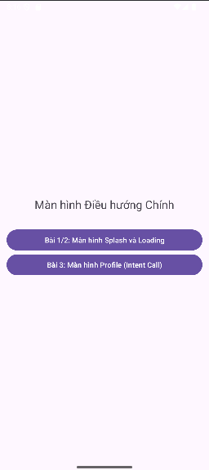

activity_main.xml

<?xml version="1.0" encoding="utf-8"?>  
<LinearLayout  
 xmlns:android="http://schemas.android.com/apk/res/android"  
 xmlns:tools="http://schemas.android.com/tools"  
 android:layout_width="match_parent"  
 android:layout_height="match_parent"  
 android:orientation="vertical"  
 android:gravity="center"  
 android:padding="16dp"  
 tools:context=".MainActivity">  
  
 <TextView  
 android:layout_width="wrap_content"  
 android:layout_height="wrap_content"  
 android:text="Màn hình Điều hướng Chính"  
 android:textSize="22sp"  
 android:layout_marginBottom="30dp"/>  
  
 <Button  
 android:id="@+id/btn_to_splash"  
 android:layout_width="match_parent"  
 android:layout_height="wrap_content"  
 android:text="Bài 1/2: Màn hình Splash và Loading" />  
  
 <Button  
 android:id="@+id/btn_to_profile"  
 android:layout_width="match_parent"  
 android:layout_height="wrap_content"  
 android:text="Bài 3: Màn hình Profile (Intent Call)" />  
</LinearLayout>

Bài tập 1: Trong bài luyện tập 1, viết code để mỗi khi chạy lên sẽ ra một màu nền khác nhau

và 1 icon khác nhau.

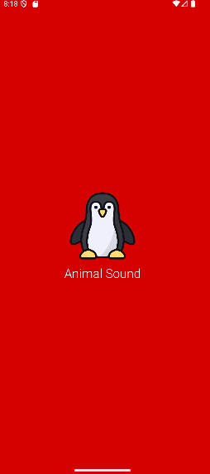

Bài tập 2: Trong bài luyện tập 2, sử dụng Custom ProgressBar để làm giao diện đẹp hơn.

activity_home.xml

<?xml version="1.0" encoding="utf-8"?>  
<LinearLayout  
 xmlns:android="http://schemas.android.com/apk/res/android"  
 android:layout_width="match_parent"  
 android:layout_height="match_parent"  
 android:gravity="center"  
 android:background="#E8EAF6"  
 android:orientation="vertical">  
  
 <TextView  
 android:layout_width="wrap_content"  
 android:layout_height="wrap_content"  
 android:text="ỨNG DỤNG ĐÃ LOAD XONG!"  
 android:textSize="28sp"  
 android:textColor="@color/indigo"  
 android:textStyle="bold"/>  
  
 <TextView  
 android:layout_width="wrap_content"  
 android:layout_height="wrap_content"  
 android:layout_marginTop="10dp"  
 android:text="Đây là màn hình chính của ứng dụng (HomeActivity)"  
 android:textSize="16sp"  
 android:textColor="@color/gray_dark"/>  
</LinearLayout>



item_loading.xml

<?xml version="1.0" encoding="utf-8"?>  
<LinearLayout  
 xmlns:android="http://schemas.android.com/apk/res/android"  
 android:layout_width="match_parent"  
 android:layout_height="match_parent"  
 android:gravity="center"  
 android:background="#BF000000"  
 android:orientation="vertical">  
  
 <ProgressBar  
 android:layout_width="60dp"  
 android:layout_height="60dp"  
 android:indeterminate="true"  
 android:indeterminateDrawable="@drawable/custom_progress_spinner"  
 android:indeterminateTint="@null" />  
  
 <TextView  
 android:layout_width="wrap_content"  
 android:layout_height="wrap_content"  
 android:layout_marginTop="10dp"  
 android:fontFamily="sans-serif-light"  
 android:text="@string/txt_loading"  
 android:textColor="@color/white"  
 android:textSize="24sp" />  
</LinearLayout>

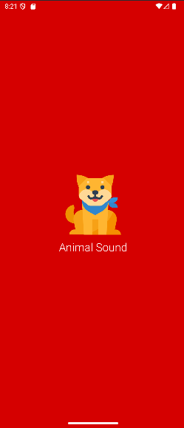

Bài tập 3: Lập trình để khi bấm vào icon thì chuyển về cuộc gọi, sử dụng Intent.

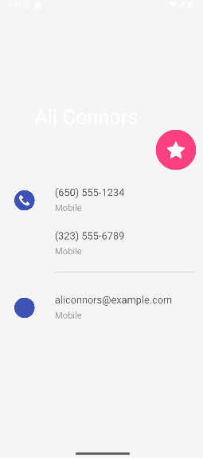

m001_act_profile.xml

<?xml version="1.0" encoding="utf-8"?>  
<LinearLayout  
 xmlns:android="http://schemas.android.com/apk/res/android"  
 xmlns:app="http://schemas.android.com/apk/res-auto"  
 xmlns:tools="http://schemas.android.com/tools"  
 android:layout_width="match_parent"  
 android:layout_height="match_parent"  
 android:background="@color/gray_light"  
 android:orientation="vertical">  
  
 <FrameLayout  
 android:layout_width="match_parent"  
 android:layout_height="350dp">  
 <ImageView  
 android:layout_width="match_parent"  
 android:layout_height="300dp"  
 android:scaleType="centerCrop"  
 android:src="@drawable/bg_avatar"  
 tools:ignore="ContentDescription" />  
 <TextView  
 android:layout_width="wrap_content"  
 android:layout_height="wrap_content"  
 android:layout_gravity="bottom"  
 android:layout_marginStart="70dp"  
 android:layout_marginBottom="90dp"  
 android:fontFamily="sans-serif"  
 android:text="@string/txt_name"  
 android:textColor="@color/white"  
 android:textSize="40sp" />  
 <ImageView  
 android:layout_width="80dp"  
 android:layout_height="80dp"  
 android:layout_gravity="end|bottom"  
 android:layout_marginEnd="20dp"  
 android:layout_marginBottom="10dp"  
 android:background="@drawable/bg_oval"  
 android:padding="20dp"  
 android:src="@drawable/ic_star"  
 app:tint="@color/white"  
 tools:ignore="ContentDescription" />  
 </FrameLayout>  
  
 <TableRow  
 android:id="@+id/phone_row_1"  
 android:layout_width="match_parent"  
 android:layout_height="wrap_content"  
 android:padding="20dp"  
 android:clickable="true"  
 android:focusable="true"  
 android:background="?android:attr/selectableItemBackground">  
  
 <ImageView  
 android:layout_width="60dp"  
 android:layout_height="60dp"  
 android:padding="10dp"  
 android:src="@drawable/ic_phone"  
 app:tint="@color/indigo"  
 tools:ignore="ContentDescription" />  
 <LinearLayout  
 android:layout_width="match_parent"  
 android:layout_height="wrap_content"  
 android:layout_marginStart="30dp"  
 android:orientation="vertical">  
 <TextView  
 android:layout_width="match_parent"  
 android:layout_height="wrap_content"  
 android:text="@string/txt_phone1"  
 android:textColor="@color/gray_dark"  
 android:textSize="20sp" />  
 <TextView  
 android:layout_width="match_parent"  
 android:layout_height="wrap_content"  
 android:layout_marginTop="5dp"  
 android:text="@string/txt_title_mobile"  
 android:textColor="@color/gray_mid"  
 android:textSize="18sp" />  
  
 <TextView  
 android:layout_width="match_parent"  
 android:layout_height="wrap_content"  
 android:layout_marginTop="30dp"  
 android:text="@string/txt_phone2"  
 android:textColor="@color/gray_dark"  
 android:textSize="20sp" />  
 <TextView  
 android:layout_width="match_parent"  
 android:layout_height="wrap_content"  
 android:layout_marginTop="5dp"  
 android:text="@string/txt_title_mobile"  
 android:textColor="@color/gray_mid"  
 android:textSize="18sp"/>  
 <View  
 android:layout_width="match_parent"  
 android:layout_height="0.5dp"  
 android:layout_marginTop="30dp"  
 android:background="@color/gray_mid" />  
 </LinearLayout>  
 </TableRow>  
  
 <TableRow  
 android:id="@+id/email_row"  
 android:layout_width="match_parent"  
 android:layout_height="wrap_content"  
 android:padding="20dp"  
 android:clickable="true"  
 android:focusable="true"  
 android:background="?android:attr/selectableItemBackground">  
  
 <ImageView  
 android:layout_width="60dp"  
 android:layout_height="60dp"  
 android:padding="10dp"  
 android:src="@drawable/ic_mail"  
 app:tint="@color/indigo"  
 tools:ignore="ContentDescription" />  
 <LinearLayout  
 android:layout_width="match_parent"  
 android:layout_height="match_parent"  
 android:layout_marginStart="30dp"  
 android:orientation="vertical">  
 <TextView  
 android:layout_width="match_parent"  
 android:layout_height="wrap_content"  
 android:text="@string/txt_email"  
 android:textColor="@color/gray_dark"  
 android:textSize="20sp" />  
 <TextView  
 android:layout_width="match_parent"  
 android:layout_height="wrap_content"  
 android:layout_marginTop="5dp"  
 android:text="@string/txt_title_mobile"  
 android:textColor="@color/gray_mid"  
 android:textSize="18sp" />  
 </LinearLayout>  
 </TableRow>  
</LinearLayout>

Bài tập 4: Tạo màn hình chính MainActivity để chuyển qua và chuyển về giữa các màn hình

