**BÀI TẬP LÝ THUYẾT 2**

**1. Làm bằng RelativeLayout**

**Hình ban đầu :**

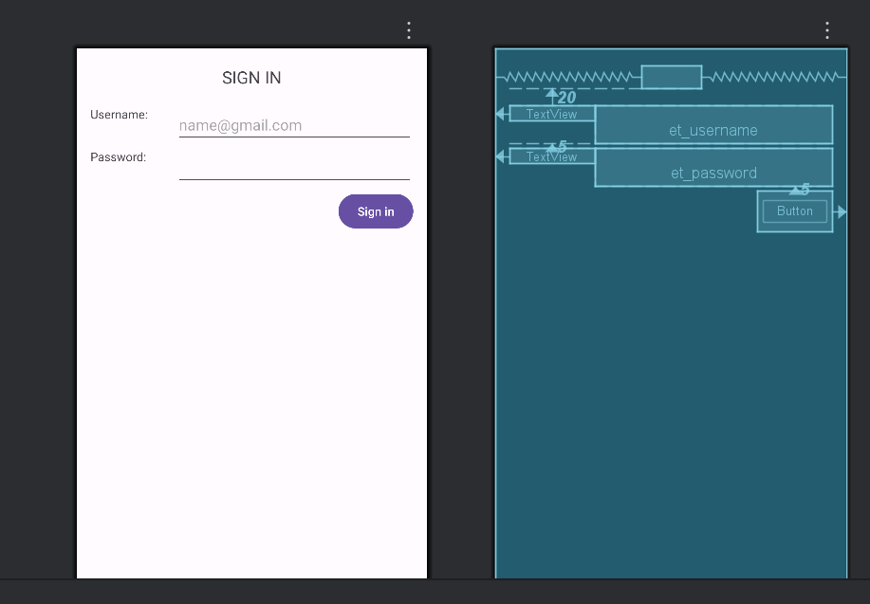

**Chỉnh code activity_main.xml :**

<?xml version="1.0" encoding="utf-8"?>  
<RelativeLayout xmlns:android="http://schemas.android.com/apk/res/android"  
 android:id="@+id/main"  
 android:layout_width="match_parent"  
 android:layout_height="match_parent"  
 android:paddingLeft="@dimen/activity_horizontal_margin"  
 android:paddingRight="@dimen/activity_horizontal_margin"  
 android:paddingTop="@dimen/activity_vertical_margin"  
 android:paddingBottom="@dimen/activity_vertical_margin"  
 android:background="#F5F5F5">  
  
 <!-- Tiêu đề -->  
 <TextView  
 android:id="@+id/tv_sign_in"  
 android:layout_width="wrap_content"  
 android:layout_height="wrap_content"  
 android:text="@string/sign_in"  
 android:textAllCaps="true"  
 android:layout_centerHorizontal="true"  
 android:layout_marginTop="@dimen/margin_basex4"  
 android:textSize="@dimen/text_large"  
 android:textStyle="bold"  
 android:textColor="#000000" />  
  
 <!-- Username -->  
 <TextView  
 android:id="@+id/tv_user_name"  
 android:layout_width="100dp"  
 android:layout_height="wrap_content"  
 android:text="@string/username"  
 android:layout_below="@id/tv_sign_in"  
 android:layout_marginTop="@dimen/margin_basex4"  
 android:textSize="@dimen/text_medium"  
 android:textColor="#333333" />  
  
 <EditText  
 android:id="@+id/et_username"  
 android:layout_width="match_parent"  
 android:layout_height="wrap_content"  
 android:hint="name@gmail.com"  
 android:layout_alignTop="@id/tv_user_name"  
 android:layout_toRightOf="@id/tv_user_name"  
 android:backgroundTint="#2196F3"  
 android:padding="8dp" />  
  
 <!-- Password -->  
 <TextView  
 android:id="@+id/tv_password"  
 android:layout_width="100dp"  
 android:layout_height="wrap_content"  
 android:text="@string/password"  
 android:layout_below="@id/et_username"  
 android:layout_marginTop="@dimen/margin_basex2"  
 android:textSize="@dimen/text_medium"  
 android:textColor="#333333" />  
  
 <EditText  
 android:id="@+id/et_password"  
 android:layout_width="match_parent"  
 android:layout_height="wrap_content"  
 android:inputType="textPassword"  
 android:layout_alignTop="@id/tv_password"  
 android:layout_toRightOf="@id/tv_password"  
 android:backgroundTint="#2196F3"  
 android:padding="8dp" />  
  
 <!-- Nút Sign In -->  
 <Button  
 android:id="@+id/btn_sign_in"  
 android:layout_width="wrap_content"  
 android:layout_height="wrap_content"  
 android:layout_below="@id/et_password"  
 android:layout_alignParentRight="true"  
 android:layout_marginTop="@dimen/margin_basex2"  
 android:paddingLeft="@dimen/margin_basex3"  
 android:paddingRight="@dimen/margin_basex3"  
 android:text="@string/sign_in"  
 android:textAllCaps="true"  
 android:textColor="#FFFFFF"  
 android:backgroundTint="#2196F3" />  
  
 <!-- Nút Sign In via Facebook -->  
 <Button  
 android:id="@+id/btn_sign_in_fb"  
 android:layout_width="match_parent"  
 android:layout_height="wrap_content"  
 android:layout_below="@id/btn_sign_in"  
 android:layout_marginTop="@dimen/margin_basex3"  
 android:text="SIGN IN VIA FACEBOOK"  
 android:textAllCaps="true"  
 android:textColor="#FFFFFF"  
 android:backgroundTint="#3b5998" />  
  
 <!-- Nút Sign Up -->  
 <Button  
 android:id="@+id/btn_sign_up"  
 android:layout_width="match_parent"  
 android:layout_height="wrap_content"  
 android:layout_below="@id/btn_sign_in_fb"  
 android:layout_marginTop="@dimen/margin_basex2"  
 android:text="@string/signup"  
 android:textAllCaps="true"  
 android:textColor="#FFFFFF"  
 android:backgroundTint="#4CAF50" />  
  
</RelativeLayout>

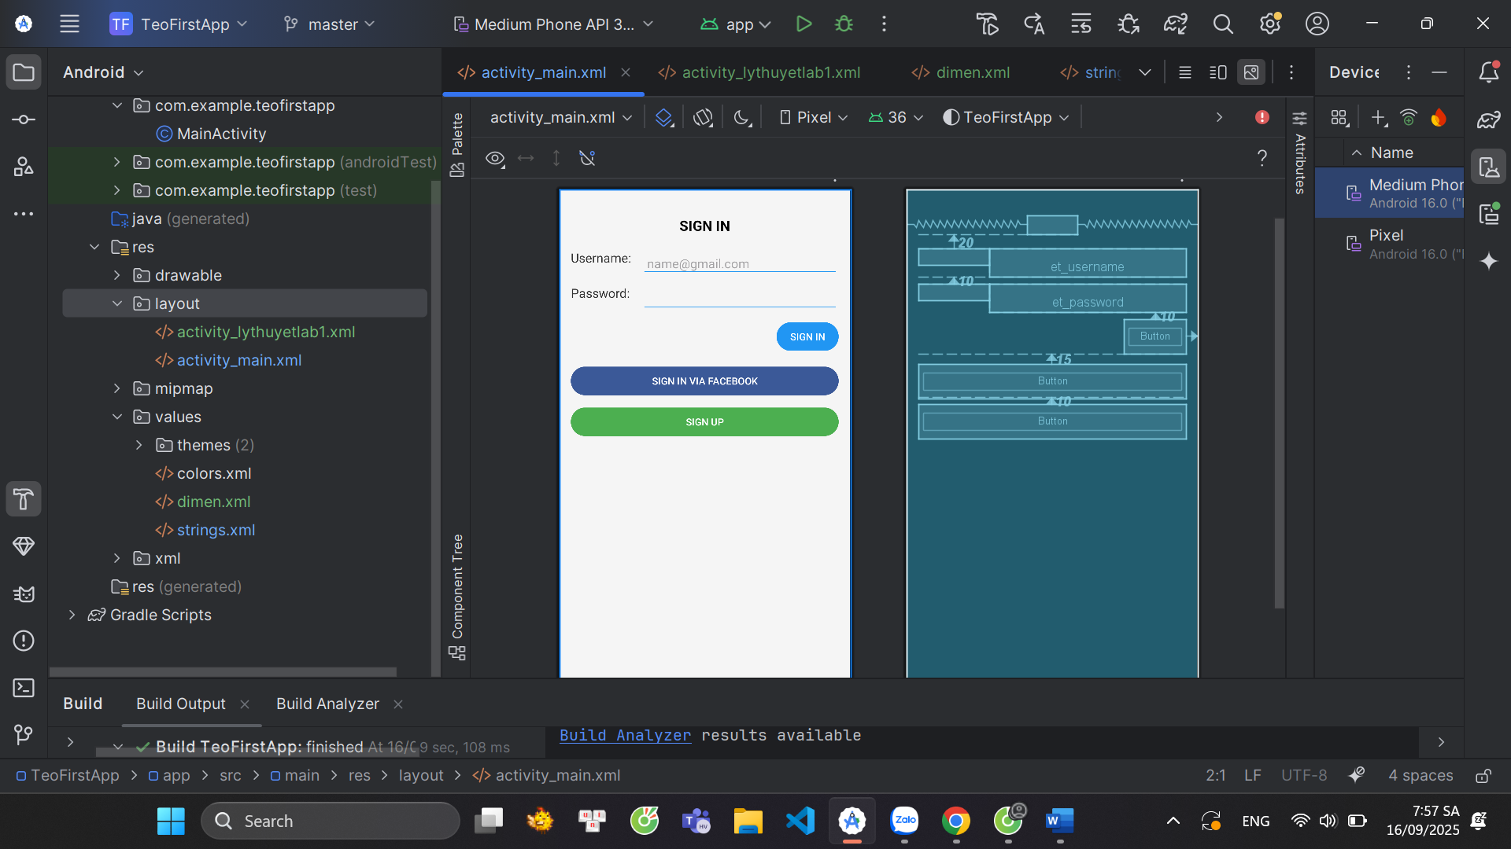

**2. Làm bằng ContraintLayout**

<?xml version="1.0" encoding="utf-8"?>  
<androidx.constraintlayout.widget.ConstraintLayout xmlns:android="http://schemas.android.com/apk/res/android"  
 xmlns:app="http://schemas.android.com/apk/res-auto"  
 xmlns:tools="http://schemas.android.com/tools"  
 android:id="@+id/main"  
 android:layout_width="match_parent"  
 android:layout_height="match_parent"  
 android:padding="@dimen/activity_horizontal_margin"  
 android:background="#F5F5F5"  
 tools:context=".MainActivity">  
  
 <!-- Tiêu đề -->  
 <TextView  
 android:id="@+id/tv_sign_in"  
 android:layout_width="wrap_content"  
 android:layout_height="wrap_content"  
 android:text="@string/sign_in"  
 android:textAllCaps="true"  
 android:textStyle="bold"  
 android:textSize="@dimen/text_large"  
 android:textColor="#000000"  
 app:layout_constraintTop_toTopOf="parent"  
 app:layout_constraintStart_toStartOf="parent"  
 app:layout_constraintEnd_toEndOf="parent"  
 android:layout_marginTop="@dimen/margin_basex4"/>  
  
 <!-- Username Label -->  
 <TextView  
 android:id="@+id/tv_user_name"  
 android:layout_width="0dp"  
 android:layout_height="wrap_content"  
 android:text="@string/username"  
 android:textSize="@dimen/text_medium"  
 android:textColor="#333333"  
 app:layout_constraintTop_toBottomOf="@id/tv_sign_in"  
 app:layout_constraintStart_toStartOf="parent"  
 android:layout_marginTop="@dimen/margin_basex4"  
 android:layout_marginEnd="8dp"  
 app:layout_constraintEnd_toStartOf="@id/et_username"/>  
  
 <!-- Username Input -->  
 <EditText  
 android:id="@+id/et_username"  
 android:layout_width="0dp"  
 android:layout_height="wrap_content"  
 android:hint="name@gmail.com"  
 android:backgroundTint="#2196F3"  
 android:padding="8dp"  
 app:layout_constraintStart_toEndOf="@id/tv_user_name"  
 app:layout_constraintTop_toTopOf="@id/tv_user_name"  
 app:layout_constraintEnd_toEndOf="parent"/>  
  
 <!-- Password Label -->  
 <TextView  
 android:id="@+id/tv_password"  
 android:layout_width="0dp"  
 android:layout_height="wrap_content"  
 android:text="@string/password"  
 android:textSize="@dimen/text_medium"  
 android:textColor="#333333"  
 app:layout_constraintTop_toBottomOf="@id/et_username"  
 app:layout_constraintStart_toStartOf="parent"  
 android:layout_marginTop="@dimen/margin_basex2"  
 app:layout_constraintEnd_toStartOf="@id/et_password"  
 android:layout_marginEnd="8dp"/>  
  
 <!-- Password Input -->  
 <EditText  
 android:id="@+id/et_password"  
 android:layout_width="0dp"  
 android:layout_height="wrap_content"  
 android:inputType="textPassword"  
 android:backgroundTint="#2196F3"  
 android:padding="8dp"  
 app:layout_constraintStart_toEndOf="@id/tv_password"  
 app:layout_constraintTop_toTopOf="@id/tv_password"  
 app:layout_constraintEnd_toEndOf="parent"/>  
  
 <!-- Sign In Button -->  
 <Button  
 android:id="@+id/btn_sign_in"  
 android:layout_width="wrap_content"  
 android:layout_height="wrap_content"  
 android:text="@string/sign_in"  
 android:textColor="#FFFFFF"  
 android:backgroundTint="#2196F3"  
 android:paddingLeft="@dimen/margin_basex3"  
 android:paddingRight="@dimen/margin_basex3"  
 android:textAllCaps="true"  
 app:layout_constraintTop_toBottomOf="@id/et_password"  
 android:layout_marginTop="@dimen/margin_basex2"  
 app:layout_constraintEnd_toEndOf="parent"/>  
  
 <!-- Sign In via Facebook Button -->  
 <Button  
 android:id="@+id/btn_sign_in_fb"  
 android:layout_width="0dp"  
 android:layout_height="wrap_content"  
 android:text="SIGN IN VIA FACEBOOK"  
 android:textColor="#FFFFFF"  
 android:backgroundTint="#3b5998"  
 android:textAllCaps="true"  
 app:layout_constraintTop_toBottomOf="@id/btn_sign_in"  
 android:layout_marginTop="@dimen/margin_basex3"  
 app:layout_constraintStart_toStartOf="parent"  
 app:layout_constraintEnd_toEndOf="parent"/>  
  
 <!-- Sign Up Button -->  
 <Button  
 android:id="@+id/btn_sign_up"  
 android:layout_width="0dp"  
 android:layout_height="wrap_content"  
 android:text="@string/signup"  
 android:textColor="#FFFFFF"  
 android:backgroundTint="#4CAF50"  
 android:textAllCaps="true"  
 app:layout_constraintTop_toBottomOf="@id/btn_sign_in_fb"  
 android:layout_marginTop="@dimen/margin_basex2"  
 app:layout_constraintStart_toStartOf="parent"  
 app:layout_constraintEnd_toEndOf="parent"/>  
  
</androidx.constraintlayout.widget.ConstraintLayout>

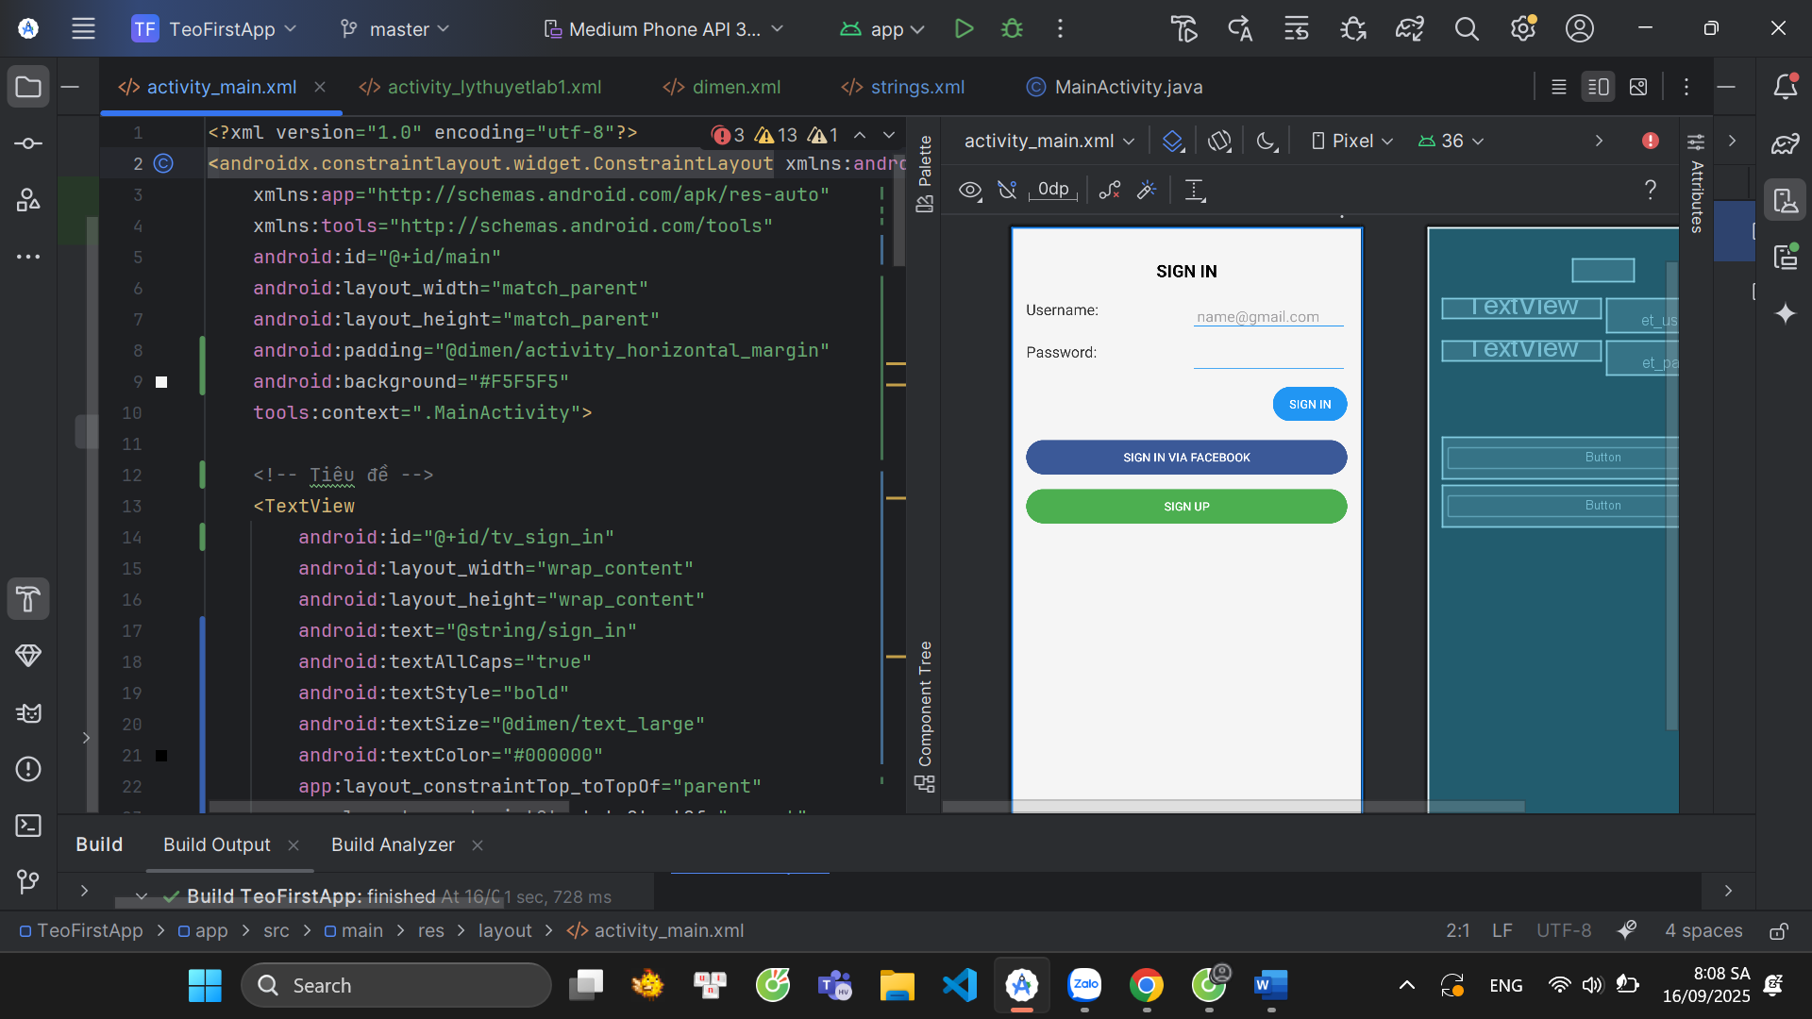

**🔥 Điểm khác biệt so với RelativeLayout**

* Dùng ConstraintLayout → giảm việc lồng nhiều layout, dễ căn chỉnh hơn.
* TextView (label) nằm cạnh EditText (input), canh chuẩn bằng constraint.
* Các nút Sign In, Sign In via Facebook, Sign Up xếp dọc nhau, full width đẹp mắt.