Classes in Red

Under-Classes in Orange

Under-Under Classes in Green

Maps

Square Matrix = [][]

Int level;

Int Rover;

Int Pacer;

Int Jumper;

String name;

Methods

getSquares(I,j);

Squares

Caract

Int ID;

Jpg;

Methods

Brick

Hyper

Freeze

Ladder

Goal

Empty

Empty w/ apple

Characters

Caract

Int Power

Position [i][j]

Methods

Move ();

Switch (getSquare(I,j){

Empty w/ apple = SetPower

Goal

Empty

…

}

Humans

Methods

OR_Move ();

Enemy

Int Pause

Rover

Methods

OR_Move ();

Pacer

Methods

OR_Move ();

Jumper

Methods

OR_Move ();

IHM

Option :

Stars

Skins

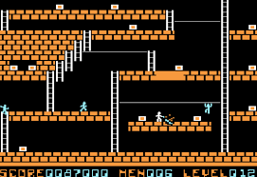Coins

Time: XX:XX

Apple: X

14

15

13

12

11

10

9

8

7

6

5

4

3

2

1

Shop

Settings

Exit

Continue

New Game