Securing AI Supply Chains via
Update Instability Analysis

Asmit Chatterjee
Department of Computer Science and Engineering
Manipal Institute of Technology, Bengaluru, India

Abstract—This work evaluates the security of machine learning model updates using CIFAR-10, with deployment validation under dataset shift on STL-10. Experiments are conducted using standard convolutional architectures and post-training fine-tuning. Modern AI supply chains increasingly rely on externally sourced model updates, yet existing validation mechanisms primarily depend on task accuracy, which fails to detect stealthy malicious updates. We define Adversarial Model Update Poisoning (AMUP) as malicious behaviour injected through post-training updates and introduce Update Instability Score (UIS), a metric that measures prediction sensitivity to small parameter perturbations. The objective is to detect malicious model updates prior to deployment without relying on accuracy degradation. We simulate benign and malicious updates and evaluate UIS across attack strength, perturbation magnitude, model architecture, ensemble updates, and dataset shift. Results show a 100 to 160 times separation between benign and poisoned updates with non-overlapping confidence intervals, even when accuracy remains unchanged. These findings demonstrate that update-level instability provides a reliable and deployable signal for securing AI supply chains.
Keywords— AI supply chain security, model update poisoning, adversarial machine learning, robustness, deployment validation

Introduction
Machine learning models are increasingly deployed through distributed AI supply chains, where models are trained, updated, and maintained by multiple stakeholders. In practical scenarios such as cloud-based inference services, federated model maintenance, or third-party fine-tuning pipelines, model updates are often received from external or semi-trusted sources before deployment. These updates are typically validated using limited test data and standard accuracy checks, after which they are integrated into production systems. Such workflows introduce a critical security risk, as malicious updates can be injected at the update stage without direct access to the original training data.
In these scenarios, existing validation mechanisms are insufficient. Accuracy-based evaluation assumes that malicious behaviour will manifest as a drop in overall performance; however, adversarial updates can be crafted to preserve global accuracy while embedding targeted or undesired behaviours. As a result, a poisoned update may pass all conventional checks and still compromise downstream systems. This limitation is especially problematic in deployment settings where updates must be
evaluated quickly, labels may be unavailable, and retraining from scratch is infeasible.
To address this gap, we study Adversarial Model Update Poisoning (AMUP) as a realistic threat model for AI supply chains. We propose Update Instability Score (UIS), a lightweight metric that evaluates the behavioural stability of a model update by measuring prediction sensitivity under small parameter perturbations. Unlike accuracy-based validation, UIS operates independently of task performance and can be applied prior to deployment. Through controlled experiments, ablation studies, and deployment-oriented evaluations, we demonstrate that UIS provides a reliable signal for detecting malicious updates in modern AI supply chains.

Related Work
Prior work on machine learning security has extensively studied data poisoning and backdoor attacks, where adversaries manipulate training data or embed triggers to induce targeted misclassification. These approaches typically assume access to the training pipeline and focus on detecting anomalous data patterns or trigger-based behaviours. While effective in certain settings, such methods do not directly address scenarios where the adversary operates at the model update stage, without modifying the original training data or introducing explicit triggers.
Recent studies have begun exploring machine learning supply-chain threats, including compromised pre-trained models, poisoned fine-tuning, and framework-level attacks. Detection techniques in this space often rely on task-level metrics such as accuracy degradation, attack success rate, or performance on specially constructed test inputs. However, several works have shown that malicious updates can preserve global accuracy while embedding targeted or subtle misbehaviour, allowing them to bypass conventional validation pipelines. This limitation highlights the need for defences that operate independently of task performance.
A smaller body of work has proposed robustness and stability-based metrics, such as gradient norms, loss sensitivity, or noise-induced prediction changes, to characterize model behaviour. While these methods provide useful insights, they often lack clear decision thresholds, exhibit high variance across architectures, or degrade under dataset shift. In contrast, our work focuses explicitly on update-level behavioural instability and introduces Update Instability Score (UIS) as a lightweight and statistically separable metric for detecting malicious model updates in realistic deployment settings.

Problem Statement and motivation
Existing AI model update validation pipelines suffer from three major limitations: (I) reliance on task-level accuracy for update verification, (ii) inability to detect stealthy update-only attacks that preserve global performance, and (iii) lack of robustness under architectural variation and dataset shift. These limitations allow adversarial model updates to bypass conventional checks and be deployed undetected in modern AI supply chains.
The objective of this work is to design a lightweight, deployment-ready validation mechanism that detects malicious model updates prior to deployment by analysing update-level behavioural instability, without requiring labelled data, retraining, or accuracy degradation.

System Architecture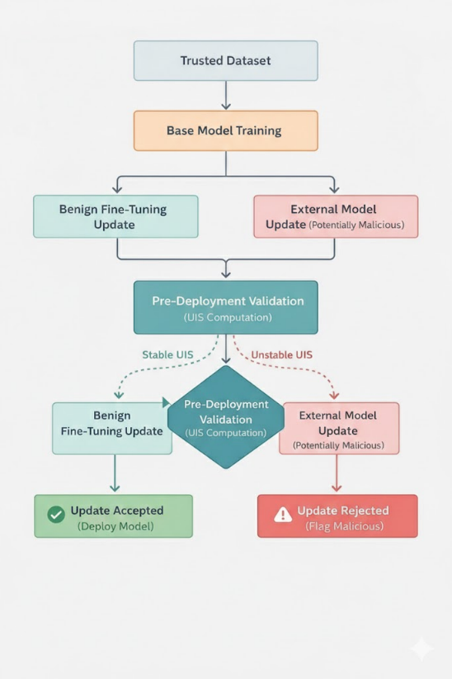
Fig 1. System architecture for pre-deployment validation of model updates using Update Instability Score (UIS).
The proposed system consists of a base model training stage, an update ingestion module, and a pre-deployment validation component. A trusted base model is first trained and subsequently receives either benign or externally sourced fine-tuning updates. Each incoming update is evaluated prior to deployment using the Update Instability Score (UIS), which measures prediction sensitivity under small parameter perturbations.
Based on the computed UIS, the system performs update validation by distinguishing stable benign updates from unstable malicious ones. Updates that exceed a predefined instability threshold are flagged and rejected, while stable updates are approved for deployment. This architecture is lightweight, model-agnostic, and can be integrated into existing AI supply-chain pipelines without modifying the training process or relying on task-level accuracy.

Methodology
The proposed methodology evaluates the security of AI model updates under adversarial conditions by analysing update-level behavioural stability. The approach simulates benign and malicious model updates and validates them prior to deployment using a lightweight instability metric.
A. Dataset Description and Experimental Setup
Experiments are conducted using the CIFAR-10 dataset, which consists of 60,000 labelled images across 10 classes. CIFAR-10 is used for training the base model as well as for generating benign and adversarial fine-tuning updates. To evaluate robustness under deployment conditions, additional validation is performed on the STL-10 dataset by resizing inputs to match the CIFAR-10 resolution.
All models are trained using the Adam optimizer with fixed learning rates in the range of 10⁻³ to 10⁻⁴, depending on the training stage. Experiments are executed on a single consumer-grade GPU. No external surveys or human annotations are used; all data is obtained from publicly available benchmark datasets and controlled experimental simulations.
TABLE I
DATASET DESCRIPTION
Property | Value
Primary dataset | CIFAR-10
Deployment dataset | STL-10
Number of classes | 10
Training samples | 50,000
Test samples | 10,000
Input resolution | 32 × 32
Task | Image classification
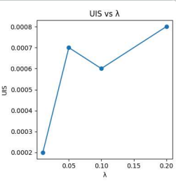
Fig 2. Effect of attack strength on Update Instability Score
B. Workflow
The overall workflow consists of three stages. First, a trusted base model is trained using standard supervised learning. Second, model updates are generated through either benign fine-tuning or adversarial model update poisoning, where malicious objectives are injected during post-training optimization. Third, each update is evaluated prior to deployment using the proposed Update Instability Score (UIS), enabling detection of unstable and potentially malicious updates. Additional analyses include attack-strength ablation, perturbation-magnitude ablation, ensemble-level validation, and dataset-shift evaluation. All results are aggregated across multiple random seeds to ensure statistical reliability.
C. Training and Optimization Configuration
All models are trained using standard supervised learning and fine-tuning procedures. A trusted base model is first trained on CIFAR-10, followed by either benign fine-tuning or adversarial model update poisoning. Optimization settings are kept consistent across experiments to ensure fair comparison between benign and malicious updates.
TABLE II
TRAINING AND OPTIMIZATION CONFIGURATION
Parameter | Value
Optimizer | Adam
Base model learning rate | 1e-3
Fine-tuning learning rate | 1e-4
Batch size | 128
Base training epochs | As per convergence
Fine-tuning epochs | 3–5
Loss function | Cross-entropy
Attack strength parameter (λ) | Varied (ablation study)
Perturbation magnitude (ε) | Small Gaussian noise
Hardware | Single GPU
Framework | Porch

Conclusion and Future Work
TABLE III
STATISTICAL SUMMARY OF UPDATE INSTABILITY SCORE (UIS)
Metric | Benign Updates | Poisoned Updates
Mean UIS | 0.00047 | 0.07867
Std. Deviation | 0.00015 | 0.00021
Std. Error | 0.00006 | 0.00012
95% Confidence Interval | ±0.00016 | ±0.00052
Minimum | 0.00031 | 0.07815
Maximum | 0.00062 | 0.07918

The statistical summary highlights a clear separation between benign and poisoned model updates. Benign updates consistently exhibit very low UIS values with minimal variance, indicating stable behavior under parameter perturbations. In contrast, poisoned updates produce significantly higher UIS values with tight confidence intervals, despite maintaining comparable classification accuracy. The non-overlapping 95% confidence intervals further confirm that UIS provides a reliable and statistically robust signal for distinguishing malicious updates from benign ones prior to deployment.

Limitations
The proposed evaluation focuses on update-level behavioral instability under controlled perturbations and simulated adversarial objectives. While strong separation is observed between benign and poisoned updates, detection performance may degrade for extremely weak attacks or unsuitable perturbation scales. Additionally, experiments are limited to image classification tasks and controlled update scenarios.

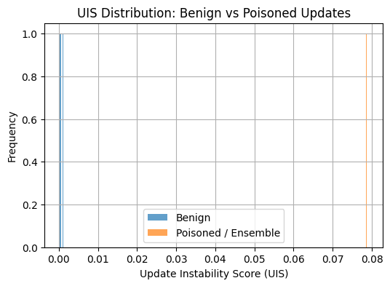
Figure 3. Distribution of Update Instability Score (UIS) for benign and adversarial model updates.
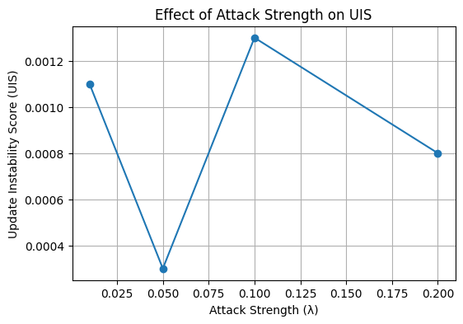
Figure 4. Effect of attack strength (λ) on Update Instability Score.
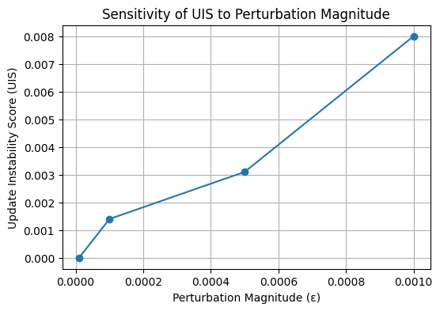
Figure 5.Sensitivity of Update Instability Score to perturbation magnitude (ε)
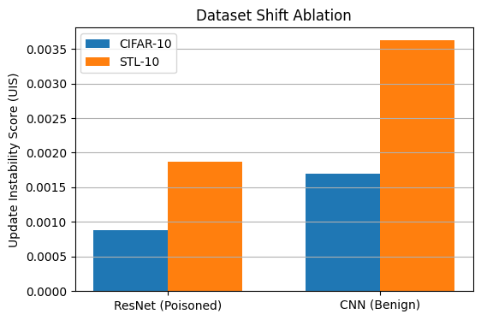
Figure 6. Update Instability Score evaluated under dataset shift from CIFAR-10 to STL-10.

Conclusion and Future Work
This work addresses a critical gap in AI supply-chain security by demonstrating that accuracy-based validation is insufficient for detecting stealthy adversarial model update poisoning. By introducing the Update Instability Score (UIS), we show that malicious updates can be reliably detected prior to deployment through update-level behavioral analysis, even when task performance remains unchanged. Extensive experiments across attack strengths, perturbation magnitudes, architectures, ensemble updates, and dataset shift validate the robustness and deploy ability of the proposed approach. Future work will focus on extending update-instability analysis to additional domains such as natural language processing, incorporating richer interpretability mechanisms, and evaluating the approach within larger, real-world AI supply-chain pipelines.

References
- [4] R. Salay, R. Queiroz, and K. Czarnecki, “Supply-Chain Attacks in Machine Learning Frameworks,” OpenReview, 2023.
- R. Salay, R. Queiroz, and K. Czarnecki, “Supply-Chain Attacks in Machine Learning Frameworks,” OpenReview, 2022.

