Tome of Friends? Tome of Guises? Something similar to that probably

Mini Project 1
Character Creator (D&D or other TTRPGs if possible)

The project aims to be (with polish, so probably not within the couple of weeks we have to complete this phase of the project) a character creation tool and library for TTRPG (Tabletop Role-Playing Game) characters.

Concept
This project will be a character creation tool for tabletop role-playing games such as dungeons and dragons. Ideally this program should be extensible to other game systems, if time permits.

Market and Sector
This project is in the entertainment sector and competing with other tabletop rpg tools such as roll20 or foundry. I believe that the ability to easily create and share character sheets and concepts in a wide variety of systems would be a useful addition to the space, and could be a viable product if planned well and given a lot of polish.
The way I would go about this is to approach independent TTRPG and homebrew creators for the ability to digitise their work rather than focusing on D&D fifth edition specifically (although the core system is creative commons so working with that is easy enough)

Required Features
- User can view a list of characters that they have created
- User can create a new character in the D&D 5e System
- User can view the character sheet for a character that they created

Optional Features
- User can update the character sheet of their characters (levelling up)
- User can create a new character in the Lancer System
- User can specify a custom system for use when creating new characters
Obviously not all of these features are feasible, but ideally all of the base features will be included, with some optional features if possible. Lancer was picked in this example because it has an existing open-source character creator and the data it uses is available on github.

API
I will be using the D&D fifth edition API (dnd5eapi.co) which is a fan-made API based on the Systems Reference Document provided by Wizards of the Coast under the Creative Commons license (CC-BY-4.0). Unfortunately this is only version 5.1 of the document, as 5.2, which is scheduled for release soon, is not yet available.

Application Design

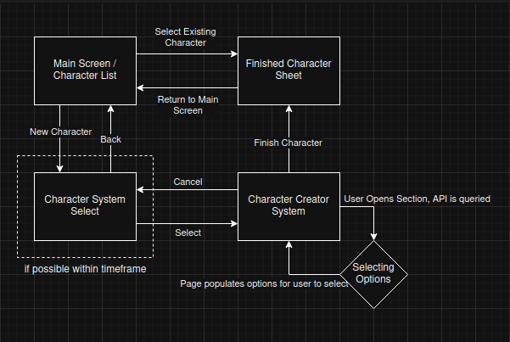
Layout Sketches
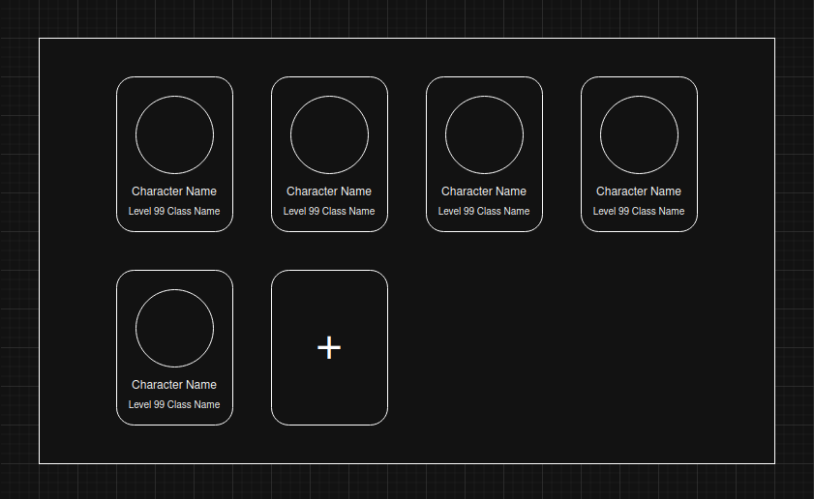
Main Page
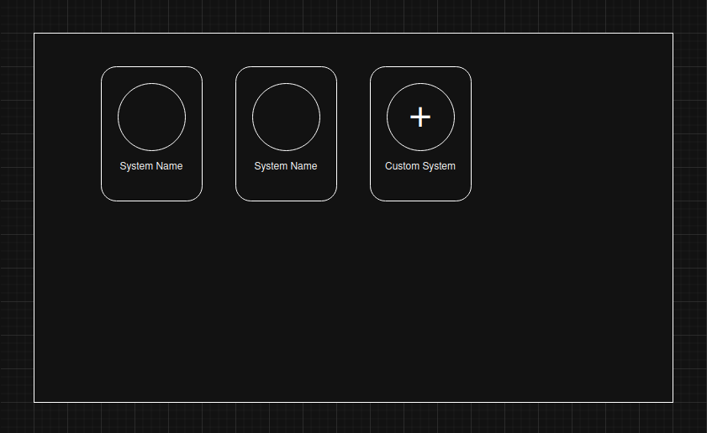
System Select
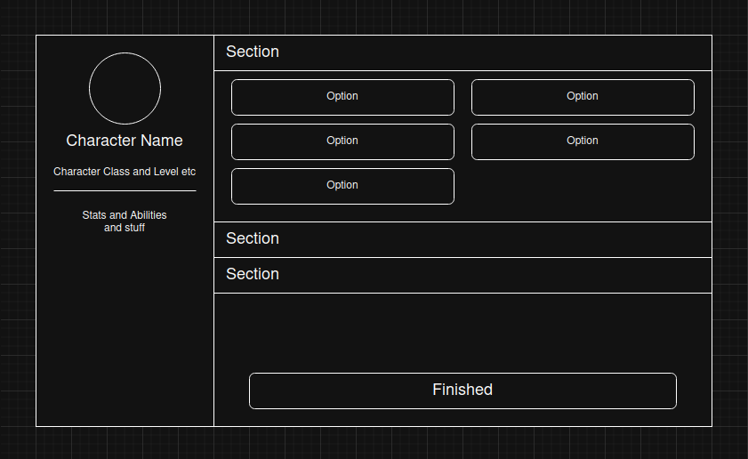
Character Creation
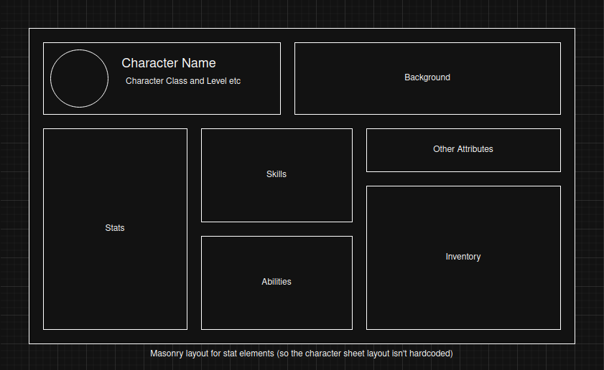
Finished Character Sheet

The Results
Do a demonstration here

What went well?
I really think that this application is pretty neat, it looks good (although I can’t really take full credit for that), the flow of the application is smooth, and it’s overall a good prototype or first effort towards this kind of project.

What went wrong?
The scope! Dungeons and Dragons is so ubiquitous in the tabletop RPG space and even in mainstream culture that sometimes you forget how incredibly complex it is. If for this project I focused only on creating a character creator for D&D I believe that the end result would have been better, but the focus on modularity meant that I was focusing too much on making things generic. Additionally, I fully understand why React is so popular, as every other step of this project I was document.createElement ing something new.

What would I do differently/How to expand
Rewrite in React, first of all. React would allow this app to be much easier to develop and additionally much more responsive. In terms of the plans discussed in the Market section above, waiting for D&D to release the SRD version 5.2 before progressing further with the system would be ideal, but implementing character creation processes for other systems and approaching their creators would be the way to start out.

