- Downloading the Corporate Database
The first step should be to download the Corporate Database from the ECET-296 website to a folder on your flash drive. You should probably create a folder named ECET296, and save the database to it. Right-click on the Corporate Database link on the course website and select “Save target as” from the popup menu. Select the ECET296 folder you created on your flash drive, and click OK.

Next, you must set Ultiboard to look in your ECET296 folder for the corporate database. Launch Ultiboard, then select “Options->Global Preferences” on the menubar. Select the “Paths” tab on the dialog box which appears:

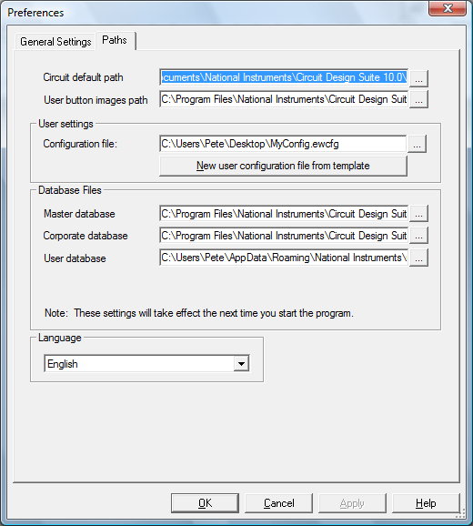

The Corporate Database path is still set to the default location. Click the little “…” button to the right of the default path (circled in red, above), then navigate to the folder in which you saved the Corporate Database file, and select the file named “CPComp_S.prj”.
Click “OK” to dismiss the file selection dialog, then click “Apply” and then “OK” to dismiss the Preferences dialog. Exit out of Ultiboard before going on to the next step.

- Tranferring The Design to Ultiboard

The Multisim schematic file for Project I is provided to you on the website, and is ready to be transferred to Ultiboard. Download the file (Coin24.ewprj), then open it in Multisim. On the Multisim menu bar, select Transfer->Transfer to Ultiboard. Save this file to the folder containing your schematic

Ultiboard 10 should launch automatically, and the “Default Track Width and Clearance” dialog should appear:

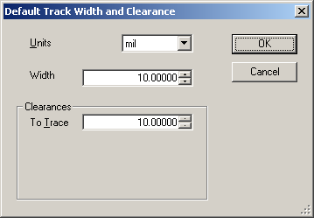

Change the width to 20 mils, and the clearance to 31 mils, and click OK to dismiss the dialog. An “Import Netlist Action Selection” dialog should appear. Simply click OK to dismiss it.

A new PCB design will appear, with an empty board outline (a yellow rectangle), with all of the parts placed above the board outline:

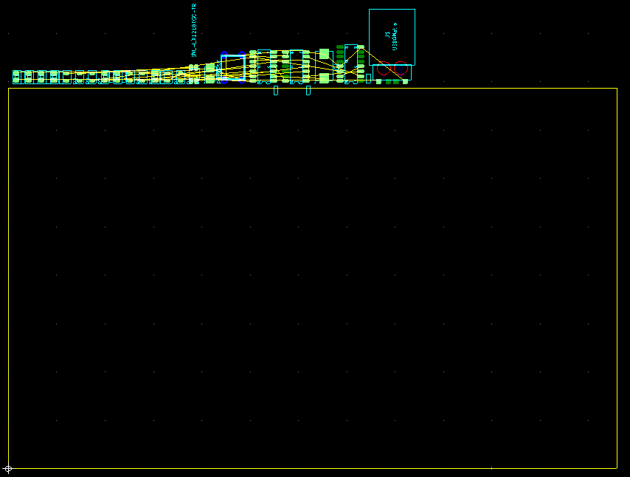

2. Changing the Board Size

The finished board should measure approximately 2.628 inches by 1.229 inches. The next step is to modify the Board Outline (the yellow rectangle) to that size. You will need to select the Board Outline, which is on the Board Outline layer. Open the “Design Toolbox” pane (if it is not already open) by selecting “View” on the menubar and making sure “Design Toolbox” is checked. Then select the “Layers” tab of the design toolbox, and double-click on the Board Outline layer. It will be highlighted in red:

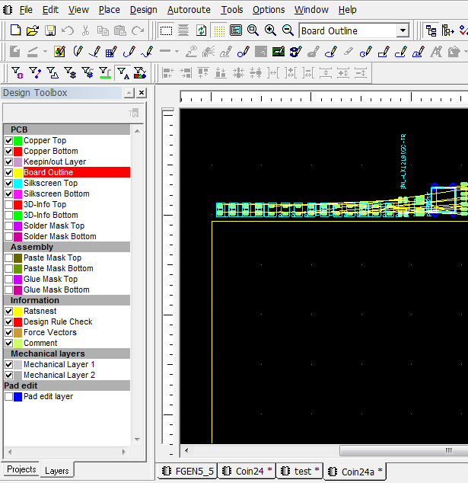

Now, set the selection filters so only selection of “Other Objects” is enabled. The “Other Objects” button is circled above, make sure it is pressed and the other selection filter buttons are not.

Doubleclick on the yellow rectangle. This launches a Rectangle Properties dialog. On the Rectangle tab, set the Width and Height to 2628 mils (2.628 inch) and 1229 mils (1.229 inch) respectively:

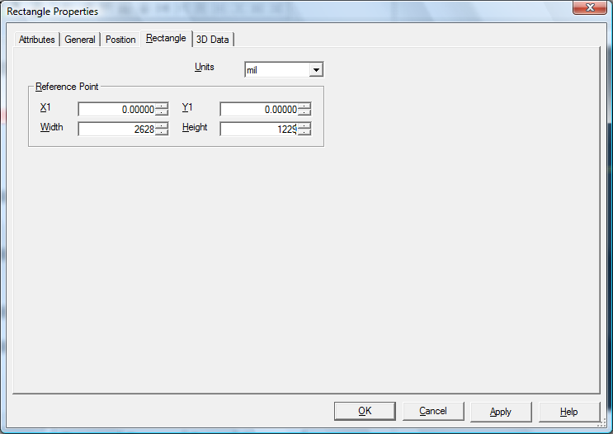

Click OK to dismiss the dialog. Notice that the board outline is much smaller.

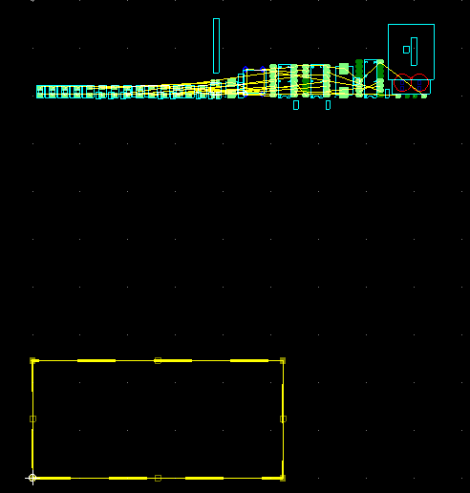

Now, disable selection of “other objects” by clicking on the “other objects” button, enable selection of parts by clicking the Parts button (circled in red in the following figure), and select the “Copper Top” layer in the Design Toolbox:

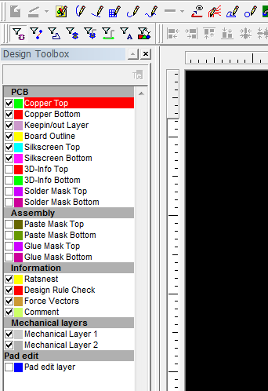

On the Menubar, select Edit->Select All. This selects all the parts. Drag them until they are conveniently just above the board outline, as shown below:

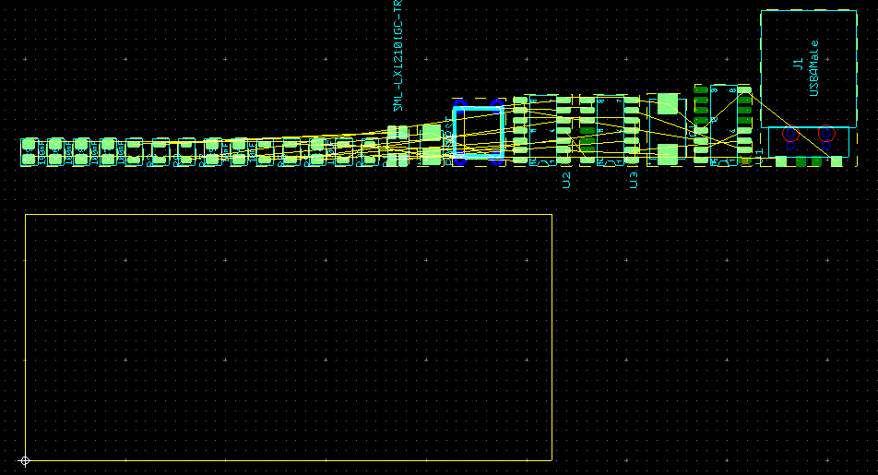

3. Ultiboard Configuration

Now it’s time to set up Ultiboard. On the menubar select Options -> General Preferences, then select the “General Settings” tab. Make sure it matches the settings shown below:

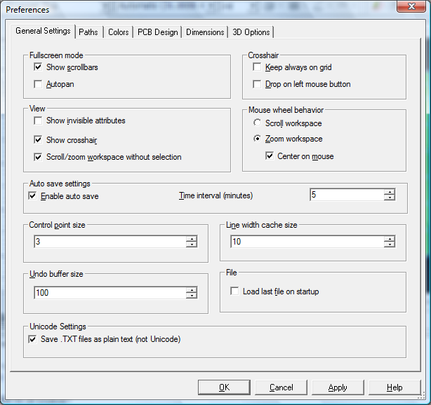

Then select the “Paths” tab. Set the circuit default path as you did for Multisim, and create your configuration file as you did for Multisim. Set the path for your User database to point to the same folder that you pointed Multisim to, then go on to the “PCB Design” tab. Make all settings match those shown below:

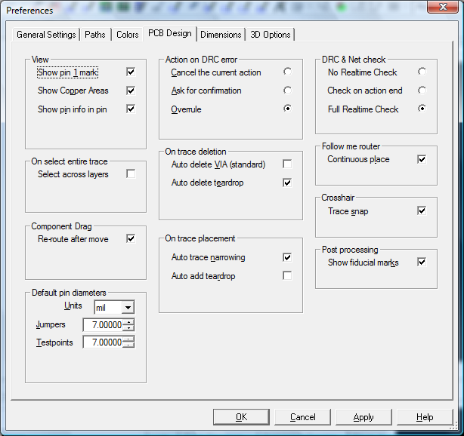

Then click OK to dismiss the dialog.

Select Options -> PCB Properties on the menubar, and go to the “Grid And Units” tab. Make it look as shown:

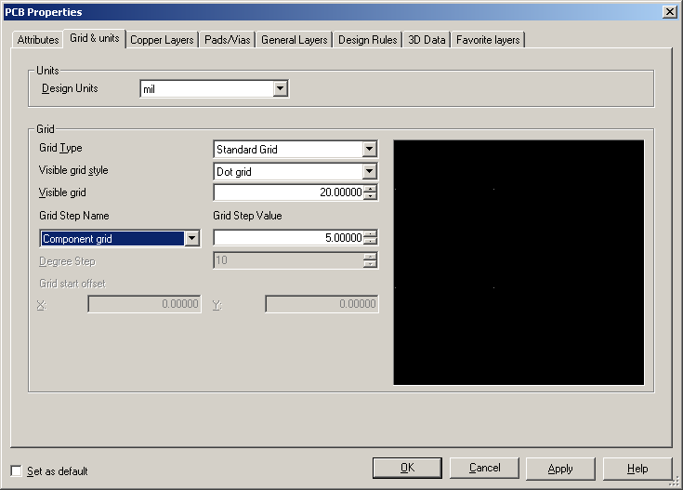

Then set the Copper Grid, Via Grid, and SMD Grid each to 5 mils. Click “Apply”, then select the “Copper Layers” tab. Make sure all settings on this tab are as shown:

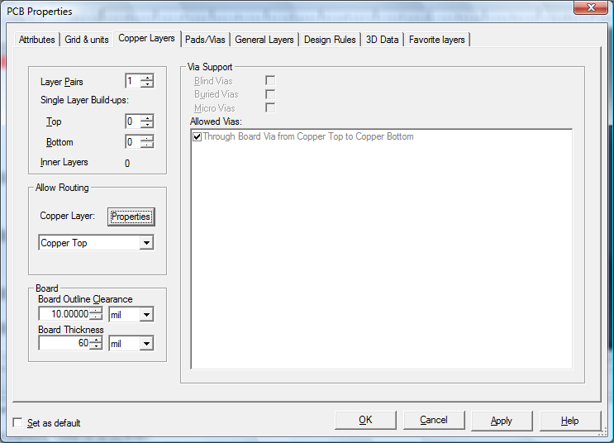

Go on to the “Pads/Vias” tab. Modify the settings as shown (this is rather important):

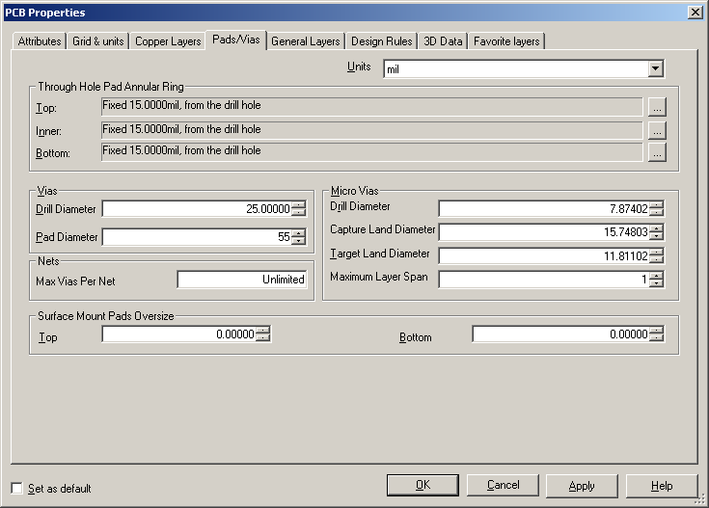

Next, go to the “Design Rules” tab. Modify the settings as shown. BE SURE TO CHECK THE “Use multiple clearances” CHECKBOX:
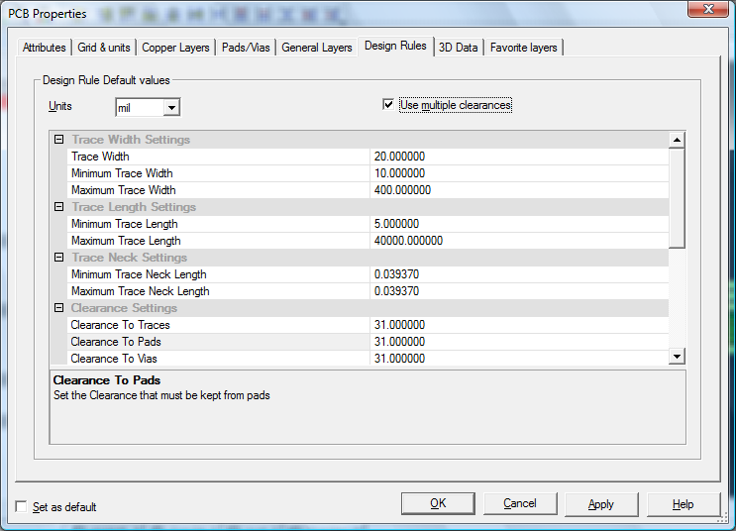

Scroll down to set the rest of the design rules as shown below:
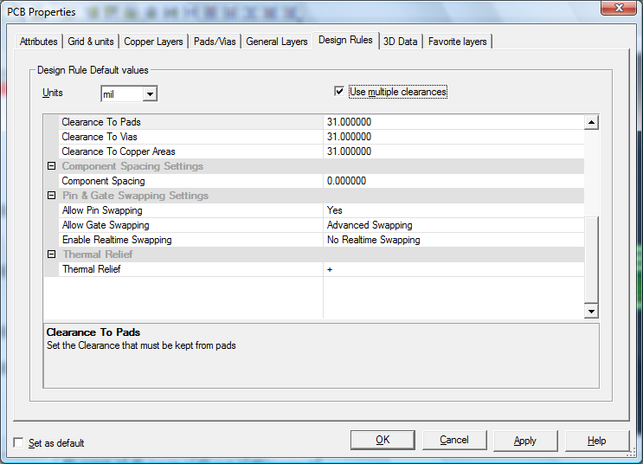

Be sure that “Use Multiple Clearances” is checked, then click “OK”

Note: When you set the “Clearance to Traces” parameter to 32.000, you made the DEFAULT clearance between neighboring traces to 32 mils. This means that the edge of one trace cannot be closer to another trace than .032 inch. This value was chosen as the default because of the way PCBs are fabricated in the IPFW lab. Starting with a blank sheet of FR4 fiberglass with copper foil laminated to both sides, copper is removed by a CNC milling machine to leave traces which are electrically isolated from all other traces and from the power or ground plane. The preferred milling tool is a 31-mil diameter endmill. Using this tool wherever possible speeds the process (it can cut faster than smaller-diameter tools) and reduces cost (smaller tools are more expensive, more prone to breakage, and wear out faster).

ANOTHER IMPORTANT REASON to make the default clearance 32 mils instead of a smaller value: It makes soldering easier. Soldering to a pad which is very close to a trace must be done with great care to avoid inadvertently shorting the pad to the trace with a “solder bridge.” Making the clearance as large as possible (32 mils is plenty) will make this task easier.

THIS DOES NOT MEAN THAT TRACES CANNOT BE CLOSER TO EACH OTHER THAN 32 MILS! The default clearance can be overridden for individual traces, and even for segments of traces. You WILL need to override clearances within your design, but setting the default to 32 mils helps insure that the preferred tool is used wherever possible.

Similarly, you set the default clearances to Vias (via to via, via to trace, via to pad, via to copper area), to Pads (pad to pad, pad to trace, pad to via, pad to area), and to Areas (The Power Plane and Ground Plane are copper areas, so this sets the minimum clearance between each of the planes and Pads, Traces, and Vias).

4. Power and Ground Planes
Most of the parts you will be using are surface mount parts and will be attached to the Copper Top layer. Whereas through hole parts have pins which extend through the pad holes from the top of the board to the bottom and are soldered on the bottom, the interconnection traces will be routed on the Copper Top layer wherever possible. The Copper Bottom layer will be used primarily as a “ground plane”. Ideally this would mean that the bottom would simply be a sheet of copper with vias connecting to any grounded component pins on the top layer. In reality there will be some traces on the bottom, but most of the bottom copper will be ground. This provides a good, low impedance ground, provides a degree of shielding for EMI and EMC, and simplifies routing of interconnect traces.

On the menu bar, select Place->Powerplane. Make the settings on the dialog match those shown below:

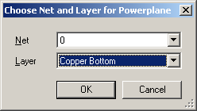

This fills in the bottom with copper, and connects it to net 0 (ground). Click OK to dismiss the dialog, and notice that the bottom layer fills in:

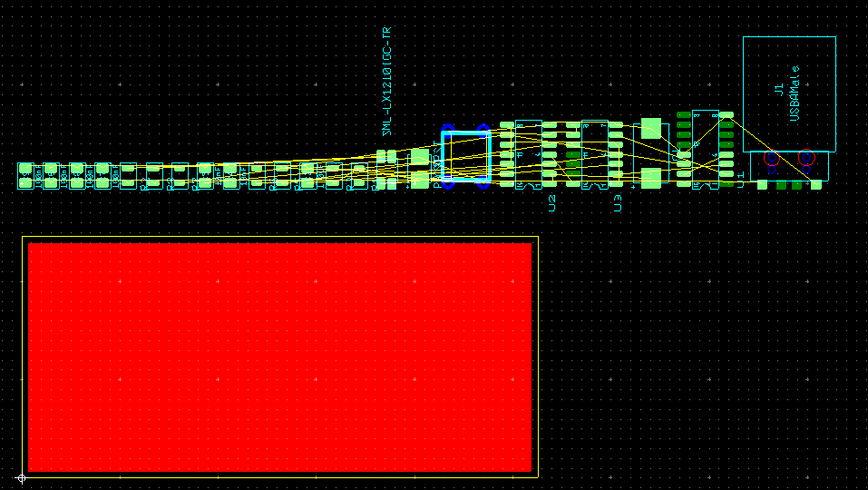

Thos portions of the top layer which are not used as traces will be used as a power plane, connect to VDD. Again, this provides low-impedance power distribution and shielding, and simplifies the routing of interconnects. Again select Place->Powerplane on the menubar, and make the settings shown:

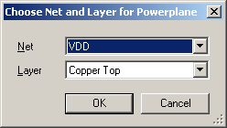

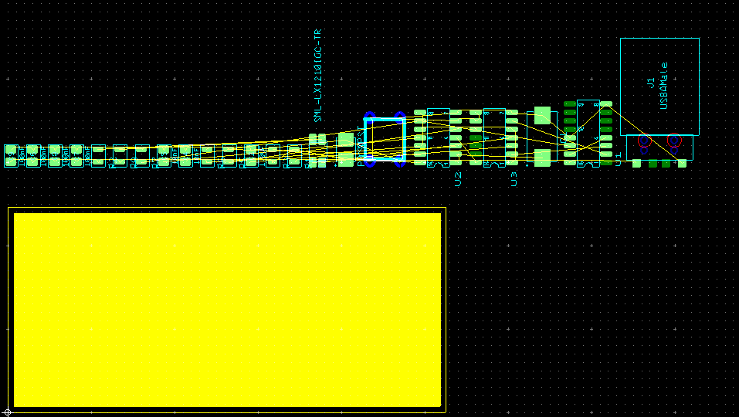

5. Placing Parts
Now you’re ready to start placing parts and routing interconnections. Begin with the one-shot, which means placing the LM556 (U2) and several of the resistors and capacitors. Before placing anything, hide the bottom-layer copper. Find Copper Bottom on the Layers tab of the design toolbox, and make sure it is unchecked. Find U2, the LM556, and drag and rotate it to the position shown on the reference layout:

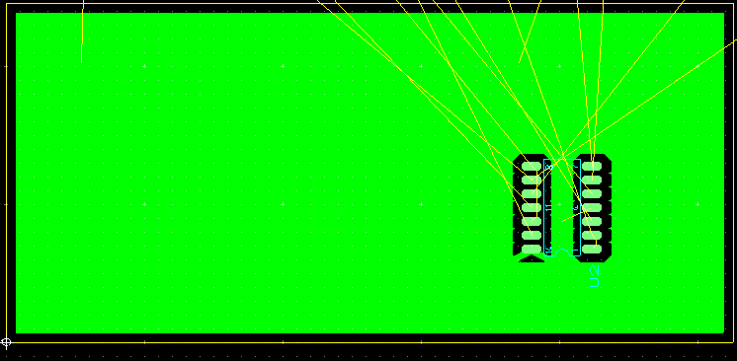

Notice that pin 14 was automatically connected to the top-layer copper:

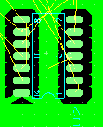

If pin 13 were further from pin 14, a copper x would appear through pin 14. This is called a “thermal relief”. If Pin 14 were merely soldered to a solid sheet of copper, the entire surrounding area would have to be heated to the melting point of the solder. By making the connection through the X, the thermal conductivity between the pad and the rest of the power plane is reduced, making it easier to heat the pad. The X shape is only one of several, and is not always the best.

Zoom in on pin 14, and notice that it is labeled with its own pin name and the name of the net it connects to:

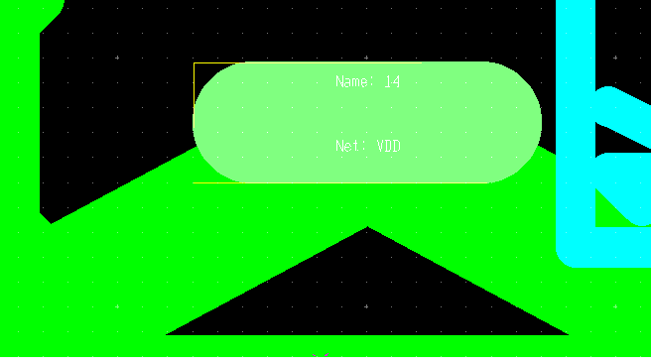

Enable selection of surface-mount pads, and select pin 14. Right click, and select “Properties” from the popup menu. Select the “Thermal Releif” tab, and note the different thermal relief shapes you may choose from. For this instance, the dash-shaped relief probably makes the most sense. Select it:

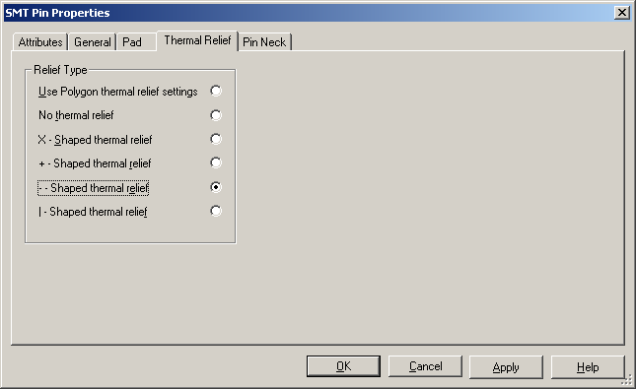

and click OK:

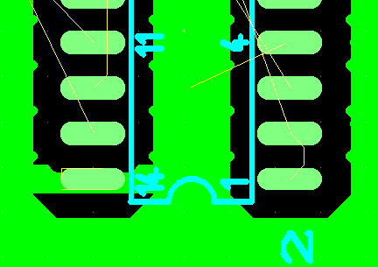

When you place U2, you dragged some yellow and brown lines along with it. The brown lines are called “force vectors”. They are supposed to be a helpful guide in placing the parts, but are not really very useful. Find “Force Vectors” on the Layers tab of the design toolbox, and uncheck it to hide the force vectors.

The yellow lines are called “ratlines”, and are very useful. There is a yellow ratline between every pair of pins which must be wired together. As you route traces to replace the ratlines, they disappear.

Referring to the schematic, R1 and R3 connect directly to U2. Select them and drag them to the vicinity of U2:

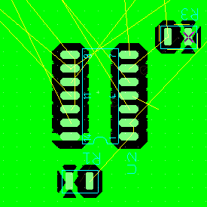

Also, drag C1 and C2 close to U2:

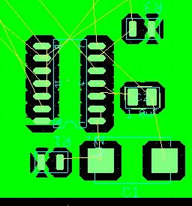
notice that, because of the placement and rotation of C1 and C2 relative to U2, the ratlines connecting the two capacitors to U2 do not cross each other, or any other ratlines. You may need to rotate one or both of the capacitors 180 degrees (NEVER, NEVER FLIP A PART IN ULTIBOARD!) to achieve this. Traces on the same side of the board (the top in this case) cannot cross each other, so parts should be placed in such a way that crossing ratlines are minimized. It’s also best that ratlines don’t cross an IC package.

6. Routing Traces
Now try routing a trace. Notice the ratlines between pins 1 and 2 of U2. Double click the Copper Top layer in the design toolbox, then click the “Follow Me” button shown below:

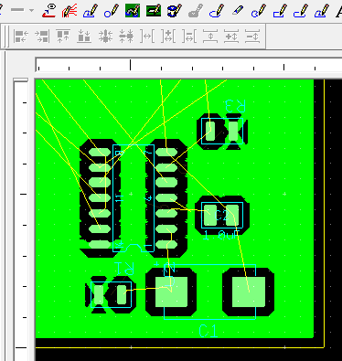
Then place the cursor on pin 1 of U2. Click to start a trace:

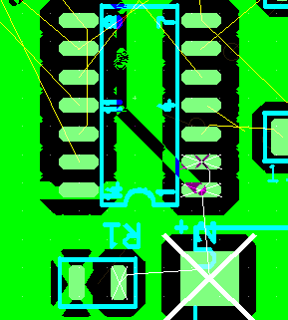

Each of the pads which are connected to the same net as U2 Pin1 are marked with an X. Move the cursor to Pin 2. Click on Pin 2 to connect the trace, then press the “esc” key to end the trace. Begin another trace on Pin 1, this time connecting to C1. Click on the C1 pad indicated by the X (only click once!), then continue to R1. Click on the R1 pad, then press “esc”.

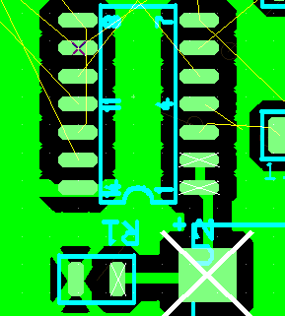

7. Connecting To The Ground Plane
The right-hand pad of C2 must be connected to the ground plane (Net 0),

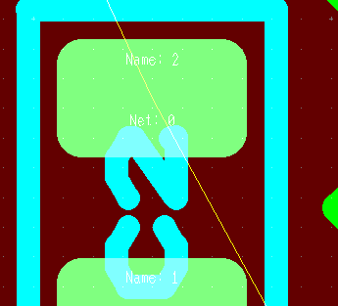
but the power plane is on the opposite side of the board. To make the connection, we must add a via. A via is a small hole drilled through the board, in the center of a small ring of copper on the top layer and an identical ring on the bottom layer. The copper rings are called “annular rings”. Ideally, the inside of the hole would be plated with copper to electrically connect the two annular rings. This is called a plated-through hole, but unfortunately we do not have the equipment to plate the hole. The via includes both annular rings and hole (plated or not). A via is identical in structure to a through-hole pad.

Before placing the via, make the copper bottom visible by clicking on the checkbox next to it (on the Layers tab of the design toolbox) once or twice, so there is a dim checkmark in the box. You may place a via by selecting Place-> Via on the menubar, or by clicking the “place via” button which is circled below:

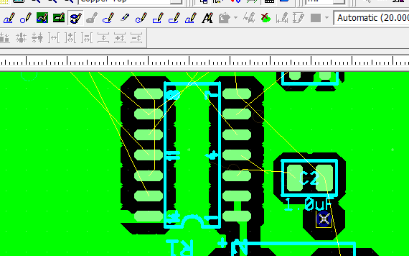

Click the button or use the menubar, and place the via near C2. The dialog shown below should appear:

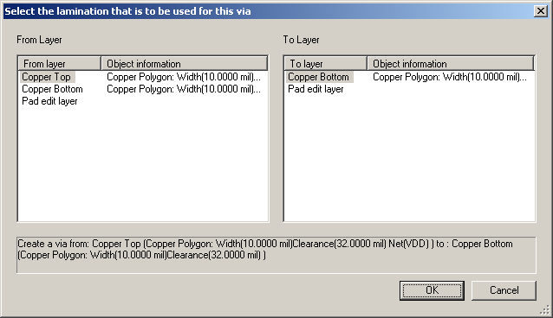

As shown, select Copper Top as the From layer, and Copper Bottom as the To layer, and click OK:

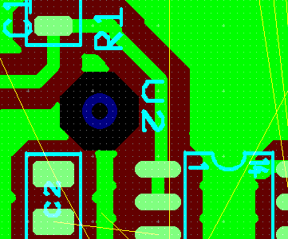

Enable selection of vias:

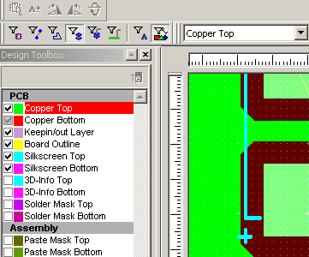

And select the via. Double click on it to launch the Properties dialog, and select the Via tab:

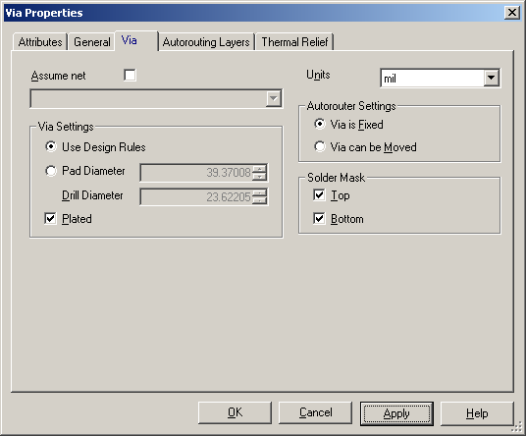

Click the “Assume Net” checkbox, and select Net 0. This tells the via that it will be connected to Net 0:

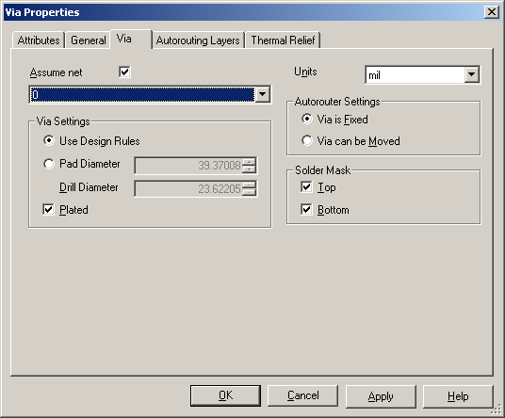

Click OK to dismiss the dialog, and see what happens to the via:

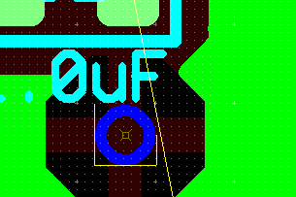
The via has turned bright blue, indicating that it is connected to a net. Also, a thermal relief has appeared, connect the via’s bottom annular ring to the ground plane. The top annular ring still needs to be connected to C2. Do this by routing a trace as shown:

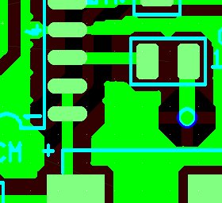

8. Adjusting Clearances
After connecting C2 to U2, pin 3, notice that the segment of the trace which goes to pin 3 of U2 is very narrow:

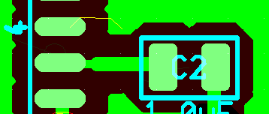

Now enable trace selection, and select the narrow segment. Double click on it to show its properties:

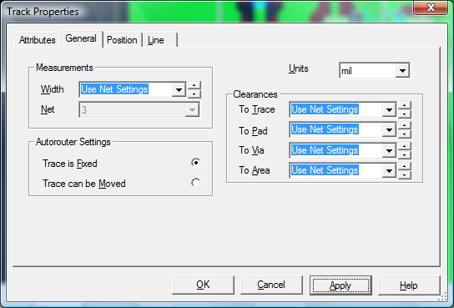

The Width property says “Use Net Settings”, and the default trace width is 31 mils. However, you selected “Auto Trace Narrowing” when configuring Ultiboard, so whenever a trace is routed close to another entity (trace, pad, copper area or via) it is automatically narrowed to keep the clearance to that entity within the design rules. In this case, the trace segment passes very close to Pins 2 and 4 of U2, and is automatically narrowed so its edge is at least 32 mils (the default clearance from a trace to a pd) from those pins. To avoid this trace narrowing, while the narrow segment is selected change its clearance “To Pad” to 21 mils (be sure you click the “Apply” button):

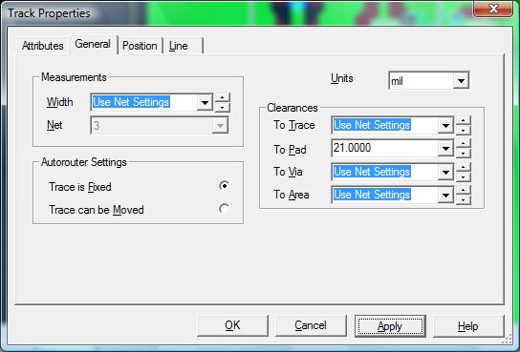

Then dismiss the dialog, and look at the result:

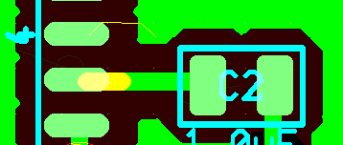

Obviously, it made no sense for the clearance to nearby pads to be 32 mils, because the pads themselves are only about 26 mils apart. Make this type of local adjustment to the trace clearances wherever a trace is automatically narrowed unnecessarily, but leave the trace clearances at the default value everywhere else.

Now rout the trace from R3 to U2, pin 6. Note that it is automatically narrowed:

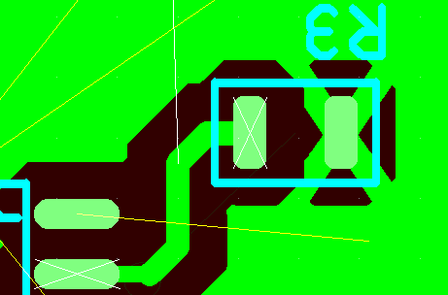

Try fixing this by selecting the narrow segment, and changing its “To Pad” clearance to 21 mils:

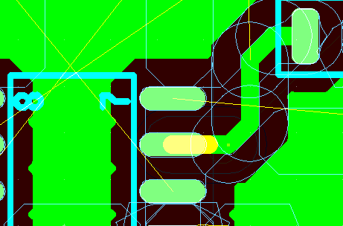

Notice the ratline between U2, Pin 4 and the power plane. Pin 4 should be connected to VDD, as Pin 14 is, but this did not happen automatically. The reason is that the power plane, which is a copper area, has a default clearance to any pad of 31 mils, but the pads are only 25 mils from each other. The power lane cannot reach Pin 4 while maintaining a 31-mil minimum clearance from pads 3 and 5. Select the power plane (enable only Copper Area selection, then click somewhere within the power plane), then double-click and select the “General” tab. Change the “To Pad” value to 21 mils:

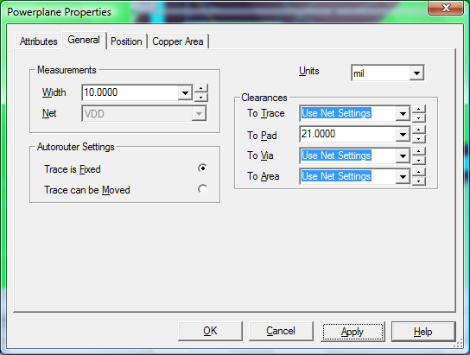

The power plane connects to pin 2. Select the pad (pin 2), and change its thermal relief to the same as pin 14:

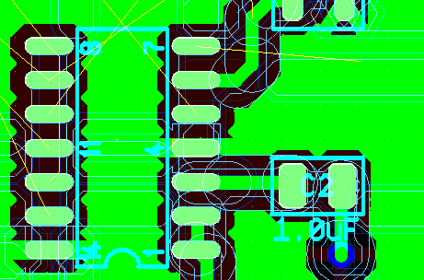

9. Removing Copper Islands
Notice the ratline connecting U2, Pin 12 to U2, Pin 8. Route a trace as shown:
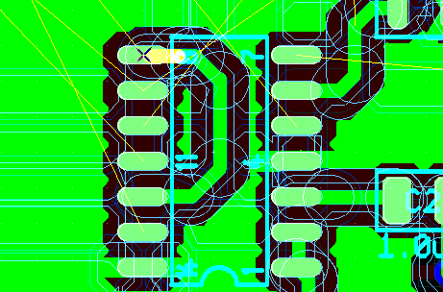

Notice the island of copper, not connected to anything, between the new trace and the pads. This will not be part of the power plane, because it is completely isolated. It would not do any harm to leave it there, but it might slow the milling process because the milling software thinks it has to mill out exactly that shape. In face, the exact shape does not matter, and the island may be removed entirely. This may be done manually by going to the Ultiboard menubar and selecting Edit->Copper Delete->Copper Island. Do this, and then place the selection cursor (the arrow, not the “place” cursor) on the copper island and selecting it:

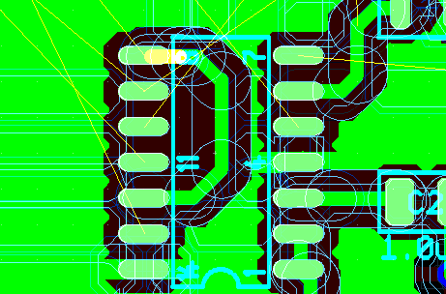

If you choose to delete copper islands manually, you must select Edit->Copper Delete->Copper Island, and then manually identify and select each island.

If you would like to try removing copper islands automatically, click “Edit->Undo Remove copper islands” on the menubar. The island should reappear. Now, enable selection of copper areas and disable all other selections. Place the cursor anywhere on the powerplane (not on a trace), and click to select. Double click to display the properties dialog, and select the “Copper Area” tab:

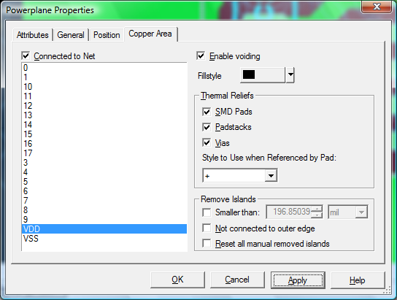

Notice that the dialog clearly shows that this copper area is connected to net “VDD”. Now check the first two “Remove Islands” checkboxes, and make the “smaller than” value 200 mils:

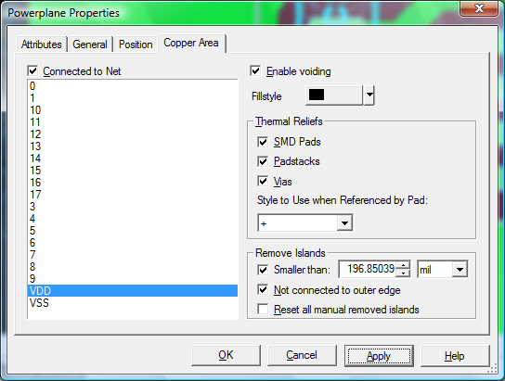

Note that the island disappears. As long as the powerplane properties are set in this way, islands should disappear as they are created.

10. Clearing a Design Rule Violation
You may continue placing parts and routing traces as shown on the reference layout. At some point, it is very likely that you will route a trace and will encounter a design rule violation such as the one shown below:

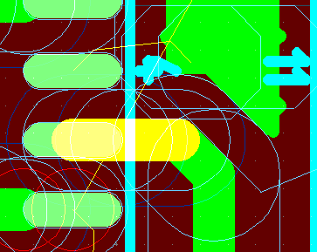
The blue circles and ovals, which appear if you select “View” on the menubar and check “Clearances”, are outlines of the clearance areas around the various entities (pads, traces, etc.) These can be helpful in identifying the cause of a violation.

The violation(s) are indicated by the red circles. Also, if you have the spreadsheet view turned on (you should have it turned on. Select “View” on the menubar and make sure “Spreadsheet View” is checked), the “DRC” tab at the bottom of the screen will be red. Select the “DRC” tab, and you will see a list of design rule violations. If you click on one of them, it will move to the center of the screen.

These particular violations were detected because the new trace is closer to the trace connect to the nearby pin than the trace to trace clearance allowed. For some reason, it was not automatically narrowed, so it must be dealt with manually. If you encounter something like this, you may manually narrow the offending trace segment or you may adjust the trace to trace clearances. To manually narrow the segment, select it and double-click to display its properties. On the General tab, change the Width property to make the trace narrower. Click “Apply”, then “OK”, and then select “Design->Netlist and DRC Check” on the menubar. If the red circles disappear, the violation has been cleared.

10. Moving Traces to the Copper Bottom
At some point you will need to route a portion of a trace on the bottom of the board. As you may know, this should be minimized because of grounding considerations (the ground plane should be as nearly as possible an unbroken sheet of copper), but it cannot usually be avoided altogether. Here is one easy way to do it. As shown below, a tace must be routed from R7 to U1 pin 14, and the Reference Layout shows that a portion of the trace must be routed on the bottom to avoid touching the trace from R5 to R6. First, route the trace from R7 to U1 on the copper top, following the Reference Layout except that the trace is entirely on the top layer:

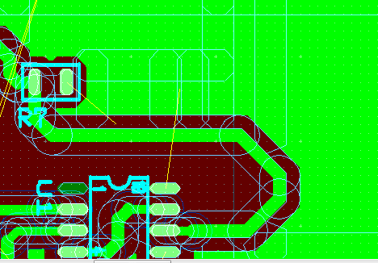

Next, referring to the Reference Layout, identify the segments which must be moved to the copper bottom. Select them:

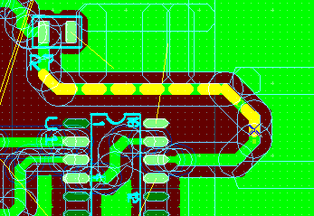

Place the cursor on one of the highlighted segments, and doubleclick. When the Properties dialog appears, select the Position tab:

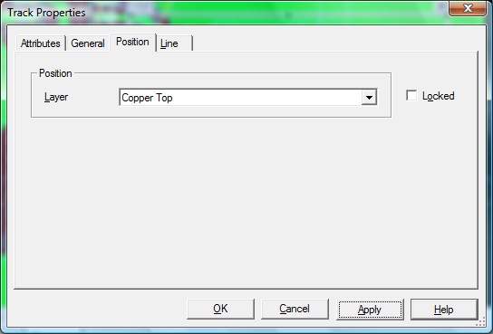

Change the Layer property from Copper Top to Copper Bottom, then click “Apply” and “OK”. Note the result:

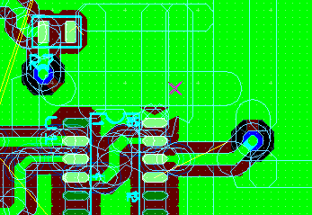

The selected trace segments were moved to the Copper Bottom layer, and vias were automatically generated to connect the top layer segments to the bottom layer segments. You should now select one of the top layer segments and look at the General tab of its Properties dialog. It shows the net which this trace represents, in this case Net 8 (your net numbers may be different):

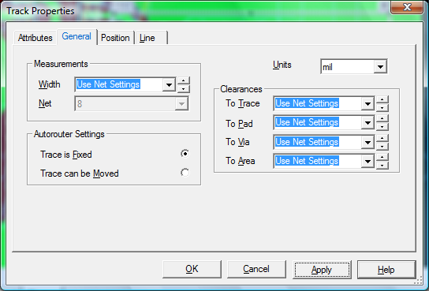

Now disable trace selection, and enable via selection. Select one of the vias this trace connects to, and double-click to display its properties. Select the “Via” tab, and notice that the “Assume Net” checkbox is not checked. Check it, and then select the net the trace represents (again, net 8 in this case):

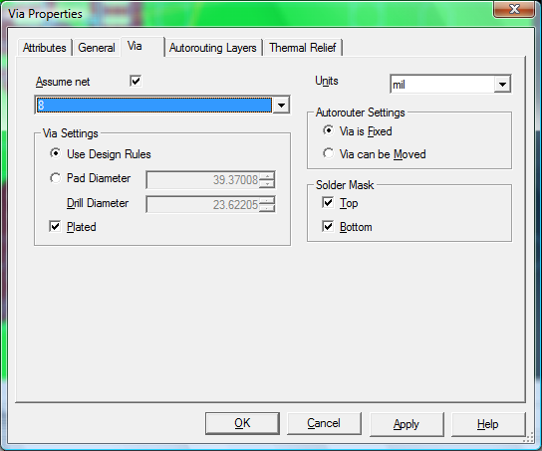

followed by “OK” Do the same with the other via. Vias should always explicitly “Assume” the net to which they are connected.

You should now know most of what you need to know to complete the layout of the Electronic Coin Flipper, using the Reference Layout as a guide. If you get stuck or if there is something you don’t understand, don’t hesitate to ask the instructor.

When your layout is complete and has been approved by the instructor, you will need to prepare it for fabrication by performing final DRC and connectivity checks, exporting a set of “Gerber” files, and viewing the Gerber files to make sure they match your layout. These steps will be covered in another tutorial.

