Project Report

For the AG44 courses at UTBM, I had to write a little software. A given adjacency matrix stored in a file represent the places in a video-game and the links between them. From this input, we had to calculate several informations about this graph.

Answer to questions
The classical problem of graph theory raised with the list of the different game levels problem is a strongly-connected components finding problem. Indeed, a level is defined as the set of places each of which is accessible from all other.
Description
To do what was required, I chose the C language because it allows me the ability to manage memory as I want (and because it is my favorite programming language). It starts by reading the adjacency matrix contained in the file called "input.data". Then he will search levels. From this result, he calculates the reduced matrix N. From this one, it will compute the longest path between the level containing the first place and the one containing the last place. Finally, he realizes a bonus picture of the graph, stored in the file "graph.png".

Choice of data structure
To achieve this, I decided to store the two Matrices (A and N) in two-dimensional dynamically allocated arrays. This is in my opinion the best solution, because data are arranged in a matricial way. This makes them very easy to access, logically, and all the allocated memory is used.
To perform the required algorithms, I had to use some first-in first-out lists. I decided to store them in dynamically allocated arrays, these are set to the size of a matrix (A or N, as appropriate). A range of hand-made functions allow me to easily manage my arrays (add, pop, retrieve, count, ...). I preferred this option to the use of chained lists, although there was some memory allocated which may remain not used, it remains insignificant in my opinion compared to the time and resources necessary for the repetitive memory allocations and frees process.

Algorithms
My implementation of the project uses two algorithms related to graphs.
The first is used to find the strongly connected components. I chose a first place which I apply a BFS algorithm, and I record all the places through which I went. Then I do it a second time, starting from the same point, but after reversing the direction of the edges, and recording the places in a second list. The intersection of the two lists gives me all the places strongly connected to the first one. Then I start this operation again as long as there are places which do not belong to any level.
The second one is a Bellman-Ford algorithm. It can be used, because I want ton compute a path starting from just one point, and because there is absolutely no loop : indeed, if there were any loop, then those levels would be strongly connected and are supposed to made a single one. But instead of looking at each steps for the smallest number, I search the biggest one, to get the longest path between the first and the last level.
Results
Here are the output of the software obtained using the matrix given on the subject of the project.
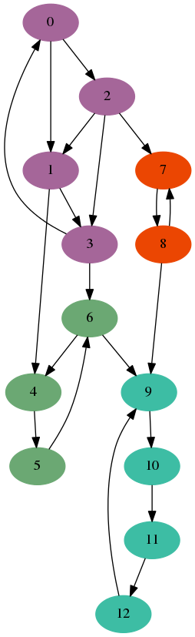
========
Levels
========
--> Place 0 is in the Level n° 0
--> Place 1 is in the Level n° 0
--> Place 2 is in the Level n° 0
--> Place 3 is in the Level n° 0
--> Place 4 is in the Level n° 1
--> Place 5 is in the Level n° 1
--> Place 6 is in the Level n° 1
--> Place 7 is in the Level n° 2
--> Place 8 is in the Level n° 2
--> Place 9 is in the Level n° 3
--> Place 10 is in the Level n° 3
--> Place 11 is in the Level n° 3
--> Place 12 is in the Level n° 3

=================
Reduced Matrix
=================
6 2 1 0
0 3 0 1
0 0 2 1
0 0 0 4

==================
Longest path
================
--> { 0 ; 1 ; 3 }

