Project 2 Report

For the AG44 courses at UTBM, I had to write a little software, which had to compute the shortest Path between two points in a ski resort.

Answer to questions
The classical problem of graph theory raised by Mr Touchousse is shortest path finding problem, in a weighted graph. Indeed, each points in the ski resort is a Vertex, each route (pistes, lifts, bus, …) represent an edge between two Vertices and we assign for each route a weight which is the time required to run through it.
The second problem is for its part a graph traversal problem.
Description
To do what was required, I chose the JavaScript programming language because it is easily linkable to a HTML/CSS interface, which allow me to easily build a GUI that represent the ski resort. Without noticing the interface management functions, the program starts by reading data in the file called “data.txt”. It store the informations about the vertices and the edges in two separated data structure.
Then, if the user has selected only the starting point, it will apply an algorithm to search and display all the reachable vertices. And if both departure and arrival points are chosen, the program will apply the same algorithm, but this time to search and display the shortest path between the two vertices. The user has also the ability to select the type of route he wants to take.

Choice of data structure
To achieve this, I decided to store the informations about the vertices and the edges in two multidimensional dynamic arrays, just like they are in the file. It's one of the best solution using Javascript to store such data, because this language does not allow a more refined memory management solution.
To perform the required algorithms, I had to use some first-in first-out lists. I decided to store them also in dynamic arrays, and I used some build-in function to manage them : «myArray.unshift(value)» to add data at the beginning of the list and «value = myArray.pop()» to get the value at the end of the list out.

Algorithms
My implementation of the project uses only one algorithms related to graphs, which compute the shortest path between the starting point and all the other points.
This algorithm is a kind of Bellman-Ford algorithm. It can be used, because I want to compute a path starting from just one point, and because there is absolutely no negative cycle : indeed, to go through a route, you take a positive amount of time.
At the beginning, the algorithm put the starting point into the waiting list. Then it will apply the following instructions until there is no vertex left in the list. The algorithm pop out a vertex from the list. It looks for all the vertices he can directly access, and update them with the value of (the actual vertex + weight of the edge) if it is smaller than it's own value. All the updated vertex are added to the list, and it loop.
This allow the program to execute one time a single algorithm for both problems. To find out which points are accessible, you just have to look those which have been updated at least one time ; and to know the path to a specific point, we start from the arrival, and it goes back to the start (if this point is reachable).
Results
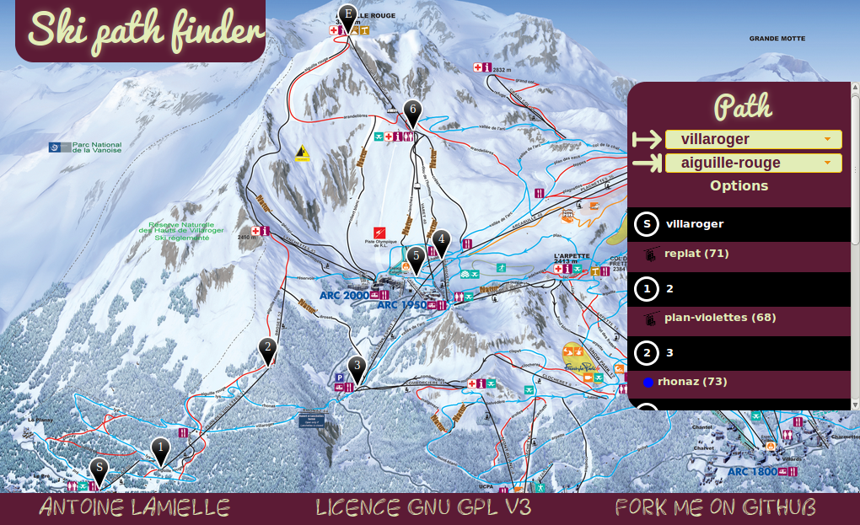
Here is a screen-shot of the software's output

