**FMO-I (a**)

PAKISTAN POST OFFICE POSTAL CONFIRMATION



No.

Oblong M.O. and month stamp of issue Date.

2025-04-25

Amount in figures

Rs. Ps.

Issue for Rs.

32



M.O. Clerk **Issuing Postmaster**



- - - - - - - - - - - - - - - - - - - - - - - - - - - - - - - - - - - - - - - - - - - - - - - - - - - - - - - - -

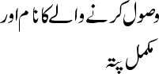



32



532, ew

**Ph #**

11111111111

2025-04-25



- - - - - - - - - - - - - - - - -

2025-04-25



32



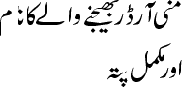

532, ew