**­­­­FMO-I (a**) **PAKISTAN POST OFFICE POSTAL CONFIRMATION**

No.

Oblong M.O. and month stamp of issue Date.

{date}

Amount in figures

Rs. Ps.

Issue for Rs.

{rupees}



M.O. Clerk **Issuing Postmaster**

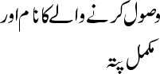



{rupees}

{senderName}, {senderAddress}



{date}

**Ph #**

{phoneNumber}









{rupees}

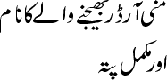

{senderName}, {senderAddress}

**PRODUCT INFO:**

{productData}

**To:**

{rupees}

**NAME:** {senderName} **VPP**

**ADDRESS:** {senderAddress}

**PHONE NO:** {phoneNumber}

**PRODUCT DETAIL:** {productData}

**From:**