## Scheduling Application Manual

This document serves as a manual for the scheduling application used by employees at Tomaso’s Barbershop. This document explains basic functionality, and “how-tos” of the application. Any questions not answered in this document can be directed to Christian Bonacore.

This is a web-based application, meaning it is used by opening a web browser (Safari, Google Chrome, Firefox, etc.) and accessing the application from an address. Can be used on a computer or tablet.

Upon opening the application, you will be brought to the login page, as shown below:

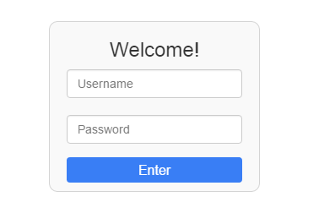

Once logged in, you will be brought to the main page of the application, shown below:

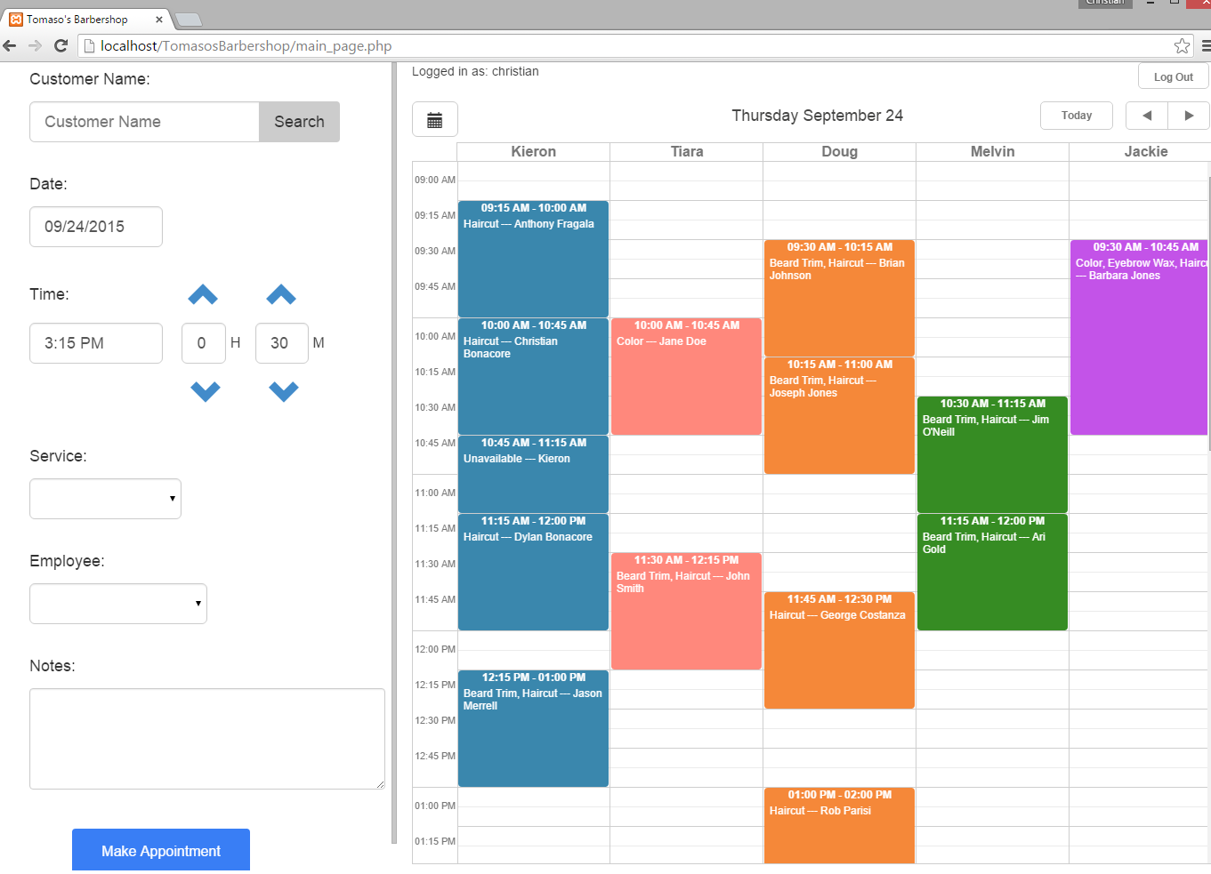

Navigation

The main screen can be divided into two parts: the **Form** and **Calendar**. These parts are highlighted by the blue rectangles.



**Form**

**Calendar**

Calendar

This section describes the Calendar section of the application. The controls are shown below:



Stylist Names

Current Date

Username

Today Button

Logout Button

Prev Day

Next Day

Go-To-Date Button

Please enter your username and password and press Enter.

The instructions below will explain each control, moving from left to right, starting with the Go-To-Date Button.

**Go-To-Date Button**

The Go-To-Date button allows you to select any date, and the calendar will show that date. This is opposed to the Next and Prev Date buttons, which only move ahead/behind one day at a time. When clicked, the Go-To-Date button brings up a calendar widget, as shown below:

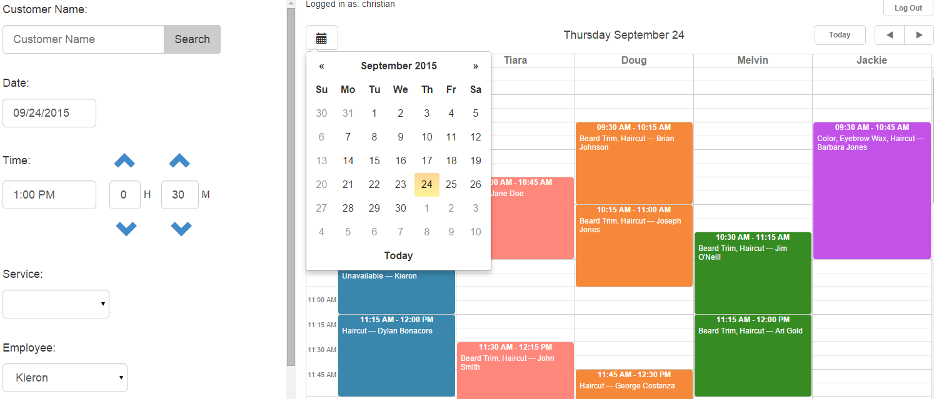

Notice the current day will be highlighted. A closer look at the calendar is shown below:

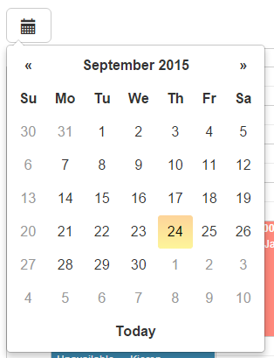

Next Month

Prev Month

Today Button

Selecting a date on the widget will close the widget, and then the calendar will be changed to the date selected. Note also the date in the Date field in the Form section will be updated to the date you select. This is done to save time when filling out the Form section

**Username**

The username you are currently logged in as. To login as a different user, click the Logout button, and log in under a different username.

**Stylist Names**

Each of the stylists who currently take appointments will be assigned a column in the calendar.

**Current Date**

This will list the current date shown in the calendar. When the application starts, it will default to the current day, and will change if the user changes the date using either the Go-To-Date, Next, Previous, or Today button.

**Today Button**

Clicking this button will automatically select the current date as the day to show in the calendar. For example, if you navigate to a different date using one of the controls, you can quickly get back to the current date by clicking this button.

**Next Day**

This will show the next day in the calendar view

**Prev Day**

This will show the previous day in the calendar view

**Logout**

This will log you out of the system, and bring you to the login screen

Form

This section describes the Form section of the application. The controls are shown below:

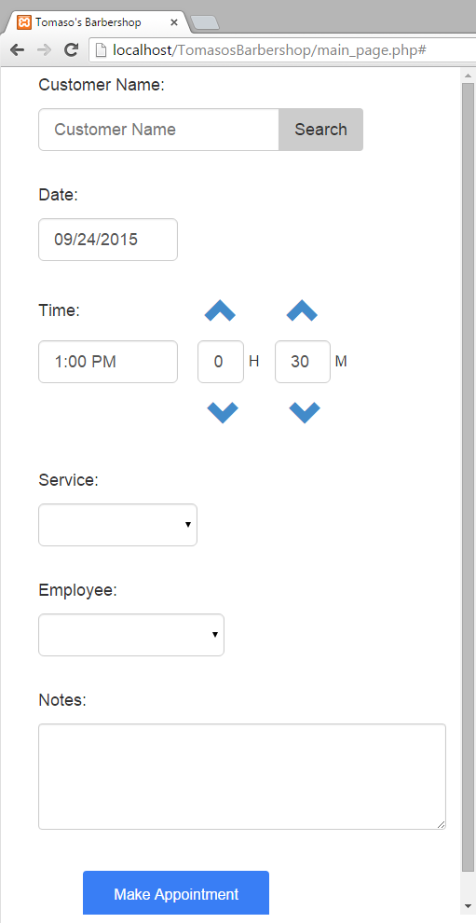

Customer Search Button

Date Field

Minutes Length

Decrease Minutes

Decrease Hours

Start Time

Increase Minutes

Increase Hours

Hours Length

Services Dropdown

Notes Section

Make Appointment Button

Start Time

Appt Hours Length

Employee Dropdown

**Customer Search Button**

Typing a customer’s name in the Customer Name field and clicking Search will search for the customer in the system. Visit the Customer Search section of this document for more information on searching for a customer.

**Date Field**

Clicking the date field will bring up a calendar widget similar to that of the Go-To-Date button.

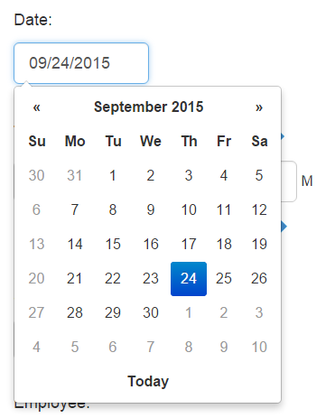

Prev Month

Next Month

Today Button

Note the current day will be highlighted, and the current day can be selected by clicking the Today button.

Selecting a date on the widget will close the widget, and then the value in the Date field will be changed to the date selected. Note also the date in the Calendar section will be updated to the date you select. This is done to save time when filling out the Form section

**Start Time**

Clicking on the Start Time field will bring up a widget that allows you to select a start time. The widget is shown below:

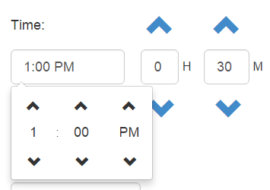

Increases hours by 1

Increases minutes by 15 minutes

Changes from AM to PM and vice-versa

Decreases hours by 1

Decreases minutes by 15 minutes

Use the arrows as indicated above to choose a start time for the appointment. Note that the time wraps. For example, if the time is set to 1:45 PM, and you increase the time by 15 minutes, it will move to 2:00 PM, and vice versa.

The length of the appointment is determined by the Hours and Minutes fields. By default, the length will be set to 0 hours and 30 minutes. You can use the following controls to increase/decrease hours/minutes.

**Increase Hours**

Increases the number of hours for the appointment by 1. Note the hour values are only from 0-8. If you are at 8 hours and select Increase Hours, hours will go back to 0.

**Decrease Hours**

Decreases the number of hours for the appointment by 1. Note the hour values are only from 0-8. If you are at 0 hours and select Decrease Hours, hours will go to 8.

**Increase Minutes**

Increases the number of minutes by 15 minutes. The time does NOT wrap and increase hours. For example, if hours is set to 0 and minutes is set to 45, increasing minutes by 15 will set both hours and minutes to 0.

**Decrease Minutes**

Decreases the number of minutes by 15 minutes. The time does NOT wrap and decrease hours. For example, if both hours and minutes are set to 0, decreasing minutes by 15 will set hours to 0, and minutes to 45.

**Services Dropdown**

This can be used to select the service(s) for the appointment. Note one appointment can have more than one service. Once a selection has been made from the dropdown (the value is not blank), a plus sign will appear. To add another service to the appointment, click the plus sign to add a copy of the dropdown below the first one.

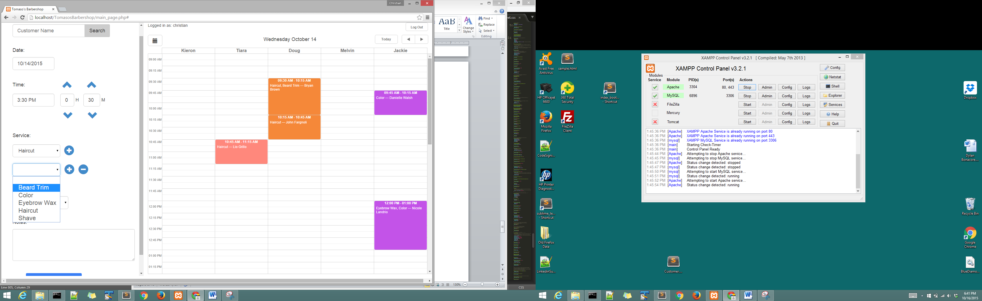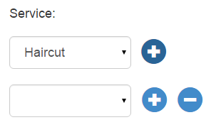

A selection can be made from this newly added dropdown. The minus sign will remove the dropdown, and the plus sign will add another dropdown of services. If you select a service from an added dropdown, and then remove it by clicking the minus sign, then that service will not be included in the appointment.

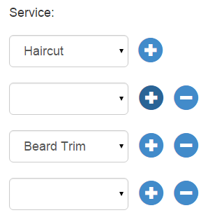

You can add as many dropdowns as you’d like; however when the appointment is made, only the dropdowns with selected values will be included in the appointment. For example, if these are the dropdowns under Service when the user clicks Make Appointment, then the appointment will include a Haircut and Beard Trim as the services included in the appointment.

**Employee Dropdown**

Select the employee with whom the appointment will be scheduled. Only employees assigned a column in the Calendar will be listed in the dropdown.

**Notes Section**

Add any text here to be included in the notes of the appointment. For example, “Coming in with 3 kids”, or “may be a few minutes late”, etc.

**Make Appointment Button**

This will validate the data entered, and then add the appointment. The only field in the Form which can be left blank is the Notes section. If any are not entered or entered incorrectly, then an error message will appear. When the appointment is added successfully, you will see it appear under the date/time you selected in the Calendar, and a notification will display for a few seconds in the top right of the screen, and then disappear.

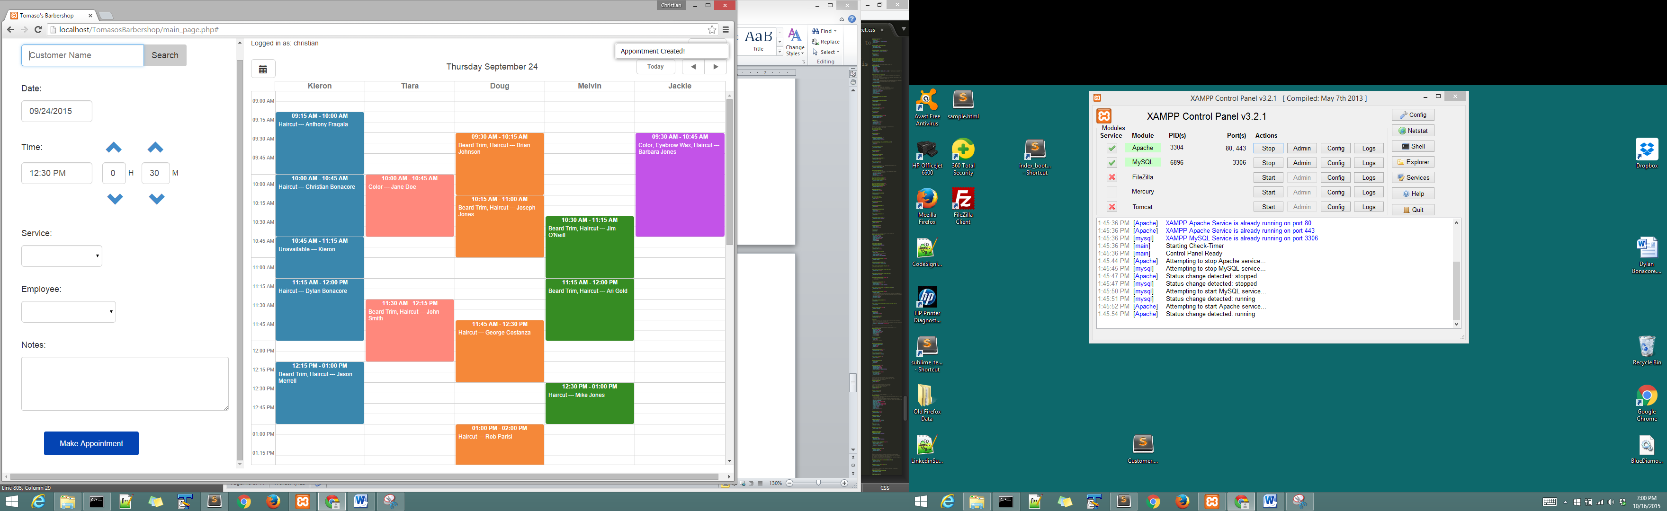

Navigation

Form Fields

Each of the buttons/controls

Calendar

Each of the buttons/controls

Making an Appointment

Searching for a customer

Selecting Date

Selecting Start Time and Duration

Selecting Services

Selecting Employee

Adding Notes

Tips

Employee name and start time can be selected in one click

Unavailable

All Day v. Specific Start and End Time

Editing an Appointment

Navigate to lightbox by either quickinfo or 2x click

Lightbox Controls

Start/End Time

Date

Changing Services

Save/Cancel/Delete

Customer Search

Navigating through results from customer search

Quick Customer History

Full Customer History

Editing Customer Information

Adding a Customer

Empty search or no results found prompt to add customer

Form controls

Email must contain the “@” symbol and “.”

Phone numbers must be either 7 or 10 digits long (area code not required, but recommended)

If select Text/Email, then must enter a Cell number/Email address

No duplicate customer names

Birthday on year is optional

“Make Appointment with this customer” adds them to system, then populates their name