Using Chatsonic

Generating a anime character

prompt : Generate a image, a girl anime character who's 23 years old, pro in cyber field, wearing street fashion, ultra realistic, HDR, in 8k resolution, cgi, glow, cinematic lighting background, soft light , insane detail, dramatic lighting effects, bold, rtx on --s 500 --ar 16:9 –v5.2
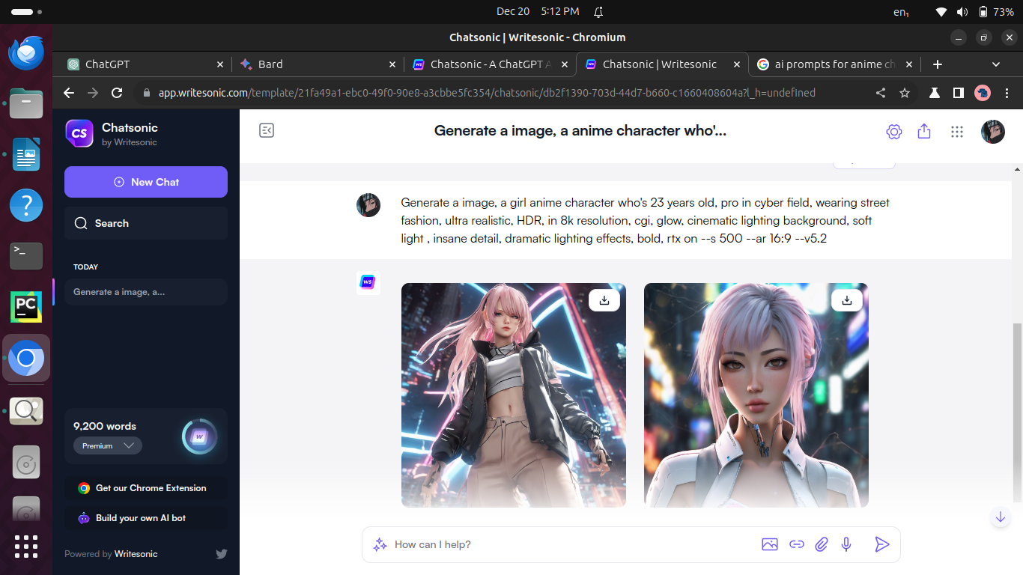

Writing a blog about being a content creator

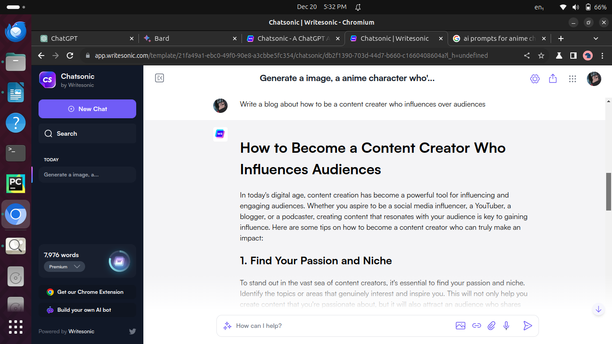

Using ChatGPT

Asking chatGPT to pass CCIE exam in 1 year

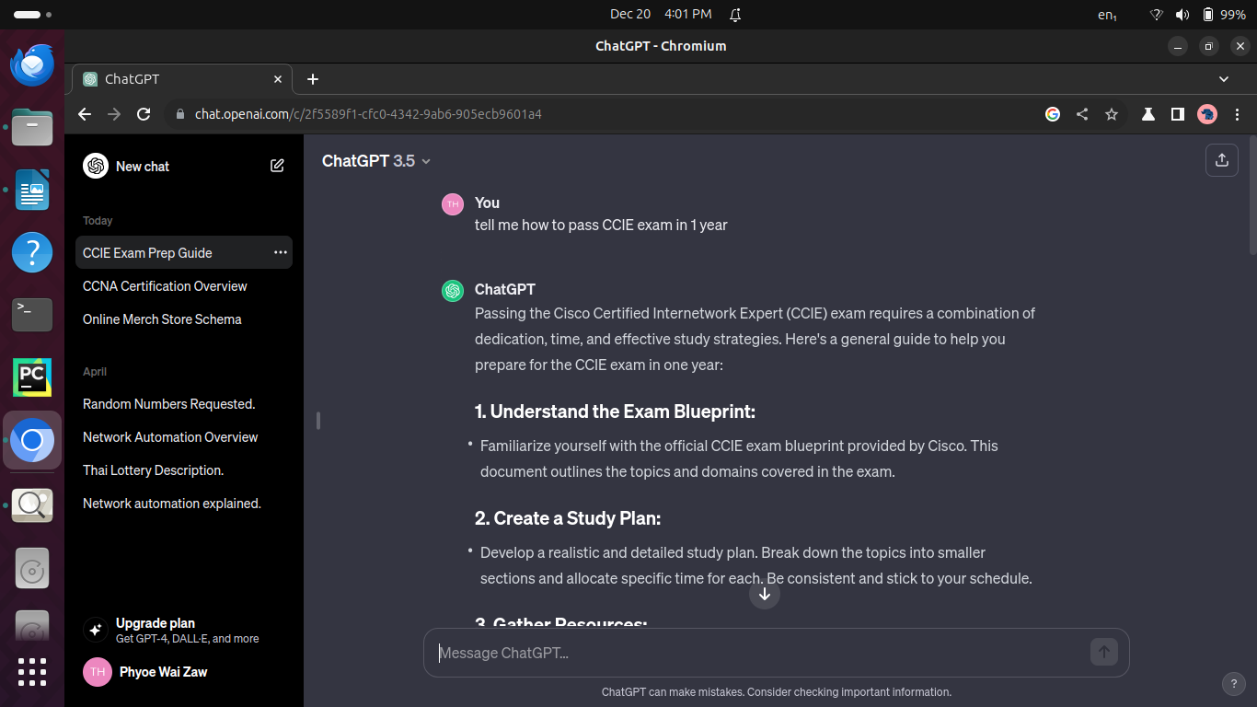

About CCNA

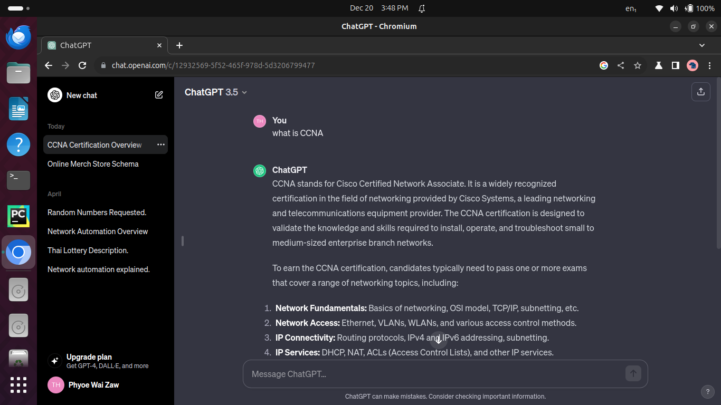

Google Chatbot (Bard)

Asking to generate a daily routine to be a web developer in healthy ways

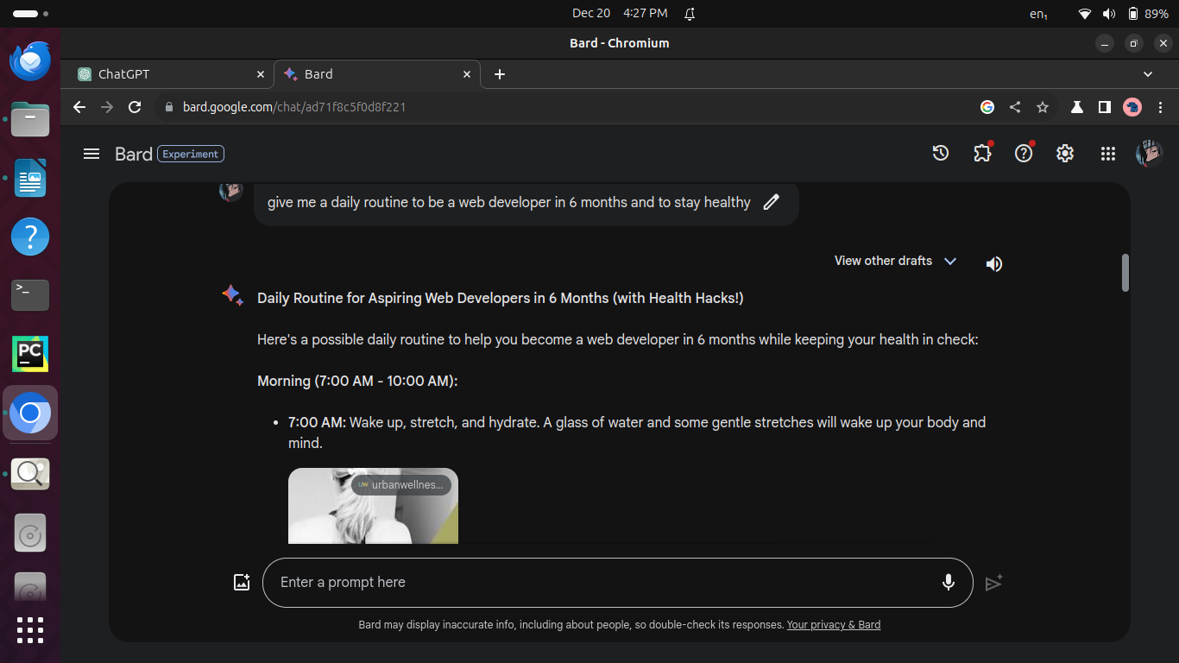

Write a blog about ROI and some business ideas that can get high ROI percentage

