

Casting Porous Bearing Pads
with Dental Plaster

Description:
This experiment tests the feasibility of casting porous fluid bearing pads from dental plaster. An easy production method using a 3D-printed mold is applied and the structural integrity of the bearing pad under pressurized air and water is examined.

Author: 0x23
State: Document is work in progress

Casting

For casting, a simple 3D-Printed mold was used. It consists of three separable parts: The bottom with a line grid to create the fluid distribution channels. And two right angled Side pieces to contain the plaster.
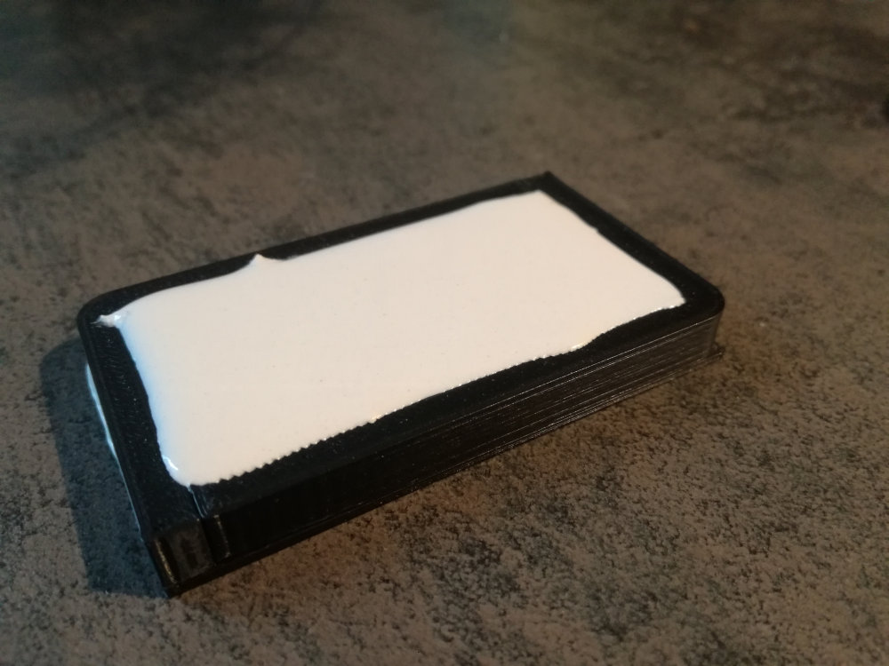Figure 1: Bearing Pad Casting

Demolding

Demolding proved to be difficult and destroyed the small features of the fluid distribution channels. This could be mitigated by using a soft silicone mold, which however is more laborious to create and was not used at this stage of prototyping.
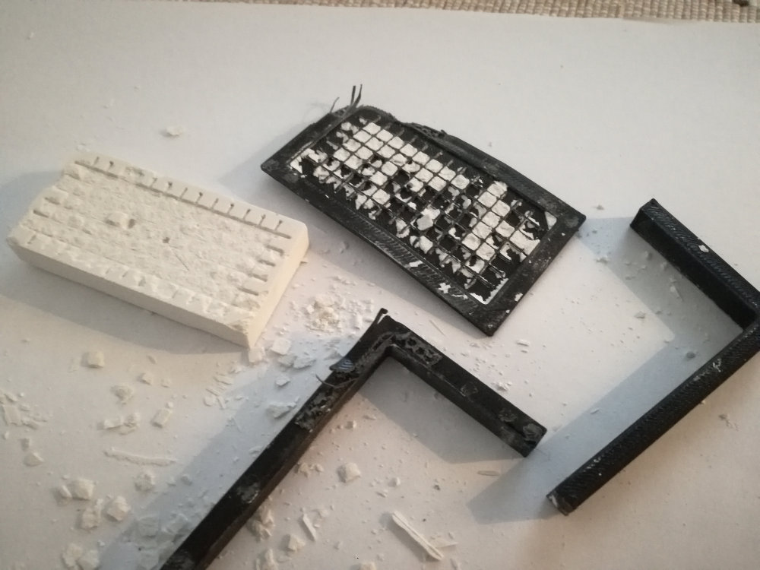Figure 2: Failure of demolding cast from 3D-printed mold.

Alternative Approach

The bearing pad was cast using a flat bottom mold and the distribution channels where scraped in afterwards with a knife.

The top and bottom surfaces of the bearing pad were ground flat using sandpaper and a glass plat (which tend to be quite flat). This process took only a few minutes. (Note the picture were taken after testing to failure)

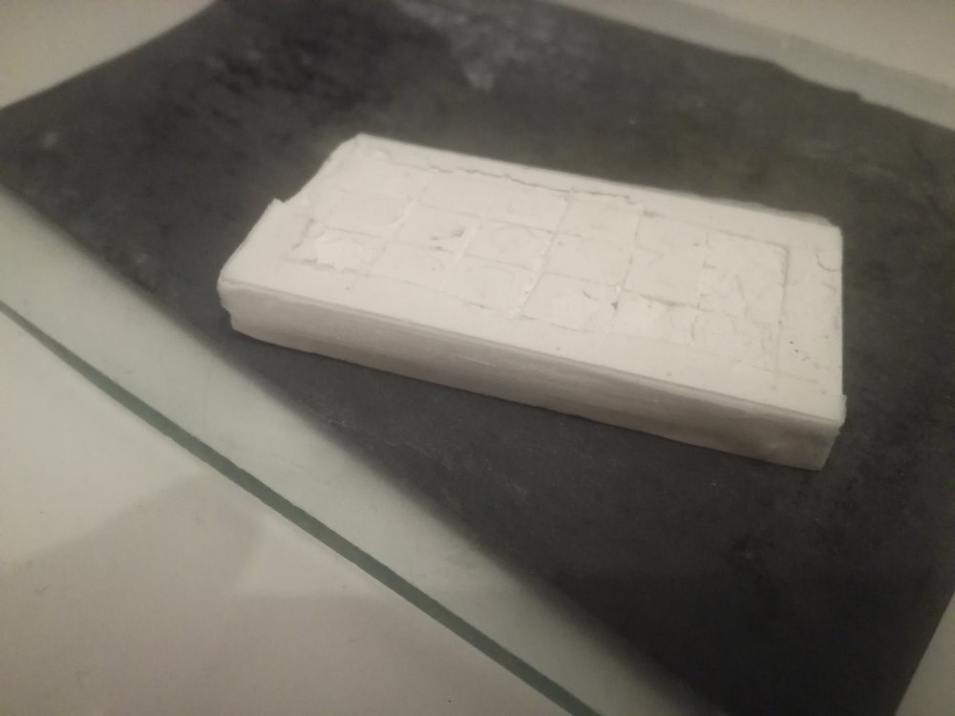
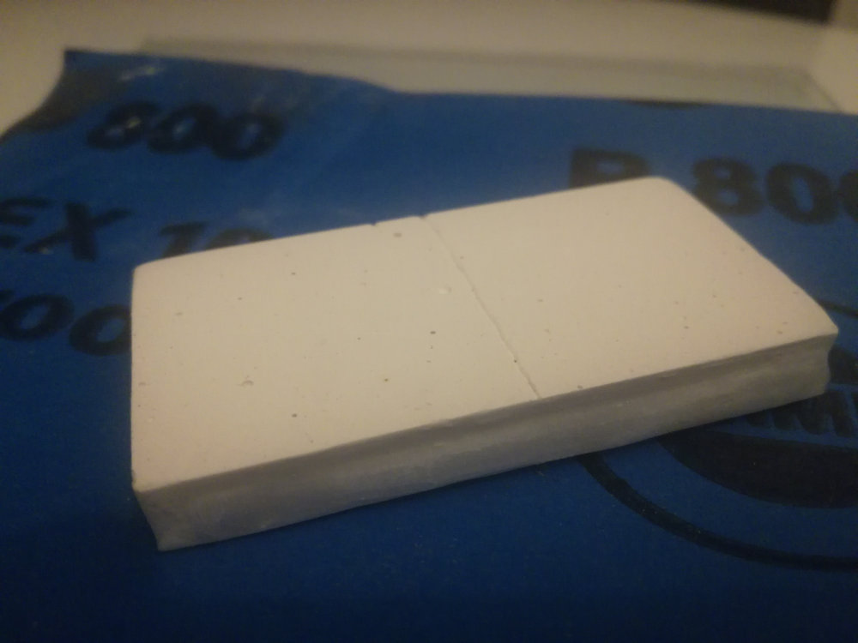

Figure 3: Figure 3: Grinding bearing pad surfaces using sandpaper on a glass plate.^
The side containing the distribution channels was then glued (cyanacrylate super glue) to a piece of glass with a fluid inlet hole in the middle.

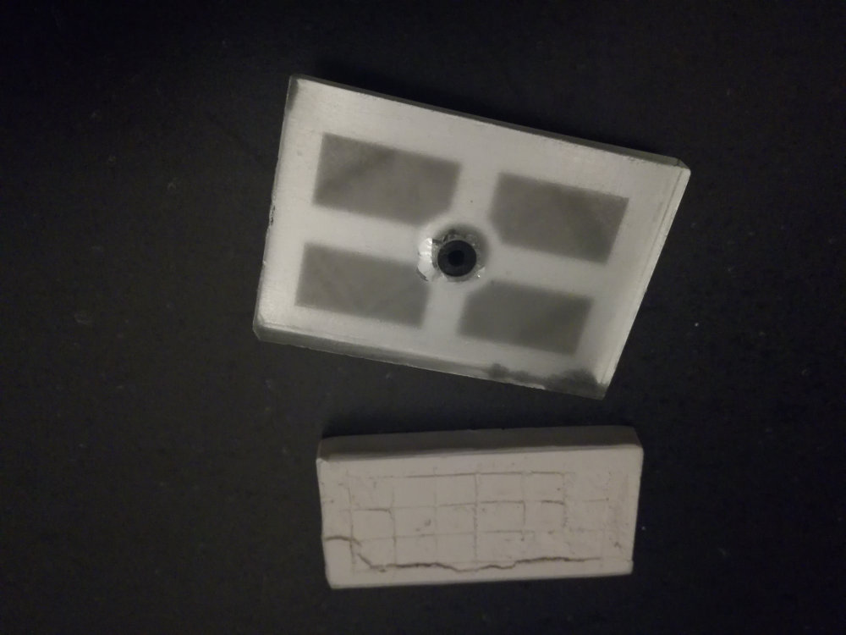
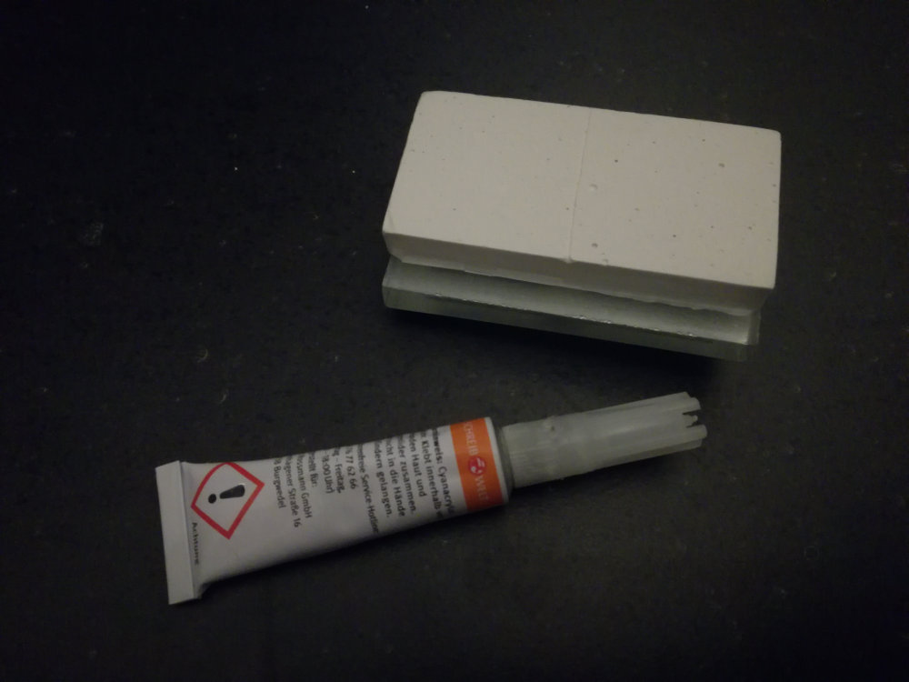

Result

The experiment was partially successful. The Bearing pad worked using water as working fluid until disintegration due to the large forces create by fluid pressure. The failure happened even though relatively low pressures were used – somewhere around 2–5bar. Also the glue partially failed.

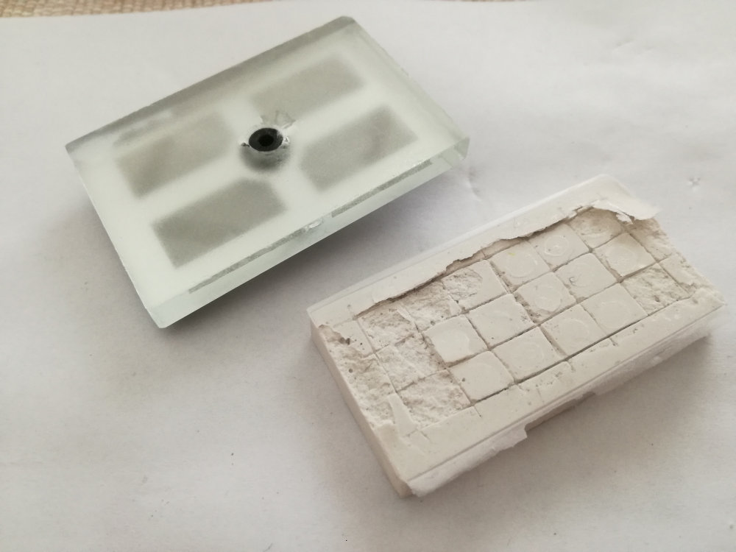Figure 4: Structural integrity failure at medium pressure (approx. 2-5 bar)

