Rodriguez, Gabriel DC. PHILIPPINE READINGS BT501

CEREMONIES OF CALOOCAN CITY

**FIRST FLAG CEREMONY AT NEW CITY HALL**

In March 21, 2015 at 10:00am, the official ground-breaking ceremony of the new Caloocan City Hall project occurred at 8th Ave. cor. 8th St., East Grace Park. The event will be led by Mayor Oscar Malapitan along with Vice Mayor Maca Asistio III, city councilors and the city's department heads. This 8-storey building will house the executive, front-line social services and revenue-generating offices of the city government.

The new state-of-the-art building will have basement parking, centralized aircon, elevators, hotel-type lobby, airport-type waiting areas, manicured gardens, CCTV system, modern security system, events and conference centre. A commercial complex will also rise within the city hall compound, housing various restaurants, boutiques, specialty shops and service-oriented businesses.

**FIRST FLAG CEREMONY AT NEW CITY HALL**

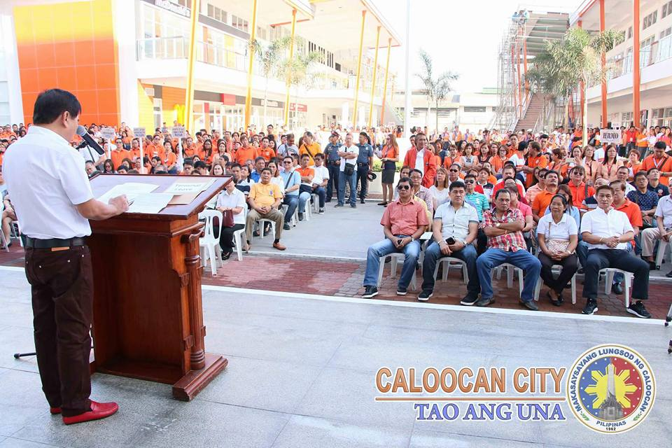

The Mayor Oca Malapitan informed the city government staff and thanked everyone because of their continuous efforts to serve the people. According to the mayor, all of the accomplishments of the departments and offices at the city hall have increased. The collection of taxes and fees has increased, the number of those who have been employed has increased, those who have been helped in business, the number of people who have been helped has increased. According to Oca, by the year 2018 7,000 sq.m. PEOPLE'S PARK behind the new city hall will now be opened. Next year, a new convention centre will also be opened.

The front of the new city hall looks like a mini greenbelt or BGC high street that will be filled with food and eating areas and service shops which is the new gimmick area of ​​the people of Caloocan. McDonalds is open and in the coming months Starbucks, Barrio Fiesta, Goodah, Anytime Fitness, and other restaurants and service shops will open.

**Bonifacio Day in Caloocan**

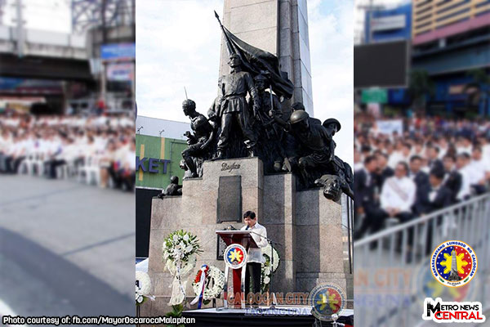

The City Government of Caloocan, under the leadership of Mayor Oscar Malapitan, have led the entire nation on Friday’s commemoration of the 155th birth anniversary of Gat. Andres Bonifacio at the Bonifacio Monument Circle in Caloocan. Malapitan, together with Executive Secretary Salvador Medialdea, Armed Forces of the Philippines Chief of Staff General Carlito Galvez Jr., other Cabinet and City Government officials, headed the flag-raising and wreath laying ceremonies at the 45-feet monument of Bonifacio. In his speech before many people at the historical shrine, Mayor Malapitan encouraged those people to surpass the father of the Katipunan and the Great Plebeian from Tondo, who fought for change for the freedom of his countrym“Change is Bonifacio’s legacy which he intends us to emulate. We should be united for our motherland,” the City Mayor said.

“By uniting for a common goal, we can achieve anything. Each and everyone of us plays a potent role in our society,” Mayor Malapitan emphasized. Also present during the event were Bonifacio’s descendants, other city and barangay officials, city employees, educators, and students. Andres Bonifacio, born on November 30, 1863, was the founder of the Kataas-taasan, Kagalang-galangan, Katipunan ng mga Anak ng Bayan (KKK) who fought the Spaniards during the Philippine Revolution. For the residents of Caloocan City, the monument of Bonifacio is a symbol of bravery and love of the country.

Reference:  
<https://caloocancity.gov.ph/services/accomplishment-report/30-news/90-official-groundbreaking-ceremony-of-the-new-caloocan-city-hall>  
<https://caloocancity.gov.ph/74-programs-and-projects/news/357-unang-flag-ceremony-sa-bagong-city-hall>