**AD User Creation Tool – Testing Notes**

Version Tested: 1.1

The application has the following main functionality features:

* Single User Creation Mode
* CSV Mode for bulk account creation from a CSV file
* Create CSV Template CSV file to use with ‘CSV Mode’

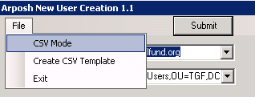

The ‘ANUC.options.xml’ file is also used to store configurable XML options for Single User Creation Mode.

**Known issues with CSV Mode**

In CSV Mode; the application is meant to ignore the options of Single Mode and the ‘ANUC.options.xml’ file. When attempting to Submit accounts to be created in this mode; you often encounter an exception related to the –Path parameter in the New-ADUser PowerShell commandlet:

New-ADUser : Cannot validate argument on parameter 'Path'. The argument is null or empty. Supply an argument that is n

t null or empty and then try the command again.

As a workaround; manually entering the details in for this into the fields in the tool appear to fix this like the example below:

Current Domain

OU

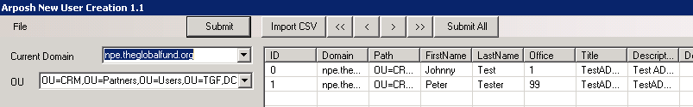

Sometimes having these entered into the ‘ANUC.options.xml’ file on first run also resolved it.

<Domain></Domain>

<Path></Path>