**SharePoint Server: Using soapUI and burp suite for testing Web Services**

Overview: When using soapUI to test web services (especially SharePoint web services); you are unable to connect to the WSDL definition, and get a ‘Error loading WSDL’ exception message.

This issue is often the cause of soapUI not been able to authenticate via your web service with NTLM authentication. The solution below shows how you can use the excellent burp suite to act as a proxy connection between soapUI and the web services.

Resources:

[soapUI](http://sourceforge.net/projects/soapui) (Free Edition)

[Burp Suite](http://www.portswigger.net) Free Edition

Solution:

In soapUI when you add a WSDL connection to your project you get the error message below when attempting to connect to the web service.

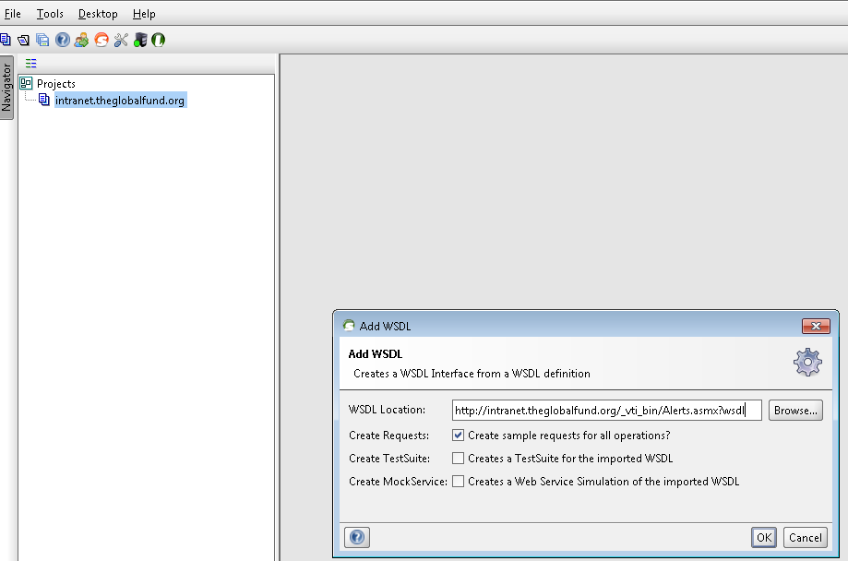

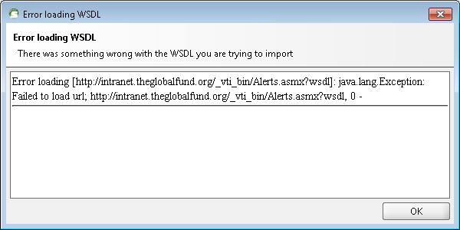

**Solution - Using burp as a proxy for soapUI**

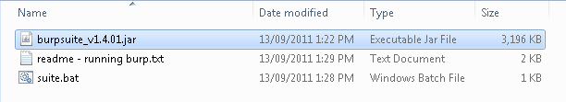

On the ‘proxy’ – ‘intercept’ tab ensure to toggle ‘intercept is on’ to Off

default

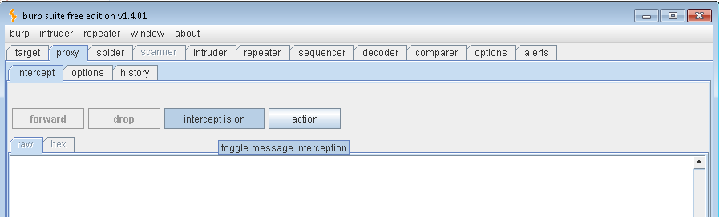

Set intercept to ‘intercept is off’

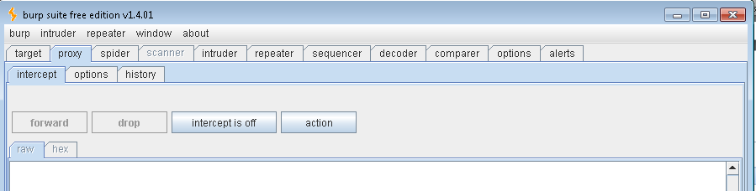

On the ‘proxy’ – ‘options’ tab check to make sure that the proxy listener port under ‘proxy listeners’ is set to one not in use. Burp appears to use defaults of ‘8080’ or ‘8081’

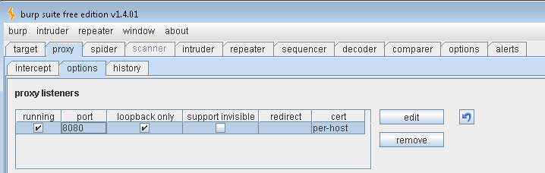

Now on the ‘options’ – ‘connections’ tab add your credential you want to use for querying your web service

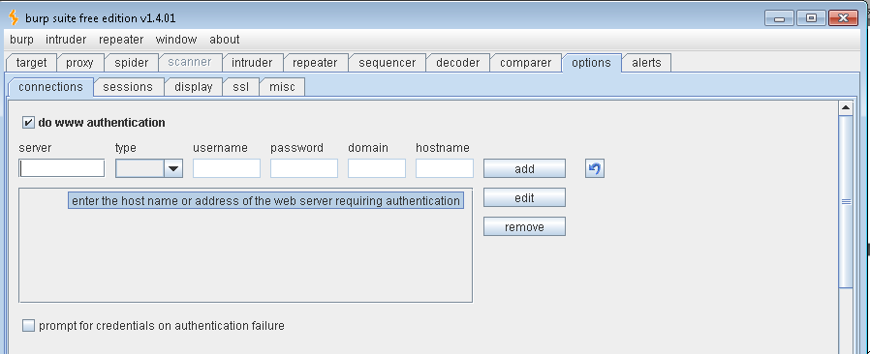

Select ‘do www authentication’ tick box and add your credentials

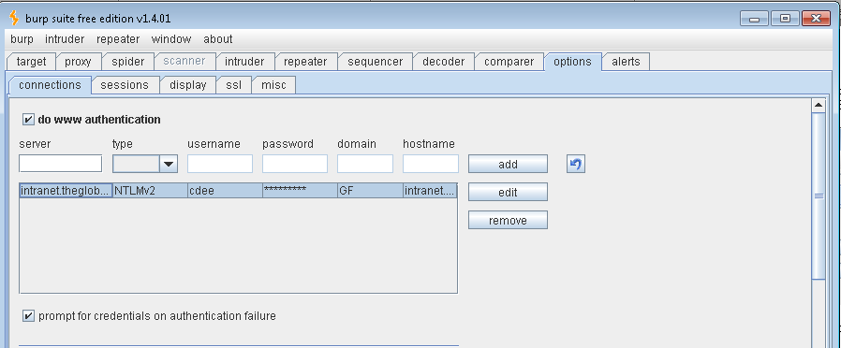

Now flip back to the ‘proxy’ – ‘history’ tab for a view of the HTTP requests and responses when they come back through burp.

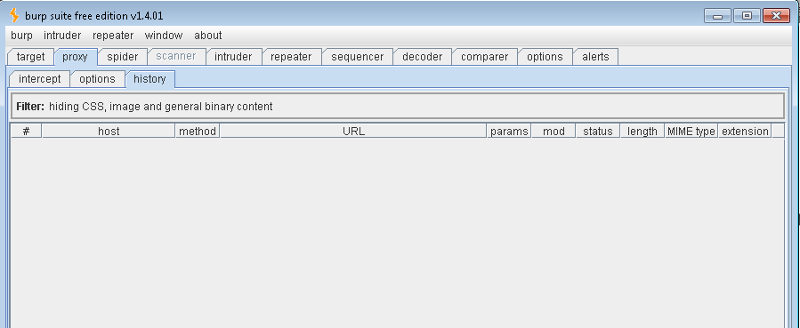

**Last Changes In soapUI**

In soapUI go to your ‘File’ – ‘Preferences’ options

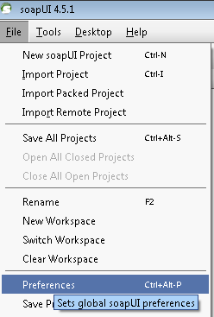

Under ‘Proxy Settings’ add the following:

Host: localhost

Port: 8080 *This must be the same port that was configured in burp under the ‘proxy’ – ‘options’

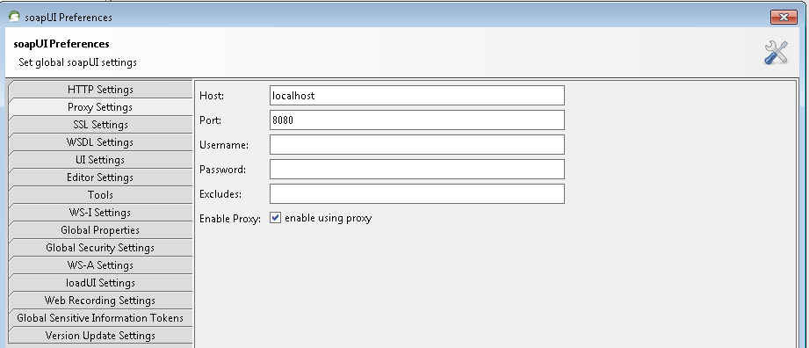

You should now be able to hit your web services through soapUI and will see the traffic throughput on the burp ‘proxy’ – ‘history’ tab

