# Calling the Tekton API from your application

The controller of the ESTA Tekton build system provides a RESTful API which is documented with OpenAPI/Swagger. The URL to the controller is a bit hidden but follows this schema:

https://esta-tekton-controller-<tekon-namespace>.sbb-cloud.net/

The API requires authentication with OAuth2 JWT tokens issued by Microsoft Azure AD. Here's the process for an application (machine-2-machine) to successfully authenticate to the controller API:

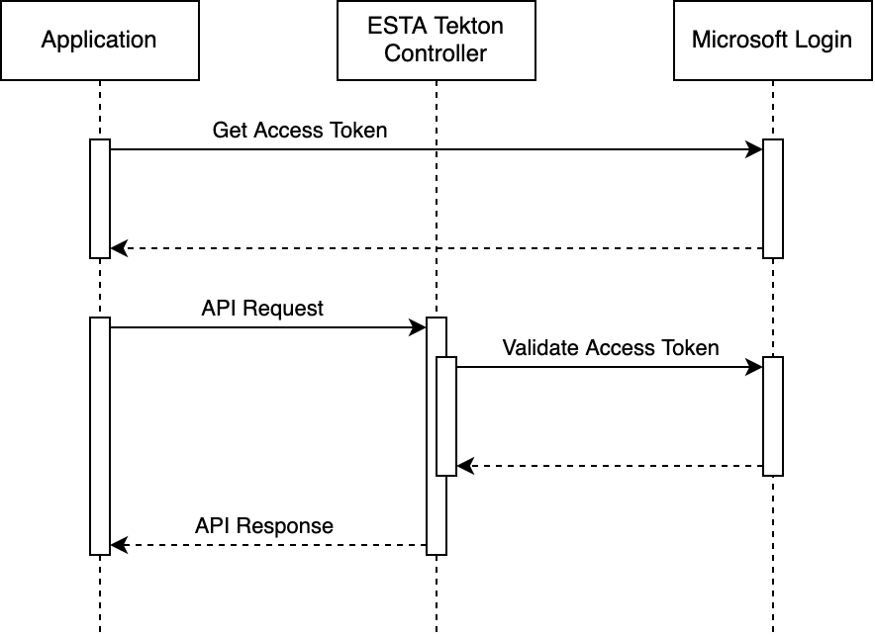

# Prerequsites

1. Register an [Azure AD client](https://developer.sbb.ch/apis/azure_ad_api/information) and obtain client credentials (ID and secret) for the client credential flow.
2. Store the credentials to an OpenShift secret which is accessible for the application which performs the API calls.
3. Add the client ID to the app registration config for your Tekton instance (ask the ESTA team to do this for your managed Tekton instance)

# Example shell script

# (1) Obtain an access token

export AUTH_TOKEN=$(curl -s --fail -X POST ${TOKEN_ENDPOINT} \

-H 'Content-Type: application/x-www-form-urlencoded' \

-d grant_type=client_credentials \

-d client_id=${CLIENT_ID} \

-d client_secret=${CLIENT_SECRET} \

-d scope=${TEKTON_CLIENT_ID}/.default \

| grep -o -E '"access_token":"[^"]+"' | cut -f 2 -d ":" | tr -d '"\n')

# (2) Perform an API request to the Tekton controller

curl ${TEKTON_CONTROLLER_URL}/api/bitbucket/projects/*/repos \

-H "Authorization: Bearer $AUTH_TOKEN" \

-H "Accept: application/json"

The script expects the following env variables:

* TOKEN_ENDPOINT: URL to the Microsoft Login service (usually https://login.microsoftonline.com/2cda5d11-f0ac-46b3-967d-af1b2e1bd01a/oauth2/v2.0/token)
* CLIENT_ID: UUID of your Azure AD client
* CLIENT_SECRET: Secret key of the client credentials
* TEKTON_CLIENT_ID: The Azure AD UUID of your Tekton instance (ask the ESTA team to get it for you)
* TEKTON_CONTROLLER_URL: The URL to the ESTA Tekton controller (see first paragraph)

The scope to be requested for this token is "<tekton-client-id>/.default".

The API documentation can be found when opening the controller URL in the browser and navigate to "Swagger UI".