# ESTA Tekton Pipeline

The ESTA Tekton Pipeline provides an easy-to-use CI/CD system with a standardized process for building and deploying your software projects on Openshift.

The key benefits for using ESTA Tekton are:

* Easy setup for projects using the standard SBB stacks like SpringBoot, Angular/Typescript and Go
* Simple build configuration with a single JSON file similar to the well known estaCloudPipeline.json
* Fast migration for builds from ESTA Cloud Pipeline (the deployment part needs a little more effort)
* Makes use of Lean Gitflow and Semantic Versioning
* Scalable build infrastructure using dedicated Openshift 4 clusters
* Extensible using custom pipelines and individual build namespaces
* Standard ESTA Tekton Pipelines with options to be customized
* Customized builder images if necessary
* Flexible pipeline configurations which get triggered by User, REST API or Bitbucket Webhooks

# Architecture Overview

Build and Deployment Setup for individual Business Units:

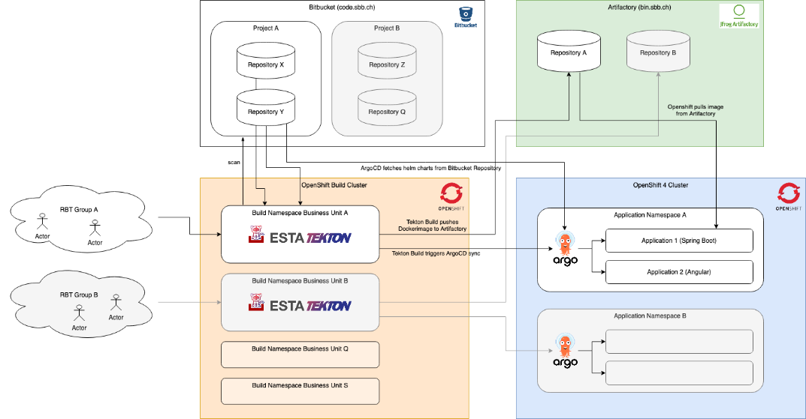

Build and Deployment Workflow with Tekton Pipelines:

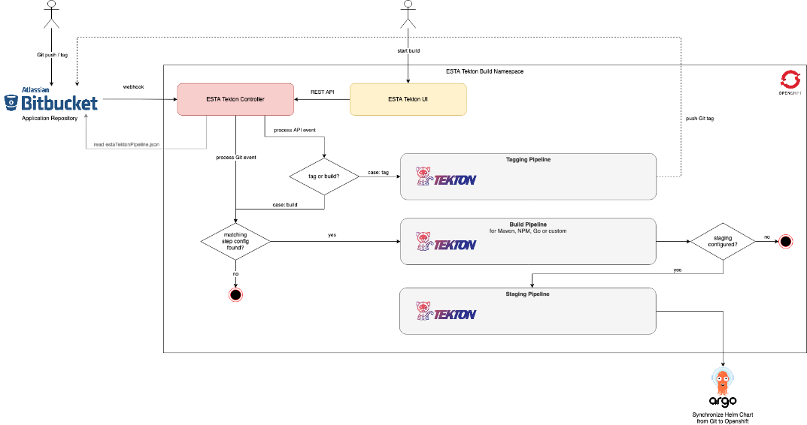

# Documentation

* Getting Started
  + Prerequisites
  + Setup your Build Namespace
  + Enable your Repository for Tekton
  + Start your first Tekton Pipeline
  + What's next?
* Core Concepts
  + Tekton Pipelines for CI/CD
  + Deployment with ArgoCD
  + ESTA Tekton Pipelines
* Dedicated Build Namespaces
  + Tekton Build Clusters
  + Setup your own Build Namespace
  + Secrets to access your resources
* Deployment with ArgoCD and Helm Charts
  + Setup ArgoCD for your Deployments
  + Create Helm Charts
  + Manage ArgoCD Deployments in Git
  + Update ArgoCD Values from Tekton Pipelines
* ESTA Tekton Workflow
  + Continuous Integration
  + Release Process
  + Bitbucket Integration
  + Notifications
* ESTA Tekton Parameters - estaTektonPipeline.json
  + Steps and Stages
  + Helm Charts
  + Docker Settings
  + Examples
  + Parameter Documentation
* Tekton Control Panel
  + Authentication
  + Projects and Repositories
  + Start Builds and Releases
  + Monitor Pipeline Runs
  + ESTA Cloud Pipeline Migration Tool
  + User Permissions
  + Pipeline Secrets
  + System Configuration
* Advanced Topics
  + Custom Pipelines
  + Custom Pipeline Tasks
  + Environment Variables in Pipeline Tasks
  + Java and Maven Versions
  + Using Buildpacks
  + SonarCloud Test Coverage
* Migrating from ESTA Cloud Pipeline
  + Migrating estaCloudPipeline.json
  + Dockerfile Migration
  + OpenShift Templates to Helm Migration
* How-to Tekton
* Known Issues

# Release Notes

Notes about releases of ESTA Tekton and it's components can be found in this [CHANGELOG](https://code.sbb.ch/projects/KD_ESTA/repos/esta-tekton-pipeline-config/browse/CHANGELOG.md).

Our backlog for future development with the possibility to vote in listed in Planned Features.