# Tekton UI Architektur

# ****Package Diagram****

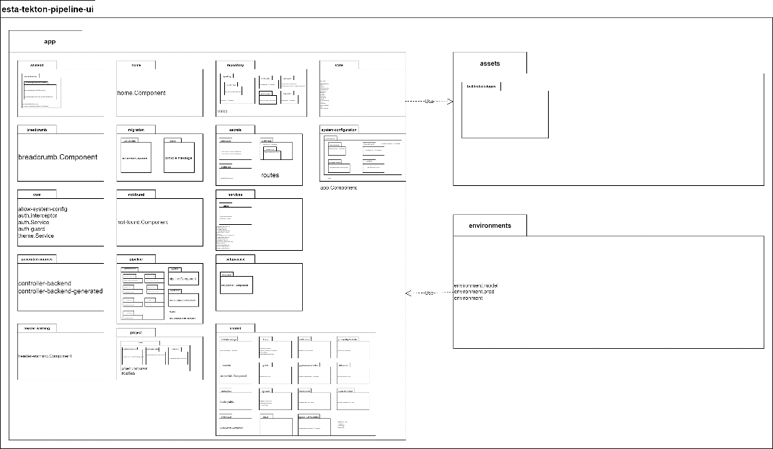

# ****Class Diagram Pipeline****

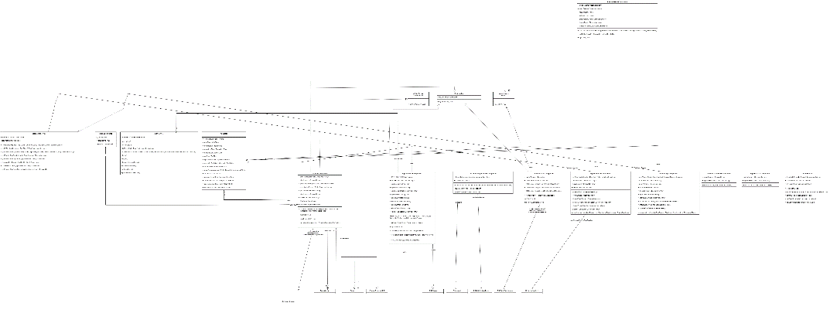

# ****HTML Structure Pipelines and Pipeline Detail****

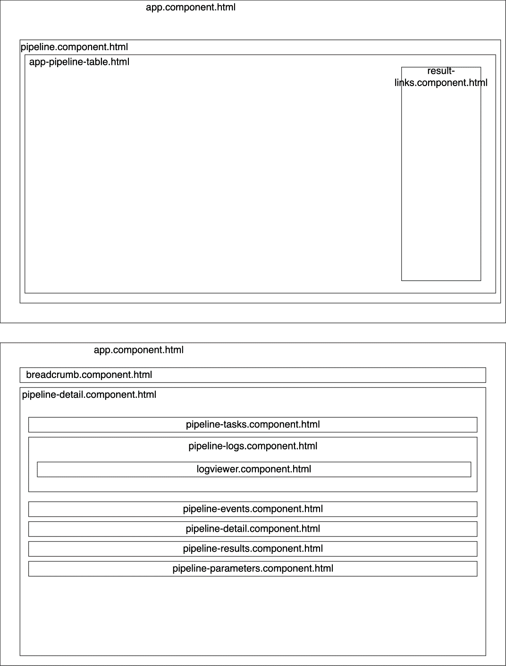

# ****Class Diagram Repositories****

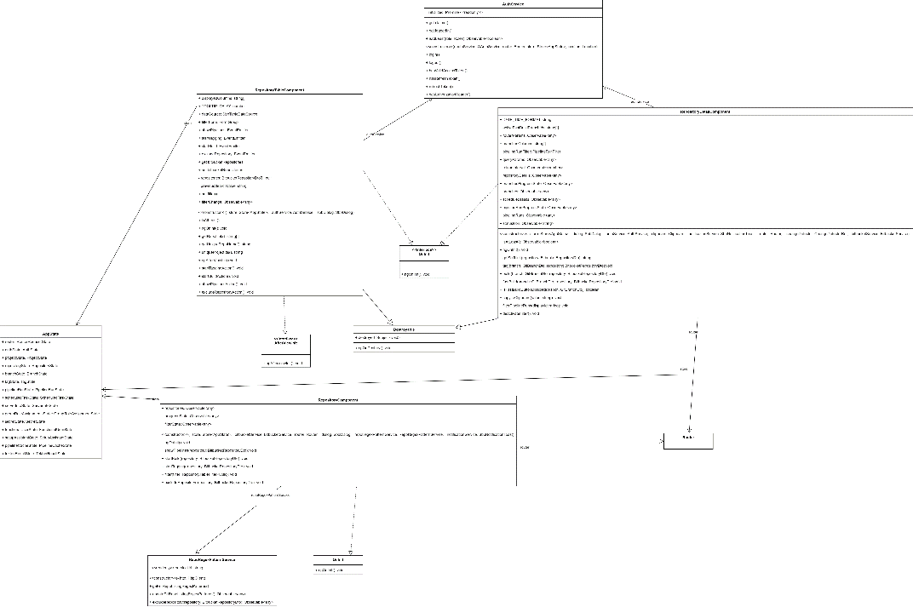

# ****HTML Structure Repositories and Repository Detail****

