Linarda Jukmaņa

2. Laboratorijas darbs
Funkcionālo un loģisko shēmu modelēšanā
“BCD skaitītājs”
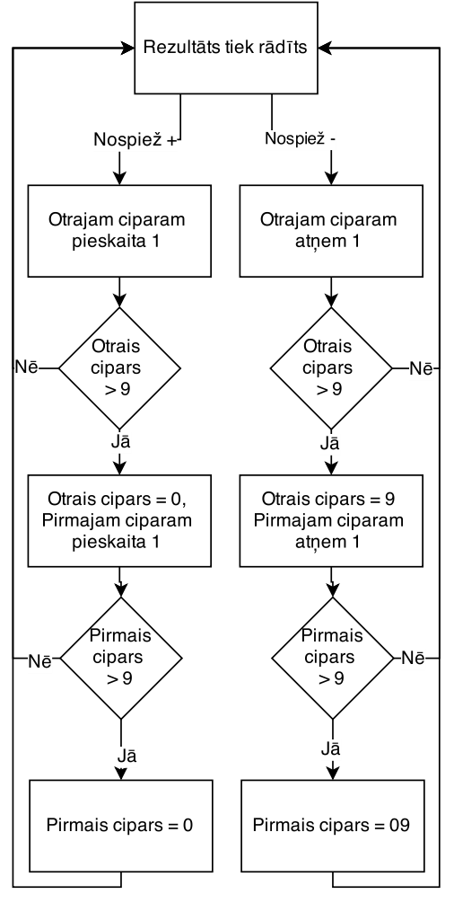
Laboratorijas darba ietvaros tika izstrādāts divciparu decimāls skaitītājs. Autors piedāvā darbības blokshēmu un izmantoto kodu.

entity TEST is

port
(
plus : in std_logic;
minus : in std_logic;
clock : in std_logic;
data : out std_logic_vector(7 downto 0);
dig_leds : out std_logic_vector(7 downto 0);
dig1_gnd : out std_logic;
dig2_gnd : out std_logic
);

end entity;

architecture rtl of TEST is

type DECODE_ARRAY is array (0 to 15) of std_logic_vector(0 to 7);
constant segment_values : DECODE_ARRAY := ( X"3F", X"06", X"5B", X"4F", X"66", X"6D", X"7D", X"07", X"7F", X"6F", X"77", X"7C", X"39", X"5E", X"79", X"71");

shared variable bcd0 : std_logic_vector(3 downto 0) := X"0";
shared variable bcd1 : std_logic_vector(7 downto 4) := X"0";
shared variable tmp_dig_leds : std_logic_vector(7 downto 0) := X"00";
shared variable act_dig1 : std_logic := '0';

signal clocker : integer := 0;
signal clocker2 : integer := 0;
begin

process(plus, minus, clock)

begin
if(rising_edge(clock)) then
if(clocker < 5000000) then
clocker <= clocker + 1;
else
clocker <= 0;
if(plus = '0') then
bcd0 := bcd0 + 1;
elsif(minus = '0') then
bcd0 := bcd0 - 1;
end if;

if(bcd0 > X"09") then
if(plus = '0') then
bcd1 := bcd1 + 1;
bcd0 := X"0";
else
bcd1 := bcd1 - 1;
bcd0 := X"9";
end if;
end if;

if(bcd1 > X"09") then
if(plus = '0') then
bcd1 := X"0";
else
bcd1 := X"9";
end if;
end if;
end if;
end if;
end process;

process(clock)
variable temp : integer := 0;

begin
if(rising_edge(clock)) then
if(clocker2 < 50000) then
clocker2 <= clocker2 + 1;
else
clocker2 <= 0;

act_dig1 := not act_dig1;
if(act_dig1 = '1') then
temp := to_integer(unsigned(bcd1));
else
temp := to_integer(unsigned(bcd0));
end if;

tmp_dig_leds := segment_values(temp);
end if;
end if;

end process;

dig1_gnd <= not act_dig1;
dig2_gnd <= act_dig1;
dig_leds <= not tmp_dig_leds; -- Common anode
data <= bcd1 & bcd0;

end rtl;

