## CSCI 140 PA 10 Submission

## Due Date: 11/09/2021 Late (date and time):_________________

## Name(s): Nero Li

Exercise 1 -- need to submit source code and I/O  
 -- check if completely done ✔️ ; otherwise, discuss issues below

Source code below:

/* Program: PA_10_exercise_1

Author: Nero Li

Class: CSCI 220

Date: 11/09/2021

Description:

Use SearchTree class in C++ book (modified by me and provided here)

and set up a test driver to perform some operations such as insert,

erase, and find. Perform the operations in question 1 below (steps

1 to 7) and then search for 15, 30, and 8. Print the BST as the final

step. Assume that key is an integer and value is a string such as a

name (come up with your own names).

I certify that the code below is my own work.

Exception(s): N/A

*/

#include <iostream>

#include "bst.h"

#include "BinaryTree.h"

#include "Entry.h"

#include "RuntimeExceptions.h"

using namespace std;

void findKey(int key,SearchTree<Entry<int, char>> test, SearchTree<Entry<int, char>>::Iterator itr)

{

itr = test.find(key);

if (!(itr == test.end()))

{

cout << (*itr).key() << ": " << (*itr).value() << endl;

}

}

int main()

{

SearchTree<Entry<int, char>> test;

SearchTree<Entry<int, char>>::Iterator itr{NULL};

test.insert(10, 'a');

test.insert(20, 'b');

test.insert(4, 'c');

test.insert(8, 'd');

test.insert(15, 'e');

test.erase(8);

test.erase(10);

findKey(15, test, itr);

findKey(30, test, itr);

findKey(8, test, itr);

itr = test.begin();

while (!(itr == test.end()))

{

cout << (*itr).key() << ' ';

++itr;

}

cout << endl;

cout << "Modified by: Nero Li\n";

return 0;

}

Input/output below:

15: e

4 15 20

Modified by: Nero Li

Exercise 2 (with extra credit) -- need to submit source code and I/O  
 -- check if completely done ✔️ ; otherwise, discuss issues below

Source code below:

bst.h:

#ifndef BST_H

#define BST_H

// Modified for CSCI 220 Fall 15

// Updated Fall 21

#include "BinaryTree.h"

#include "RuntimeExceptions.h"

template <typename E>

class SearchTree { // a binary search tree

public: // public types

typedef typename E::Key K; // a key

typedef typename E::Value V; // a value

class Iterator; // an iterator/position

SearchTree(): T(), n(0)

{ T.addRoot(); T.expandExternal(T.root()); } // create the super root

int size() const { // number of entries

return n;

};

int trace()

{

return traceCount;

}

bool empty() const { // is the tree empty?

return size() == 0;

}

Iterator find(const K& k)

{

traceCount = 0;

TPos v = finder(k, root()); // search from virtual root

if (!v.isExternal()) return Iterator(v); // found it

else return end(); // didn't find it

}

Iterator insert(const K& k, const V& x) // insert (k,x)

{

traceCount = 0;

TPos v = inserter(k, x);

return Iterator(v);

}

void erase(const K& k) //throw(NonexistentElement) {

{

traceCount = 0;

TPos v = finder(k, root()); // search from virtual root

if (v.isExternal()) // not found?

throw NonexistentElement("Erase of nonexistent");

eraser(v); // remove it

}

void erase(Iterator& p) // remove entry at p

{

traceCount = 0;

eraser(p.v);

}

Iterator begin() {

TPos v = root(); // start at virtual root

while (!v.isExternal()) v = v.left(); // find leftmost node

return Iterator(v.parent());

}

Iterator end() // iterator to end entry

{ return Iterator(T.root()); } // return the super root

protected: // local utilities

typedef BinaryTree<E> BinaryTree; // linked binary tree

typedef typename BinaryTree::Position TPos; // position in the tree

TPos root() const { return T.root().left(); } // left child of super root

TPos finder(const K& k, TPos v){

//TPos finder(const K & k, TPos & v) {

++traceCount;

if (v.isExternal())

return v; // key not found

if (k < (*v).key())

return finder(k, v.left()); // search left subtree

else if ((*v).key() < k)

return finder(k, v.right()); // search right subtree

else

return v; // found it here

}

/* this version alows duplicates

TPos inserter(const K& k, const V& x) {

TPos v = finder(k, root()); // search from virtual root

while (!v.isExternal()) // key already exists?

v = finder(k, v.right()); // look further

T.expandExternal(v); // add new internal node

(*v).setKey(k); (*v).setValue(x); // set entry

// operator -> is not overloaded

// v->setKey(k); v->setValue(x); // set entry

n++; // one more entry

return v; // return insert position

}

*/

// no duplicates -- modified by T. Vo

TPos inserter(const K& k, const V& x) {

TPos v = finder(k, root()); // search from virtual root

if (!v.isExternal()) // key already exists?

(*v).setValue(x); // replace value

else

{

T.expandExternal(v); // add new internal node

(*v).setKey(k); (*v).setValue(x); // set entry

n++; // one more entry

}

return v; // return insert position

}

TPos eraser(TPos& v) {

TPos w;

if (v.left().isExternal()) w = v.left(); // remove from left

else if (v.right().isExternal())

w = v.right(); // remove from right

else { // both internal?

w = v.right(); // go to right subtree

do { w = w.left(); } while (!w.isExternal()); // get leftmost node

TPos u = w.parent();

(*v).setKey((*u).key());

(*v).setValue((*u).value()); // copy w's parent to v

}

n--; // one less entry

return T.removeAboveExternal(w); // remove w and parent

}

// not needed here

// TPos restructure(const TPos& v); // restructure

// throw(BoundaryViolation);

private: // member data

BinaryTree T; // the binary tree

int n; // number of entries

int traceCount; // number of Nodes that went through

public:

// ...insert Iterator class declaration here

class Iterator { // an iterator/position

private:

TPos v; // which entry

public:

Iterator(const TPos& vv) : v(vv) { } // constructor

const E& operator*() const { return *v; } // get entry (read only)

E& operator*() { return *v; } // get entry (read/write)

bool operator==(const Iterator& p) const // are iterators equal?

{ return v == p.v; }

Iterator& operator++( ){

TPos w = v.right();

if (!w.isExternal()) { // have right subtree?

do { v = w; w = w.left(); } // move down left chain

while (!w.isExternal());

}

else {

w = v.parent(); // get parent

while (v == w.right()) // move up right chain

{ v = w; w = w.parent(); }

v = w; // and first link to left

}

return *this;

}

friend class SearchTree; // give search tree access

};

};

#endif

exercise_2.cpp:

/* Program: PA_10_exercise_2

Author: Nero Li

Class: CSCI 220

Date: 11/09/2021

Description:

You will implement a simple population database for California counties

using a simple search tree from exercise 1 to store the database records.

Define and implement PopMap class that supports standard map operations

using county code as a key for each record (no duplicate keys). Your

PopMap class uses binary search tree to store population records. Download

the data file p4small.txt, containing a list of a few population records

– county code, population in million, and county with state abbreviation

(3 fields separated by commas). Build the search tree from the records of

the input data file by inserting one record at a time to the tree.

I certify that the code below is my own work.

Exception(s): N/A

*/

#include <iostream>

#include <fstream>

#include <string>

#include "bst.h"

#include "BinaryTree.h"

#include "Entry.h"

#include "RuntimeExceptions.h"

using namespace std;

class PopMap

{

private:

struct County

{

int pop;

string county;

};

SearchTree<Entry<int,County>> countyTree;

SearchTree<Entry<int,County>>::Iterator itr{NULL};

public:

// constructor accepts file name and construct search tree

PopMap(string filename)

{

ifstream fin;

string countyData;

fin.open(filename, ios::binary);

while (!fin.eof())

{

County newData;

int code{-1};

bool gotKey{false};

newData.pop = -1;

newData.county = "";

getline(fin, countyData);

for (int i = 0; i < countyData.size(); ++i)

{

if (countyData[i] == ',')

{

gotKey = true;

}

else if (countyData[i] >= '0' && countyData[i] <= '9')

{

if (gotKey)

{

if (newData.pop == -1)

{

newData.pop = countyData[i] - '0';

}

else

{

newData.pop *= 10;

newData.pop += countyData[i] - '0';

}

}

else

{

if (code == -1)

{

code = countyData[i] - '0';

}

else

{

code *= 10;

code += countyData[i] - '0';

}

}

}

else if (countyData[i] == '\"')

{

++i;

while (countyData[i] != '\"')

{

newData.county += countyData[i];

++i;

}

}

}

countyTree.insert(code, newData);

}

countyTree.erase(-1);

}

// print appropriate message and data if found

void find(int code)

{

itr = countyTree.find(code);

if (itr == countyTree.end())

{

cout << "Nothing found.\n";

}

else

{

cout << (*itr).key() << "," << (*itr).value().pop << ",\"" << (*itr).value().county << "\"" << endl;

}

numberOfNodesExamined("search", countyTree.trace());

cout << endl;

}

// print appropriate message and insert node if not found

// replace data if found

void insert(int code, int pop, string county)

{

County newData;

newData.county = county;

newData.pop = pop;

itr = countyTree.find(code);

if (itr == countyTree.end())

{

cout << "Inserting a new data...\n";

}

else

{

cout << "Replacing exist data...\n";

}

countyTree.insert(code, newData);

numberOfNodesExamined("insert", countyTree.trace());

cout << endl;

}

// print appropriate message and erase node if found

void erase(int code)

{

itr = countyTree.find(code);

if (itr == countyTree.end())

{

cout << "Nothing found...\n";

numberOfNodesExamined("erase", countyTree.trace());

}

else

{

cout << "Found data:\n";

cout << (*itr).key() << "," << (*itr).value().pop << ",\"" << (*itr).value().county << "\"" << endl;

countyTree.erase(code);

cout << "Data erased...\n";

numberOfNodesExamined("erase", countyTree.trace());

}

cout << endl;

}

// print one record per line using an in-order traversal

void print()

{

itr = countyTree.begin();

while (!(itr == countyTree.end()))

{

cout << (*itr).key() << "," << (*itr).value().pop << ",\"" << (*itr).value().county << "\"" << endl;

++itr;

}

cout << endl;

}

protected:

void numberOfNodesExamined(string op, int num)

{

cout << "Number of nodes examined for " << op << ": " << num << endl;

}

};

void menu()

{

cout << " Operating Menu\n" << endl;

cout << "1. List all records" << endl;

cout << "2. Search for record" << endl;

cout << "3. Insert new record" << endl;

cout << "4. Delete a record" << endl;

cout << "5. Exit program" << endl;

cout << endl;

}

int main()

{

PopMap p4small("p4small.txt");

int choice;

int code;

int pop;

string county;

bool exitCode{true};

menu();

while (exitCode)

{

cout << "Please input your option: \n";

cin >> choice;

switch (choice)

{

case 1:

p4small.print();

break;

case 2:

cout << "Please input the code: \n";

cin >> code;

p4small.find(code);

break;

case 3:

cout << "Please input the code: \n";

cin >> code;

cout << "Please input the population: \n";

cin >> pop;

cout << "Please input the county data: \n";

getline(cin, county);

getline(cin, county);

p4small.insert(code, pop, county);

break;

case 4:

cout << "Please input the code: \n";

cin >> code;

p4small.erase(code);

break;

case 5:

exitCode = false;

cout << endl;

break;

default:

break;

}

}

cout << "Modified by: Nero Li\n";

return 0;

}

Input/output below:

Operating Menu

1. List all records

2. Search for record

3. Insert new record

4. Delete a record

5. Exit program

Please input your option:

1

6001,3648,"Alameda, CA"

6019,1242,"Fresno, CA"

6037,22851,"Los Angeles, CA"

6047,341,"Merced, CA"

6055,225,"Napa, CA"

6059,6214,"Orange, CA"

6065,1784,"Riverside, CA"

6067,1809,"Sacramento, CA"

6071,1920,"San Bernardino, CA"

6073,5351,"San Diego, CA"

6075,2039,"San Francisco, CA"

6083,721,"Santa Barbara, CA"

6097,655,"Sonoma, CA"

6111,1130,"Ventura, CA"

Please input your option:

2

Please input the code:

6037

6037,22851,"Los Angeles, CA"

Number of nodes examined for search: 5

Please input your option:

2

Please input the code:

6000

Nothing found.

Number of nodes examined for search: 5

Please input your option:

3

Please input the code:

6066

Please input the population:

1

Please input the county data:

New County, CA

Inserting a new data...

Number of nodes examined for insert: 5

Please input your option:

3

Please input the code:

6065

Please input the population:

2000

Please input the county data:

Riverside, CA

Replacing exist data...

Number of nodes examined for insert: 3

Please input your option:

4

Please input the code:

6999

Nothing found...

Number of nodes examined for erase: 6

Please input your option:

4

Please input the code:

6075

Found data:

6075,2039,"San Francisco, CA"

Data erased...

Number of nodes examined for erase: 2

Please input your option:

4

Please input the code:

6055

Found data:

6055,225,"Napa, CA"

Data erased...

Number of nodes examined for erase: 5

Please input your option:

1

6001,3648,"Alameda, CA"

6019,1242,"Fresno, CA"

6037,22851,"Los Angeles, CA"

6047,341,"Merced, CA"

6059,6214,"Orange, CA"

6065,2000,"Riverside, CA"

6066,1,"New County, CA"

6067,1809,"Sacramento, CA"

6071,1920,"San Bernardino, CA"

6073,5351,"San Diego, CA"

6083,721,"Santa Barbara, CA"

6097,655,"Sonoma, CA"

6111,1130,"Ventura, CA"

Please input your option:

5

Modified by: Nero Li

Answer for Question 1:

1. Insert 10

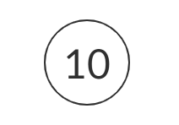

2. Insert 20

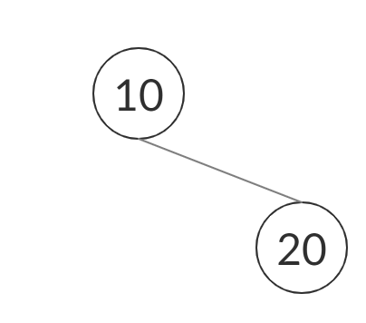

3. Insert 4

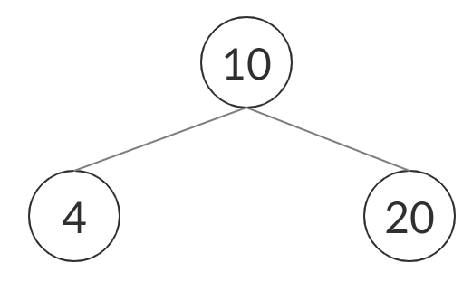

4. Insert 8

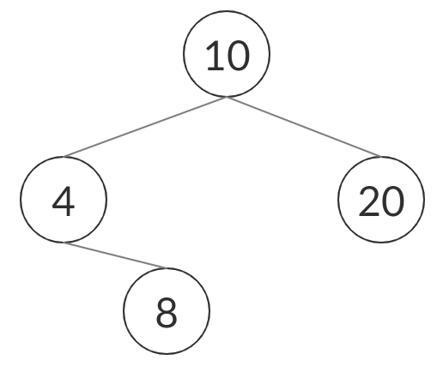

5. Insert 15

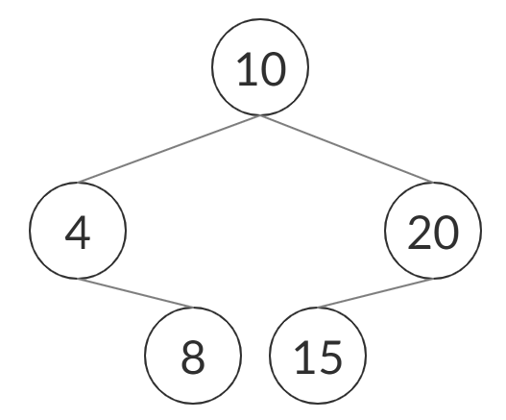

6. Erase 8

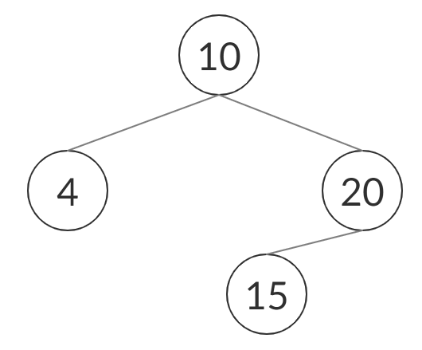

7. Erase 10

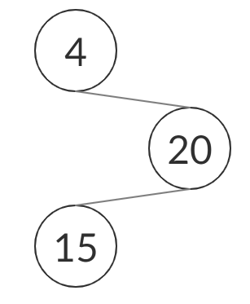

The tree that has shown in the final step is also the result tree after operations.

Answer for Question 2:

Here is an example Binary Search Tree:

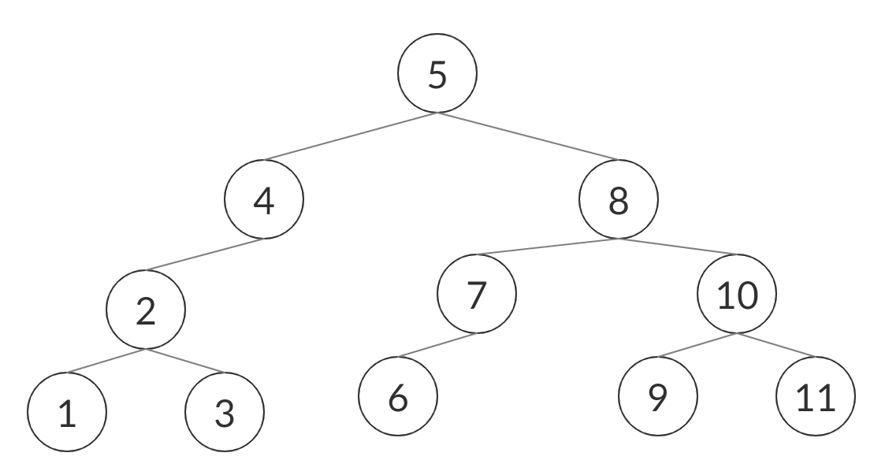

The in-order traversal for this tree will be:

1 2 3 4 5 6 7 8 9 10 11

For removing a node in a BST:

* If the node is an external node, directly remove that node.

For example, after we remove key 1 in the binary tree shown above, it will look like:

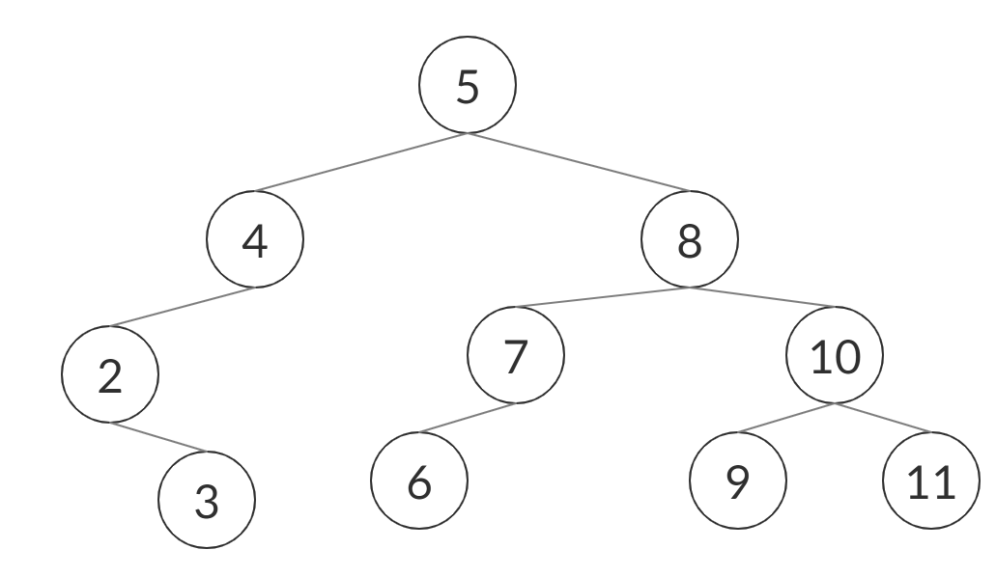

The in-order traversal for this tree will be:

2 3 4 5 6 7 8 9 10 11

* If the node has only left child or right child, use that child to replace the node that we plan to remove.

For example, after we remove key 4 in the binary tree shown above, it will look like:

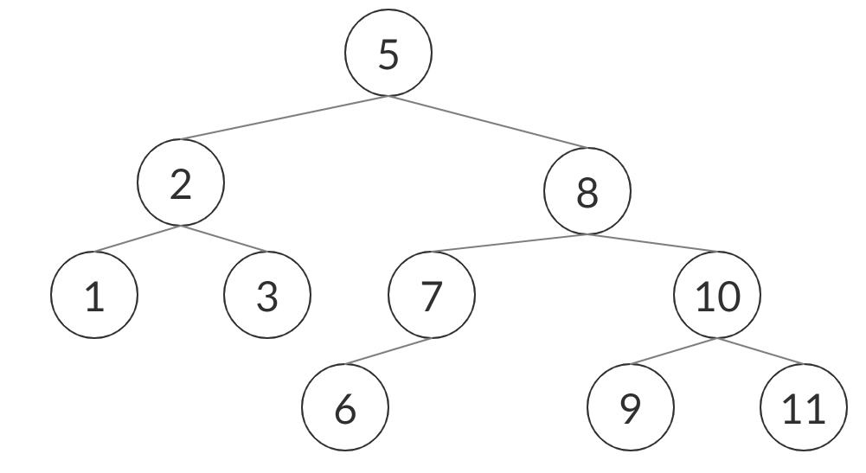

The in-order traversal for this tree will be:

1 2 3 5 6 7 8 9 10 11

* If the node has both left child and right child, use the left child to replace the node that we plan to remove.

For example, after we remove key 5 in the binary tree shown above, it will look like:

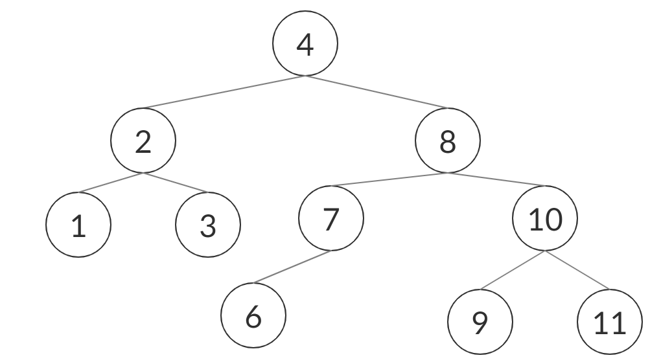

The in-order traversal for this tree will be:

1 2 3 4 6 7 8 9 10 11