## CSCI 140 PA 11 Submission

## Due Date: 11/16/2021 Late (date and time):_________________

## Name(s): Nero Li

Header file for both exercise

AVLEntry.h:

#ifndef AVLENTRY_H

#define AVLENTRY_H

// Updated Fall 21

template <typename E>

class AVLEntry : public E { // an AVL entry

private:

int ht; // node height

protected:

typedef typename E::Key K; // key type

typedef typename E::Value V; // value type

int height() const { return ht; } // get height

void setHeight(int h) { ht = h; } // set height

public:

AVLEntry(const K& k = K(), const V& v = V()) // constructor

: E(k, v), ht(0) { }

int getHeight() const { return ht; }

template <typename F>

friend class AVLTree; // allow AVLTree access

};

#endif

AVLTree1.h:

#ifndef AVLTREE_H

#define AVLTREE_H

// Updated Fall 21

// Should work reasonably well.

// Report bugs and possible fixes for extra credit.

#include <list>

#include "AVLEntry.h"

#include "bst1.h"

template <typename E> // an AVL tree

class AVLTree : public SearchTree< AVLEntry<E> > {

public:

typedef AVLEntry<E> AVLEntry; // an entry

typedef typename SearchTree<AVLEntry>::Iterator Iterator; // an iterator

protected:

typedef typename AVLEntry::Key K; // a key

typedef typename AVLEntry::Value V; // a value

typedef SearchTree<AVLEntry> ST; // a search tree

typedef typename ST::TPos TPos; // a tree position

typedef typename ST::BinaryTree::PositionList PositionList;

public:

AVLTree() : ST() { } // constructor

Iterator insert(const K& k, const V& x) // insert (k,x)

{

TPos v = ST::inserter(k, x); // insert in base tree

setHeight(v); // compute its height

rebalance(v); // rebalance if needed

return Iterator(v);

}

void erase(const K& k) // remove key k entry

{

TPos v = ST::finder(k, ST::root()); // find in base tree

if (Iterator(v) == ST::end()) // not found?

throw NonexistentElement("Erase of nonexistent");

TPos w = ST::eraser(v); // remove it

rebalance(w); // rebalance if needed

}

void erase(Iterator p) { // remove entry at p

ST::eraser(p.v);

}

int countDepth(TPos v)

{

if (v.isRoot())

{

return 0;

}

else

{

return 1 + countDepth(v.parent());

}

}

void draw()

{

PositionList pl;

int maxHeight;

pl = ST::getTree().positions();

maxHeight = height(ST::root());

while (!pl.empty())

{

if ((*pl.front()).key())

{

for (int i = 1; i < countDepth(pl.front()); ++i)

{

cout << " ";

}

cout << (*pl.front()).key() << endl;

}

pl.pop_front();

}

}

protected:

int height(TPos v) const // node height utility

{

return (v.isExternal() ? 0 : (*v).height());

}

void setHeight(TPos v) // set height utility

{

int hl = height(v.left());

int hr = height(v.right());

(*v).setHeight(1 + std::max(hl, hr)); // max of left & right

}

bool isBalanced(const TPos& v) const // is v balanced?

{

int bal = height(v.left()) - height(v.right());

return ((-1 <= bal) && (bal <= 1));

}

TPos tallGrandchild(const TPos& z) const // get tallest grandchild

{

TPos zl = z.left();

TPos zr = z.right();

if (height(zl) >= height(zr)) // left child taller

if (height(zl.left()) >= height(zl.right()))

return zl.left();

else

return zl.right();

else // right child taller

if (height(zr.right()) >= height(zr.left()))

return zr.right();

else

return zr.left();

}

void rebalance(const TPos& v) // rebalance utility

{

TPos z = v;

while (!(z == ST::root())) { // rebalance up to root

z = z.parent();

setHeight(z); // compute new height

if (!isBalanced(z)) { // restructuring needed

TPos x = tallGrandchild(z);

z = ST::restructure(x); // trinode restructure

setHeight(z.left()); // update heights

setHeight(z.right());

setHeight(z);

}

}

}

};

#endif

Exercise 1 -- need to submit source code and I/O  
 -- check if completely done ✔️ ; otherwise, discuss issues below

Source code below:

/* Program: PA_11_exercise_1

Author: Nero Li

Class: CSCI 220

Date: 11/16/2021

Description:

Use AVLTree class in C++ book (modified by me and provided here)

and set up a test driver to perform some operations such as insert,

erase, and find. Perform the operations in question 1 below (steps

1 to 7) and then search for 15, 30, and 8. Print the BST as the final

step. Assume that key is an integer and value is a string such as a

name (come up with your own names).

I certify that the code below is my own work.

Exception(s): N/A

*/

#include <iostream>

#include "Entry.h"

#include "AVLEntry.h"

#include "AVLTree1.h"

using namespace std;

void findKey(int key,AVLTree<AVLEntry<Entry<int, char>>> test, AVLTree<AVLEntry<Entry<int, char>>>::Iterator itr)

{

itr = test.find(key);

if (!(itr == test.end()))

{

cout << (*itr).key() << ": " << (*itr).value() << ',' << (*itr).getHeight() << endl;

}

}

int main()

{

AVLTree<AVLEntry<Entry<int, char>>> test;

AVLTree<AVLEntry<Entry<int, char>>>::Iterator itr{NULL};

test.insert(10, 'a');

test.insert(20, 'b');

test.insert(4, 'c');

test.insert(8, 'd');

test.insert(15, 'e');

test.erase(8);

test.erase(10);

findKey(15, test, itr);

findKey(30, test, itr);

findKey(8, test, itr);

itr = test.begin();

while (!(itr == test.end()))

{

cout << (*itr).key() << ' ';

++itr;

}

cout << endl;

cout << "Modified by: Nero Li\n";

return 0;

}

Input/output below:

15: e,2

4 15 20

Modified by: Nero Li

Exercise 2 (with extra credit) -- need to submit source code and I/O  
 -- check if completely done ✔️ ; otherwise, discuss issues below

Source code below:

/* Program: PA_11_exercise_2

Author: Nero Li

Class: CSCI 220

Date: 11/16/2021

Description:

You will implement a better population database for California counties

using an AVL tree from exercise 1 to store the database records. Define

and implement PopBetterMap class that supports standard map operations

using county code as a key for each record (no duplicate keys). Your

PopBetterMap class uses an AVL tree to store population records. Download

the data file p4small.txt, containing a list of a few population records

– county code, population in million, and county with state abbreviation

(3 fields separated by commas). Build the AVL tree from the records of the

input data file by inserting one record at a time to the tree.

I certify that the code below is my own work.

Exception(s): N/A

*/

#include <iostream>

#include <fstream>

#include <string>

#include <list>

#include "Entry.h"

#include "AVLEntry.h"

#include "AVLTree1.h"

using namespace std;

class PopBetterMap

{

private:

struct County

{

int pop;

string county;

};

AVLTree<AVLEntry<Entry<int, County>>> countyTree;

AVLTree<AVLEntry<Entry<int, County>>>::Iterator itr{NULL};

public:

// constructor accepts file name and construct search tree

PopBetterMap(string filename)

{

ifstream fin;

string countyData;

fin.open(filename, ios::binary);

while (!fin.eof())

{

County newData;

int code{-1};

bool gotKey{false};

newData.pop = -1;

newData.county = "";

getline(fin, countyData);

for (int i = 0; i < countyData.size(); ++i)

{

if (countyData[i] == ',')

{

gotKey = true;

}

else if (countyData[i] >= '0' && countyData[i] <= '9')

{

if (gotKey)

{

if (newData.pop == -1)

{

newData.pop = countyData[i] - '0';

}

else

{

newData.pop *= 10;

newData.pop += countyData[i] - '0';

}

}

else

{

if (code == -1)

{

code = countyData[i] - '0';

}

else

{

code *= 10;

code += countyData[i] - '0';

}

}

}

else if (countyData[i] == '\"')

{

++i;

while (countyData[i] != '\"')

{

newData.county += countyData[i];

++i;

}

}

}

countyTree.insert(code, newData);

}

countyTree.erase(-1);

}

// print appropriate message and data if found

void find(int code)

{

itr = countyTree.find(code);

if (itr == countyTree.end())

{

cout << "Nothing found.\n";

}

else

{

cout << (*itr).key() << "," << (*itr).value().pop << ",\"" << (*itr).value().county << "\"" << endl;

}

cout << endl;

}

// print appropriate message and insert node if not found

// replace data if found

void insert(int code, int pop, string county)

{

County newData;

newData.county = county;

newData.pop = pop;

itr = countyTree.find(code);

if (itr == countyTree.end())

{

cout << "Inserting a new data...\n";

}

else

{

cout << "Replacing exist data...\n";

}

countyTree.insert(code, newData);

cout << endl;

}

// print appropriate message and erase node if found

void erase(int code)

{

itr = countyTree.find(code);

if (itr == countyTree.end())

{

cout << "Nothing found...\n";

}

else

{

cout << "Found data:\n";

cout << (*itr).key() << "," << (*itr).value().pop << ",\"" << (*itr).value().county << "\"" << endl;

countyTree.erase(code);

cout << "Data erased...\n";

}

cout << endl;

}

// print one record per line using an in-order traversal

void print()

{

itr = countyTree.begin();

while (!(itr == countyTree.end()))

{

cout << (*itr).key() << "," << (*itr).value().pop << ",\"" << (*itr).value().county << "\"" << endl;

++itr;

}

cout << endl;

}

// Draw the tree (key only)

void draw()

{

countyTree.draw();

}

};

void menu()

{

cout << " Operating Menu\n" << endl;

cout << "1. List all records" << endl;

cout << "2. Search for record" << endl;

cout << "3. Insert new record" << endl;

cout << "4. Delete a record" << endl;

cout << "5. Draw the tree" << endl;

cout << "6. Exit program" << endl;

cout << endl;

}

int main()

{

PopBetterMap p4small("p4small.txt");

int choice;

int code;

int pop;

string county;

bool exitCode{true};

menu();

while (exitCode)

{

cout << "Please input your option: \n";

cin >> choice;

switch (choice)

{

case 1:

p4small.print();

break;

case 2:

cout << "Please input the code: \n";

cin >> code;

p4small.find(code);

break;

case 3:

cout << "Please input the code: \n";

cin >> code;

cout << "Please input the population: \n";

cin >> pop;

cout << "Please input the county data: \n";

getline(cin, county);

getline(cin, county);

p4small.insert(code, pop, county);

break;

case 4:

cout << "Please input the code: \n";

cin >> code;

p4small.erase(code);

break;

case 5:

p4small.draw();

break;

case 6:

exitCode = false;

cout << endl;

break;

default:

break;

}

}

cout << "Modified by: Nero Li\n";

return 0;

}

Input/output below:

Operating Menu

1. List all records

2. Search for record

3. Insert new record

4. Delete a record

5. Draw the tree

6. Exit program

Please input your option:

1

6001,3648,"Alameda, CA"

6019,1242,"Fresno, CA"

6037,22851,"Los Angeles, CA"

6047,341,"Merced, CA"

6055,225,"Napa, CA"

6059,6214,"Orange, CA"

6065,1784,"Riverside, CA"

6067,1809,"Sacramento, CA"

6071,1920,"San Bernardino, CA"

6073,5351,"San Diego, CA"

6075,2039,"San Francisco, CA"

6083,721,"Santa Barbara, CA"

6097,655,"Sonoma, CA"

6111,1130,"Ventura, CA"

Please input your option:

5

6059

6019

6001

6047

6037

6055

6075

6071

6065

6067

6073

6097

6083

6111

Please input your option:

2

Please input the code:

6037

6037,22851,"Los Angeles, CA"

Please input your option:

2

Please input the code:

6000

Nothing found.

Please input your option:

3

Please input the code:

6066

Please input the population:

1

Please input the county data:

New County, CA

Inserting a new data...

Please input your option:

3

Please input the code:

6065

Please input the population:

2000

Please input the county data:

Riverside, CA

Replacing exist data...

Please input your option:

4

Please input the code:

6999

Nothing found...

Please input your option:

4

Please input the code:

6075

Found data:

6075,2039,"San Francisco, CA"

Data erased...

Please input your option:

4

Please input the code:

6055

Found data:

6055,225,"Napa, CA"

Data erased...

Please input your option:

1

6001,3648,"Alameda, CA"

6019,1242,"Fresno, CA"

6037,22851,"Los Angeles, CA"

6047,341,"Merced, CA"

6059,6214,"Orange, CA"

6065,2000,"Riverside, CA"

6066,1,"New County, CA"

6067,1809,"Sacramento, CA"

6071,1920,"San Bernardino, CA"

6073,5351,"San Diego, CA"

6083,721,"Santa Barbara, CA"

6097,655,"Sonoma, CA"

6111,1130,"Ventura, CA"

Please input your option:

5

6059

6019

6001

6047

6037

6083

6071

6066

6065

6067

6073

6097

6111

Please input your option:

6

Modified by: Nero Li

Answer for Question 1:

1. Insert 10

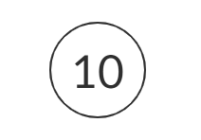

2. Insert 20

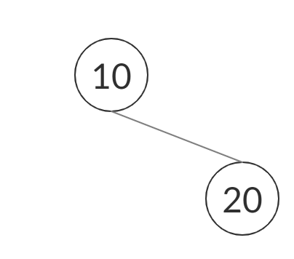

3. Insert 4

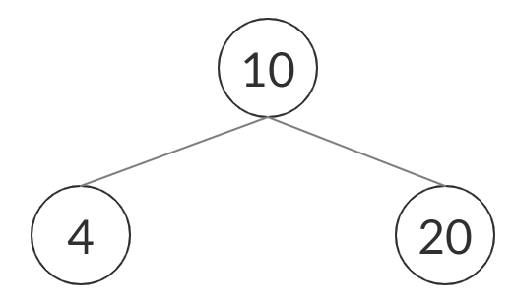

4. Insert 8

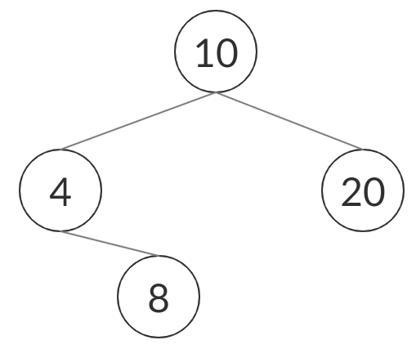

5. Insert 15

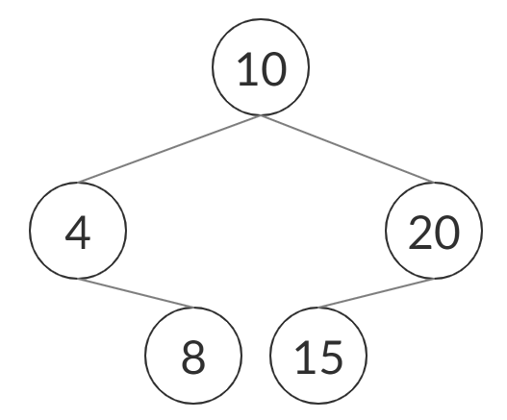

6. Erase 8

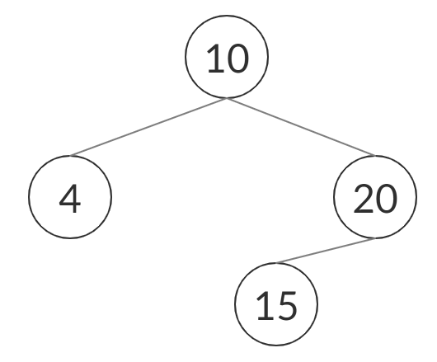

7. Erase 10

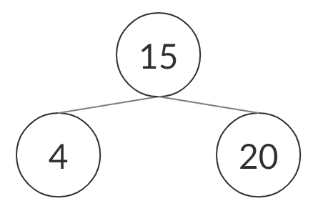

The tree that has shown in the final step is also the result tree after operations.

Answer for Question 2:

For a Splay tree, it is another kind of balanced binary search tree, and it will use splaying to make itself become a balanced binary tree when the function went to the external node. It guarantees the running time for search, insert, and remove be O(logn).

Since we need to reconstruct the tree during the operation, I suggest using the inheritance from an AVL Tree to create our Splay Tree class since the rotate is a good function for us to move a node to its root, which is also the main idea for the Splay tree. Because of that, creating a new splay(Tpos v) function and using rotate to make sure node v has become the root is a good idea for the class.