ili934 Code

Table of Contents
Initial Project Structure 1

Initial Project Structure

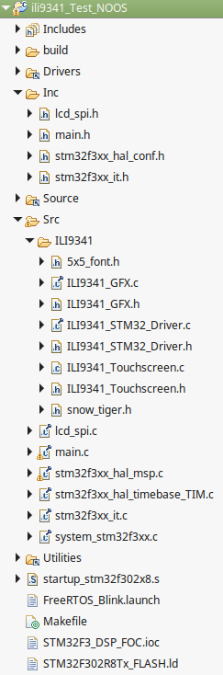

Main.c – main loop calls:
ILI9341_Init(); ILI9341_STM323_Driver.c
1. Initialises SPI port
2. Hard resets LCD (uses HAL lib e.g. HALL_GPIO_WritePin, HAL_Delay etc)
3. Setsup/Initialises LCD using series of commands

Testing:

Capture at startup:

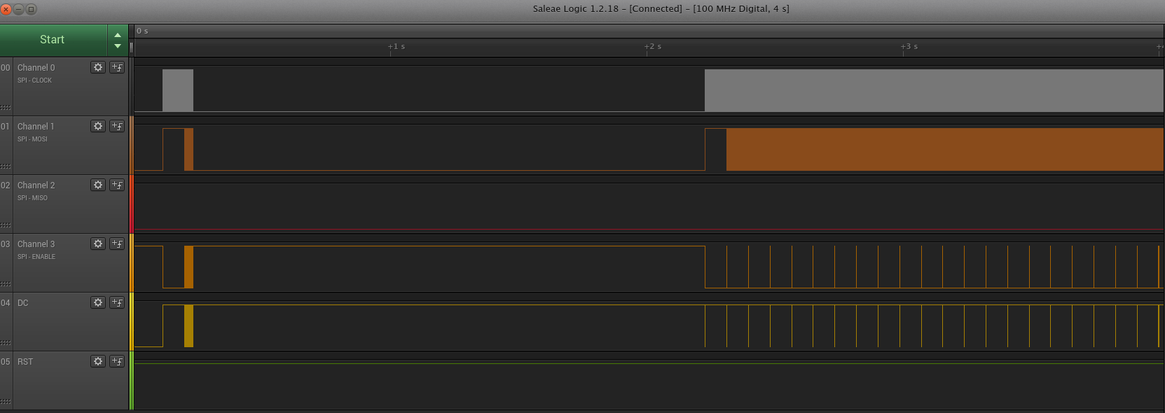
Things to note:
1. MISO does not receive anything from the LCD
2. RST (Reset Pin) does not toggle (wasnt setup in code). However LCD works.

SPI Clock frequency = 16.67 MHz (SPI3 clocks from APB1 which has a max clock rate of 36 MHz. In this program APB1 clocks at 32 MHz and SPI3 divides this by 2) The fact I'm measuring 16.67 is either down to the logic analyzers sample rate or the RC internal oscillator accuracy).

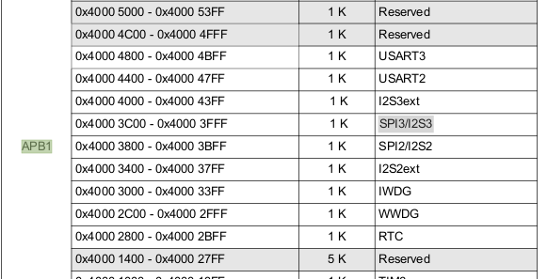

Chip select is set low for a long period relative to the SPI command.

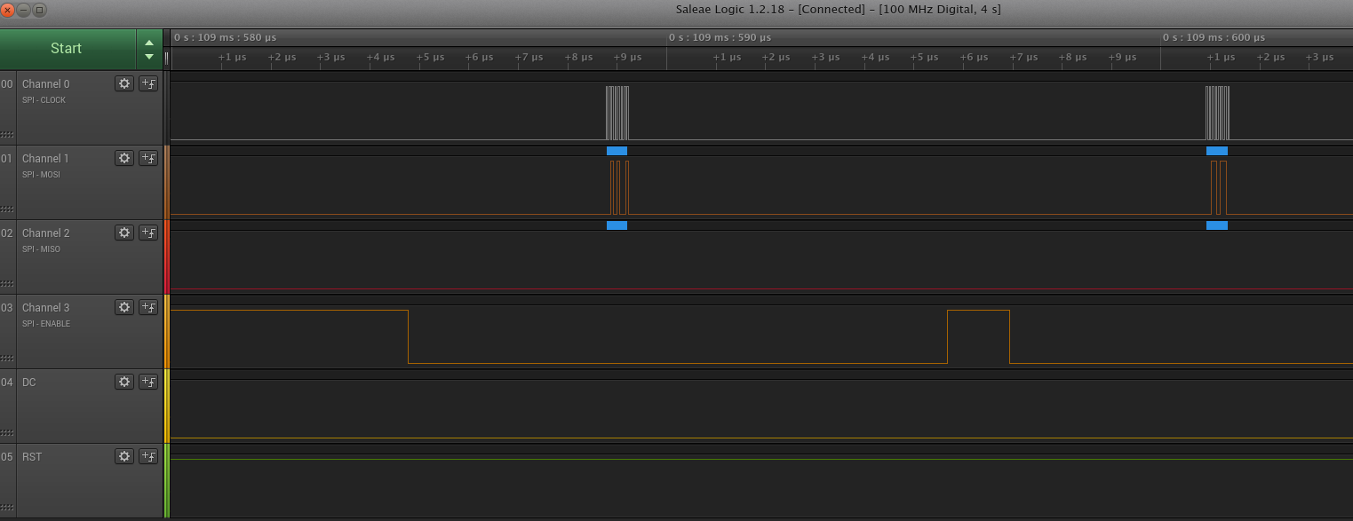

SPI Clock on rising edge
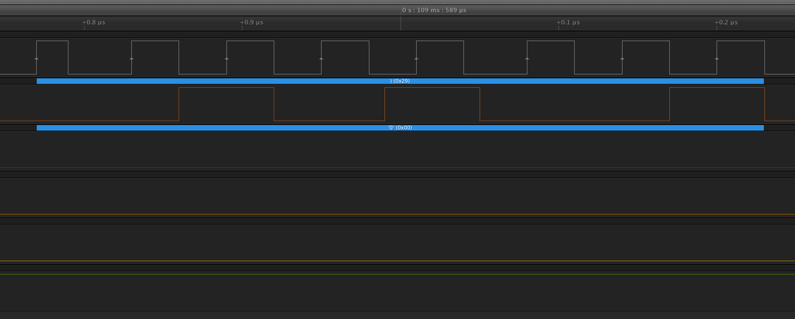

SPI Commands:

//POWER CONTROL A
ILI9341_Write_Command(0xCB);
ILI9341_Write_Data(0x39);
ILI9341_Write_Data(0x2C);
ILI9341_Write_Data(0x00);
ILI9341_Write_Data(0x34);
ILI9341_Write_Data(0x02);

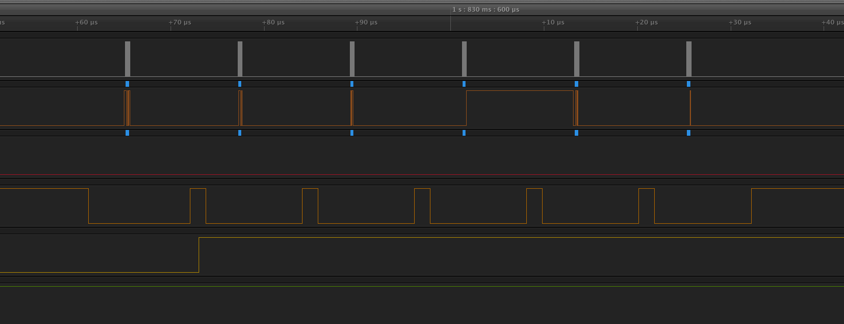
Shows command (which takes 0.5 uS):

