MODULE-2
GPU programming, Programming hybrid systems, MIMD systems, GPUs, Performance —Speedup and efficiency in MIMD systems, Amdahl’s law, Scalability in MIMD systems, Taking timings of MIMD programs, GPU performance.
2.1GPU Programming
2.1GPU Programming
GPU programming involves writing code for both the CPU host and the GPU device. Unlike general-purpose CPUs, GPUs are not standalone processors—they typically don’t run an operating system or provide services like direct access to secondary storage. Hence, the host CPU manages the allocation and initialization of memory on both itself and the GPU, launches the GPU kernel, and collects the resulting output. This style of programming is called heterogeneous programming because it involves two types of processors working together.
Each GPU processor can run hundreds to thousands of threads, and they share a large block of memory. Additionally, every GPU processor has a smaller, faster memory block, accessible only to its own threads—serving as a programmer-managed cache.
Threads are organized into groups, where threads within a group follow the SIMD model. Threads across groups can run independently, but within a group, no thread can proceed to the next instruction until all threads complete the current one. This impacts performance especially when branching occurs within a SIMD group.
Here is an example snippet from GPU thread execution:
// Thread private variables
int rank_in_gp, my_x;
...
if (rank_in_gp < 16)
my_x += 1;
else
my_x -= 1;
In this example, threads with rank_in_gp < 16 will execute the my_x += 1 instruction, while the rest are idle. Then, threads with rank_in_gp ≥ 16 execute my_x -= 1, while the others idle. This two-phase execution causes resource underutilization, and it's up to the programmer to minimize such branching for efficiency.
Another distinct feature of GPUs is their hardware-based thread scheduler. Unlike CPUs that use software to schedule tasks, the GPU scheduler incurs very low overhead. It executes a SIMD group only when all its threads are ready, thus requiring careful data preparation, such as registering rank_in_gp in advance.
To optimize throughput, programmers often create multiple SIMD groups. When one group is waiting for memory or dependent operations, another group can be

scheduled immediately, which helps to hide memory latency and maximize GPU utilization.
2.1.2 Programming Hybrid Systems
In modern parallel computing, it is possible to program hybrid systems, such as clusters of multicore processors, by using a combination of APIs. Typically, a shared-memory API (such as OpenMP) is used within each node, while a distributed-memory API (like MPI) is used for communication between nodes. This approach allows the system to exploit both shared and distributed memory architectures simultaneously.
However, this hybrid programming model is generally adopted only in cases where the highest possible performance is required. The reason is that using two different APIs in the same program significantly increases development complexity. The programmer must manage both intra-node synchronization and inter-node message passing, which makes the software harder to design, debug, and maintain.
As a result, many such systems are programmed using only a single distributed- memory API, like MPI, to handle both inter-node and intra-node communication. While this may not be the most efficient approach in terms of raw performance, it offers simplicity and portability, which are often more valuable in practical application development.
2.2Input and Output
When it comes to parallel computing, input and output (I/O) present unique challenges. In most basic programs, I/O operations are minimal and handled using standard C I/O functions such as printf, fprintf, scanf, and fscanf. However, when these functions are used in parallel programs, issues can arise due to their sequential nature and lack of built-in support for concurrent access.
2.2.1MIMD systems
In MIMD systems, each process may attempt to access stdin, stdout, or stderr. Since these standard streams were designed for serial usage, when multiple processes or threads try to read from or write to them, the behavior becomes nondeterministic. For example, output might appear in a different order each time the program is executed, or worse, the output from one process might interleave with the output from another.
In practical parallel systems, it is common for only one process (usually process 0) to read input via scanf, and typically only that process will access stdin. All processes may be allowed to write to stdout, but this often leads to interleaved or jumbled output, especially during debugging.
To ensure clarity and correctness, the following guidelines are often followed in I/O handling:
• In distributed-memory programs, only process 0 accesses stdin.
• In shared-memory programs, thread 0 or the master thread reads from stdin.

• All processes or threads can write to stdout and stderr, but usually only one is designated to do so, to preserve output order.
• Each process or thread should use a private file for reading or writing to avoid file conflicts.
• Debugging output should always include the process or thread ID to identify the source.
For example:
printf("Process %d: value = %d\n", rank, value);
This helps identify which process produced the output.
2.2.2GPUs and I/O
In GPU programming, I/O is typically performed by the host CPU code. The GPU device itself does not have access to operating system services, so it cannot interact directly with secondary storage, stdin, or stderr.
Thus, in GPU programs:
• All I/O operations (input, output, file access) are handled by the host.
• Only one process/thread runs on the host, so standard C I/O behaves as expected.
• During GPU kernel debugging, threads may write to stdout, but the output will again be nondeterministic.
• GPU threads do not have access to stderr, stdin, or files.
This I/O design in GPU systems ensures that data is loaded and output by the host and not the device itself. During debugging, you can enable selective printf statements inside the kernel, but the output should not be relied upon for sequence or consistency across runs.
2.3Performance
The main motivation for writing parallel programs is to achieve better performance. To evaluate this, we examine speedup and efficiency, especially in homogeneous MIMD systems, where all cores share the same architecture.
2.3.1Speedup and Efficiency in MIMD Systems
In the ideal case, a program using p cores would run p times faster than its serial counterpart, assuming perfect workload division and no additional overhead.

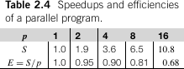
Let:
• T_serial = Time taken by the serial program
• T_parallel = Time taken by the parallel version
Then:
Speedup:
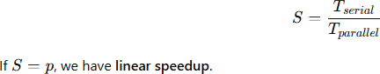
Efficiency:
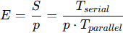
This gives the average utilization of each core. Efficiency decreases as parallel
overhead increases with more threads or processes.
Calculating Efficiency
Suppose T_serial = 24 ms, T_parallel = 4 ms, and p = 8:
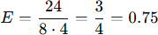
Each core works for 3 ms on actual problem solving and 1 ms is spent in overhead.
Common overheads include:
• In shared-memory systems: mutexes used in critical sections slow down
execution.
• In distributed-memory systems: communication delays across the network
reduce performance.
Thus, as p increases:
• Speedup increases sub-linearly
• Efficiency decreases

Problem Size and Its Impact
Speedup and efficiency also depend on problem size. If the problem is:
• Smaller → less work per core → higher overhead proportion
• Larger → more work per core → better efficiency Reference: Table 2.5
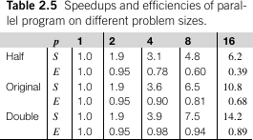
Figure 2.18 shows the speedup curve.
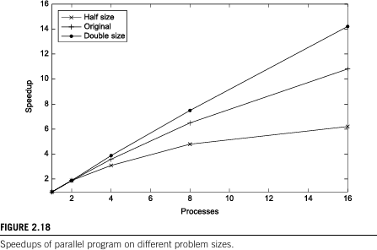
Figure 2.19 shows the efficiency trend.
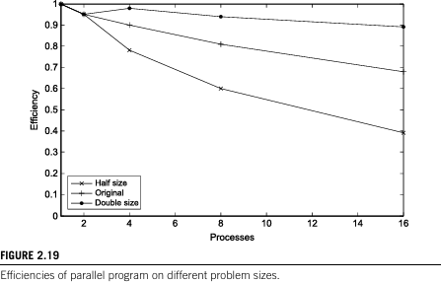
As seen in both figures, increasing problem size improves both speedup and efficiency, because T_serial grows faster than overhead Toverhead.

Overhead Model
In many programs:
Tparallel=Tserialp+ToverheadT_{parallel} = \frac{T_{serial}}{p} + T_{overhead}Tparallel =pTserial+Toverhead
The total runtime is the sum of time spent solving the actual problem and the time spent in synchronization, communication, etc.
Choosing T_serial for Comparison
There are two approaches:
• Use the fastest serial algorithm on the fastest system (idealistic)
• Use the serial version of the parallel program running on one processor of the same system (practical and common)
The second method better reflects the realistic utilization of available cores and is used in most analyses.
2.3.2Amdahl’s Law
Amdahl’s Law, formulated by Gene Amdahl in the 1960s, highlights a significant limitation in parallel computing. It states that unless virtually all of a serial program is parallelized, the overall speedup achievable will be very limited, no matter how many cores are available. Suppose 90% of a serial program is successfully parallelized. Assuming perfect parallelization, the parallel portion of the program will scale with the number of cores, p, and the speedup for that part will be p.
If theserialrun-timeisTserial=20 seconds,theparallelizedpartwouldrun in
, while the remaining serial part would take2
. Therefore, the total parallel run-time becomes
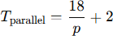
and the speedup is
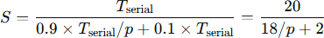
As p becomes very large, the term becomes smaller, approaching 0. The total parallel
run-time can never be smaller than 2 seconds, which means the speedup is limited to
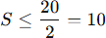

Thus, even with perfect parallelization of 90% of the program and an infinite number of cores, the maximum speedup will not exceed 10.
In general, if a fraction r of the program remains unparallelized, Amdahl’s Law asserts that the speedup cannot exceed
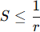
In the example. If r is as small as 1/100, the maximum speedup is still limited to 100, regardless of the number of processors. This result emphasizes that even a small serial portion can severely limit the total performance gain.
Although this may seem discouraging, there are reasons not to be overly concerned. The law does not take problem size into account. As the problem size increases, the fraction of the code that is inherently serial often becomes smaller. A more mathematical perspective of this is expressed in Gustafson’s Law. Additionally, many programs used in scientific and engineering domains routinely achieve substantial speedups on large distributed-memory systems. In practice, a speedup of 5 or 10 may be sufficient, especially when the effort to parallelize the program is not significant.
2.3.3Scalability in MIMD Systems
The term "scalable" is commonly used in informal contexts to describe how well a system or program handles growth. In parallel computing, scalability refers to whether a program continues to demonstrate performance gains as the computing power increases, for example, by increasing the number of cores. In a more formal context, especially for MIMD (Multiple Instruction, Multiple Data) systems, a program is said to be scalable if increasing the number of processes or threads and the problem size proportionally results in unchanged efficiency.
Let us consider a scenario where a parallel program is run with a fixed number of threads/processes and a fixed input size, yielding an efficiency EEE. If we increase the number of processes/threads and also increase the problem size such that the efficiency remains constant, then the program is scalable.
Suppose the serial run-time is given by
where n represents both time (in microseconds) and problem size. Also, suppose the parallel run-time is given by

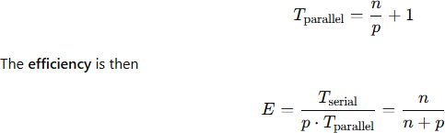
To test scalability, let us scale the number of processes/threads by a factor of k, resulting in kp threads. We now want to find the scaling factor x such that the problem size becomes xn, and the efficiency remains the same.
The new efficiency becomes
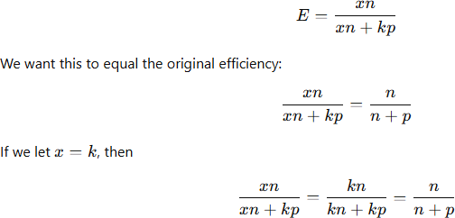
This confirms that increasing the problem size by the same factor as the number of processes/threads maintains constant efficiency, thus making the program scalable.
There are two specific cases of scalability:
• If the efficiency remains constant without increasing the problem size, even when the number of threads increases, the program is called strongly scalable.
• If the efficiency remains constant only when the problem size increases at the same rate as the number of threads, the program is called weakly scalable.
In the above example, the program would be classified as weakly scalable since it requires proportional scaling of both threads and problem size to maintain efficiency.
2.3.4Taking Timings of MIMD Programs
To evaluate the performance of parallel programs, it's essential to determine the values of Tserial and Tparallel Depending on the phase of development, we may take timings for different purposes. During program development, detailed timings help identify performance issues like message waiting time in distributed-memory programs. However, when evaluating final performance, we often focus on overall execution time, reporting just a single elapsed value.
In performance studies, we're generally not concerned with the total program runtime (from launch to exit), but only the runtime of critical code sections, such as the sorting

phase in a sorting algorithm. Thus, general-purpose tools like the time command in Unix are often unsuitable.
Moreover, we rarely use CPU time (e.g., reported by clock() in C), which only accounts for time actively spent executing code. It excludes idle time, such as when a process is blocked waiting for communication. For example, if a process is waiting in a receive() call, it might be sleeping and not using the CPU, but it still affects the real-time performance of the application.
Hence, we typically use wall clock time, which measures the actual elapsed time from start to end of a code segment. It’s equivalent to manually starting and stopping a stopwatch. The timing code would look like:
double start, finish;
start = Get_current_time();
/* Code to be timed */
finish = Get_current_time();
printf("Elapsed time = %e seconds\n", finish - start);
Here, Get_current_time() is a placeholder. In MPI, this could be MPI_Wtime(), while in OpenMP, we might use omp_get_wtime(). Both return wall clock time.
The resolution of the timing function (smallest measurable time unit) is critical. If a timer only has millisecond resolution, very fast code (e.g., nanoseconds per instruction) may appear to take zero time. Some APIs provide functions to query the timer resolution, while others guarantee a specific resolution. As developers, we must verify timer accuracy.
For parallel programs, we often care about global elapsed time—the time from when the first thread/process starts until the last one finishes. This differs from each process measuring its own time. A typical strategy is:
shared double global_elapsed;
private double my_start, my_finish, my_elapsed;
Barrier();
my_start = Get_current_time();
/* Code to be timed */
my_finish = Get_current_time();
my_elapsed = my_finish - my_start;
global_elapsed = Global_max(my_elapsed);
if (my_rank == 0)
printf("Elapsed time = %e seconds\n", global_elapsed);
Here, a barrier ensures all processes begin approximately together. After timing, a global maximum of elapsed times is computed to represent the total parallel runtime.
It's also important to consider variability in timing results. Even with the same input and system, runtime often fluctuates due to system noise. Instead of reporting mean or median, we generally report the minimum runtime, assuming it's the best approximation of true performance.

Running more than one thread per core increases variability and overhead due to thread scheduling. Hence, it is best to run one thread per core for consistent and optimal timing.
Finally, since I/O is not the focus, we exclude file or console input/output from performance timings.
2.3.5GPU Performance
When evaluating the performance of parallel programs, we often compare them against equivalent serial programs. This approach works well for MIMD systems, where we assume that both the serial and parallel versions are executed on identical types of cores. However, this assumption doesn’t hold for GPU programs, because GPU cores are fundamentally different from traditional CPU cores. As a result, using concepts like efficiency or linear speedup—common in MIMD performance evaluation—does not make sense for GPU programs.
Even though we cannot compute efficiency in the traditional sense, it’s common to report speedups of GPU programs over either serial CPU programs or parallel MIMD programs. However, since GPU cores are highly parallel in nature, comparing them to serial CPUs using standard metrics like efficiency is generally inapplicable.
The same applies to scalability. While the formal definition of scalability used for MIMD systems doesn't apply, we often use an informal definition: a GPU program is considered scalable if it can run faster on a larger GPU compared to a smaller one when the problem size increases accordingly.
There is a case where Amdahl’s Law becomes relevant to GPU performance. If the serial portion of a program is executed on a conventional CPU and the parallel portion is offloaded to the GPU, then Amdahl’s Law provides a bound on the maximum achievable speedup. Specifically, if a fraction r of the total execution remains serial, the maximum possible speedup is limited to 1/r, even when using a GPU.
Just like in MIMD programs, the limitations of Amdahl’s Law still apply: the serial portion might shrink as the problem size increases, and in practice, GPU programs often achieve significant speedups. Moreover, even a modest speedup may be sufficient, depending on the application.
In terms of timing GPU programs, we can use the CPU's timer if we are measuring the entire duration of the GPU task. This involves starting the timer before launching the GPU kernel and stopping it after the GPU computation completes. This method is sufficient for most cases where the entire program's performance is being measured. However, if we need to time specific portions of GPU code, we must use the timing facilities provided by the GPU's API.

