**Instructions:**

I am going to do a very simple performance test based on different web framework below. All of the players don’t require any web servers because they can handle all http requests by themselves. I am going to simulate 1000 concurrent users and send over total 100,000 requests to each framework. The content of response is a “Hello World” string. Please see report below.

**Environment:**

Workstation: Lenovo W540

Os: Window7 Enterprise

Node.js: 0.10.26

.Net framework: 4.5

Test tool: Apache bench

**Frameworks:**

1. Web Framework: martini, Language: Google Go,
2. Web Framework: YuShan (玉山), Language: Microsoft C#
3. Web Framework: ExpressJS 4.0 RC3, Language: JavaScript

**How to test:**

1. Open your console.
2. Type in the command => ab -k -c 1000 -n 100000 <http://localhost:3000/>

**Test Result:**

Framework1: martini

Lanuch: click “server.exe”, it will listen port 3000

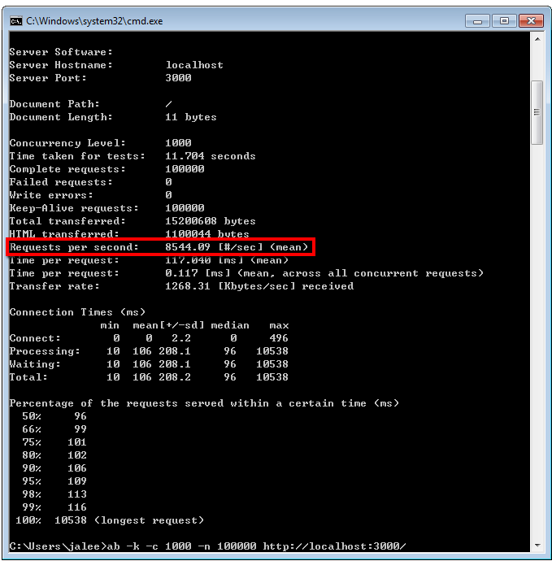

Source Code:  
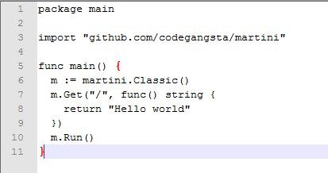

Framework 2: YuShan(玉山)

Launch: click “YuShan.exe”, it will listen port 3000

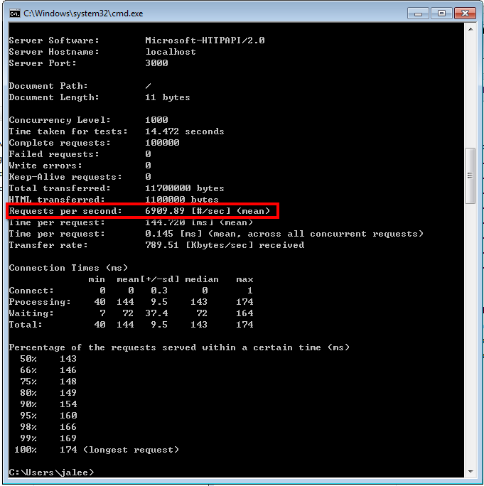

Source code:  
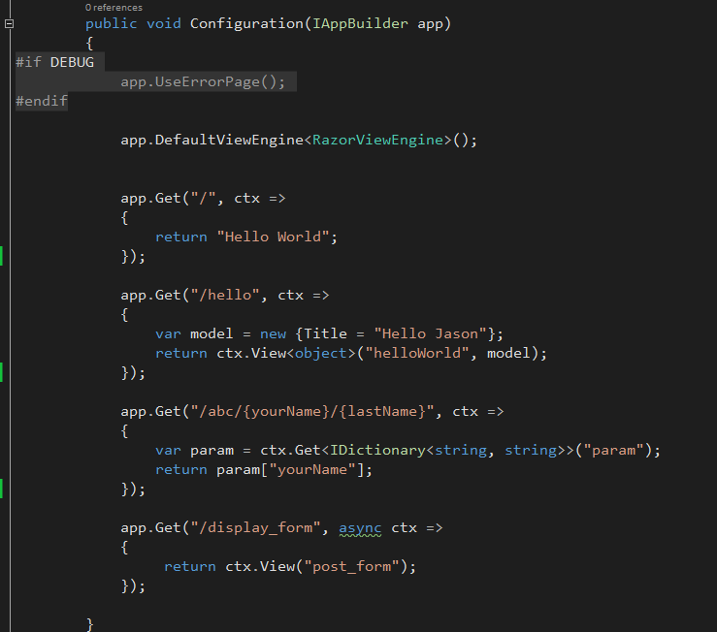

With Razor view engine:  
 hit <http://localhost:3000/hello>

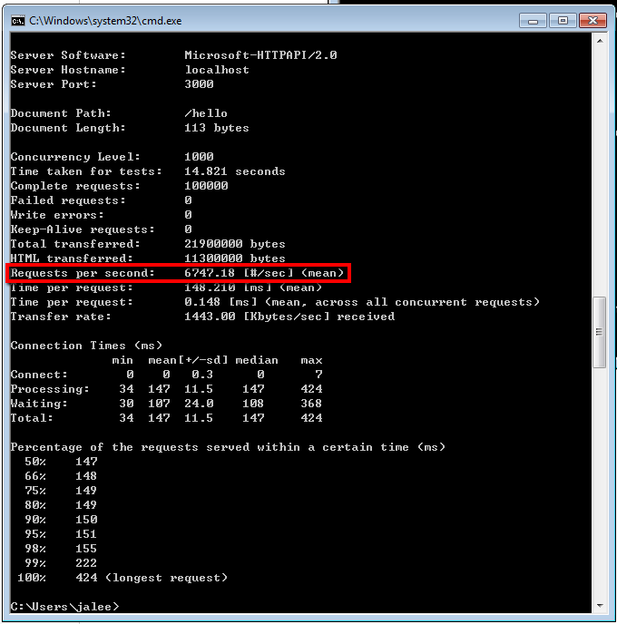

Framework 3: ExpressJS

Launch: type in “node app.js”

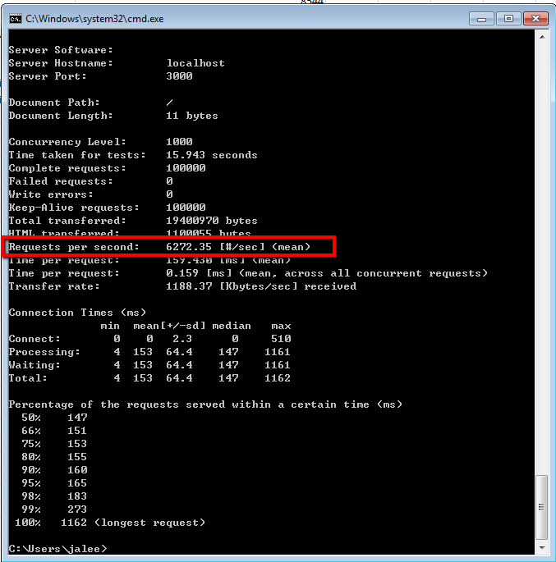

Source Code:

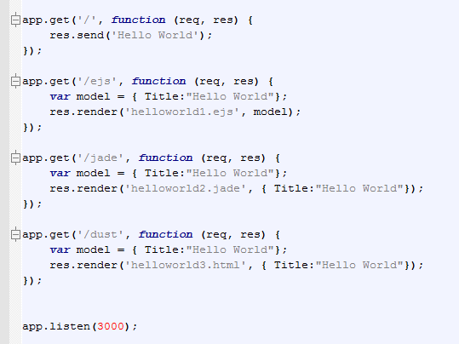

With “EJS” view engine (the view file is not cached in development mode)

Hit <http://localhost:3000/ejs>

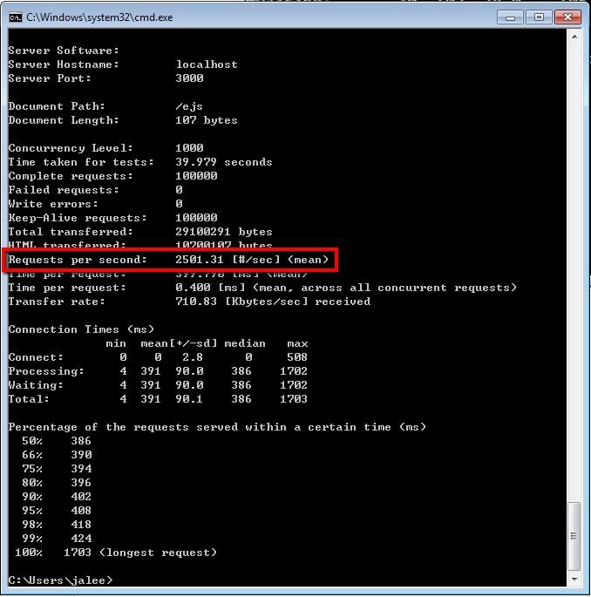

With “Jade” view engine (the view file is not cached in development mode)

Hit <http://localhost:3000/jade>

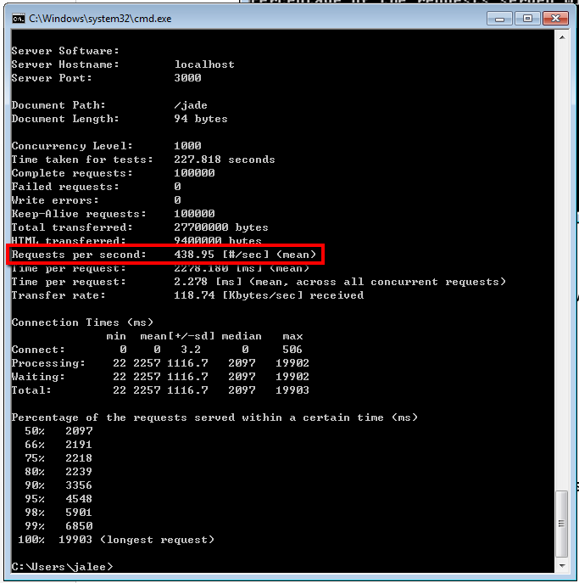

With “LinkedIn Dust” view engine (the view file is not cached in development mode)

Hit <http://localhost:3000/dust>

