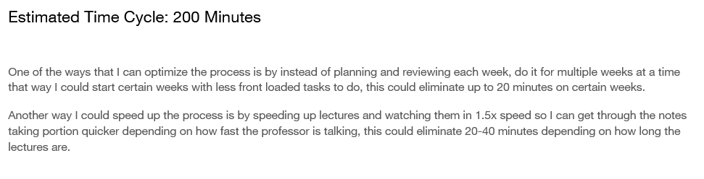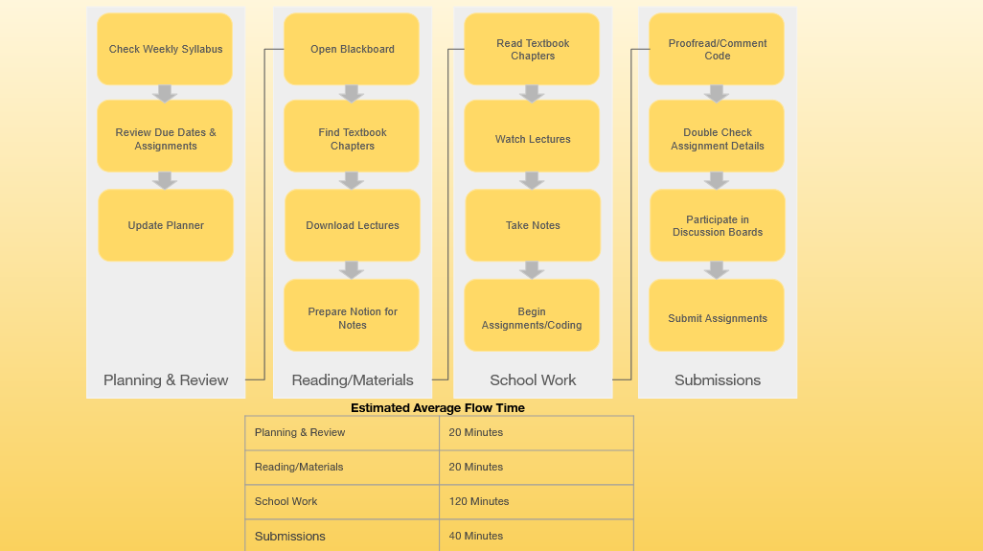

Resources:

https://www.connectall.com/3-easy-steps-for-using-vsm-in-everyday-life/