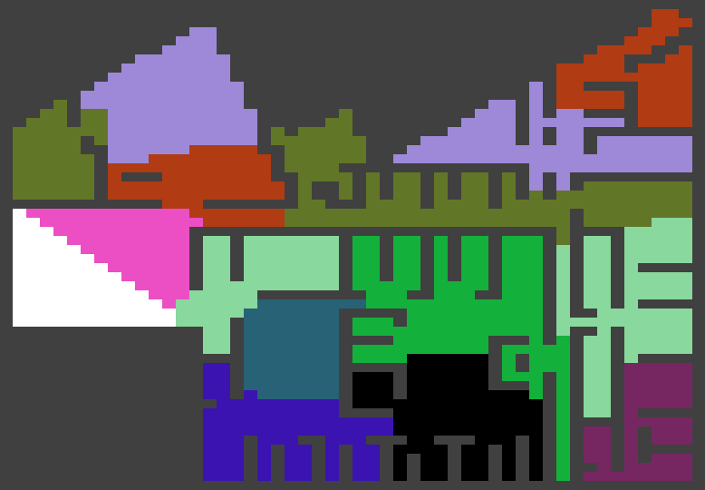

Figure : Entire Floor Plan

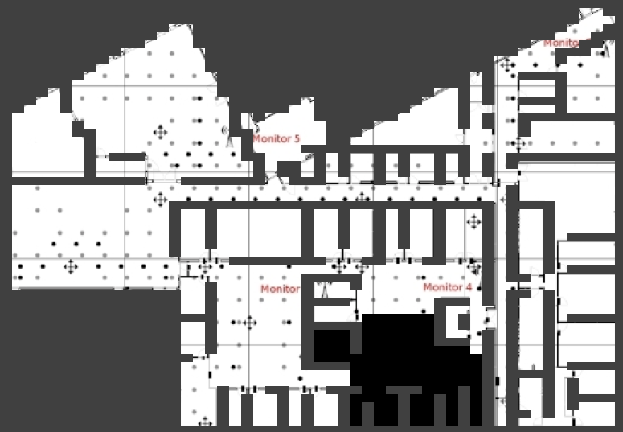

Figure : Region 1 (Binary String = 00000)

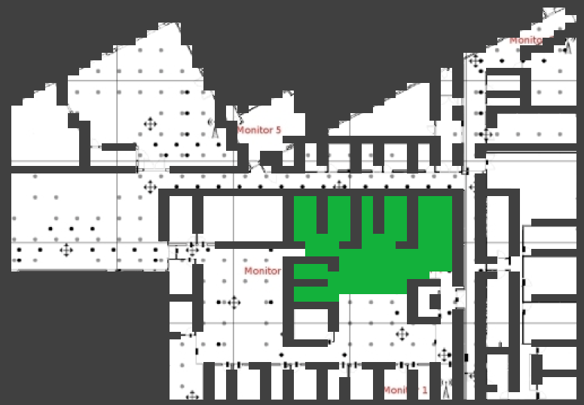

Figure : Region 2 (Binary String = 00001)

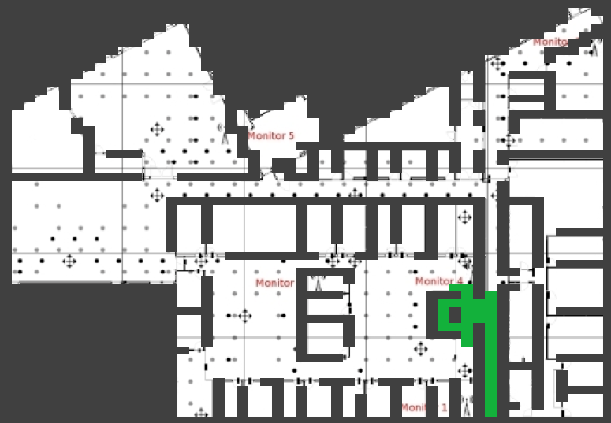

Figure : Region 3 (Binary String = 0001)

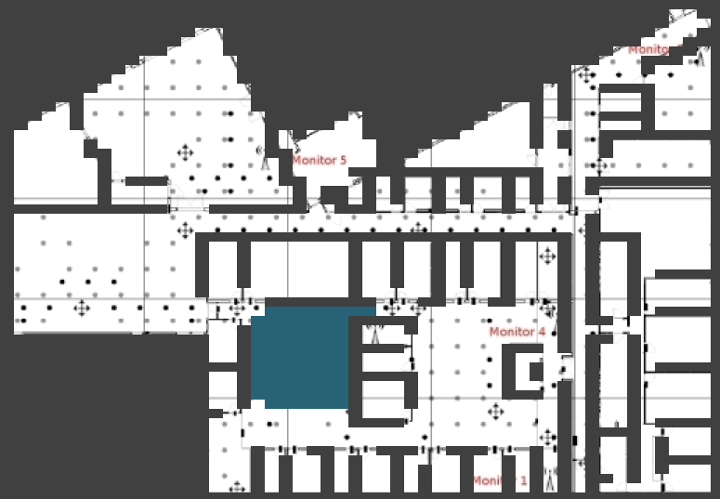

Figure : Region 4 (Binary String = 0010)

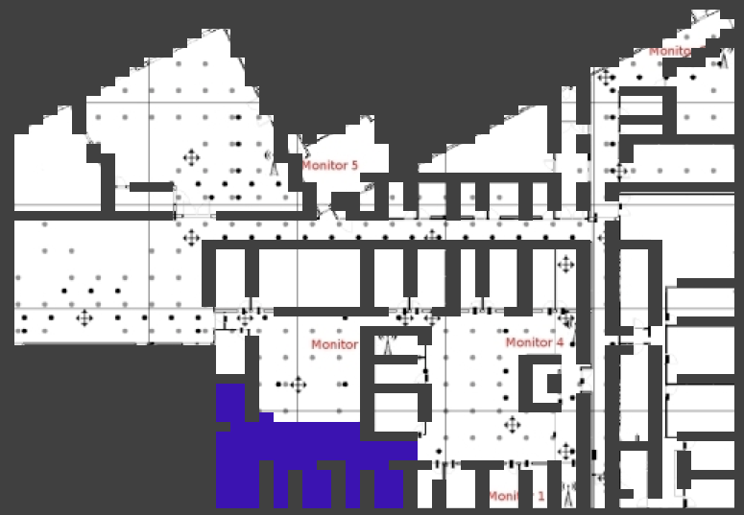

Figure : Region 5 (Binary String = 0011)

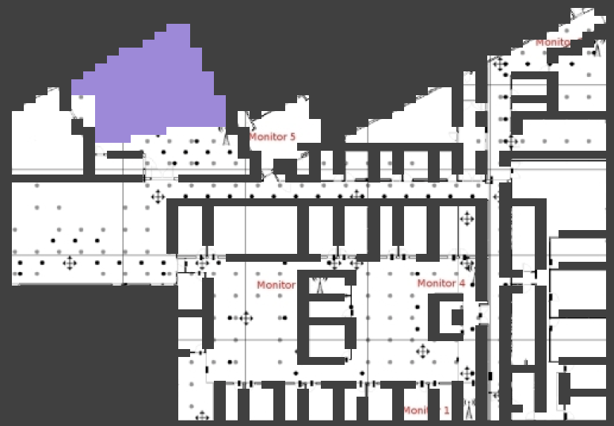

Figure : Region 6 (Binary String = 01000)

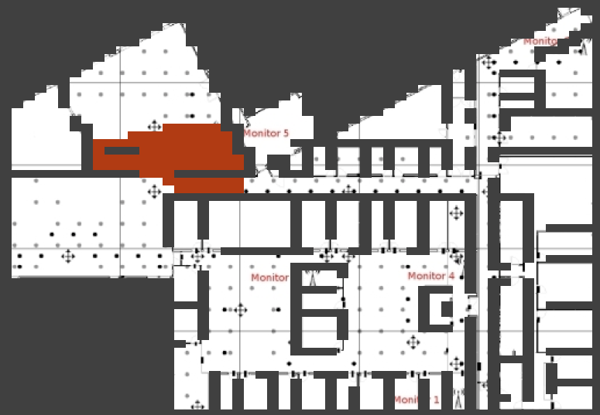

Figure : Region 7 (Binary String = 01001)

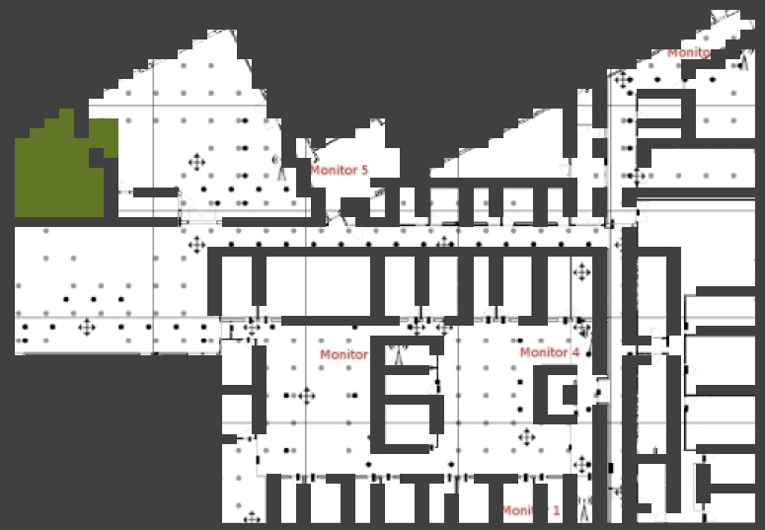

Figure : Region 8 (Binary String = 0101)

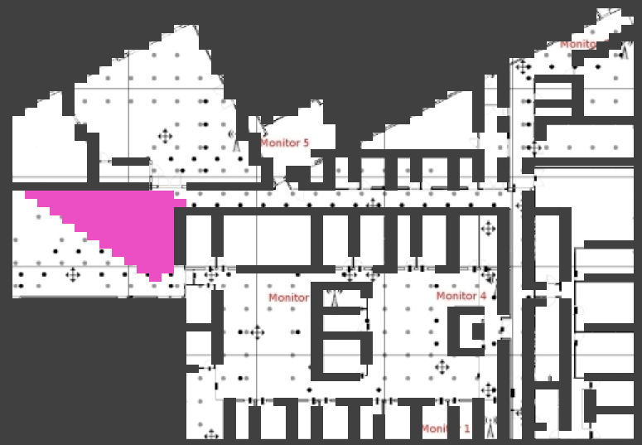

Figure : Region 9 (Binary String = 01100)

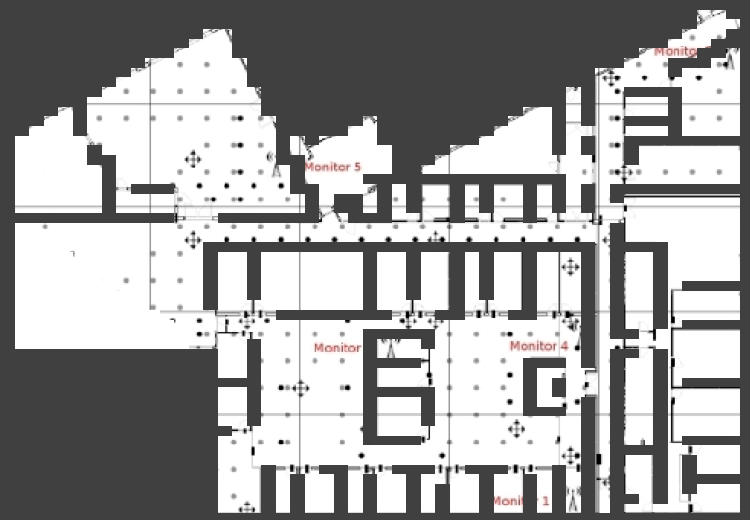

Figure : Region 10 (Binary String = 01101)

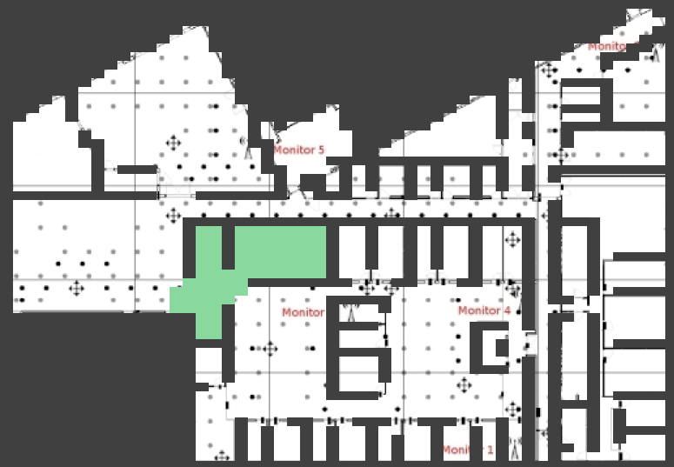

Figure : Region 11 (Binary String = 0111)

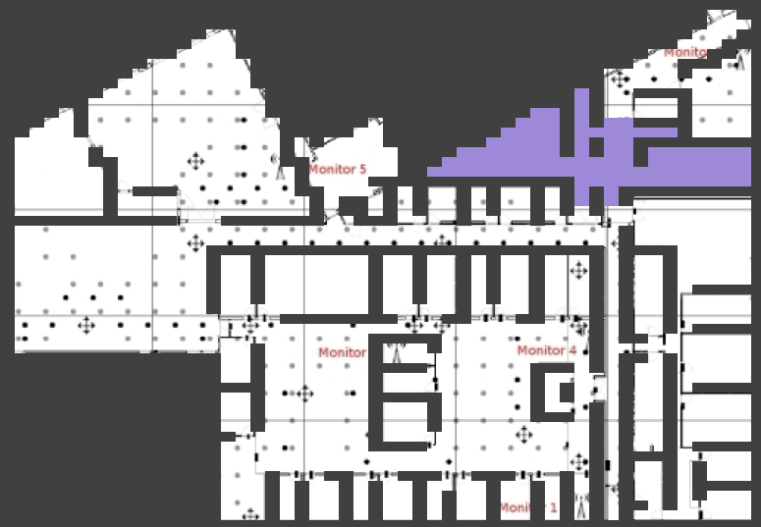

Figure : Region 12 (Binary String = 1000)

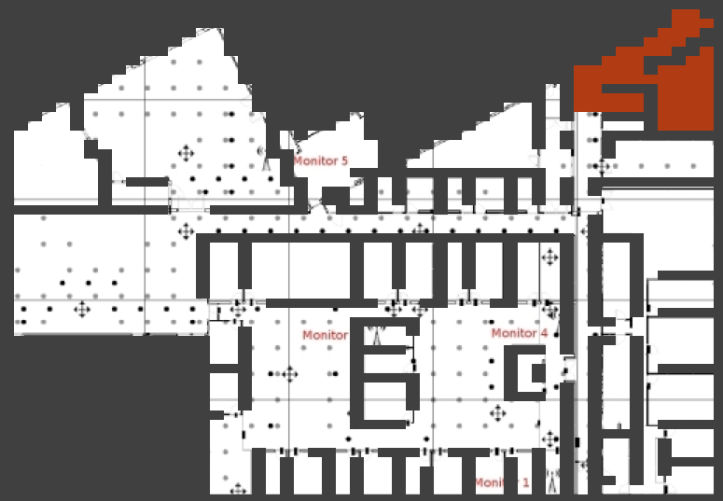

Figure : Region 13 (Binary String = 1001)

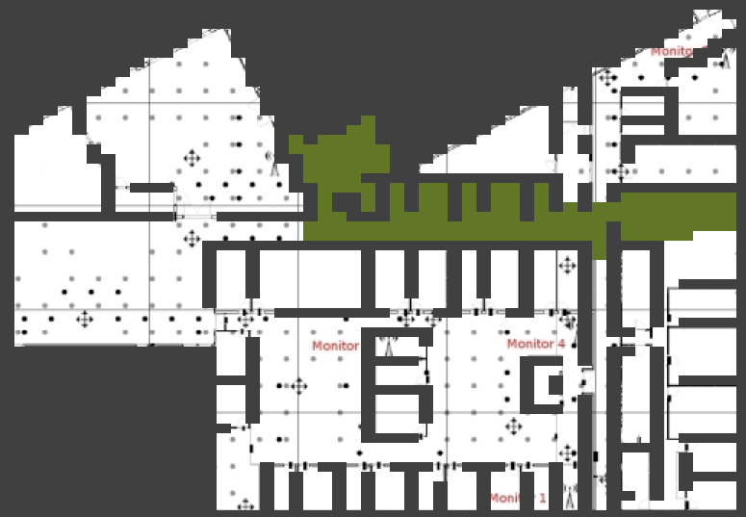

Figure : Region 14 (Binary String = 101)

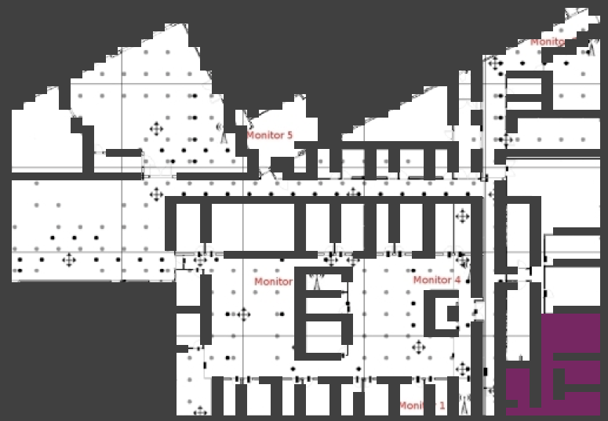

Figure : Region 15 (Binary String = 110)

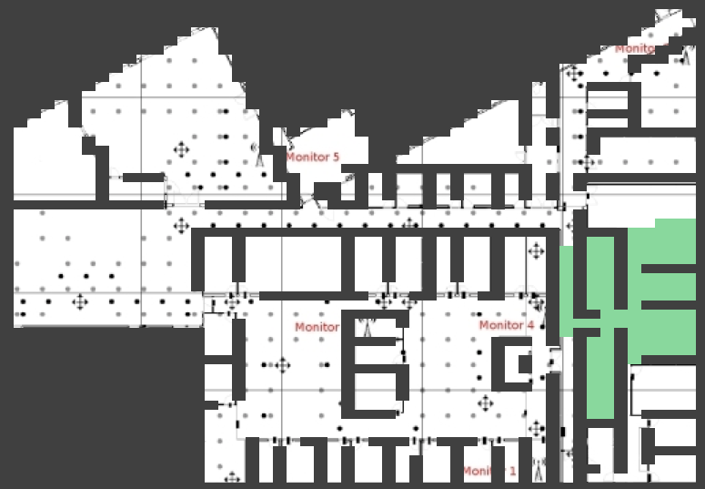

Figure : Region 16 (Binary String = 111)

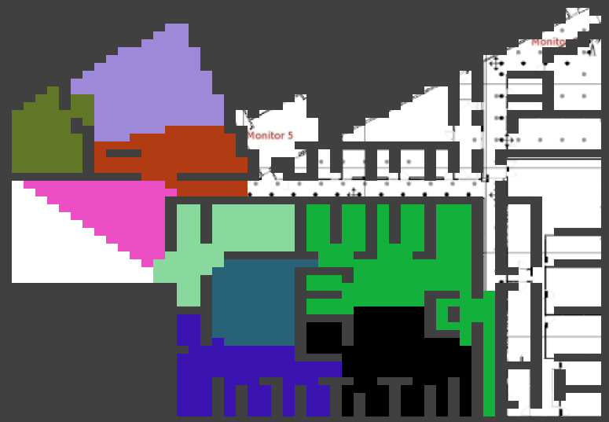

Figure : C(e)

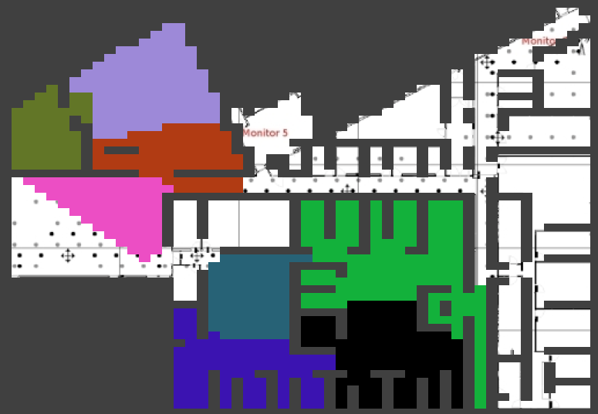

Figure : C(0110)

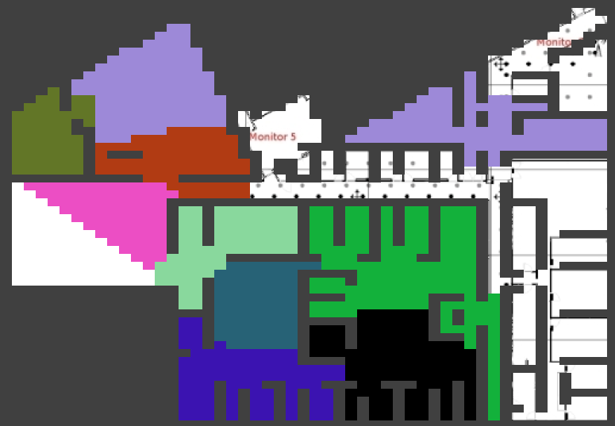

Figure : C(100)

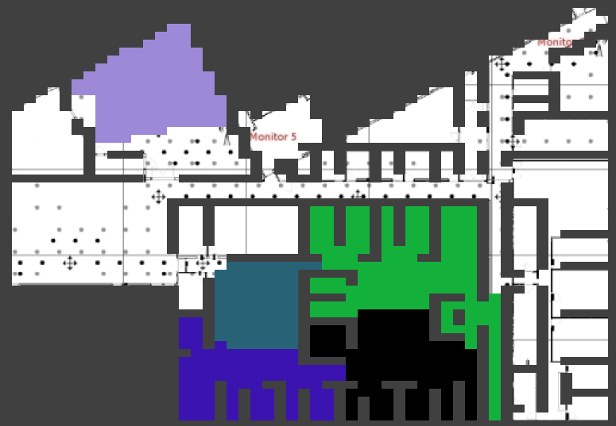

Figure : C(0100)

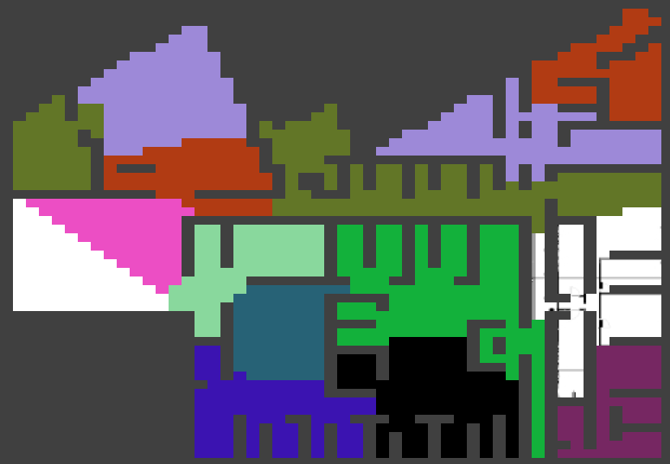

Figure : C(11)

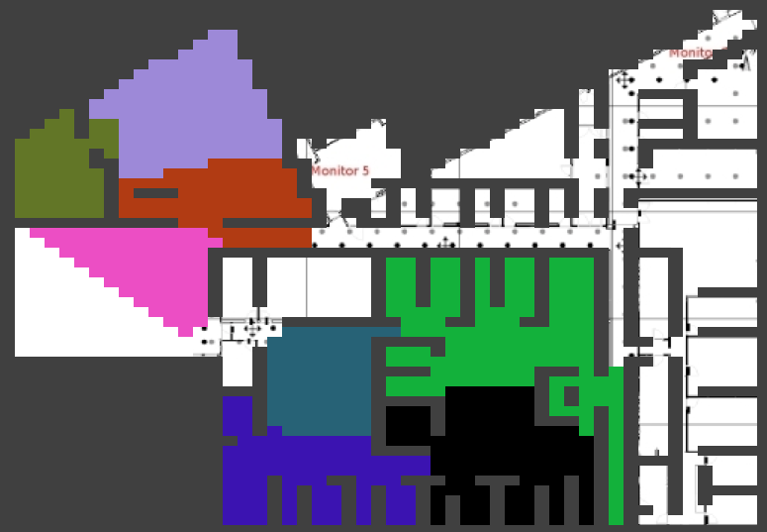

Figure : C(011)

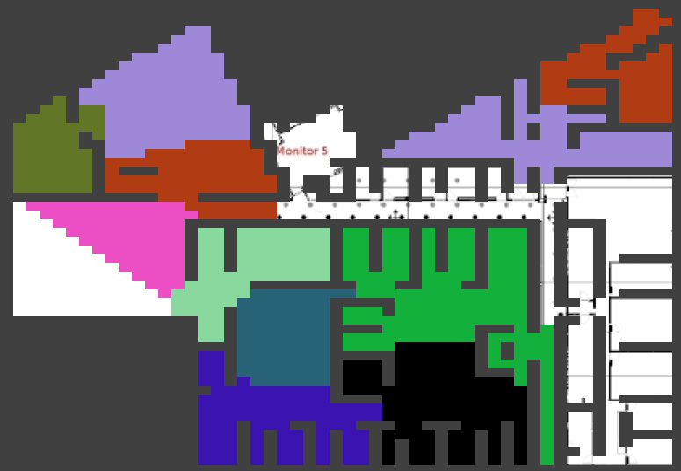

Figure : C(10)

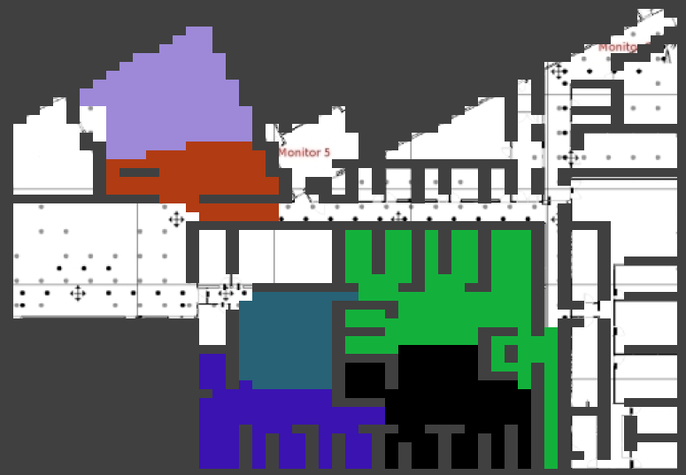

Figure : C(010)

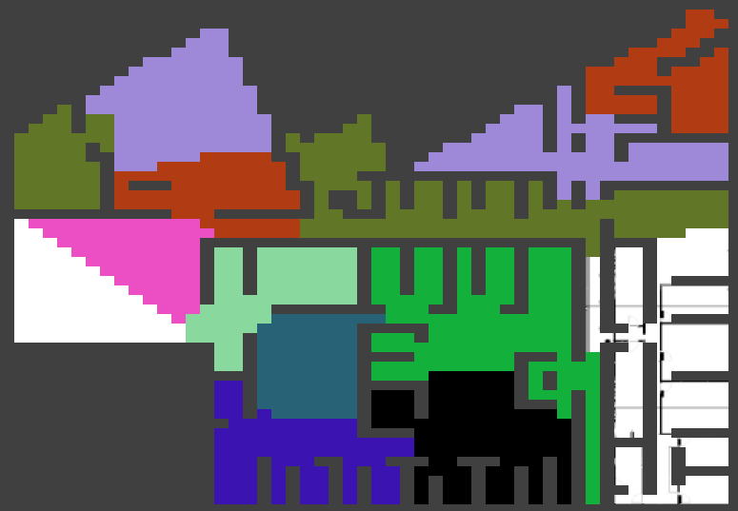

Figure : C(1)

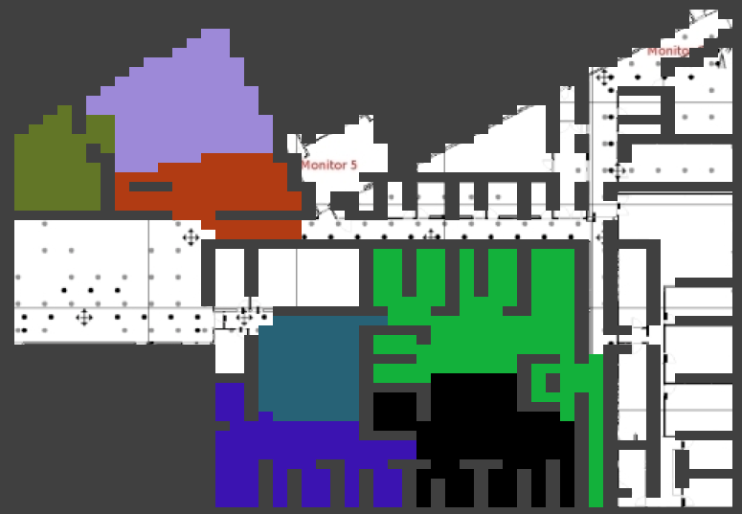

Figure : C(01)

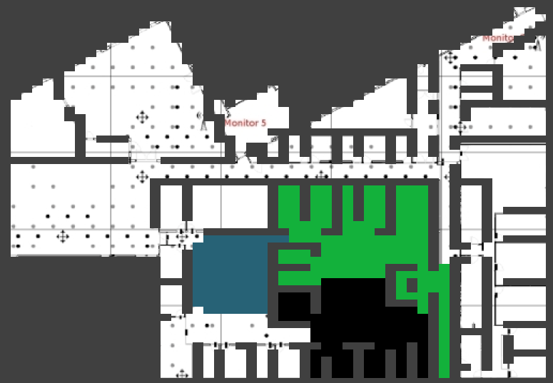

Figure : C(001)

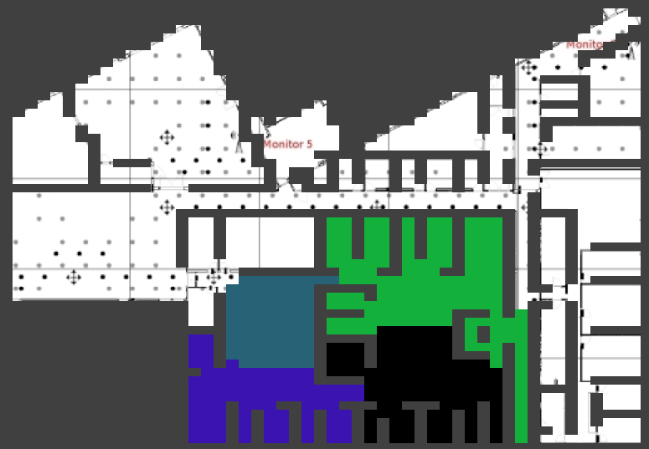

Figure : C(0)

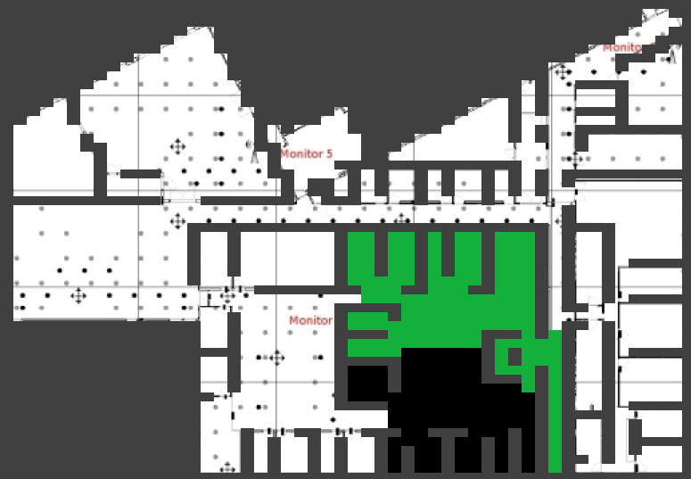

Figure : C(00)

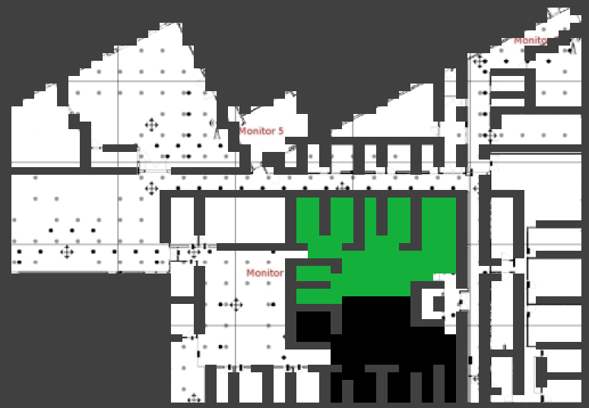

Figure : C(000)



Figure : C(0000)