Dog Breed Classification Using Deep Learning (CNN and Transfer Learning)

Contents
Chapter 1: Introduction
Chapter 2: Dataset and Data Preparation
Chapter 3: Model Design
Chapter 4: Implementation and Training
Chapter 5: Evaluation and Results
Chapter 6: Model Comparison
Chapter 7: Conclusion and Recommendations

Abstract
This project builds a system that recognises the breed of a dog from a photograph. Photographs from 5 public datasets were combined, cleaned automatically (corrupt files, inconsistent breed names and duplicate photographs) and split into training, validation and test sets, giving 55,599 images of 138 breeds. Two models were trained with TensorFlow and Keras: a convolutional neural network built from scratch, and an EfficientNetV2B0 network pretrained on ImageNet and fine-tuned on the dog data. On the held-out test set the custom CNN reached 52.6% accuracy and the tuned transfer-learning model reached 84.2% accuracy (macro F1 83.8%). Dropout, batch normalisation, data augmentation, early stopping, learning-rate scheduling, checkpointing and hyperparameter tuning were applied and their effect compared. The final model was converted to TensorFlow Lite and served through a FastAPI web service.

Chapter 1: Introduction
Background
Image classification is one of the main applications of deep learning in computer vision. A convolutional neural network (CNN) learns to recognise patterns in pictures directly from labelled examples, without hand-written rules. Recognising the breed of a dog from a photograph is a good example of a fine-grained classification problem: all classes are dogs, and many breeds differ only in small details such as ear shape, coat texture or colour.
Problem statement
Dog breeds are hard to tell apart even for people, and public photo collections name and label breeds inconsistently. The problem addressed here is to build a system that takes a photograph of a dog and predicts its breed among 138 breeds, and to show it works on photographs it has never seen.
Aim
To develop, train, evaluate and deploy a deep-learning model that classifies dog images into 138 breeds, and to compare a CNN built from scratch with transfer learning.
Objectives
Obtain dog image datasets, combine them, clean them automatically and split them into training, validation and test sets.
Pre-process the images (resize, normalise, encode labels) and apply data augmentation.
Design, train and evaluate a CNN from scratch using TensorFlow/Keras.
Improve the model with dropout, batch normalisation, early stopping, learning-rate scheduling, checkpointing, hyperparameter tuning and transfer learning, and compare performance before and after optimisation.
Evaluate with accuracy, precision, recall, F1-score and a confusion matrix, and test the model on unseen images.
Save the model and deploy it as a web service (TensorFlow Lite model served with FastAPI).
Significance
A breed classifier is useful for animal shelters, veterinary record keeping, pet-photo apps and education. The project is also a practical study of how much pretrained knowledge helps when training data is limited and unevenly spread over many classes.
Scope
The system classifies single photographs of purebred dogs into 138 breeds. It does not detect several dogs in one photo, does not identify mixed breeds (it can only suggest the closest purebreds), and does not recognise non-dog images (a confidence threshold flags uncertain answers).

Chapter 2: Dataset and Data Preparation
Dataset description and source
Several public dog-breed datasets were combined to get more images per breed and more variety in photographs. After cleaning, the combined dataset holds 55,599 images of 138 breeds.
Table 1: Source datasets and their contribution
Dataset | On Kaggle? | Images read | After cleaning | Breeds | Notes
Tsinghua Dogs Dataset | no (downloaded from the Tsinghua site) | 70,432 | 30,564 | 130 | 130 breeds, 70,428 images (Zou et al., 2020)
Stanford Dogs Dataset | no (downloaded from the Stanford site) | 20,580 | 19,738 | 120 | 120 breeds, 20,580 images, a subset of ImageNet (Khosla et al., 2011)
Oxford-IIIT Pet Dataset (dog breeds only) | no (downloaded from the Oxford site) | 4,990 | 4,796 | 25 | 25 dog breeds of 37 pet breeds, about 200 images per breed (Parkhi et al., 2012)
Dog Breeds Image Dataset (HyperAI listing) | yes | 17,498 | 488 | 54 | Kaggle dataset, downloaded with kagglehub
Dog Breed Identification (Kaggle competition) | yes | 10,222 | 13 | 9 | 10,222 labelled training images of 120 breeds (a subset of Stanford Dogs / ImageNet)

Links for every dataset are in Appendix C.
Dataset summary
Table 2: Summary of the combined dataset
Item | Value
Number of images (after cleaning) | 55,599
Number of classes (breeds) | 138
Images per class: minimum / median / maximum | 23 / 242 / 1500
Image dimensions | Originals vary (median 400 x 375 px, width 97-5184, height 96-4032); all stored as 256x256 RGB, network input 224x224
Dataset structure | One folder of cleaned JPEGs plus an index file (image path, source dataset, breed label); split into train / validation / test tables
Split (train / validation / test) | 44,479 (80%) / 5,560 (10%) / 5,560 (10%)

Data exploration
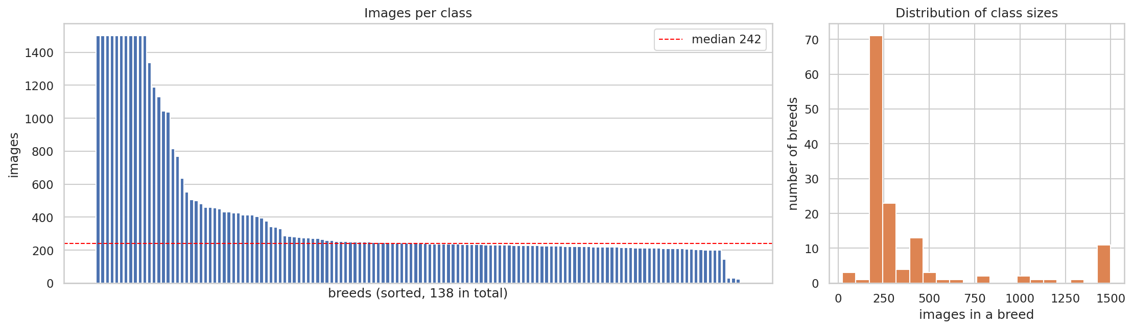
Figure 1: Number of images per breed (left) and the distribution of breed sizes (right).
The largest breed has 65.2 times more images than the smallest, so the dataset is imbalanced. 11 breeds reached the cap of 1500 images and 3 breeds have fewer than 100 images. Imbalance matters because a model can score well by being good at the large breeds only. It was handled by: capping very large breeds; a stratified split so every breed appears in all three sets in the same proportion; keeping small breeds (the pretrained network only has to learn a small classifier for them); label smoothing and augmentation; and reporting macro-averaged precision, recall and F1, which weight every breed equally.
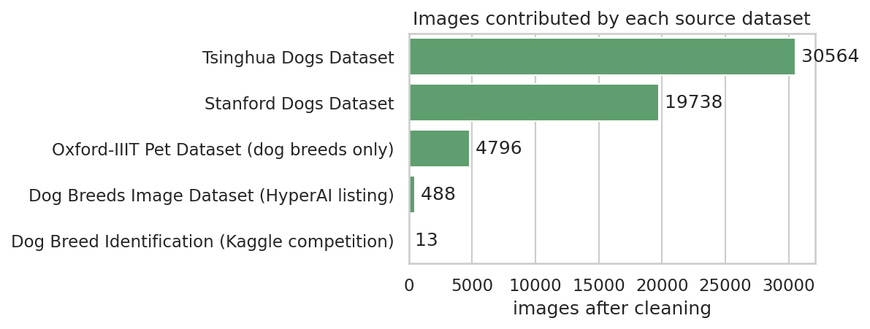
Figure 2: Images contributed by each source dataset.
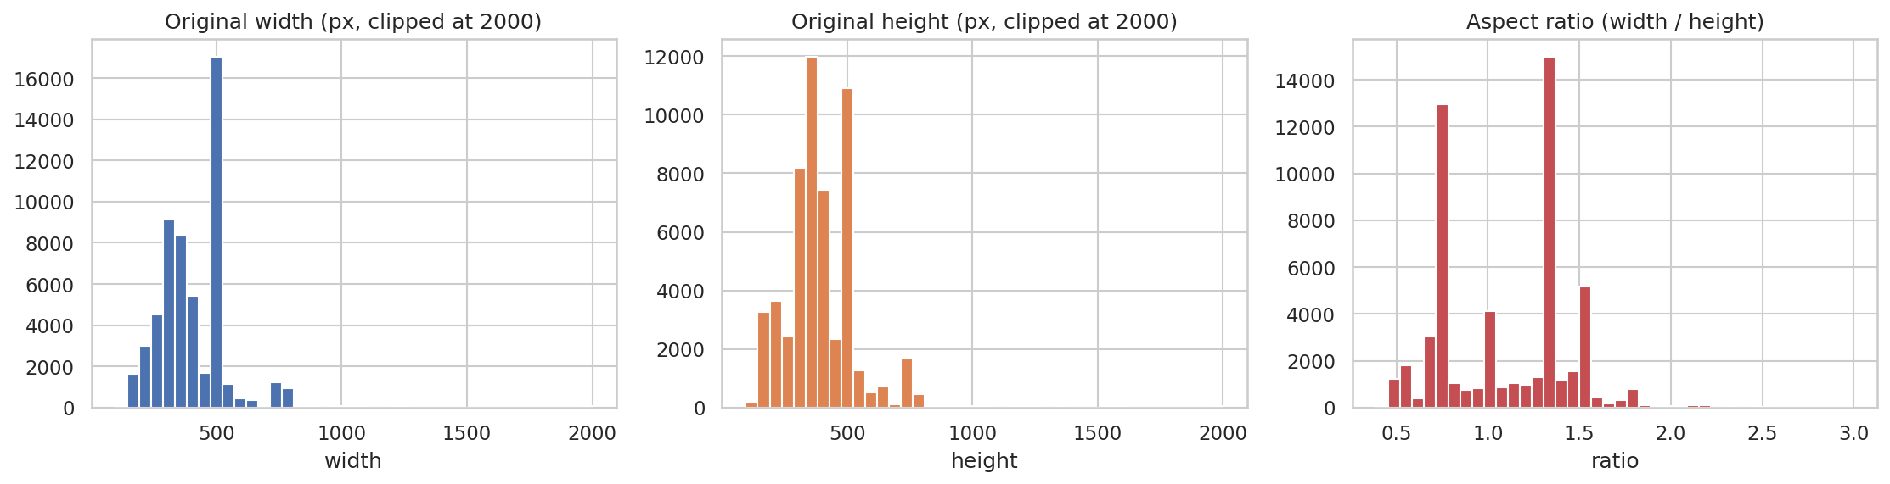
Figure 3: Original image sizes and aspect ratios, before resizing.
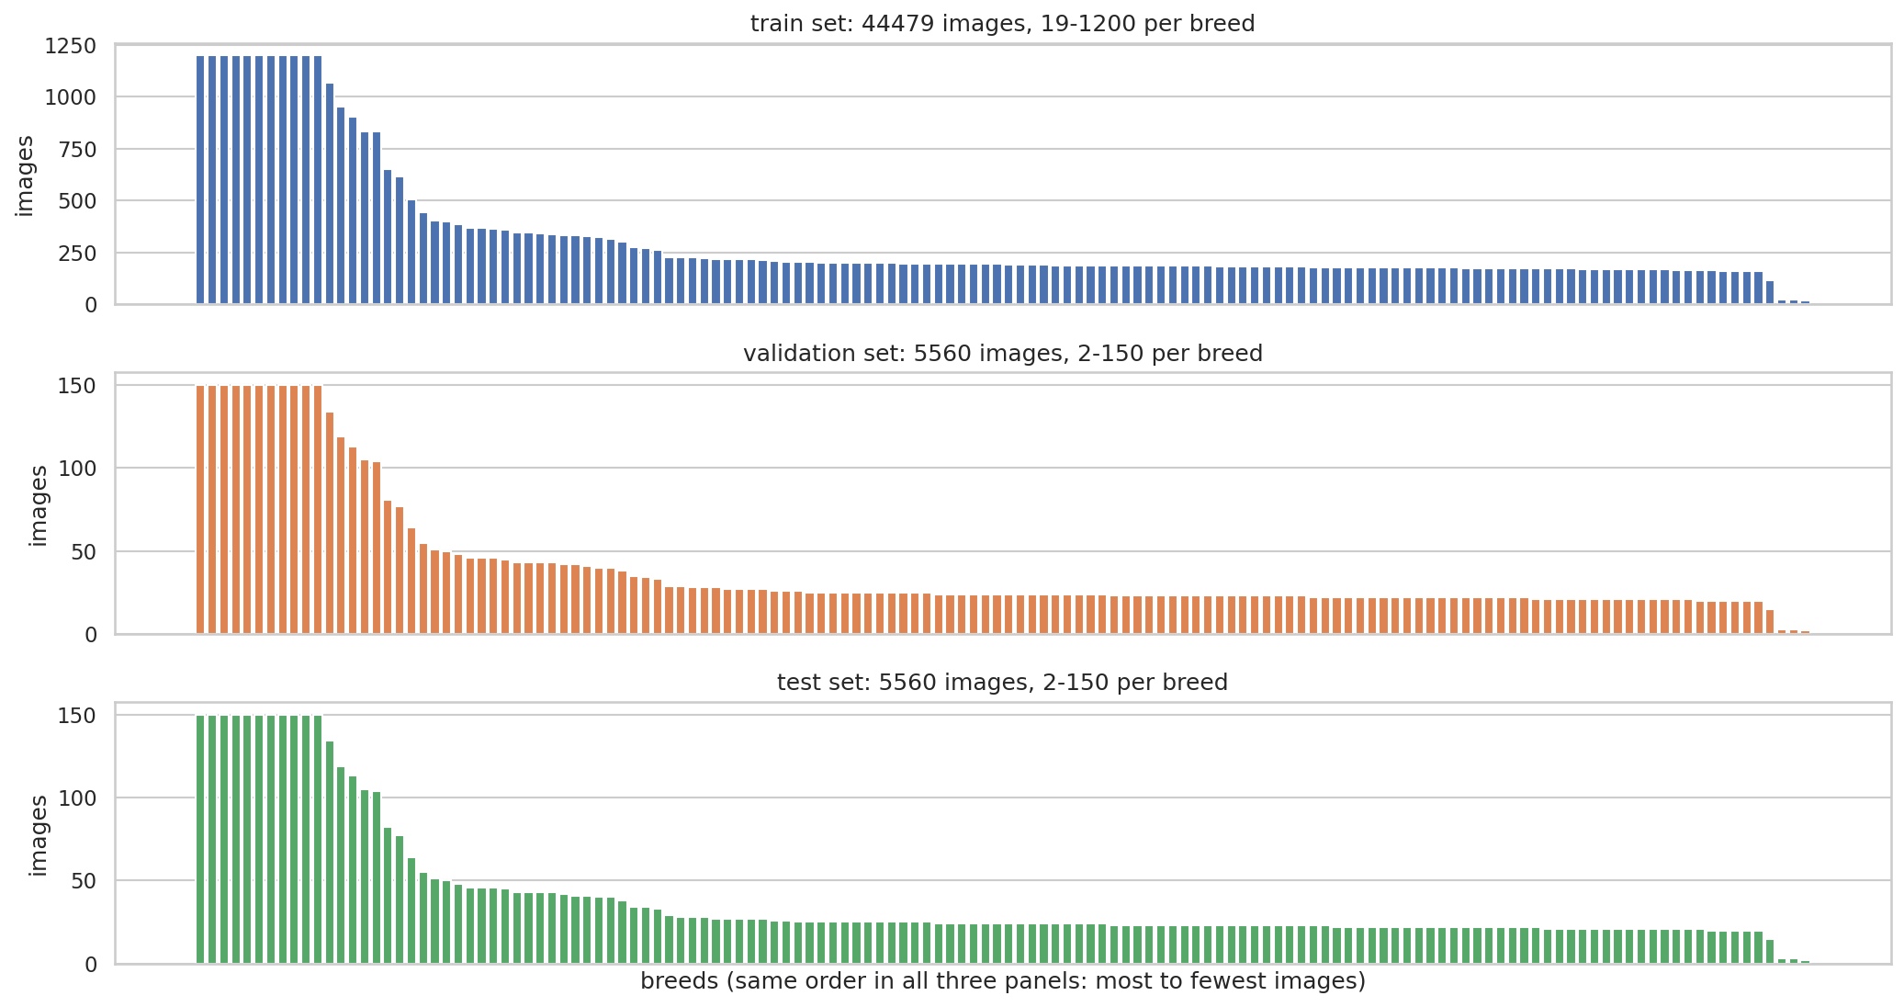
Figure 4: Distribution of images over breeds in the training, validation and test sets.
The three sets have the same breed proportions (largest difference in any breed's share: 0.0001), which is what stratification is for.
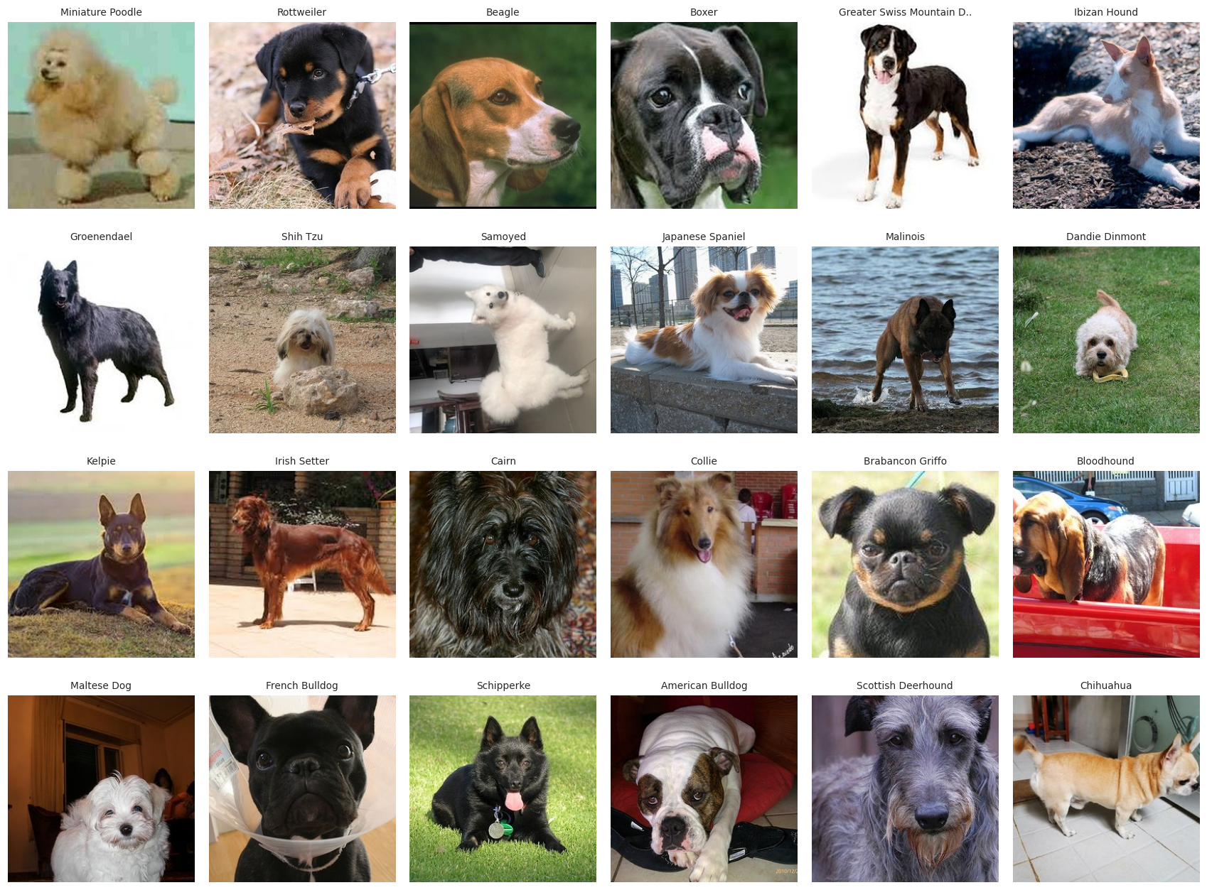
Figure 5: Sample images from 24 of the breeds (all breeds: see sample_images_all_classes.png in the results folder).
Data cleaning
The cleaning was automatic, because manual checking of tens of thousands of photographs is not practical:
Corrupt or unusable files (cannot be decoded, or shorter side below 64 pixels) were dropped.
The same breed is spelled differently across datasets (for example "Saint Bernard" and "St Bernard"). Names were normalised, matched with an alias table and fuzzy matching, and 21 more matches were learned from photographs that appear in two datasets under different names.
Near-duplicate photographs were found with a perceptual image hash. 46,005 duplicate copies were removed, and 491 images were removed because identical photographs carried different breed labels. Removing duplicates before splitting prevents the same photograph appearing in both training and test data.
32 breeds with too few images (20 or fewer after cleaning) were dropped; no breed keeps more than 1500 images.
Data preprocessing
Table 3: Preprocessing steps
Step | What was done | Why
Loading, corrupt files | Opened with Pillow, EXIF rotation applied, converted to RGB; unreadable files dropped. | Prevents crashes, standard 3-channel input.
Resizing | Short side to 256 px, centre crop 256x256; training uses a random 224x224 crop, validation/test the centre crop. | A fixed input size is needed for batches; scaling the short side avoids stretching the dog.
Normalisation | Each pretrained network's own pixel scaling is part of the model (e.g. 0-255 to [-1, 1]); the custom CNN divides by 255. | Similar input scale makes training stable and matches what pretrained weights expect.
Label encoding | Breeds are indexed alphabetically and one-hot encoded. | Needed by the softmax output and categorical cross-entropy loss.
Splitting | 80 / 10 / 10 %, stratified by breed, after duplicate removal. | Fair evaluation without leakage.
Batch generation | tf.data pipeline: parallel JPEG decoding, shuffling, batches of 32-64, prefetching. | Keeps the GPU busy; the data does not fit in memory.

Data augmentation
Augmentation randomly changes training images each epoch so the network sees many variations of the same dog: horizontal flip, rotation, zoom, shift and contrast change, plus the random crop. A dog photographed from a slightly different angle, distance or light is still the same breed, so these changes keep the label correct while reducing overfitting. Vertical flips and strong colour changes were avoided because they create unrealistic images or change coat colour, which identifies some breeds. Augmentation is only active during training.
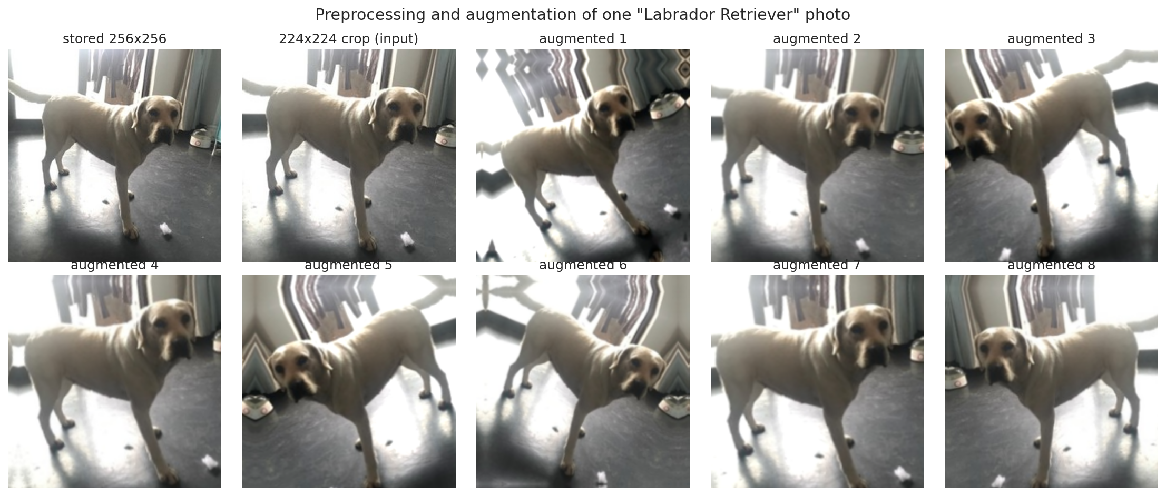
Figure 6: One photograph before and after augmentation.

Chapter 3: Model Design
Custom CNN architecture
The first model is a CNN trained from random weights. It follows the structure Input - [Convolution - BatchNorm - ReLU] x2 - MaxPooling (four times, with 32, 64, 128 and 256 filters) - Global Average Pooling - Dense - Dropout - Output.
Table 4: Layers of the custom CNN
Layer | Type | Output shape | Parameters
image | InputLayer | (None, 224, 224, 3) | 0
resize | Resizing | (None, 128, 128, 3) | 0
augment | Sequential | (None, 128, 128, 3) | 0
rescale | Rescaling | (None, 128, 128, 3) | 0
conv2d | Conv2D | (None, 128, 128, 32) | 864
batch_normalization | BatchNormalization | (None, 128, 128, 32) | 128
re_lu | ReLU | (None, 128, 128, 32) | 0
conv2d_1 | Conv2D | (None, 128, 128, 32) | 9,216
batch_normalization_1 | BatchNormalization | (None, 128, 128, 32) | 128
re_lu_1 | ReLU | (None, 128, 128, 32) | 0
max_pooling2d | MaxPooling2D | (None, 64, 64, 32) | 0
conv2d_2 | Conv2D | (None, 64, 64, 64) | 18,432
batch_normalization_2 | BatchNormalization | (None, 64, 64, 64) | 256
re_lu_2 | ReLU | (None, 64, 64, 64) | 0
conv2d_3 | Conv2D | (None, 64, 64, 64) | 36,864
batch_normalization_3 | BatchNormalization | (None, 64, 64, 64) | 256
re_lu_3 | ReLU | (None, 64, 64, 64) | 0
max_pooling2d_1 | MaxPooling2D | (None, 32, 32, 64) | 0
conv2d_4 | Conv2D | (None, 32, 32, 128) | 73,728
batch_normalization_4 | BatchNormalization | (None, 32, 32, 128) | 512
re_lu_4 | ReLU | (None, 32, 32, 128) | 0
conv2d_5 | Conv2D | (None, 32, 32, 128) | 147,456
batch_normalization_5 | BatchNormalization | (None, 32, 32, 128) | 512
re_lu_5 | ReLU | (None, 32, 32, 128) | 0
max_pooling2d_2 | MaxPooling2D | (None, 16, 16, 128) | 0
conv2d_6 | Conv2D | (None, 16, 16, 256) | 294,912
batch_normalization_6 | BatchNormalization | (None, 16, 16, 256) | 1,024
re_lu_6 | ReLU | (None, 16, 16, 256) | 0
conv2d_7 | Conv2D | (None, 16, 16, 256) | 589,824
batch_normalization_7 | BatchNormalization | (None, 16, 16, 256) | 1,024
re_lu_7 | ReLU | (None, 16, 16, 256) | 0
max_pooling2d_3 | MaxPooling2D | (None, 8, 8, 256) | 0
global_average_pooling2d | GlobalAveragePooling2D | (None, 256) | 0
dense | Dense | (None, 512) | 131,584
dropout | Dropout | (None, 512) | 0
dense_1 | Dense | (None, 138) | 70,794

Explanation of the layers
Convolution (3x3 kernels, "same" padding): slides small filters over the image and learns edges first, then textures and parts of the dog. Filters double after each block (32, 64, 128, 256) because deeper layers need to represent more complex patterns.
Batch normalisation: rescales the outputs of each convolution during training, which makes learning faster and more stable and acts as a mild regulariser.
ReLU activation: max(0, x). Cheap, avoids vanishing gradients and adds the non-linearity that lets the network learn complex shapes.
Max pooling (2x2): halves the width and height, keeps the strongest response, makes features tolerant to small shifts and cuts computation.
Global average pooling: averages each feature map into one number. It replaces a large Flatten layer, so there are far fewer parameters and less overfitting.
Dense layer with 512 units and ReLU: combines the features; followed by dropout (rate 0.5), which randomly switches off half the units in each training step to stop co-adaptation.
Output layer: 138 units with softmax, which turns the scores into probabilities that add up to 1.
Hyperparameters of the custom CNN
Table 5: Hyperparameters of the custom CNN
Hyperparameter | Value
Input size | 224x224x3, resized to 128x128 inside the model
Convolution layers | 8 (two per block), 3x3 kernels, filters 32-64-128-256
Activation | ReLU (hidden), softmax (output)
Pooling | 2x2 max pooling after each block, then global average pooling
Dropout rate | 0.5
Loss function | Categorical cross-entropy
Optimiser | Adam, learning rate 0.001 (halved on plateau)
Batch size | 64
Epochs | up to 30 (early stopping: 30 run)
Parameters | 1,377,514

Transfer-learning model
The second model reuses EfficientNetV2B0, a network pretrained on ImageNet (over a million photographs, including many dogs). Its convolutional layers stay as feature extractors and a new head (dropout, optional dense layer, 138-way softmax) is trained on the dog data. Training has two phases: first only the new head is trained with the backbone frozen; then the top part of the backbone is unfrozen and fine-tuned with a much smaller learning rate. Batch-normalisation layers stay frozen, which is important with small amounts of data per breed.
Table 6: Architectures compared on the same data with the same short training run (the best one was kept)
Architecture | Validation accuracy | Train-val gap | Parameters (M) | Minutes
EfficientNetV2B0 | 0.812 | +0.001 | 6.1 | 3.3
EfficientNetB0 | 0.791 | +0.026 | 4.2 | 3.8
InceptionV3 | 0.758 | +0.085 | 22.1 | 3.3
ResNet50 | 0.744 | +0.079 | 23.9 | 4.8
MobileNetV2 | 0.741 | -0.038 | 2.4 | 3.1
MobileNet | 0.688 | -0.019 | 3.4 | 2.5
VGG19 | 0.674 | -0.010 | 20.1 | 3.3
VGG16 | 0.652 | -0.017 | 14.8 | 2.8

Loss function and optimiser
Both models use categorical cross-entropy, which measures how far the predicted probabilities are from the true breed. The transfer model uses label smoothing, which stops the network from becoming over-confident, and the AdamW optimiser (Adam with decoupled weight decay, a regulariser that keeps weights small). The custom CNN uses plain Adam.

Chapter 4: Implementation and Training
Development environment and libraries
Table 7: Development environment
Item | Version
Platform | Google Colab (free plan)
Hardware | no GPU
Python | 3.13.16
TensorFlow / Keras | 2.21.0 / 3.13.2
Other libraries | NumPy 2.1.3, Pandas 2.2.3, Matplotlib 3.10.0, Seaborn 0.13.2, scikit-learn 1.6.1, Pillow 11.3.0, Optuna 5.0.0, FastAPI 0.141.1

Training procedure
Custom CNN: trained from random weights for up to 30 epochs with Adam, with early stopping on validation loss (patience 6, best weights restored), ReduceLROnPlateau and model checkpointing.
Transfer learning before optimisation: EfficientNetV2B0 with default settings for 8 epochs, without early stopping.
Transfer learning after optimisation: hyperparameters tuned with Optuna on a subset of the data, then trained on the full training set with early stopping and ReduceLROnPlateau.
Hyperparameter tuning
Optuna's TPE sampler explored 12 settings (8 completed, 4 stopped early because they were clearly worse). Each trial was scored on a validation subset with a penalty when training accuracy ran far ahead of validation accuracy, so the search prefers settings that generalise. Searched: dropout rate, an optional extra dense layer, label smoothing, learning rates for the new classifier and for fine-tuning, weight decay, the fraction of the backbone that is unfrozen, augmentation strength and batch size.
Table 8: Best hyperparameters found
Hyperparameter | Best value
Dropout rate | 0.38
Extra dense layer (units) | none
Label smoothing | 0.103
Learning rate, new classifier | 0.00117
Learning rate, fine-tuning | 1.17e-05
Weight decay | 0.0044
Fraction of backbone unfrozen | 0.34
Augmentation strength (0 to 1) | 0.065
Batch size | 32
Network | EfficientNetV2B0

Most influential hyperparameters: learning rate, new classifier (0.17), learning rate, fine-tuning (0.16), label smoothing (0.15), weight decay (0.15).
The search chose a very low augmentation strength (0.065 on a scale from 0 to 1; the untuned model used 0.5), so the final model relies mainly on random crops and horizontal flips rather than on rotation, zoom and shifts.
Training results
Table 9: Training results at the epoch whose weights were kept
Model | Epochs | Train acc. | Val acc. | Train loss | Val loss | Time
Custom CNN | 30 | 58.0% | 52.0% | 1.445 | 1.733 | 54.7 min
Transfer learning, default (EfficientNetV2B0) | 8 | 84.0% | 82.8% | n/a | n/a | 15.8 min
Transfer learning, tuned (EfficientNetV2B0) | 28 | 89.4% | 83.8% | 1.222 | 1.320 | 55.9 min

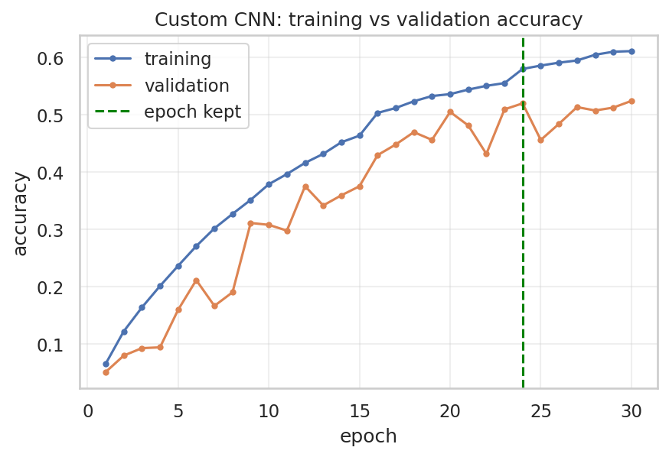
Figure 7: Custom CNN: training vs validation accuracy.
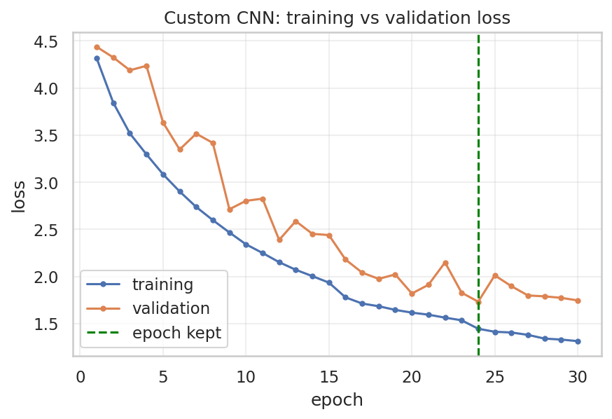
Figure 8: Custom CNN: training vs validation loss.
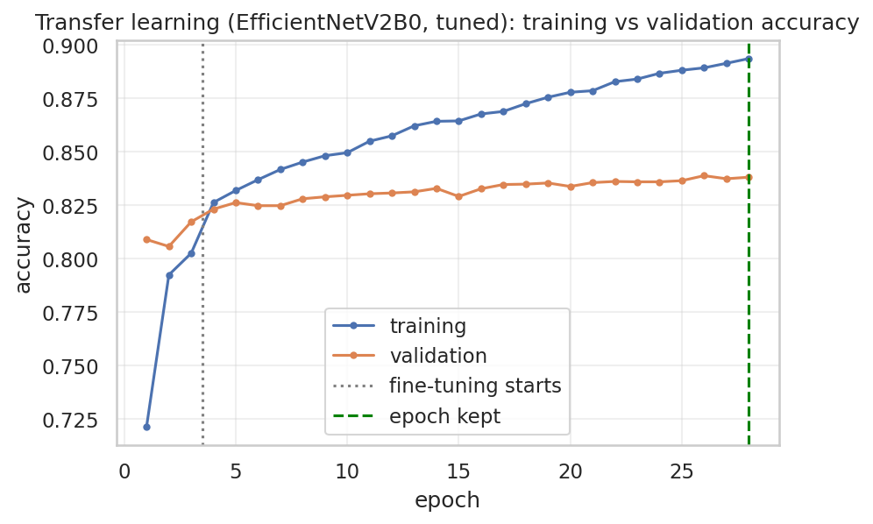
Figure 9: Final transfer-learning model: training vs validation accuracy.
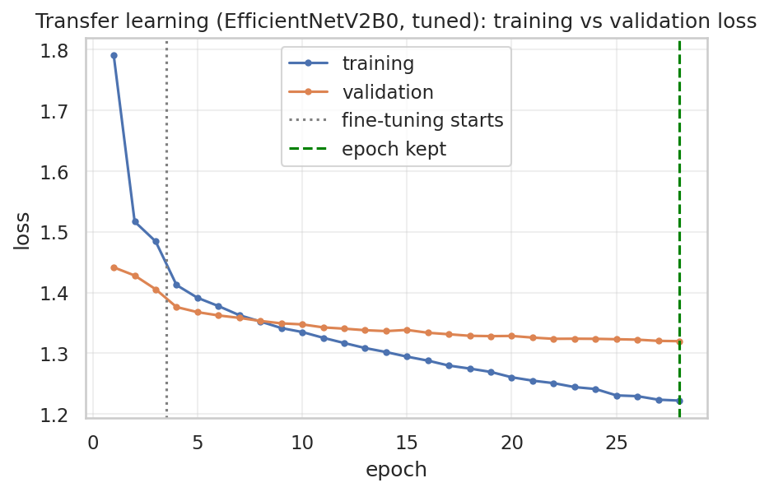
Figure 10: Final transfer-learning model: training vs validation loss.
Underfitting, overfitting or well fitted?
Custom CNN: underfitting. Training accuracy (58.0%) and validation accuracy (52.0%) are both low, so the network has not learned the task well. The gap between them is only 6.0 points, so memorising the training photographs is not the main problem. The limit is the small network trained from scratch on about 44,000 photographs of 138 breeds.
Transfer learning, default settings: well fitted. Training accuracy (84.0%) and validation accuracy (82.8%) are close (gap 1.2 points) and both are high. Training accuracy is measured with augmentation and dropout switched on, which is why it can sit slightly below what the network could reach on clean images.
Transfer learning, tuned: reasonably well fitted. Training accuracy (89.4%) is 5.5 points above validation accuracy (83.8%). This is a modest gap, well below the 10 points used here as a warning level, and validation accuracy is higher than for the default model (82.8%).
Measures used against overfitting: data augmentation, dropout, batch normalisation, weight decay, label smoothing, early stopping on validation loss, learning-rate reduction on plateau, a frozen pretrained backbone and a tuning score that penalises the train-validation gap.
Model saving and deployment
The final model is saved in the Keras format (.keras) and converted to TensorFlow Lite (float16 weights where supported). It is served with FastAPI: the service loads the TensorFlow Lite model and exposes GET /health and POST /predict (upload an image, receive the predicted breed, confidence and top-5 list). The service applies the same preprocessing as training. The code is in Appendix B.
The TensorFlow Lite model is 12.2 MB (Keras model 82.8 MB) and gives the same predicted breed as the Keras model on 100.0% of 60 test photos (about 41 ms per photo).
API test: the service was started and sent 4 test photos; it replied with valid predictions (example for a photo of a Airedale: Airedale, confidence 93.9%) and rejected a non-image upload with HTTP 400.

Chapter 5: Evaluation and Results
Test-set metrics of the final model
The final model was evaluated once on the test set (5,560 images the model never saw in training, validation or tuning).
Table 10: Final model on the test set
Metric | Result
Accuracy | 84.2%
Precision (macro / weighted) | 85.0% / 84.0%
Recall (macro / weighted) | 83.7% / 84.2%
F1-score (macro / weighted) | 83.8% / 83.8%
Top-5 accuracy | 98.0%

Interpretation: the model correctly classified about 84 out of every 100 previously unseen photographs on its first guess, and the correct breed was among its five best guesses 98 times out of 100. Precision (macro 85.0%) says that when the model names a breed, it is right that often on average across breeds; recall (macro 83.7%) says that it finds that share of each breed's photos on average. The weighted scores are close to the macro scores, so the model is not doing well only on the biggest breeds. F1 combines precision and recall in one number.
Accuracy by source dataset: Stanford Dogs 87.9%, Oxford-IIIT Pet 86.3%, Tsinghua Dogs 81.7% and the Dog Breeds Image Dataset 64.6%. The Dog Breed Identification set is not scored on its own: only 13 of its 10,222 photographs remained after duplicate removal, because nearly all of them are also in Stanford Dogs. Stanford Dogs is a subset of ImageNet, which the backbone was pretrained on, so its score is more optimistic than the others. The Dog Breeds Image Dataset has the lowest score; its photographs and labels were not checked one by one, so the reason was not investigated.
Confusion matrix
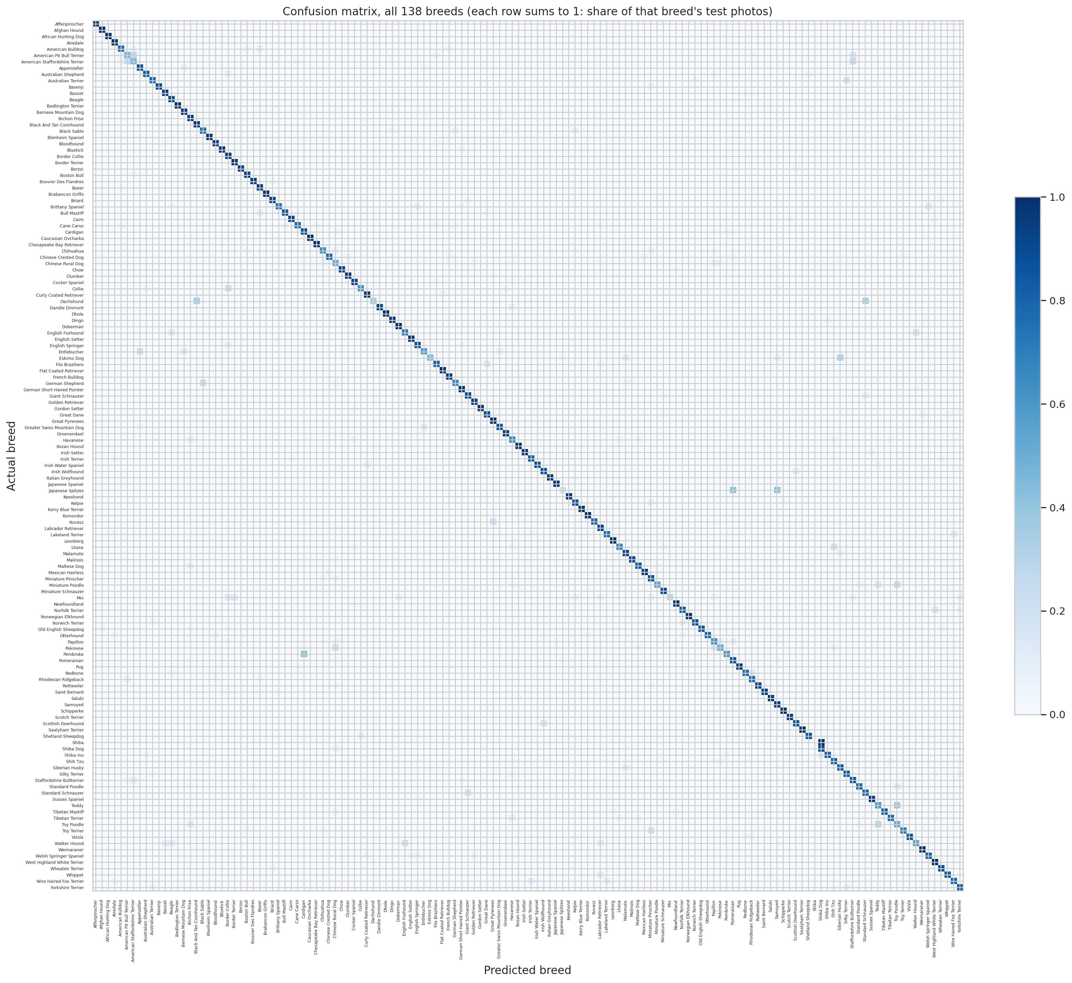
Figure 11: Confusion matrix of the final model for all 138 breeds (row-normalised).
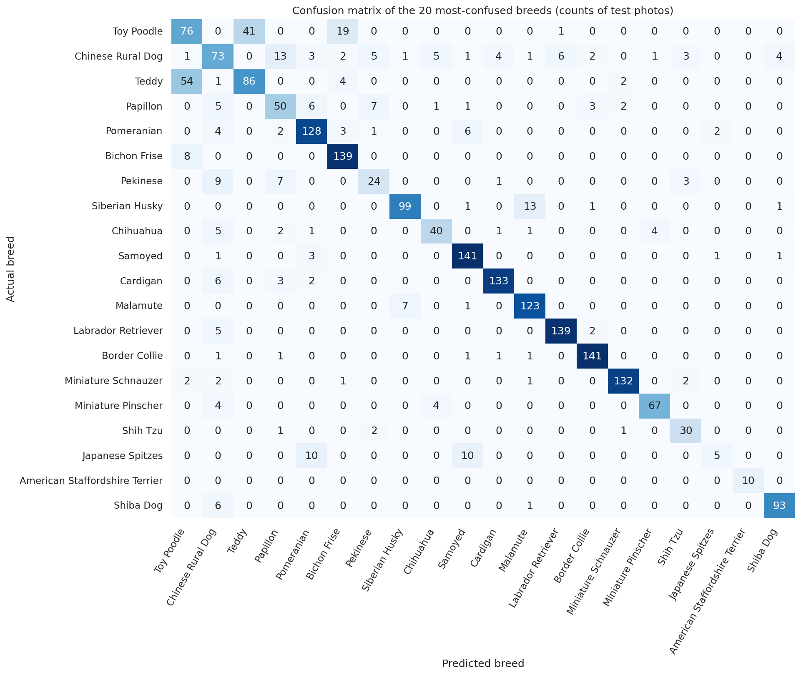
Figure 12: The 20 most-confused breeds, with counts of test photos.
A bright diagonal means most photographs of a breed are named correctly; bright cells off the diagonal are mistakes between two specific breeds.
Classification report
The full per-breed report (precision, recall, F1, support for all 138 breeds) is in classification_report.csv in the results folder. Breeds with at least 5 test photographs (135 breeds) are used below, because scores of breeds with fewer test photographs are very noisy.
Table 11: Best-performing breeds
Best-performing breeds | Precision | Recall | F1 | Test photos
African Hunting Dog | 1.00 | 1.00 | 1.00 | 26
Kerry Blue Terrier | 1.00 | 1.00 | 1.00 | 25
Dhole | 1.00 | 1.00 | 1.00 | 23
Sealyham Terrier | 1.00 | 1.00 | 1.00 | 23
Blenheim Spaniel | 1.00 | 1.00 | 1.00 | 22

Table 12: Weakest breeds
Poorly performing breeds | Precision | Recall | F1 | Test photos
Japanese Spitzes | 0.56 | 0.20 | 0.29 | 25
Mix | 0.80 | 0.27 | 0.40 | 15
American Pit Bull Terrier | 0.47 | 0.45 | 0.46 | 20
American Staffordshire Terrier | 0.48 | 0.46 | 0.47 | 22
Toy Poodle | 0.50 | 0.51 | 0.50 | 150

Prediction examples
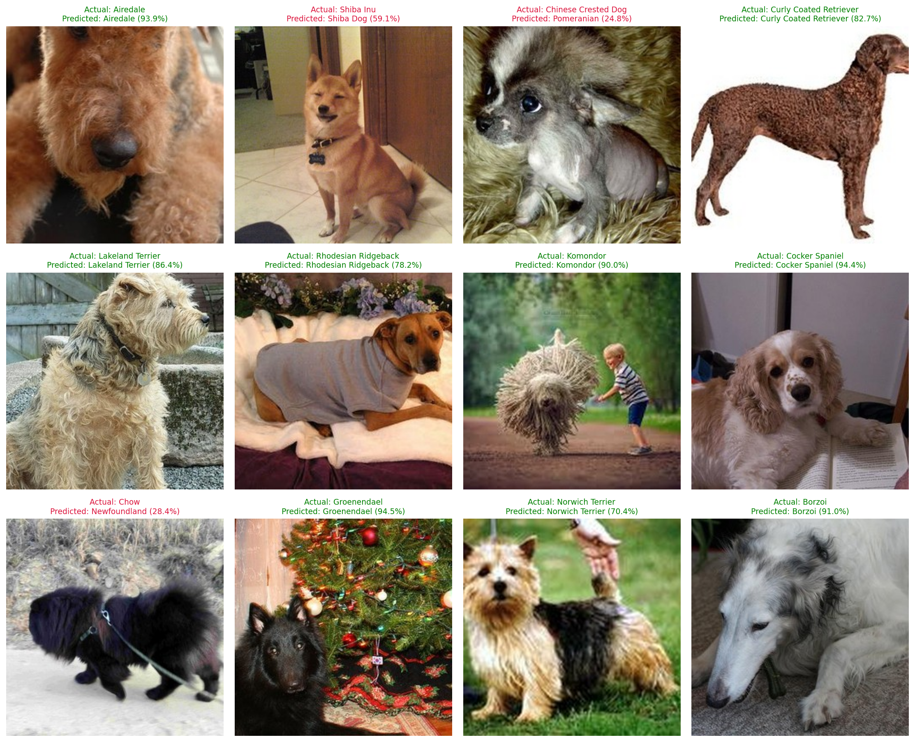
Figure 13: Predictions for unseen test photographs (title: actual breed, predicted breed and confidence; green = correct).
9 of 12 unseen photographs were predicted correctly. Predictions for photographs uploaded by the author are in Appendix A (screenshot 12).
Error analysis
Table 13: Most common confusions
Actual breed | Predicted as | Test photos
Teddy | Toy Poodle | 54
Toy Poodle | Teddy | 41
Toy Poodle | Bichon Frise | 19
Siberian Husky | Malamute | 13
Chinese Rural Dog | Papillon | 13
Japanese Spitzes | Samoyed | 10
Japanese Spitzes | Pomeranian | 10
Pembroke | Cardigan | 9
Pekinese | Chinese Rural Dog | 9
Eskimo Dog | Siberian Husky | 8

The two largest confusions are Teddy mistaken for Toy Poodle (54 photographs) and Toy Poodle mistaken for Teddy (41). Together they are about 95 of the roughly 880 errors, or one in nine. "Teddy" is a name used for a poodle-type dog groomed in a teddy-bear style, so the two classes look almost the same and are labelled by different datasets. The same pattern appears for Japanese Spitzes (taken for Samoyed or Pomeranian), Siberian Husky and Malamute, and Pembroke and Cardigan Welsh Corgi.
Why these errors happen: breeds of the same family (terriers, spaniels, retrievers, spitz types) share body shape, coat and colour, so even experts confuse them; some breeds have few training photographs, so the model has seen fewer variations; photographs with several dogs, people, or unusual poses add noise; labels coming from different datasets are not perfect; and breeds with few test photographs give noisy scores. Mixed-breed dogs cannot be named correctly by a purebred classifier. This is why the application reports a confidence and flags low-confidence answers as "unsure".

Chapter 6: Model Comparison
Table 14: Custom CNN vs transfer learning on the test set
Metric | Custom CNN | Transfer learning (default) | Transfer learning (tuned)
Accuracy | 52.6% | 83.9% | 84.2%
Precision (macro) | 48.2% | 84.9% | 85.0%
Recall (macro) | 43.6% | 83.7% | 83.7%
F1-score (macro) | 43.5% | 83.7% | 83.8%
Top-5 accuracy | 83.4% | 98.0% | 98.0%
Training time | 54.7 min | 15.8 min | 55.9 min
Number of parameters | 1,377,514 | 6,096,090 | 6,096,090

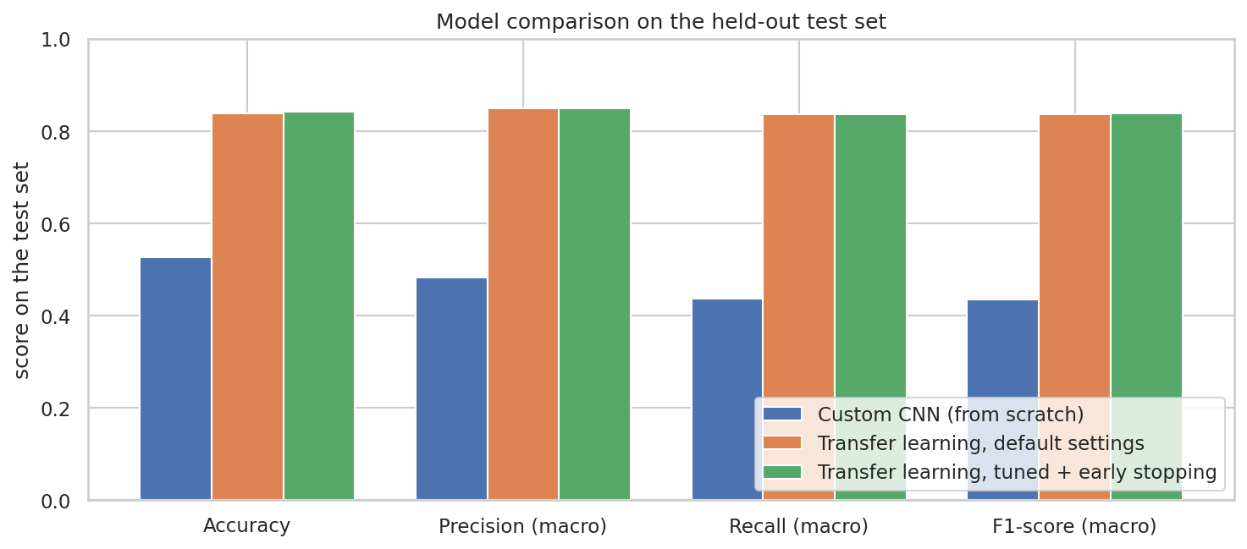
Figure 14: Test-set comparison of the three models.
Before and after optimisation: the untuned transfer-learning model reached 83.9% and the tuned model 84.2% (+0.2 percentage points). With 5,560 test photographs, a difference of 0.2 points is within normal sampling error (about plus or minus 1 point), so tuning did not change test accuracy in a measurable way. It did raise validation accuracy (83.8% against 82.8%) and gave training that stops by itself through early stopping. The custom CNN reached 52.6%.
Which model is better and why: the transfer-learning model is better (+31.6 points over the custom CNN). The pretrained network has already learned general visual features (edges, textures, fur, ears, faces) from over a million ImageNet photographs, so only a small classifier has to be learned from the dog data. The custom CNN has to learn every feature from scratch from the same number of photographs, spread over 138 breeds, which is slower and leaves it confusing similar breeds.
The cost of transfer learning is size and speed: the transfer-learning model has 6.1 million parameters against 1.38 million for the custom CNN, and fine-tuning needed extra tuning time.
Part of the advantage of the pretrained model comes from ImageNet containing the photographs behind some of the datasets, so the comparison favours it somewhat.

Chapter 7: Conclusion and Recommendations
What was achieved
A dataset of 55,599 dog photographs of 138 breeds was built from 5 public sources, cleaned and split automatically.
A CNN was built from scratch (52.6% test accuracy) and a transfer-learning model (EfficientNetV2B0) reached 84.2% test accuracy, macro F1 83.8%.
Dropout, batch normalisation, early stopping, ReduceLROnPlateau, model checkpointing, data augmentation, hyperparameter tuning and transfer learning were applied and compared before and after.
The model was tested on unseen photographs, saved, converted to TensorFlow Lite and deployed as a FastAPI web service.
Model performance
The final model meets the 80% accuracy target set in the project brief (test accuracy 84.2%; top-5 accuracy 98.0%). The custom CNN built from scratch, at 52.6%, does not reach the target; the transfer-learning models do.
Challenges encountered
The same breed has different names in different datasets, and the same photograph appears in several datasets. Without cleaning, this would have caused wrong labels and test photographs leaking into the training data.
Many breeds look alike, and some breeds have few photographs.
Limited free GPU time on Google Colab, which required running tuning on subsets and saving progress to Google Drive.
Limitations
Only purebred dogs: mixed breeds cannot be named, and non-dog images are not rejected reliably.
Stanford Dogs and the Kaggle competition set come from ImageNet, so test scores on those photographs are optimistic.
Dataset labels are not perfect, and some breeds have few test photographs, which makes their scores noisy.
One dog per photograph is assumed.
Recommendations for future improvement
Collect more photographs of the weakest breeds and of mixed breeds, and add a "not a dog" class.
Try larger or newer backbones, higher input resolution, and test-time augmentation.
Add an object detector to crop the dog first, so photographs with people or several dogs work better.
Calibrate the confidence scores, and ship the TensorFlow Lite model in a mobile app.

