Pentest Report: Security Analysis of Metasploitable 2
Network Assessment Using NMAP
Security Assessment:
- Port 21: FTP anonymous login with outdated version (vsftpd 2.3.4).
- Port 512, 513, 514: r-services misconfigured to allow remote access.
- Port 23: Telnet service with a backdoor vulnerability.
- Port 139, 445: Samba client misconfiguration allowing access to unauthorized files.
- Port 1524: Blind shell vulnerability.
- Port 5900: VNC service using default password.
- Port 5432: PostgreeSQL database using default password.
Scope of Assessement:
- Metasploitable 2 Virtual Machine (IP:192.168.1.4)
- To perform network scanning using nmap to identify open ports, services and identify the potential vulnerabilities and risks.
Methodology:
- Information Gathering: Conducted network scanning to identify targeted system and find the open ports, services, versions.
- Vulnerability Analysis: Analyse the identified services for known vulnerabilities and misconfigurations.
- Exploitation: Attempted to exploit through discovered vulnerabilities and gain access to target system.
- Post-Exploitation and Reporting: Documented the findings, successfully
exploits and assessed the potential risks.

Assessor Details:
Name: Anand M S
Date: July 18, 2026

Table of Contents
- Executive Summary…………………………………………………..3
- Introduction and Scope……………………………………………..3
2.1 Introduction………………………………………………………………………….3
2.2 Scope………………………………………………………………………………….3
- Methodology……………………………………………………………..4
- Information Gathering………………………………………………..4
4.1 Nmap Scan Details………………………………………………………………..4
4.2 Proof of Concept……………………………………………………………………4
- Vulnerability Analysis and Exploitations………………………..5
5.1 Anonymous FTP Login and vsftpd Backdoor……………………………….5
5.2 Legacy R-Services Misconfiguration………………………………………….6
5.3 Unauthorized Bind Shell………………………………………………………….6
5.4 Misconfigured Samba Service………………………………………………….7
5.5 Weak VNC Authentication……………………………………………………….7
5.6 PostgreSQL Default Credentials………………………………………………8
- Post-Exploitation and Reporting…………………………………..8
6.1 Post-Exploitation……………………………………………………………………8
6.2 Reporting and Remedies…………………………………………………………9
6.3 References…………………………………………………………………………..10

1.0 Executive Summary
The security analysis of the Metasploitable 2 system identified multiple critical security vulnerabilities. The key issues include outdated service versions, exposed and undocumented services, backdoors, weak default credentials, and misconfigured network services. These vulnerabilities increase the risk of unauthorized access, privilege escalation, and data breaches. Immediate remediation is recommended to reduce the risk of unauthorized attacks and improve the overall security measures of the system.
2.0 Introduction and Scope
2.1 Introduction
The Metasploitable 2 virtual machine is an intentionally vulnerable linux environment designed for security training and testing. The system is designed to expose common security issues, allowing testers to safely expose various attacks and techniques, it helps the tester to understand the impact of poor configurations in real-world scenarious. It comes with different types of vulnerabilities including FTP, network services, SMB and HTTP, each containing well-documented security flaws. This report present the findings of a security analysis of the Metasploitable 2 virtual machine. The purpose of the testing was to identify the security vulnerabilities, open ports, identify the outdate services, configuration weaknesses such as weak default credentials, and possible attacks that exploit by an attacker.
2.2 Scope
The scope of this assessment is strictly limited to Metasploitable 2 , virtual network lab configured with virtualbox environment operating at the IP address [192.168.1.4]. This authorized security assessment was conducted as a black-box test, focusing on stimulating real-world attacks without proper knowledge of internal network architecture. The activities within scope include active network discovery, port scanning, vulnerability assessment and the validation of known exploitation vulnerabilities. Any system, network or devices outside the scope of Metasploitable 2 environment are strictly excluded from the attack.

3.0 Methodology
The analysis start by scanning the IP with the tool called Nmap, it identify active host , open ports, and detailed service versions. After that I use the Nmap default script scan to identify the known vulnerability. Next I use exploit DB for searching for CVE’s and use search exploit to discover vulnerabilities. The exploitation attempts are done by using Metasploit framework, it successfully exploit the system. Finally, post-exploitation techinques are used to escalate privileges and access critical system files such as etc/passwd and etc/shadow. Then retrieving password hashes and crack by using john ripper tool. Then access the system using recover credentials.
4.0 Information Gathering
4.1 Nmap Scan Details
In this section the Nmap scan execute to identify the open ports, services and find the version of the services. Host discovery techniques were used to identify the active system on the target network. Additionally, service version detection was performed to enumerate the specific software versions associated with each open port, providing critical data for the subsequent vulnerability analysis phase.
4.2 Proof of Concept
The POC for information gathering using Nmap scanning is detailed below.
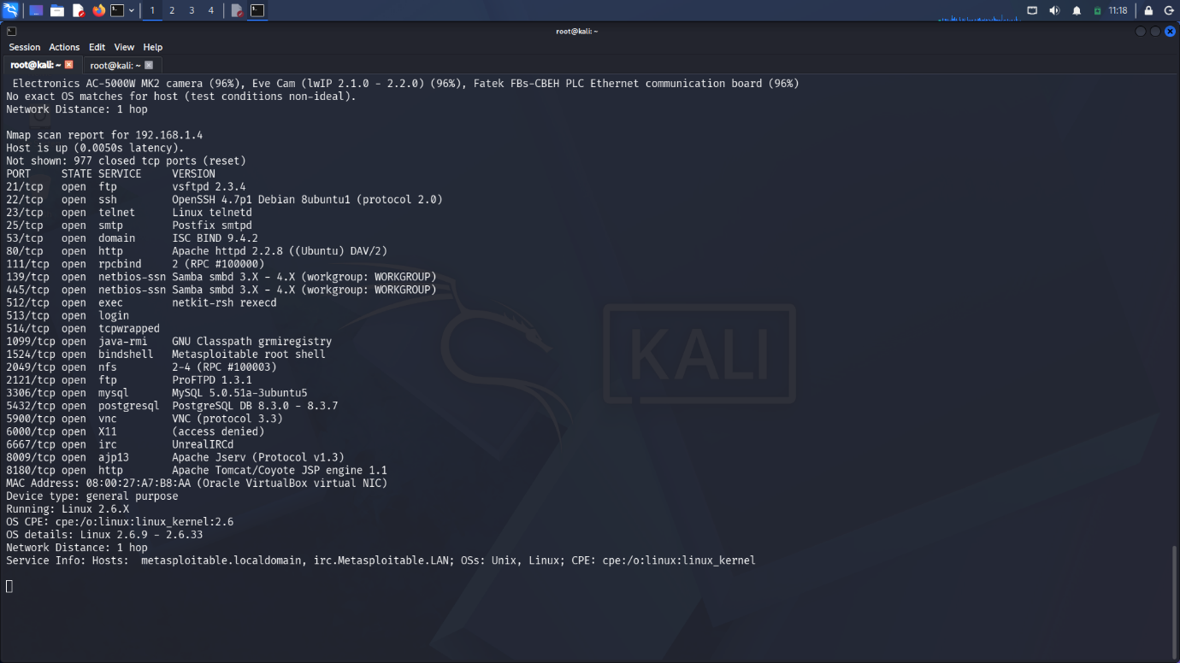

5.0 Vulnerability Analysis and Exploitations
5.1 Anonymous FTP Login and vsftpd Backdoor
On Port 21, the vsftpd version 2.3.4 allows for anonymous FTP logins and contains a known backdoor that can be exploited to gain root access. By anonymous ftp login attacker can login using username and password as “anonymous”. In vsftpd 2.3.4 there is a backdoor vulnerability in Metasploit framework, can access the root privilege in meterpreter shell.
Severity: Critical
The POC for Anonymous FTP Login and vsftpd 2.3.4 is detailed below.
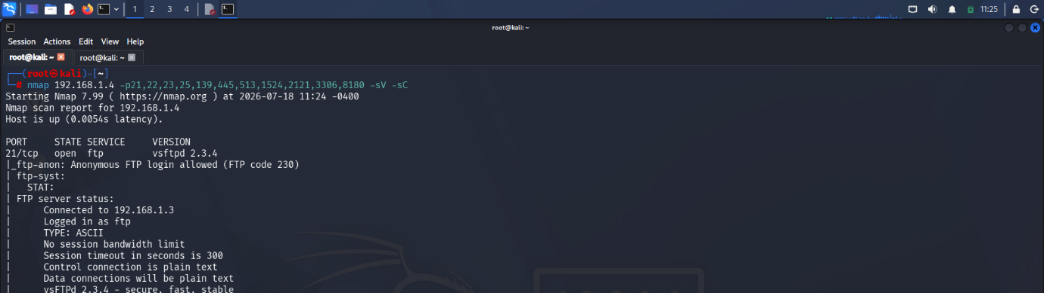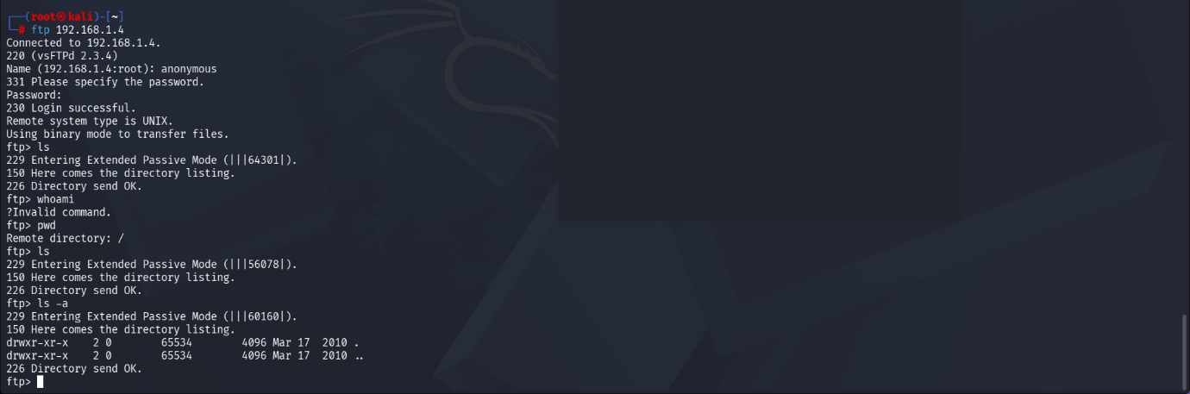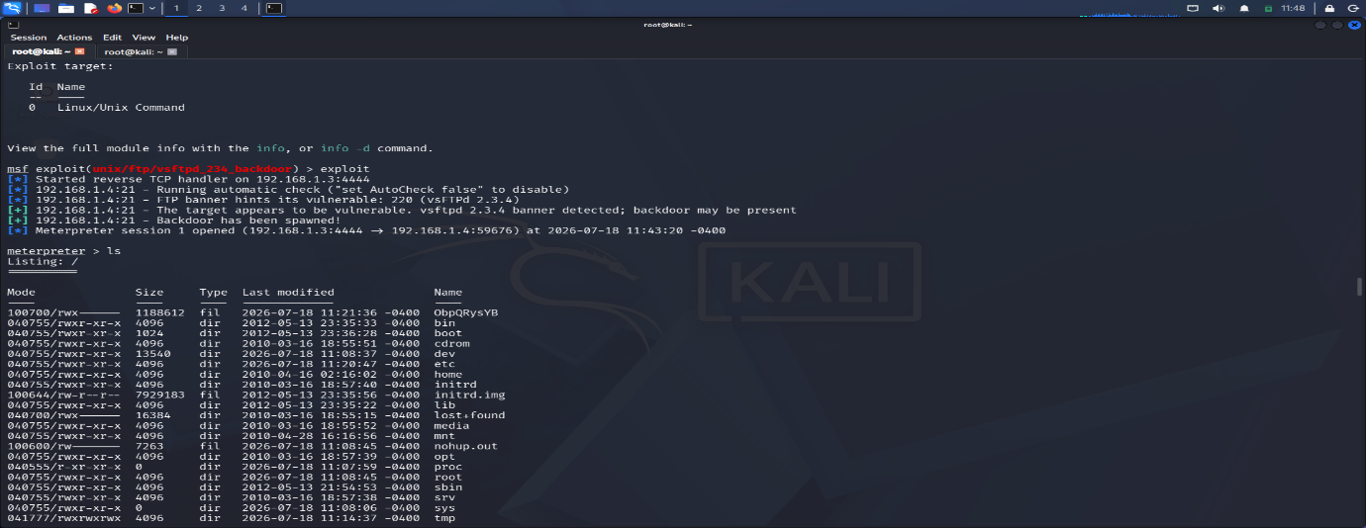

5.2 Legacy R-Services Misconfiguration
The legacy 'r' services on Ports 512, 513, and 514 are misconfigured and permit remote access without proper authentication. We can access by using single command to gain root privilege .
Severity: High

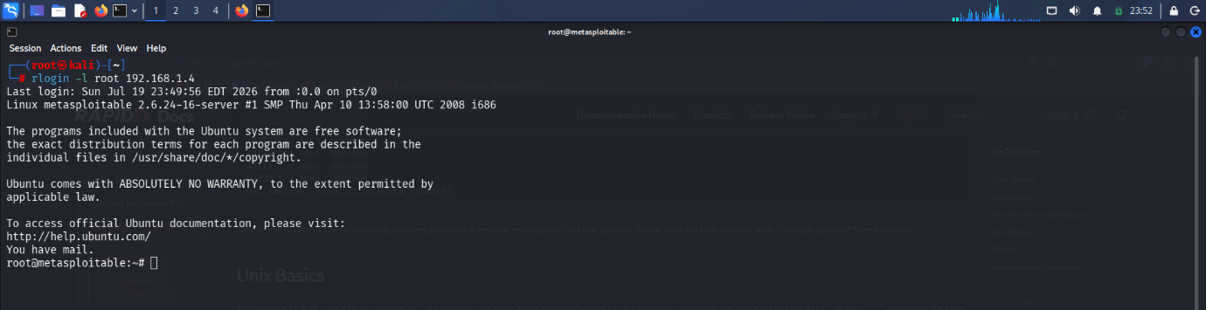

5.3 Unauthorized Bind Shell
On Port 1524, a bindshell provides an unauthorized listening port with full system access.
Severity: Critical
The POC for Bind Shell is below.

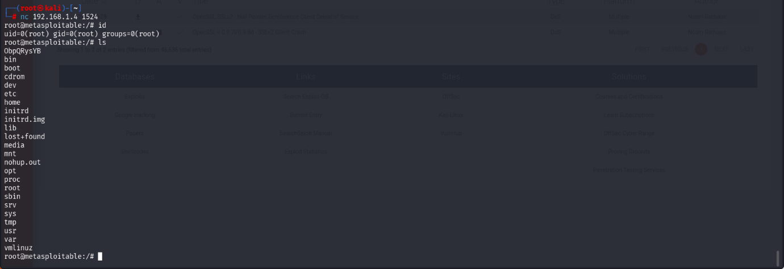

5.4 Misconfigured Samba Service
The Samba service on Ports 139 and 445 is misconfigured, creating risks of unauthorized file access and potential remote code execution.
Severity: High
The POC for Samba Service is below.

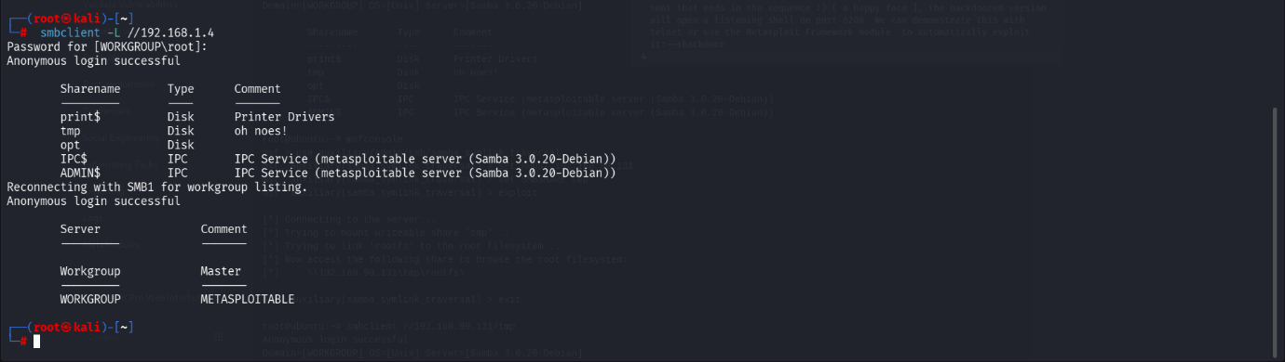

5.5 Weak VNC Authentication
VNC on Port 5900 is using a default password, allowing unauthorized remote desktop access.
Severity: Medium
The POC for VNC Authentication is below.
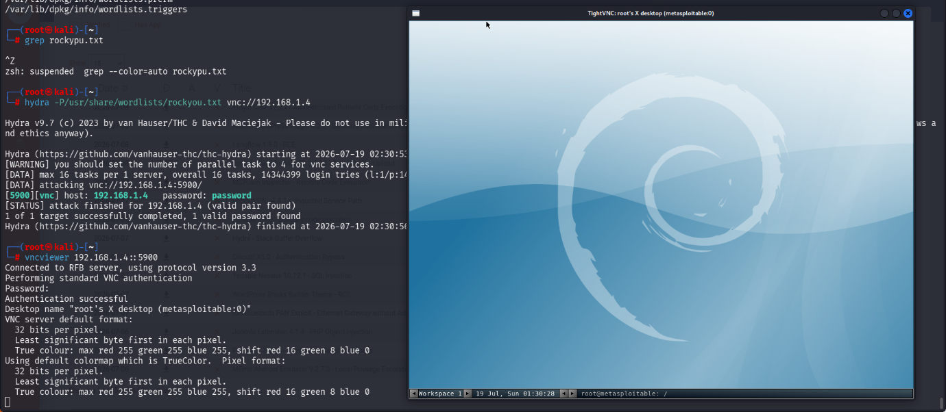

5.6 PostgreSQL Default Credentials
PostgreSQL database on Port 5432 is also used default credentials.
Severity: Medium
The POC for PostgreSQL is below.
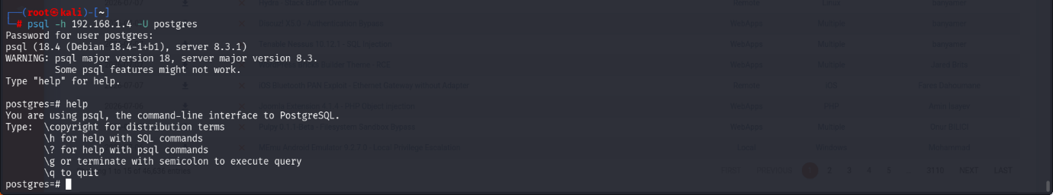

6.0 Post-Exploitation and Reporting
6.1 Post-Exploitation
In this phase, we focus on gaining full system access. This involves user privileges escalations, retrieving sensitive files such as etc/passwd and etc/shadow and retrieving password hashes to analysing them to recover user passwords. John ripper is used to retrieving password hashes to plaintext. These credentials were used to establish an SSH session, thereby validating the exploit path and demonstrating unauthorized access to the target system.
The POC for accessing sensitive file and password cracking using john is below.
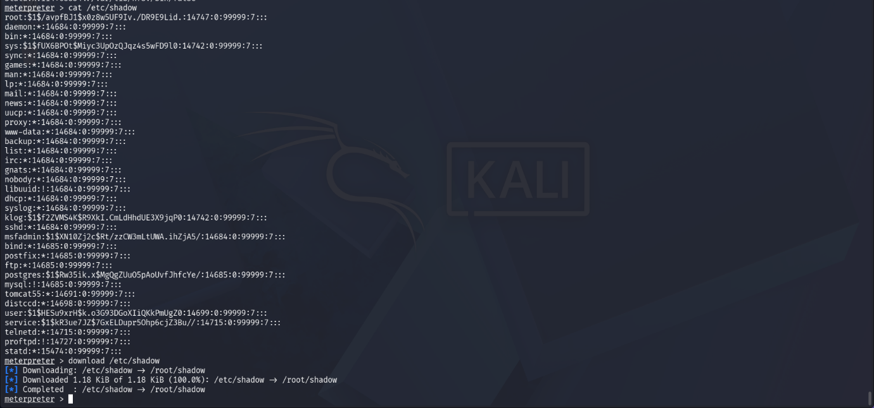

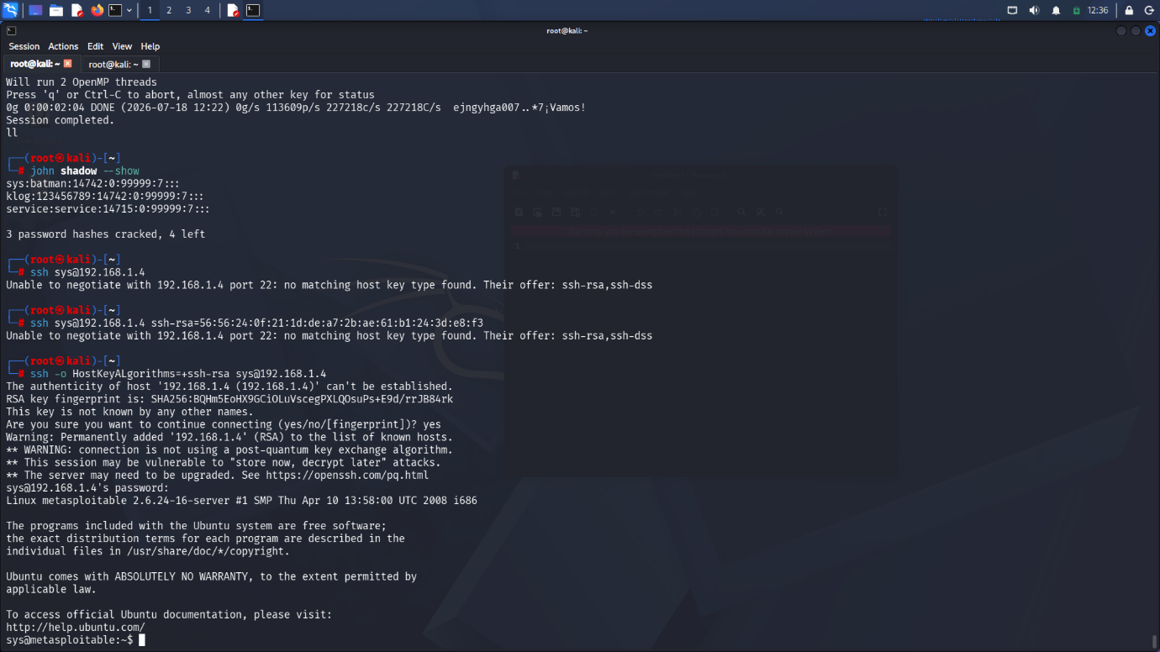

6.2 Reporting and Remedies
In this assessment reveals that there are multiple vulnerabilities that could compromise the integrity and confidentiality of the system. In this system there are multiple critical, high vulnerabilities are found.
To prevent anonymous FTP login and vsftpd backdoor vulnerabilities, you should disable anonymous login in the FTP configuration, update the vsftpd package to a secure version and remove any backdoored version of the software.
The legacy ‘r’ services are misconfigured and permit remote access from any host without proper authentication. To prevent this to disable these obsolete services and secure protocols like SSH for remote access.
The bindshell provides an unauthorized listening port with full system access. To prevent this, you should identify the service binding to this port and terminate it and review system services and startup scripts to prevent unauthorized execution.
The Samba service on ports 139 and 445 is misconfigured, creating risks of unauthorized file access and potential remote code execution due to writable file shares and 'wide links' being enabled. To prevent this, you should restrict access to the Samba service, disable anonymous file sharing, and reconfigure the smb.conf file to disallow 'wide links' and enforce strict access controls.
The VNC service on port 5900 uses a default password, allowing unauthorized remote desktop access. To prevent this, you should change the default VNC password to a strong, unique passphrase and enforce authentication requirements.
The PostgreSQL database on port 5432 uses default credentials. To prevent this, you should update the database administrator and service account passwords to strong, unique credentials.
6.3 References
The following resource were utilized during the security assessment of the system
https://docs.rapid7.com/metasploit/metasploitable-2-exploitability-guide/

