Empire: Breakout
This document is a write-up for a recent machine that I pwned from VulnHub, which is available for free. The End goal of this challenge is to get the root access and get the flag. I was able to get the root access with two different ways which I will write here including the ideal way the author of the machine wanted us to proceed with and an alternative way that you could potentially use to get the root access.

1. Information Gathering
Nmap
Started by doing a nmap scan using the following command,
nmap -A -T5 10.0.0.62
-A: This option is a combination of the following 3 options: -sV,-sC, -O
-T5: This defines the timing template and “5” means “aggressive”
It seems like the server is running multiple services that I will enumerate. I will not perform a vulnerability scanning script on the target IP address to see If these services are vulnerable to any exploit.
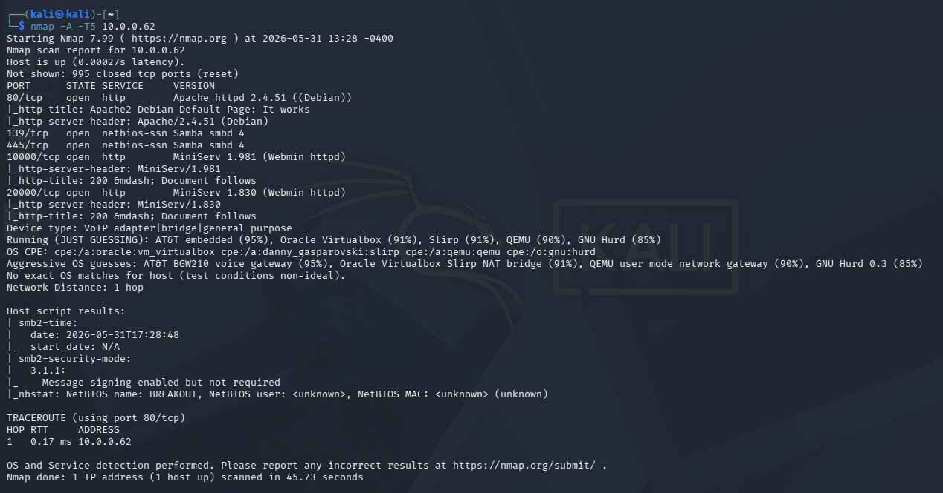Figure 1: Nmap advanced scanning -A( includes -sV, -sC, O ).
The command used,
nmap –script vuln 10.0.0.62
<<output here>>

HTTP enumeration

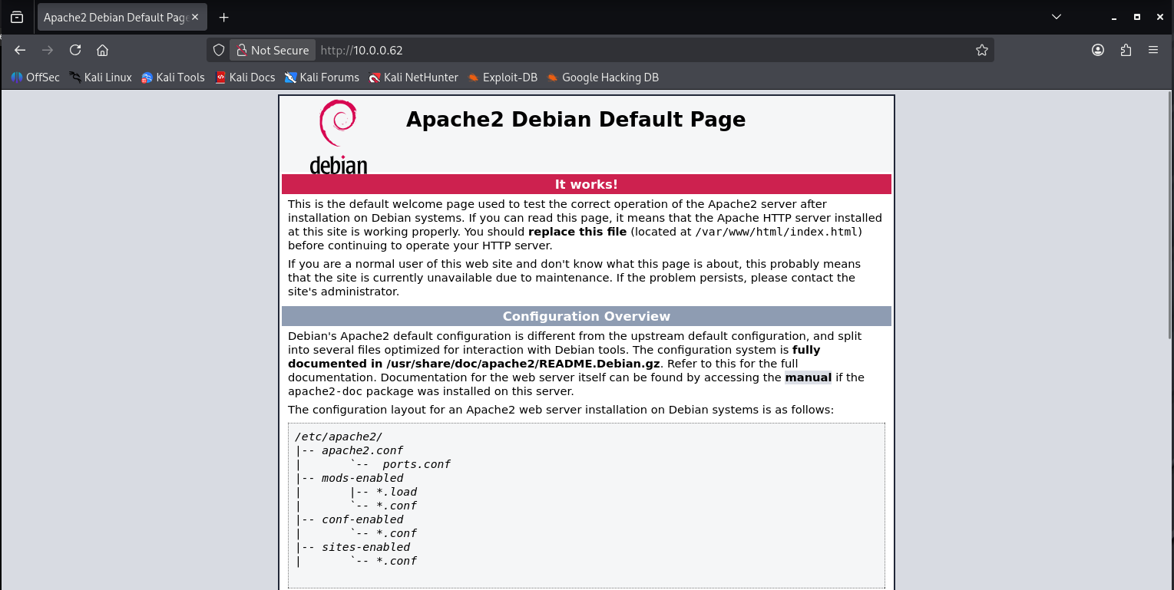
The website seems to be running a default apache2 website.

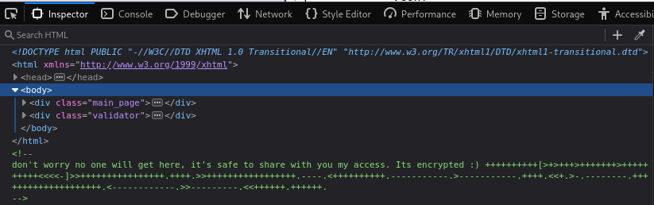
OH look at that… This looks like brainfuck language, yep, that’s the name of a programming language.
Decoding that gave me
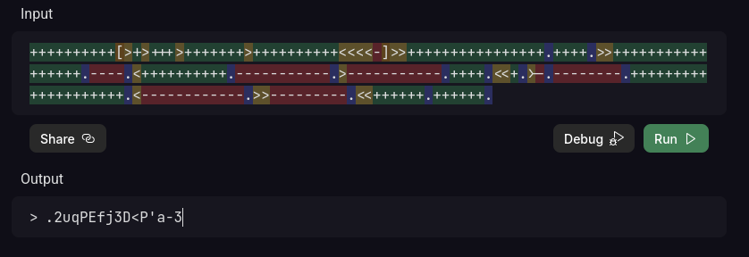
hmmm
is this a ROT13?
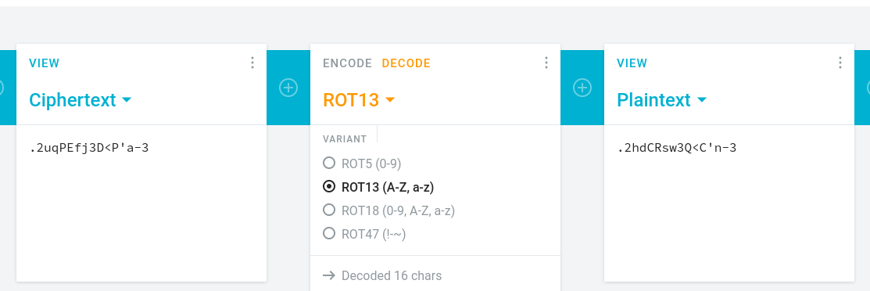

Seems not
the website also has a /manual/ as you can see from dirb’s output

I did a simple dirb scan using
dirb http://10.0.0.62/

<←output here→

nitko scanning

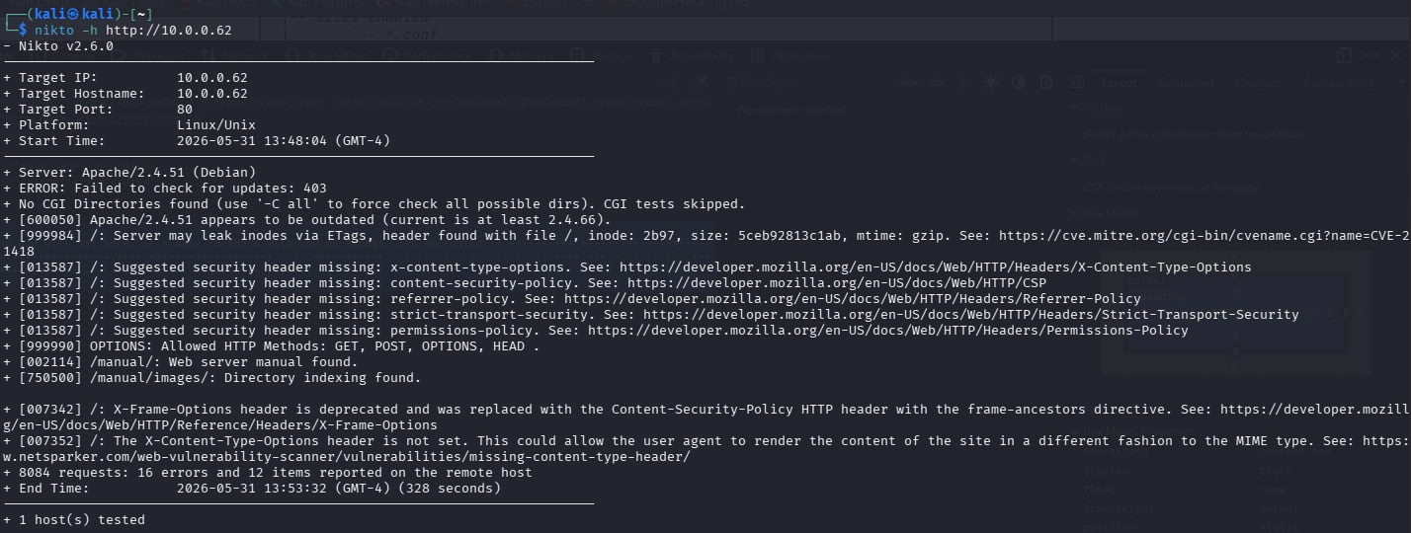
let’s move on to other ports
SMB 445 / 143
I always start by listing out any shares that I can access using the following command
smbclient -L //10.0.0.62//

<< output >>
then I moved on to using enum4linux if I can find a username because the thing that I just decoded above could potentially be password then I can form password spraying attack on those usernames.
If it gives a username that is..

I used the following command to enumerate,
enum4linux 10.0.0.62

<<output here>>

oohhh it seems like there is a user named CYBER hahahahah
let’s see if I can login using cyberaccount on the smb but before that let’s see the kind of version smb is running. This time I’ll use msfconsole

<<output>>
I tried logging in using psexec and smb_login but I did not find anything useful, but I was able to sucessfully login. It seems like this is not a way to get into the system or I could be wrong..
Let’s checkout the other ports

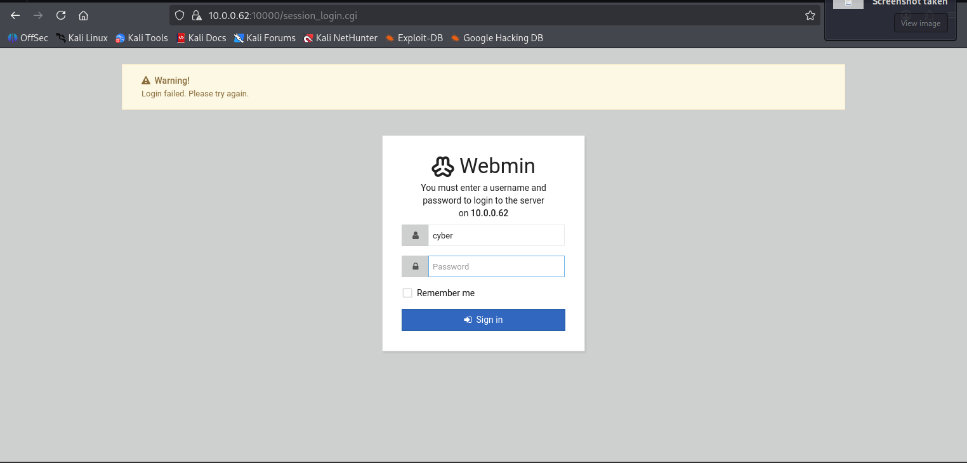
hmm let’s scan this website more. I know this is running Webmin and webmin is known to have a vulnerability as listed by NMAP but it seems like the author prevents us from explotining the vunlerabilities defined in the above nmap scan by switching to HTTPS, as I’ve tried couple of msf modules or even python scripts that

Ok it seems like this webmin thing is serious and I can get a shell if I can get access to it somehow. I checked all the endpoints found with nikto and I was not able to access any of them without being authenticated. Let’s try the different port number to see if the credentials can be used on that account.

Et la voila!

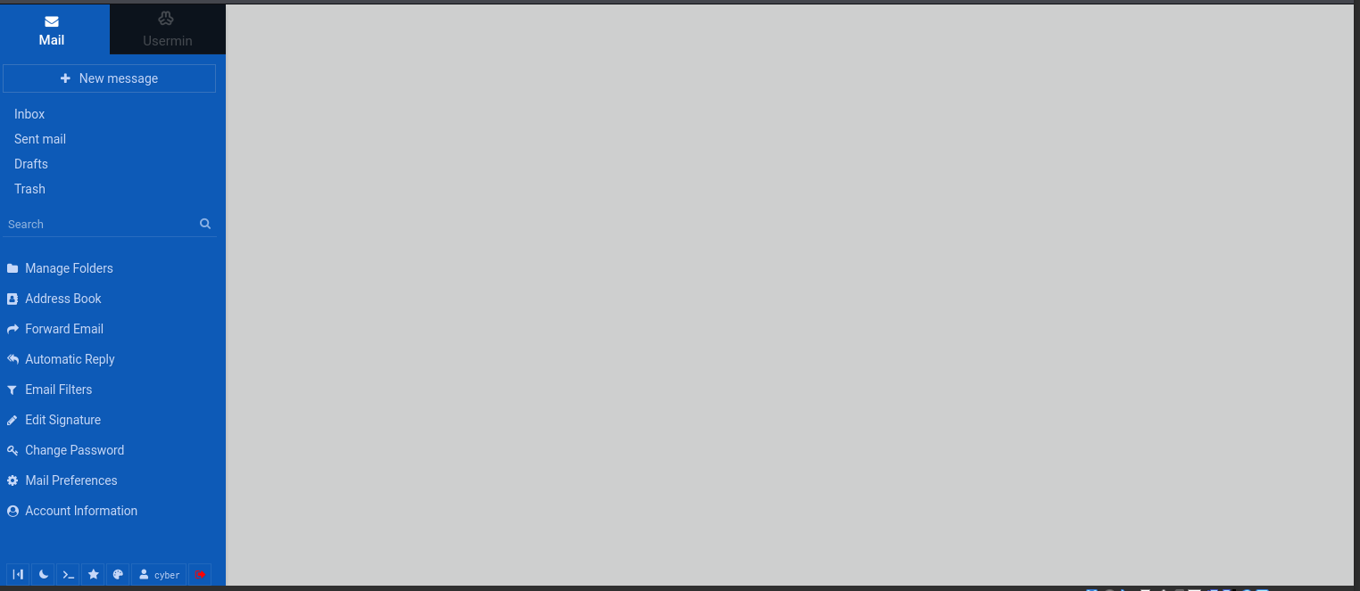
I could login to usermin at port :20000. now let’s doo some hacking ahahahahha
there are couple of ways to get access to the shell using this. I’ll use a simple reverse shell using netcat to get initial foothold from this page specifically
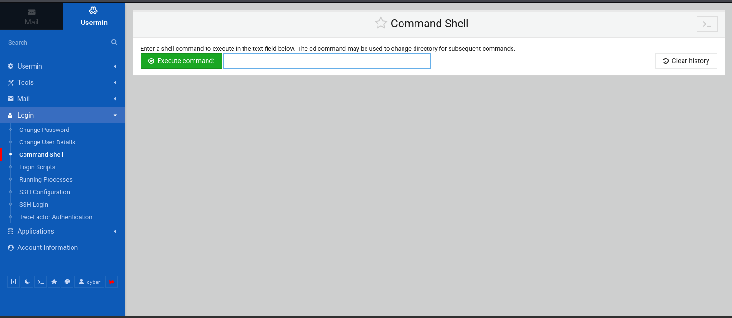
you can craft a reverse shell using the website revshells.com and set the right options. Make sure the port number that you pick is not being used by any other service and the ip that you put in will be your kali’s ip (machine you’re using to attack from)
meanwhile I got my first flag
3mp!r3{You_Manage_To_Break_To_My_Secure_Access}
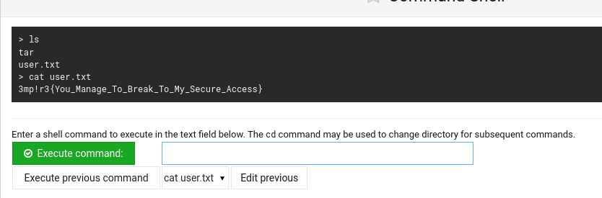
Let’s get a shell using the website listed above

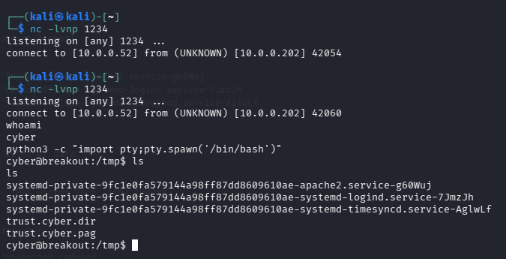

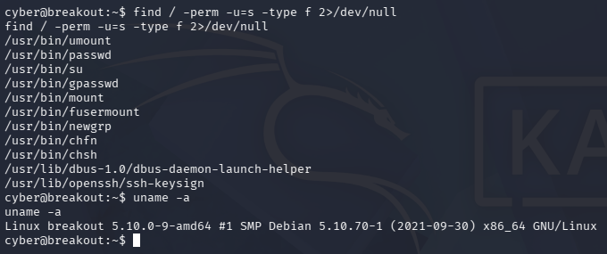

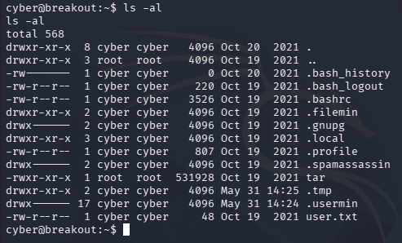
seems like the tar file in my directory can be executed by any user which includes me, but I cannot use it to get a shell but maybe something with it.
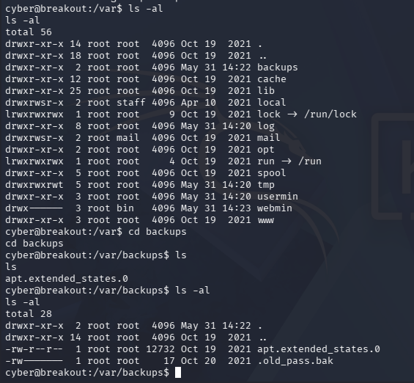
After navigating my way around. It seems like the backups contain a file called .old_pass but I cannot read it. I went through the internet and did a search if there is any way I can use tar to read this file because this is the only thing that looks different.
I found out you can actually use tar to read the contents from the old_pass file

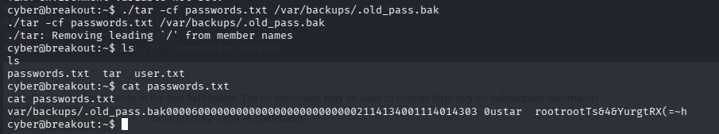
wooooo

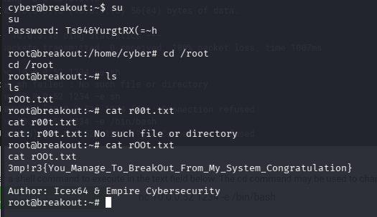

3mp!r3{You_Manage_To_BreakOut_From_My_System_Congratulation}

..
what’s the other way?
Using kernal vulnerability. This system is running an older version of kernal which is vulnerable to dirty pipe and dirty frag.

Using this script in github, https://github.com/AlexisAhmed/CVE-2022-0847-DirtyPipe-Exploits
I’ll clone this to my linux and compile the binaries with an exception -static
because static compilation instructs the compiler to bundle all necessary library dependencies (like libc) directly inside the executable binary itself. This eliminates the target machine's reliance on its own /lib/x86_64-linux-gnu/libc.so.6.
The cyber user does not have the permission to run gcc so we’ll have to use static and compile the binaries transfer it to the target machine and run it on the target machine.
Here’s how,

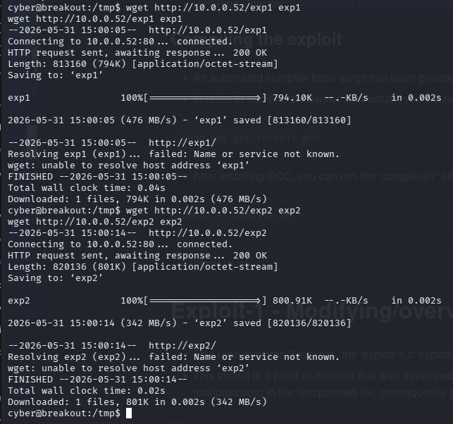
you see ^
and then

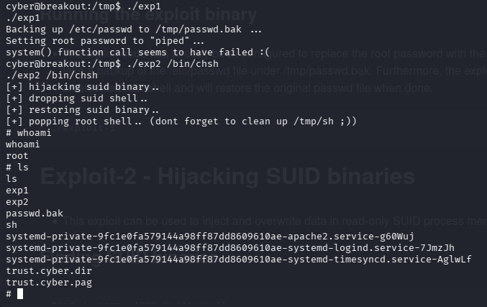
you can use any shell /bin/bash or /bin/chsh it will work.
That’s the second method

