

Entropy as a measure of password strength

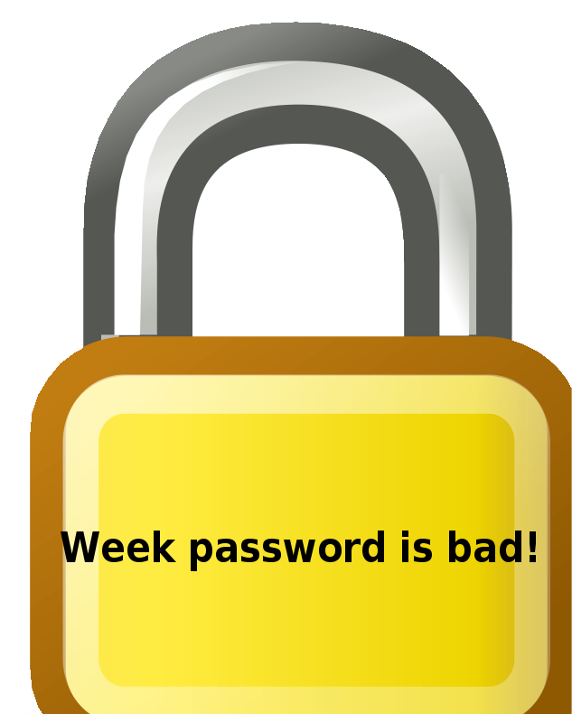
It is usual in the computer industry to specify password strength in terms of information entropy, measured in bits, a concept from information theory. Instead of the number of guesses needed to find the password with certainty, the base-2 logarithm of that number is given, which is the number of "entropy bits" in a password. A password with, say, 42 bits of strength calculated in this way would be as strong as a string of 42 bits chosen randomly, say by a fair coin toss. Put another way, a password with 42 bits of strength would require 242 attempts to exhaust all possibilities during a brute force search. Thus, adding one bit of entropy to a password doubles the number of guesses required, which makes an attacker's task twice as difficult. On average, an attacker will have to try half the possible passwords before finding the correct one.

Here are example passwords that discourage 'brute force' dictionary cracking:
OK Password: | Better Password: | Excellent Password:
kitty | 1Kitty | 1Ki77y
susan | Susan53 | .Susan53.
jellyfish | jelly22fish | J3lly22Fish
smellycat | sm3llycat | $m3llycat.
allblacks | AllBlacks! | A11B1ack$!
jackbauer | jAckBauer | jA(kBauer
doctorhouse | Doct0rH0use | .Doct0rH0use.
adamsandler | adamSandler | #adamS@ndler
ilovemypiano | ILoveMyPiano | ILov3MyPi@no
ihateliverandonions | 1Hateliver@ndonions | 1Hat3liver@Onions!
mypuppylikescheese | MyPuppyLikesCh33s3 | .MyPuppyLikesCh33s3
julieloveskevin | JulieLovesKevin | Jul1eLovesK3v1n
ieatcarrots | IeatCarrots | I34tcarr0ts:

