**[Pharmacy Management System]**

**By  
Mohamed Badawy Sayed   
Mostafa Ahmed Hasan El-Gelany**

**[](https://github.com/Mohamed-badawy-sayed/CMS)**

[**GitHub Repo**](https://github.com/Mohamed-badawy-sayed/CMS)

**Dr.**

**Bassem Abd El-Atty Eldeeb**

**Mohamed Ahmed El kholy**

**Table of Contents**

**Requirements 2**

**Functional requirements** 2

**Non-Functional requirements** 4

**Use Case Diagram** 5

**Use Case Scenario** 6

**ERD Diagram 15**

**Class Diagram 16**

Seqance Diagram **17**

**Requirements**

Functional requirements

**1** Sales:

**1.1** Selling Medicine:

**1.1.1** The system should allow employees to record sales transactions, including details such as customer   
 information, medicine name, quantity sold, and unit price.

**1.1.2** Integration with a barcode scanner or manual entry should be supported for efficient sales processes.

**1.2** Inventory Management:

**1.2.1** The system should automatically update the available quantity of each medicine after a sale is  
 completed ensuring real-time inventory tracking.

**1.2.2** Notifications should be generated when the stock of a particular medicine falls below a predefined threshold.

**1.3** Sales Performance Tracking:

**1.3.1** The system should provide tools for tracking and analyzing sales performance, including metrics such as  
 total sales, top-selling medicines, and sales trends over time.

**2** Purchase:

**2.1** Buying Medicine from Distributors:

**2.1.1** Employees should be able to create purchase orders for medicines from authorized distributors, specifying details like quantity, and expiration dates.

**2.2** Inventory increase:

**2.2.1** The system should automatically update the available quantity of each purchased medicine, reflecting the increase in stock.

**3** Reports:

**3.1** Sales Reports: **3.1.1** The system should generate detailed reports on sales activities, including daily, weekly,  
 and monthly summaries, as well as custom date ranges. **3.1.2** Reports should include information on total sales, and top-selling medicines.

**3.2** Purchase Reports: **3.2.1** Detailed reports on purchases should be available, displaying information such as total expenditure,   
 and quantities purchased.

**3.3** Medicine Reports:  
 **3.3.1** Comprehensive reports on medicine inventory, including stock levels, expiration dates,   
 and reorder suggestions, should be generated.

**3.4** Net Profit Reports:

**3.4.1** The system should calculate and provide reports on the net profit, taking into account both sales and   
 purchase transactions.

**4** Alerts:

**4.1** Expiration Alerts:

**4.1.1** The system should generate alerts for employees when the expiration date of a medicine is approaching,  
 allowing timely actions such as marking for discounts or removal from shelves.

**5** Employees:

**5.1** User Authentication:  
 **5.1.1** The system should have a secure login mechanism with role-based access control, ensuring that employees   
 can only access functions relevant to their roles.

**5.2** Activity History:  
 **5.2.1** A detailed activity log should be maintained for each employee, capturing actions such as logins, logouts,   
 sales transactions, purchases, and any system operations.

**6** Return:

**6.1** Return to Distributors: **6.1.1** Employees should be able to process returns of medicines to distributors within the specified time frame, recording relevant details such as reasons for return and quantities returned.

**6.2** Inventory Update: **6.2.1** The system should automatically adjust the available quantity of returned medicines in the inventory.

**6.3** Stock Reduction: **6.3.1** The return process should result in a decrease in the number of available medicines, reflecting accurate stock levels.

**Non-functional requirements:**

**1**. **Performance**:  
 1.1 The system should respond to user interactions within two seconds under normal operating conditions.

1.2 The time taken to generate reports, should not exceed five seconds.

**2**. **Reliability**:  
 2.1 The system should have a mean time between failures at least 500 hours.

2.2 In the event of a failure, the system should recover within five minutes with minimal data loss.

**3**. **Security**:  
 3.1 All sensitive customer and employee data should be encrypted during transmission and storage.

3.2 Role-based access control should be enforced, ensuring that employees can only access functionalities based on their assigned roles.

3.3 Passwords should be stored securely using industry-standard hashing algorithms.

**4. Scalability:** 4.1 It should support the addition of new features and functionalities without requiring a complete system overhaul.

4.2 Scalability tests should be conducted to ensure optimal performance under increased loads.

**5. Usability:**  
 5.1 The user interface should be intuitive and require minimal training for new employees.

5.2 The system should provide clear error messages and guidance to users in case of input errors.

**6. Availability:**  
 6.1 The system should be available 100% of the time during regular business hours.

6.2 Scheduled maintenance should be communicated in advance, and efforts should be made to minimize downtime.

**7. Backup and Recovery:**  
 7.1 Regular automated backups of the database and system configuration should be performed.

7.2 The backup data should be stored in a geographically separate location to ensure recovery in case of a catastrophic event.

**8. Dependability:** 8.1 The system should be designed with built-in fault tolerance to minimize the impact of hardware or software failures.

8.2 Dependencies on external services or APIs should be identified.

**Use Case Diagram**

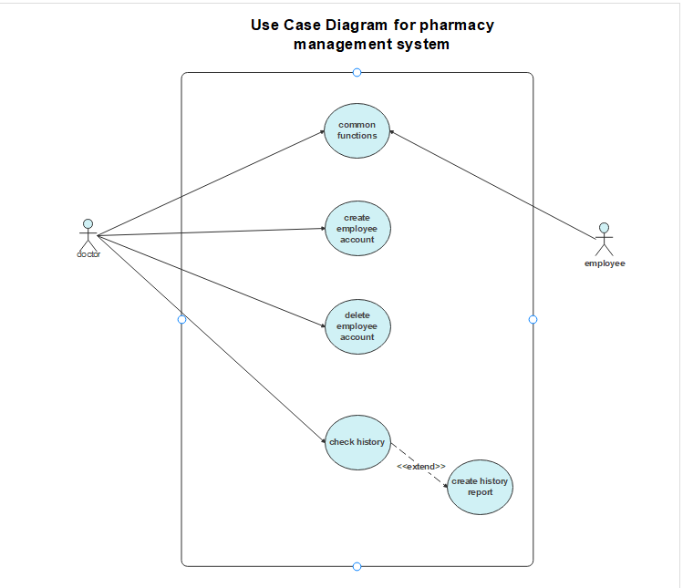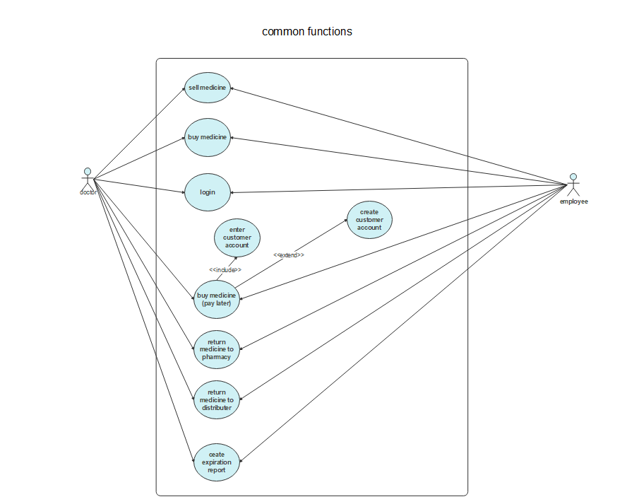

**Use Case Scenario**

|  |  |
| --- | --- |
| case name: | Login |
| case ID: | **Op1** |
| Actor(s): | **Doctor , employee** |
| Description: | **User login to the system** |
| Triggering: | **User want to use the system** |
| Preconditions : | **User isn’t logged in** |
| Main path : | 1. **Enter system** 2. **Enter username** 3. **Enter password**   **Logged in successfully** |
| Alter Path : | **Username or password isn’t correct**   1. **System display a message says that invalid user name or password** |
| Postconditions: | **User logged in successfully** |
| Priority: | **Medium** |

|  |  |
| --- | --- |
| case name: | Buy medicine |
| case ID: | **Op2** |
| Actor(s): | **Doctor , employee** |
| Description: | **User buy medicine from distributers** |
| Triggering: | **Some types of medicine got finished or about to finish from pharmacy** |
| Preconditions : | **Pharmacy needs some types of medicine** |
| Main path : | 1. **Enter type of medicine** 2. **Enter amount of medicine** 3. **Repeat this step for all types of needed medicine** 4. **Click buy button** 5. **Show a message that display the amount of needed money** |
| Postconditions: | **Medicine bought successfully** |
| Priority: | **high** |

|  |  |
| --- | --- |
| case name: | Sell medicine |
| case ID: | **Op3** |
| Actor(s): | **Doctor , employee** |
| Description: | **User enter type of medicine and amount of that type to be sold** |
| Triggering: | **A customer came to buy some medicine** |
| Preconditions : | **Medicine isn’t bought yet** |
| Main path : | 1. **Enter type of medicine** 2. **Enter amount of medicine to be sold** 3. **Repeat this step for all types of needed medicine** 4. **Click sell button** 5. **Show a message that display the amount of required money** |
| Alter Path : | **Some kind of medicine is not in the pharmacy**  **Show a message says that “some kind of medicine is not enough”** |
| Postconditions: | **Medicine sold to customer successfully** |
| Priority: | **high** |

|  |  |
| --- | --- |
| case name: | Return medicine to pharmacy |
| case ID: | **Op4** |
| Actor(s): | **Doctor , employee** |
| Description: | **A customer came to return some medicine after buying it** |
| Triggering: | **A customer came to return some medicine** |
| Preconditions : | **Medicine isn’t returned yet** |
| Main path : | 1. **Enter type of medicine** 2. **Enter amount of medicine to be returned** 3. **Repeat this step for all types of needed medicine** 4. **Click return button** 5. **Show a message that display the amount of money to return to customer** |
| Postconditions: | **Medicine returned successfully** |
| Priority: | **low** |

|  |  |
| --- | --- |
| case name: | Return medicine to distributer |
| case ID: | **Op5** |
| Actor(s): | **Doctor , employee** |
| Description: | **Pharmacy returns medicine to distributer** |
| Triggering: | 1. **Expiration date of medicine is near** 2. **There as a big amount of some kind of medicine** 3. **Pharmacy needs urgent money** |
| Preconditions : | **Bought Medicine is still in the pharmacy** |
| Main path : | 1. **Enter type of medicine** 2. **Enter amount of medicine to be sold** 3. **Repeat this step for all types of needed medicine** 4. **Click return button** 5. **Show a message that display the amount of required money** |
| Alter Path : | **Some kind of medicine is not in the pharmacy**  **Show a message says that “some kind of medicine is not enough”** |
| Postconditions: | **Medicine return to distributer successfully** |
| Priority: | **low** |

|  |  |
| --- | --- |
| case name: | Create expiration report |
| case ID: | **Op6** |
| Actor(s): | **Doctor , employee** |
| Description: | **User create report about medicine that is about to get expired** |
| Triggering: | **user need to contact with distributer about medicine that need to return** |
| Preconditions : | **Report is not created yet** |
| Main path : | 1. **Enter expiration notification tab** 2. **Enter button create report** 3. **Show message says “report created successfully”** |
| Alter Path : | **There is no medicine that is about to expire**  **Show message says that “no medicine to get reported”** |
| Postconditions: | **Report created successfully** |
| Priority: | **low** |

|  |  |
| --- | --- |
| case name: | Create employee account |
| case ID: | **Op7** |
| Actor(s): | **Doctor** |
| Description: | **Doctor create new account for new employee to enable him use the system** |
| Triggering: | **Doctor hires new employee** |
| Preconditions : | **Employee can’t access the system** |
| Main path : | 1. **Enter username** 2. **Enter name** 3. **Enter password** 4. **Enter password again** 5. **Enter button create account** 6. **Show message “account created successfully”** |
| Alter Path : | **Case 1: Password entered is not the same in 2 fields**  **Show message “password is not correct”**  **Case 2: username is empty have invalid character**  **Show message “invalid username”**  **Case 3: name is empty**  **Show message “enter name”** |
| Postconditions: | **Account created successfully** |
| Priority: | **medium** |

|  |  |
| --- | --- |
| case name: | delete employee account |
| case ID: | **Op8** |
| Actor(s): | **Doctor** |
| Description: | **Doctor deletes employee’s account because this employee is no longer work in the pharmacy** |
| Triggering: | **Employee is no longer working in the pharmacy** |
| Preconditions : | **Account is still in the system** |
| Main path : | 1. **Enter username** 2. **Enter password** 3. **Enter button delete account** 4. **Show message “account deleted successfully”** |
| Alter Path : | **Account is not in the system**  **Show message “invalid username or password”** |
| Postconditions: | **Account deleted successfully** |
| Priority: | **low** |

|  |  |
| --- | --- |
| case name: | Check history |
| case ID: | **Op9** |
| Actor(s): | **Doctor** |
| Description: | **Doctor check history of all operations that done on the system** |
| Triggering: | **Doctor need to check about pharmacy finance** |
| Preconditions : | **Doctor need to check history** |
| Main path : | **Enter button history**  **(extend)**  **Enter button create report** |
| Postconditions: | **Doctor checked history** |
| Priority: | **high** |

**ERD Diagram**

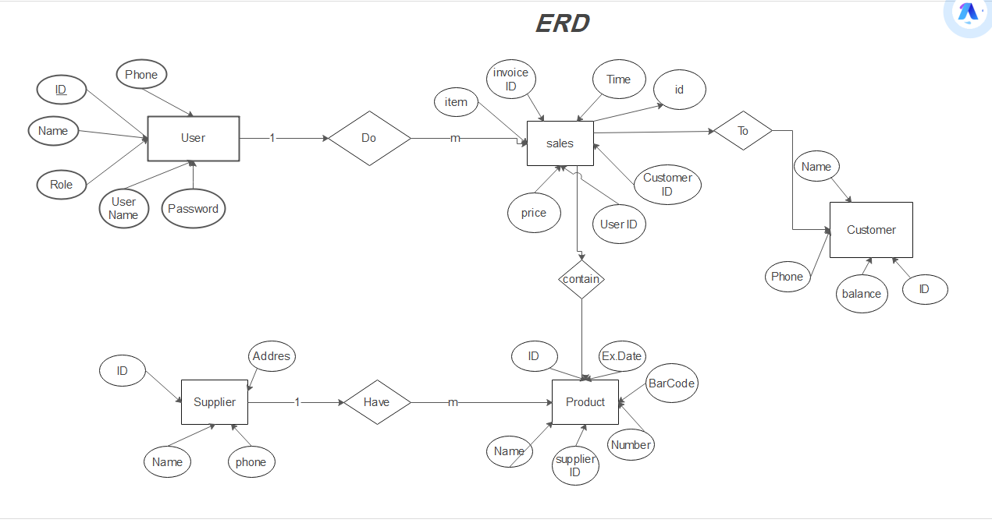

**Class Diagram**

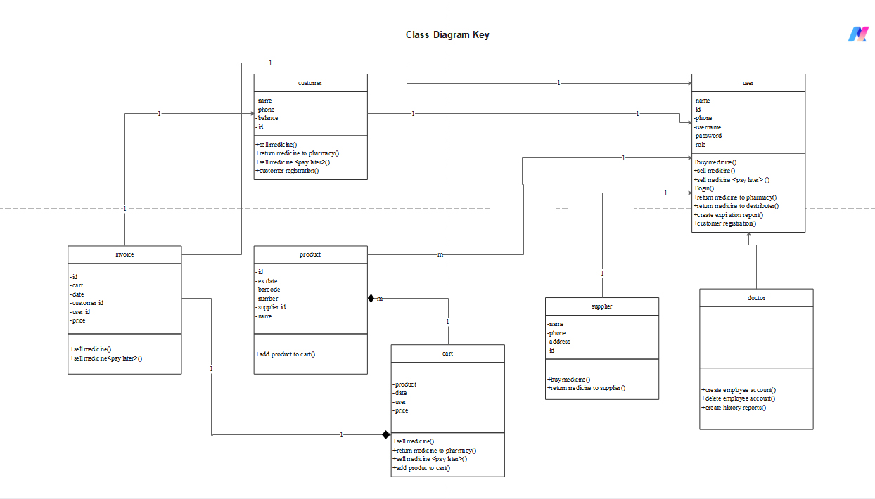

**Seqance Diagram**

