Computational Publishing Service Demo

Simon Worthington

2024-03-22

Table of contents

# 1. Title: Exhibition Catalogue - Prototype Demo

This work is licensed under a Creative Commons Attribution-ShareAlike 4.0 International License.

# 2. Copyright Page

Publication metadata collected from the Thoth.pub GraphQL API. <https://api.thoth.pub/graphiql>

PUBLISHING FROM COLLECTIONS USES OF COMPUTATIONAL PUBLISHING AND LINKED OPEN DATA

Open Science Lab - TIB

Hannover

First published 2023-03-30

Copyright © The Authors 2023 Licensed as https://creativecommons.org/licenses/by-sa/4.0/

DOI: https://doi.org/10.5281/zenodo.7701161

# 3. Essay

## 3.1 Essay Text

Lorem ipsum dolor sit amet, consectetur adipiscing elit. Integer varius cursus lacus eu aliquet. Etiam quis eros augue. Praesent aliquam, purus vitae consectetur rutrum, felis felis aliquam sapien, quis sodales lorem nibh molestie nibh. Aliquam vitae dui imperdiet, varius tortor at, facilisis neque. Cras fermentum at enim non facilisis. Proin euismod mauris et nisi aliquet sollicitudin. Donec sit amet elementum velit. Cras a quam iaculis, porta ipsum congue, consequat risus.

Mauris est purus, tempor sed odio quis, condimentum gravida nisl. Nulla facilisi. Integer commodo justo sed enim facilisis luctus. Sed suscipit vehicula tincidunt. Donec ac ornare tellus, malesuada tempor arcu. Aenean accumsan vitae leo in commodo. Etiam diam arcu, venenatis vitae mi eu, porta cursus mauris. Maecenas nisl neque, facilisis vitae cursus id, fringilla non augue. Morbi eu neque et metus accumsan pretium id feugiat sapien. Morbi sollicitudin sem non tortor cursus viverra.

Mauris eget justo eget est gravida tristique. In cursus lacinia dictum. Interdum et malesuada fames ac ante ipsum primis in faucibus. Quisque convallis consequat turpis, vel euismod justo lobortis sed. Proin sodales erat at porttitor rhoncus. Proin tincidunt felis sed dui ullamcorper, ut rutrum libero ultricies. In tincidunt rhoncus varius. Cras varius, turpis quis fermentum egestas, mauris nunc laoreet nibh, non lacinia nibh nisl ut massa.

# 4. Painting Collection

Objective: Make a selection of nine paintings for the exhibition catalogue to be selected from Wikidata and rendered multi-format in Quarto.

The below Python code uses SPARQLWrapper to retrieve data from Wikidata based on a SPARQL query.

Wikidata link: <http://www.wikidata.org/entity/Q29474642>

Title: The Birth of Benjamin

Year: 1650

Creator: Francesco Furini

Copyright: public domain

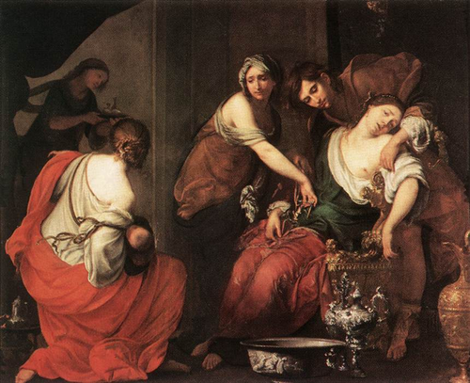

Wikidata link: <http://www.wikidata.org/entity/Q29474644>

Title: Venetian Gala Concert

Year: 1782

Creator: Francesco Guardi

Copyright: public domain

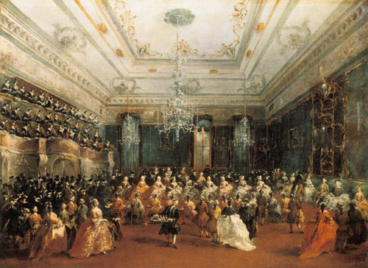

Wikidata link: <http://www.wikidata.org/entity/Q29474645>

Title: Q29474645

Year: 1789

Creator: Francesco Guardi

Copyright: public domain

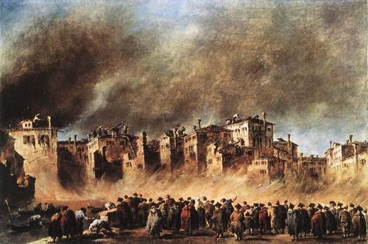

Wikidata link: <http://www.wikidata.org/entity/Q29474649>

Title: A Cynical Philosopher

Year: 1650

Creator: Luca Giordano

Copyright: public domain

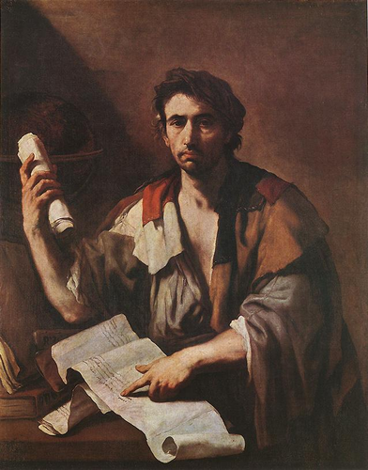

Wikidata link: <http://www.wikidata.org/entity/Q29474651>

Title: Solomon and the Queen of Sheba

Year: 1697

Creator: Luca Giordano

Copyright: public domain

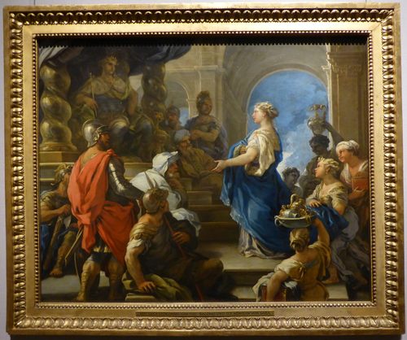

Wikidata link: <http://www.wikidata.org/entity/Q29477219>

Title: View of the Grand Canal near Cà Pesaro

Year: 1734

Creator: Michele Marieschi

Copyright: public domain

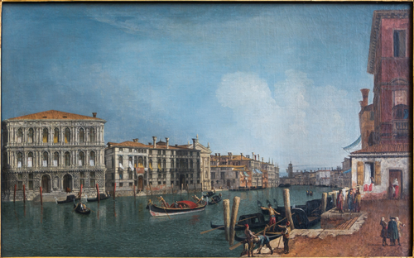

Wikidata link: <http://www.wikidata.org/entity/Q29477226>

Title: Venus and Adonis

Year: 1750

Creator: Jacopo Amigoni

Copyright: public domain

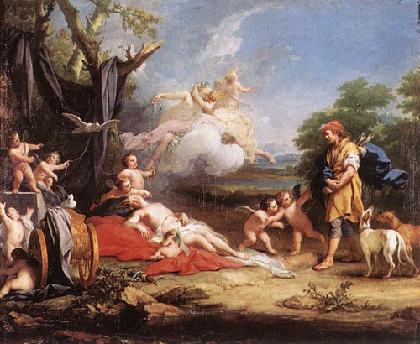

Wikidata link: <http://www.wikidata.org/entity/Q29477233>

Title: Adoration of the Kings

Year: 1753

Creator: Giovanni Battista Tiepolo

Copyright: public domain

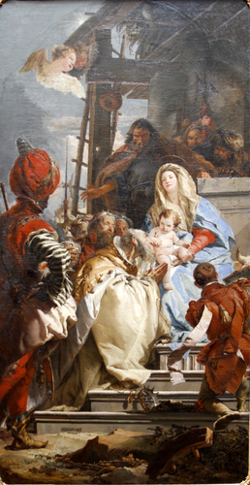

Wikidata link: <http://www.wikidata.org/entity/Q29477235>

Title: Q29477235

Year: 1674

Creator: Antonio Triva

Copyright: public domain

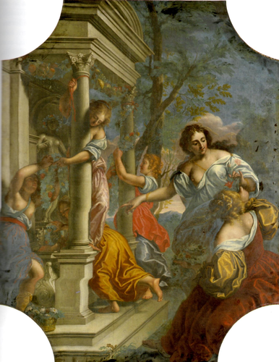

# 5. Data Analysis

Content to follow