[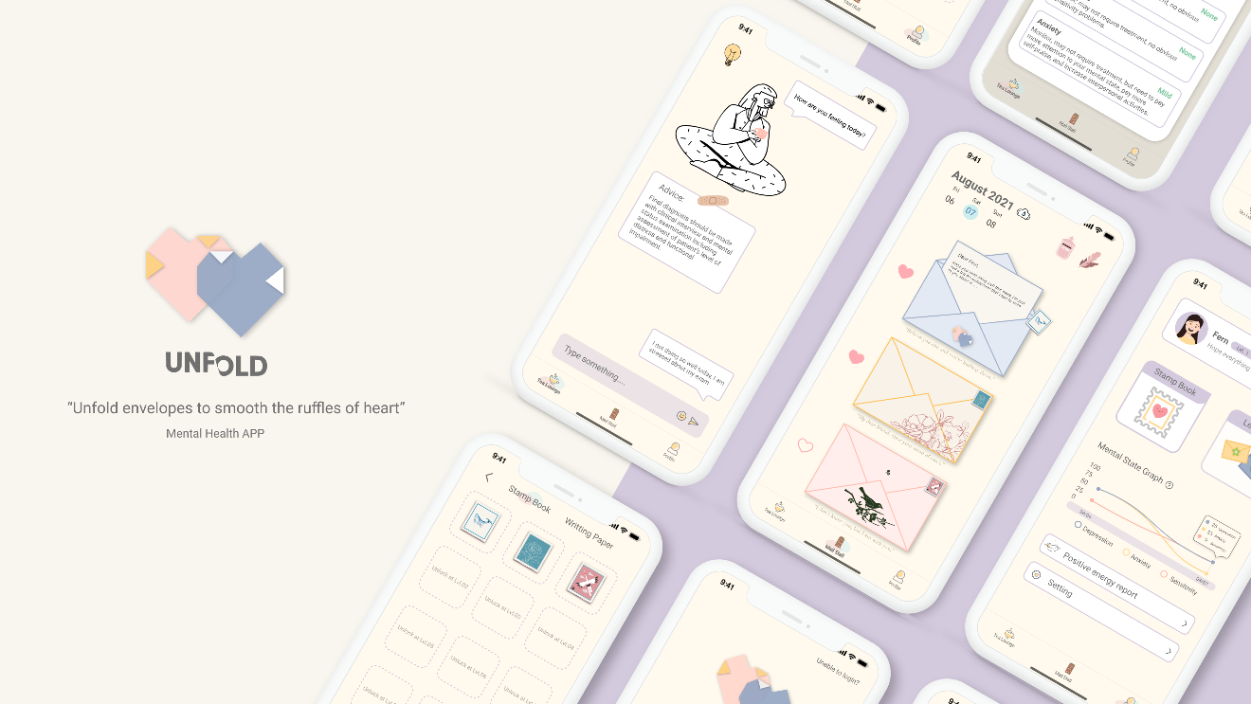](https://raw.githubusercontent.com/0xC000005/image-hosting/master/20210805212557.png)

"Unfold envelopes to smooth the ruffles of heart."

# About

Unfold is a mental heath app that helps people overcome the lack of communication during and after the pandemic. "Unfold" aims to provide a healing community for expressing feelings safely. You will encounter friends through anonymous letters and embrace every unique person with a sincere heart.

## Why different compared to the traditional therapy?

Compared to traditional 1-to-1 therapy, emotions in Unfold are shared in the community. An artificial intelligence-based recommendation system is used in our application. It selects three different letters from other users that sent out each day. These letters can be short story, emotional quotes, or a personal experience. From reading the letters, our user might smile, laugh, or even have a drop of tears. Emotion will resonance long after the reading, and this provides an emotional catharsis for our users.

## Here's how this app works.

### 1. Express Feeling

Does your mind fall apart from time to time? Do you have trouble opening up to people? Write a letter about what's bothering you and send it out. There will be a warm soul waiting to cheer you up or warm someone else with your soul.

### 2. AI Evaluation & Guidance

Understand your mood by chatting with the AI, which is not just your buddy, but also automatically assesses your mental state and provides appropriate advice through the conversation. As the AI becomes more familiar with you, the greater the likelihood that you will receive the “right” letter.

### 3. Pen pal & Hugs

Building friendships by sending out positive energy. Only the special ones deserve a place in limited mailbox capacity. Each day there will be three anonymous letters deliver to your, you can choose to reply to it or provide a warm hug to another soul.