**How to Compile CodeLab**

**Before You Begin**

Install paint.net version 4.0.20.

Install Visual Studio 2017 Community Edition.

Visit the following page and install ILMerge:

<https://www.microsoft.com/en-us/download/details.aspx?id=17630>

**Open the Project and Add ScintillaNET NuGet Package**

1. Open the project

2. Click the menu: Tools > NuGet Package Manager > Manage NuGet Packages for Solution...

3. Search for "scintillaNET":

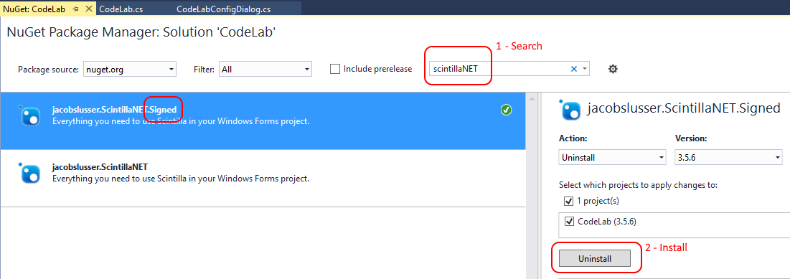

4. Select the signed package and click the Install button to install it.

**Build the Release Version of CodeLab**

1. Click the menu: Build > Rebuild Solution

2. If build fails, you'll need to debug that first.

3. If build succeeds, a window will open and you'll see CodeLab.dll and Install_CodeLab.bat