Albert Gural

EE52 FPGA Oscilloscope

Altera Cyclone III FPGA Oscilloscope

Functional Specification

1. Diagram

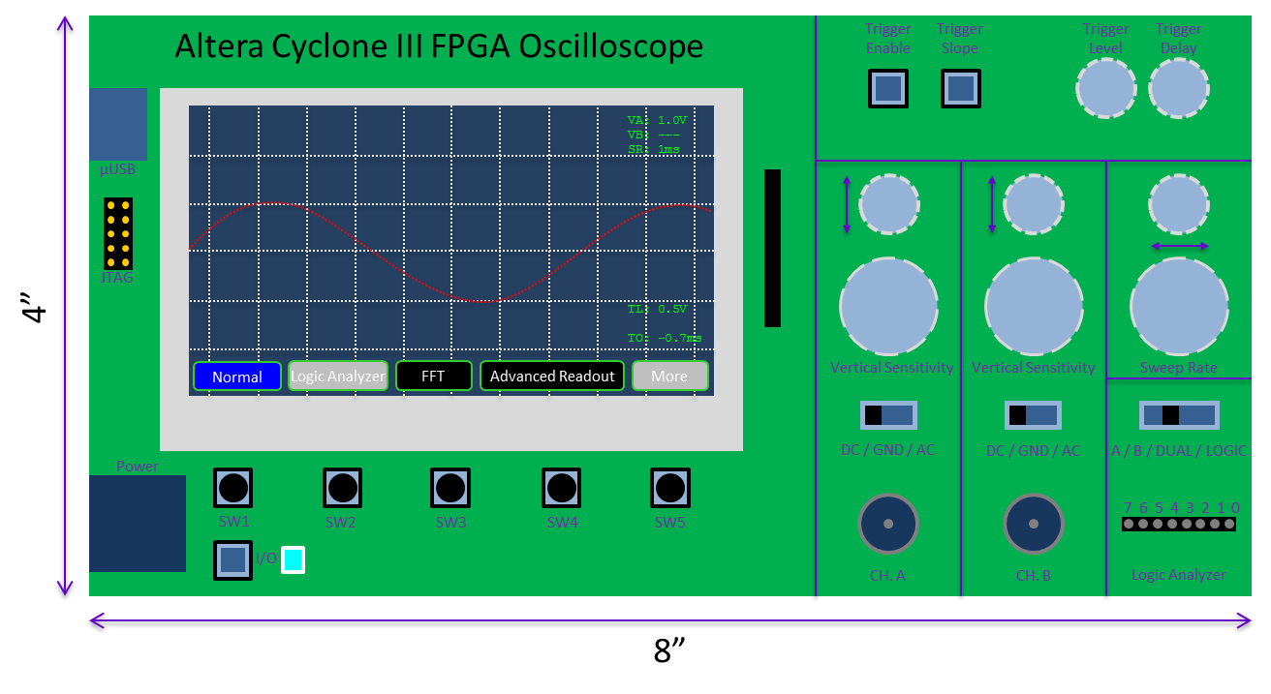

1. Power and Interfacing
   1. Power is provided by a dual -12V, 12V and 5V power supply cable to the port shown at the bottom left. The 12V is regulated down to provide a 5V line for the oscilloscope, while the 5V line is regulated down to 3.3V, 2.5V, and 1.2V to power the analog and digital circuitry.
   2. A JTAG connector (middle left) allows for in-circuit programming of the FPGA, as well as communication to a computer.
   3. A micro-USB connector converts JTAG to USB for compatibility with USB 2.0-capable computers.
   4. To turn on the oscilloscope, press the latching “I/O” button on the bottom left. The indicator LED (blue) will turn on. Press again to turn off the oscilloscope.
2. Analog and Logical Analyzer Inputs
   1. Ch. A is an analog channel input that uses a standard oscilloscope coaxial cable connector. Under “A” and “DUAL” modes, the oscilloscope displays the signal to this input. Also, for both of those modes, triggering is done with respect to the channel A input (even though in “DUAL” mode, channel B also provides input). The input mode for channel A can be selected as “DC”, “AC”, or “GND”, which correspond to the oscilloscope controls for the same. Ch. A supports hardware FFT, which is selectable as a display mode using the display buttons (see “Modes of Operation” for more detail).
   2. Ch. B is an analog channel input that uses a standard oscilloscope coaxial cable connector. Under “B” and “DUAL” modes, the oscilloscope displays the signal to this input. However, triggering is only done with respect to the B input for “B” mode. The input mode for channel B can be selected as “DC”, “AC”, or “GND”, which correspond to the oscilloscope controls for the same.
   3. Logic Analyzer is an 8-bit digital bus input that uses a 0.1” pitch female header, and is intended for low-frequency/low-noise digital applications. Under “LOGIC” mode, output from this input is shown on the display as 8 data lines.
3. Hardware Controls
   1. Channel A/B Controls
      1. “Vertical Offset” is a potentiometer that defines the offset of the channel A/B signal for displaying purposes
      2. “Vertical Sensitivity” is a rotary encoder that increases or decreases the vertical sensitivity (V/vertical division) of the channel A/B displayed signal based on whether the knob is turned counter-clockwise or clockwise, respectively.
      3. “Input Mode” is a slide switch that defines whether to take the straight analog signal (DC), to take the signal minus the DC component (AC), or to look at the ground signal (GND, useful for zeroing the vertical offset) of the channel A/B signal.
   2. Sweep Rate Controls
      1. “Horizontal Offset” is a potentiometer that defines the horizontal display offset of the displayed signal.
      2. “Sweep Rate” is a rotary encoder that increases or decreases the time per horizontal division (s/horizontal division) of the displayed signal based on whether the knob is turned counter-clockwise or clockwise, respectively.
   3. Input Channel Control
      1. “Input Channel Control” is a slide switch that has settings for displaying just the A channel, just the B channel, both channels at the same time, or just the logic channel.
   4. Triggering Controls
      1. “Trigger Enable” is a latching switch. When not pressed (triggering enabled), the display will update each time the signal causes triggering. When pressed (triggering disabled), the display will update with the first trigger and hold its data until triggering is re-enabled.
      2. “Trigger Slope” is a latching switch. When pressed, triggering occurs on the negative slope. When not pressed, triggering occurs on the positive slope.
      3. “Trigger Level” is a rotary encoder that controls the voltage level to trigger at. The level is increased by turning clockwise and decreased by turning counter-clockwise.
      4. “Trigger Delay” is a rotary encoder that controls how much to delay before collecting samples and displaying them (note: this value can be negative). The delay is increased by turning clockwise and decreased by turning counter-clockwise.
4. Display Regions
   1. The waveform viewport shows the current signal(s) of interest. It occupies most of the screen except the bottom ½” and the right ½”. The background of this regions is deep blue and in most modes contains a white-dotted grid, with the horizontal and vertical axis more bold.
   2. The software button menu occupies the bottom ½” and contains 5 boxes with text (or possibly symbols) describing what each button does in the current state. Buttons are outlined in green and have white text. The button fill color is blue for the selected mode, grey for unavailable modes in the current context, and black for selectable modes.
   3. The digital readout information occupies the right ½” of the screen. It contains information about: {vertical sensitivity (A, B, both, or none, depending on input channel select), sweep rate, trigger level, trigger delay} and can also contain information about {waveform amplitude, frequency, Vrms}, depending on the display mode. The information is given as small green text.
5. Modes of Operation and UI
   1. Normal Mode
      1. Get to this mode by selecting “A”, “B”, or “DUAL” input channel select and making sure the software button for “Normal” is selected.
      2. Waveform Viewport shows the “A” and/or “B” waveforms, depending on the input channel select. Channel A defaults to red and Channel B defaults to light blue.
      3. Software Button Menu shows options for “Normal” (selected), “Logic Analyzer” (greyed out), “FFT” (only if in “A” or “DUAL” input channel select), “Advanced Readout”, “More” (greyed out for now, until other modes are added).
      4. Digital Readout Information includes {Vertical sensitivity (VA, VB for channels A and B), Sweep rate (SR), Trigger level (TL), and Trigger offset (TO)}.
   2. Logic Analyzer
      1. Get to this mode by selecting “Logic” input channel select and making sure the software button for “Logic Analyzer” is selected.
      2. Waveform Viewport shows 8 logic lines, equally separated, along with the bit number for each line [0, 7], on the left side. The lines alternate colors so that the even bits are red and the odd bits are light blue.
      3. Software Button Menu shows options for “Normal” (greyed out), “Logic Analyzer” (selected), “FFT” (greyed out), “Advanced Readout”, “More” (greyed out for now, until other modes are added).
      4. Digital Readout Information includes {Sweep rate (SR), Trigger line (TL, one of [0, 7]), and Trigger offset (TO)}.
   3. FFT Mode
      1. Get to this mode by selecting “A” or “DUAL” input channel select and make sure the software button for “FFT” is selected.
      2. Waveform Viewport shows a graph whose horizontal axis is frequency (0 – 1mhz, logarithmic scale), and whose vertical axis is amplitude. The graph shows the FFT of the signal in channel A (color red).
      3. Software Button Menu shows options for “Normal”, “Logic Analyzer” (greyed out), “FFT” (selected), “Advanced Readout”, “More” (greyed out for now, until other modes are added).
      4. Digital Readout Information includes {Peak frequency (FP)}.
   4. Advanced Readout
      1. Get to this mode by pressing the “Advanced Readout” software button.
      2. Waveform Viewport is missing and is replaced entirely with the digital readout information (see below).
      3. Software Button Menu shows options for “Normal” (if in A/B/DUAL input channel select), “Logic Analyzer” (if in LOGIC input channel select), “FFT” (if in A/DUAL input channel select), “Advanced Readout” (selected), “More” (greyed out for now, until other modes are added).
      4. The digital readout information depends on which input channel is selected.
         1. In A/B/DUAL input channel select, the left half shows information about A and the right half shows identical information, but about B. The information shown includes things like: {Peak frequency, Peak Amplitude, Vrms, etc.}.
         2. In LOGIC input channel select, the screen is divided into a 2x4 grid containing information about bits 7-4 (top, left to right) and 3-0 (bottom, left to right). The information shown includes things like: {Main period, duty cycle, Ton, Toff}.
6. Capabilities
   1. Sample Rates
      1. 10, 20, 50, 100, 200, 500 ns
      2. 1, 2, 5, 10, 20, 50, 100, 200, 500 us
      3. 1, 2, 5, 10, 20, 50, 100, 200, 500 ms
   2. Vertical Sensitivities
      1. 1, 2, 5, 10, 20, 50, 100, 200, 500 mV
      2. 1, 2, 5 V
   3. Sample Resolution
      1. Channel A/B: 8 bits
      2. Logic Analyzer: 1 bit per channel (high-threshold at 1.0V)
   4. Input Voltage Range: -10V to 10V
   5. Trigger Level Resolution: Channel A/B is 7 bits; Logic Analyzer is one for each bit
   6. Trigger Slope: Positive or Negative
   7. Trigger Delay: -10,000 samples / +50,000 samples