Etherdelta-like-dex
29/01/2022

I am going to create a decentralized exchange for the transfer of ERC20 tokens using smart contracts, similar to, and based off, EtherDelta.

To use the EtherDelta DEX, the user would transfer funds from their wallet to the ED smart contract, and then be able to make trades. This means that funds do leave your original wallet, however the token balance is saved for that user in the smart contract, and so only that user can withdraw it/spend it, but no centralized parties can. For tokens, the token must be approved for the contract to spend it too.

A DEX like this has two types of users – a maker and a taker. A maker is somebody who creates a new order to buy or sell a token for ETH, and a taker is somebody who takes/executes that order.

A maker order is created by the maker creating a hash of their order (what token, how much, buy or sell) and signing it with their Ethereum private key, and then this order signature is stored off-chain, on the EtherDelta servers. The ED smart contract contains a way to have this order signature stored on-chain as well, however it it more costly because to store the order on-chain, you must make a transaction & pay gas.

The order signature that is stored off chain represents intent – the user, who is proven to be that user (by signing the message), wants to make the trade. Storing it off-chain doesn’t put any more risk to the users, it just means its less transparent/more centralized (relying on the off-chain storage, ie. etherdelta servers).

When a taker wants to trade against the order, the smart contract trade() function is used, called by the taker. This function is supplied the order signature and verifies that the signature was created by the Maker, along with that order is still valid (hasn’t expired or been filled), and then executes that order and transfers balances around.

So, there are a few components to a DEX like this:
- The smart contract which contains most of the functionality (e.g. deposit,withdraw,trade)
- Offchain server that stores order signatures
- Web UI that users interact with which interacts with the smart contract & offchain server
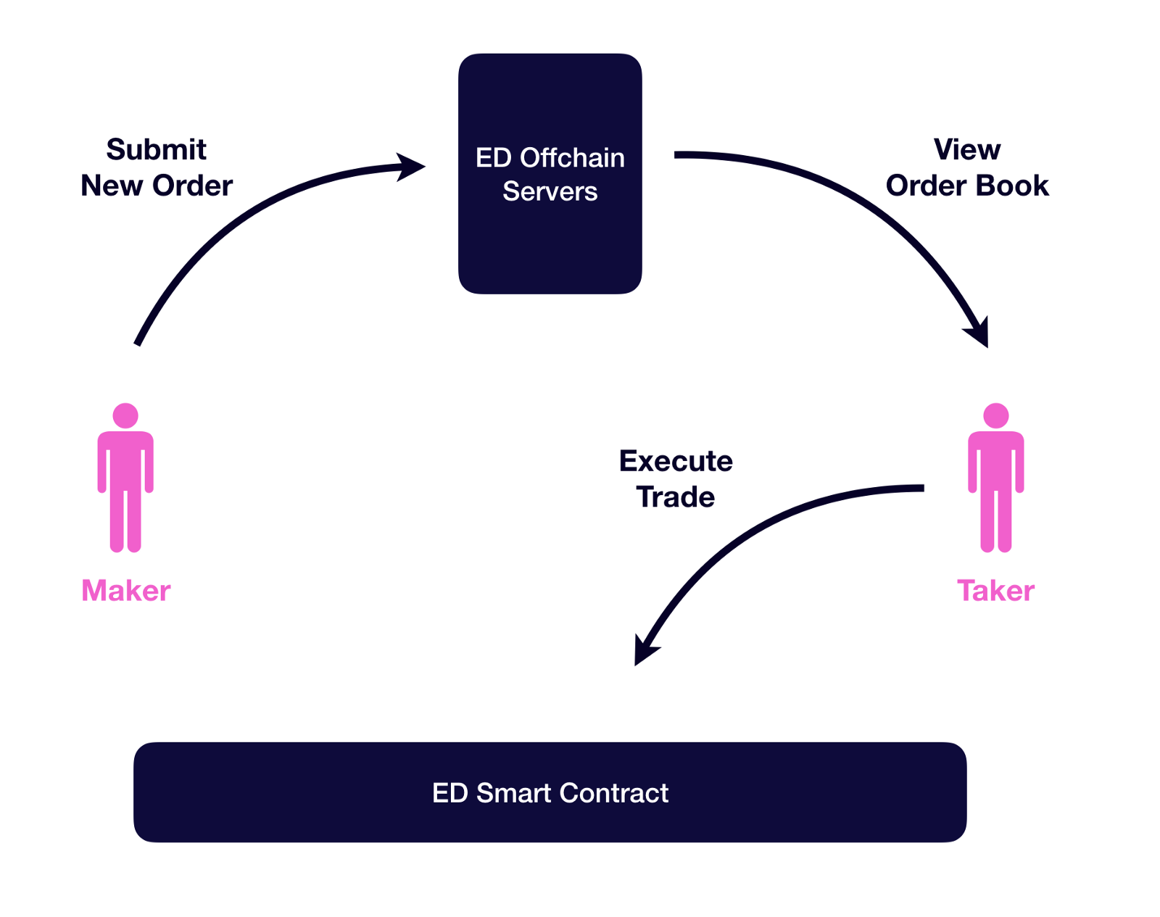

Links:

EtherDelta source code - https://github.com/etherdelta

Basic how does ED work - https://support.bitkub.com/hc/en-us/articles/360013932531-How-does-EtherDelta-work-

ED smart contract documentation - https://github.com/etherdelta/etherdelta.github.io/blob/master/site/docs/SMART_CONTRACT.md

Well explained how DEX/ED works - https://hackernoon.com/understanding-decentralized-exchanges-51b70ed3fe67

Another project I am basing mine off is this one: https://github.com/miquelTC/decentralized-exchange

This repo is a basic DEX smart contract. It does not use signatures, nor off-chain storing, but simply uses Order structs to create/manage orders. A user calls a makeOrder() function, which creates a resting order for someone else to take.

