Comparative study of RIP, OSPF and EIGRP protocols using Cisco Packet Tracer

Abstract determined by the development of new types of routing protocols, the process of designing of the new topologies had radically changed in the last years. At the modern time this designing process should consider all the existing services and also the ones that could be implemented in the future if we keep in mind the fact that at present, we witness an amazing development of the traffic generated by the various applications. The study focuses on the comparative analysis of the routing protocols RIPv2 (Routing Information Protocol), OSPF (Open Shortest Path First) and EIGRP (Enhanced Interior Gateway Routing Protocol) using the soft Cisco Packet Tracer.
Keywords—routing protocols, DNS, HTTPS, HTTP, RTP,
Cisco Packet Tracer

I. INTRODUCTION
Even from the moment of the creation of the first computers, the need of their interlinkage became a major interest in sharing the output obtained after the execution of various tasks they were originally programmed for. As the time passed by, some of the manufacturers began to develop their own systems of interlinkage for their computers. Afterwards, even though the necessity of interlinkage became a major issue among the users, this matter was still unable to be solved due to the diverse protocols that were used in order to intercommunicate in various geographical areas.
When this first issue was solved simultaneously appeared the first small real networks, which were to be known later as LAN. Meanwhile, along with the increasing number of computers and other devices (printers, IP communication cell phones and other smart devices which were designed to make one able to communicate), was developed the next stage, namely the MAN networks. The WAN networks (Wide Area Network) in comparison to MAN networks are not geographically limited. The major advantage that these networks brought is that it could interconnect more LAN networks. The price was indeed more expensive, especially because LAN networks are ones of a high speed.
At the time being the computer networks give us the opportunity to communicate and interact in real time. Now we use the networks at maximum capacity to use a great variety of applications as the ones following: web applications, video conferences, e-commerce applications, IP

Protocol telephones, conference calls, education process development, media access applications, online newspapers applications and so on.

II. TECHNICAL INFORMATION ABOUT IP PROTOCOLS
Routing protocols should be very well planned and dimensioned for each type of network. They are used according to the choices of the network administrator. The advantage of the routing protocols consists of the fact that they converge very quickly, even though the main route disappears, meaning that these protocols are auto adaptive [1].
To optimize the routing protocols, the solution should be very carefully chosen in order not to overload the low performance hardware.
The dynamic routing protocols are divided into two distinct categories: interior routing protocols and exterior routing protocols.
A. Interior routing protocols
Interior routing protocols are classified as follows: distance vector and link-state protocols.
To the category” Distance vector” belong the following protocols: RIPv1, RIPv2, OSPF and EIGRP [2-6]. These protocols are characterized by the following features:
- Very easy to implement algorithms, and very easy to be computed by the processor.
- They do not tax the hardware with a lot of network calculus.
- They do not have a picture of network topology.
- They are scaled on small networks.
- They support authentication.
- One of the great issues of these protocols is the routing loops.
Protocols OSPF and IS-IS belongs to the category” Link state”. These protocols are characterized by the following features:
- They bring more complex algorithms (Dijkstra) which use information from all the devices from the network. In addition to that, they reconstruct the topology of the whole network, determining the taxing of processing power of the network hardware devices.
- They compute the shortest route.
- Each router will create a link state advertisement that will be notified to the whole network, and each router using this will compute the routing table of the whole network in what is known as link-state database.
The disadvantage of the link-state protocol is that all the devices will compute the whole topology of the network and high-performance hardware is needed for that, which only means an additional cost.
If a router learns a route by means of two routing protocols, the one with the shorter administrative distance will be automatically used. That means that if it learns a route using OSPF protocol and one which uses the EIGRP protocol, the EIGRP protocol will be used to route the data packages because this last one has the administrative distance shorter than OSPF, respectively 90 comparing to 120.
RIP v1. - is a protocol which is based on the routing metric of the hop count. The limit of maximum hop count of RIP v1 protocol is 15. Each package which reaches the value of 16 will be thrown away. Using this protocol, each router sends its own routing table each 30 seconds, by means of the broadcast local address. The administrative distance used by this protocol is 120. Each route has an associated value of time, which is resetting each time when updates about the routes are received. When the value of time expires, the route is marked as unfindable pursuant to the setting made by the router with the metric 16, which is retained in the routing table for 180 seconds. After this period of time the” flush timer” function occurs, that retains the invalid route for other 60 seconds. RIP v1 uses UDP 520 port and has no authentication support, which is usually used in small networks.
RIP v2. This protocol improves RIP v1 because it uses VLSM (Variable-Length Subnet Mask) as an authentication support. It uses the UDP 520 port and has an administrative distance of 120, using the address 224.0.0.9 for multicast routes updates, and the update time values are like the ones used by RIP v1. It is used in small networks and supports CIDR.
OSPF implements a mechanism for a secure transmission of the messages. To compute the shortest route, the Dijkstra algorithm is used. The algorithm designs graphs that have been assigned on each segment between two intermediate points at a certain cost, this being obtained because of a formula. The adjacency in OSPF case is realized by messages of Hello type that are sent every 10 seconds and is created only with the neighbors, not with the other routers. For this model, each router will have an identifier. The number of networks determines the number of LSA that occur in the routing table of each router. The advantage of this fact is that anytime an alternative route will be found in case a link fails, but this comes with a lot of additional resources which are needed. Another advantage of OSPF is that it can also divide a topology in more regions. This one functions between regions as distance vector routing protocol, and within the regions (areas) functions as a link state protocol. This happens because between the regions it has no entire vision, and within the regions, this one knows the entire topology. OSPF protocol communicates by means of multicast messages using IP 224.0.0.5 and 224.0.0.6
EIGRP. In the middle of 80’s years, this protocol was launched by Cisco, being in great competition with OSPF, especially because it uses a simpler algorithm than OSPF, this one scale very well on the big-size networks, while OSPF is very well scaled both medium-size networks and on the big- size networks. This one was used only on Cisco devices until 2015. Since 2015 was decided to be used by anyone interested in using it, being destined for “free usage”. This protocol is the most efficient routing protocol.

TABLE I. IMPORTANT PARAMETERS OF RIP, OSPF, AND EIGRP PROTOCOLS
Protocol | RIP | OSPF | EIGRP
Convergence time | slow | fast | fast
VLSM | no | yes | yes
Bandwidth usage | high | low | low
Resources usage | low | high | low
Multiple path support | no | yes | yes
Scalability | no | yes | yes
Patented | no | no | yes
Non-IP Protocol | no | no | yes

B. Exterior routing protocols
Exterior routing protocols have only one type -” Path-Vector Routing Protocol”. To this type belong the following protocols: EGP and BGP. These are usually used for linking internet providers and big companies. They are specially created and used for internet.
III. COMPARATIVE ANALYSIS OF THE ROUTING USING CISCO PACKET TRACER
Packet Tracer is a software developed by Cisco company in order to simulate devices (router 2811, switch 2960, cell phones VoIP 7960, computers and other devices that can be assigned to IP-s) and various protocols that are used for devices interlinking in order to create the networks; they can be studied in what concerns their function in order to avoid the issues that may occur (Figure 1) [7-9].
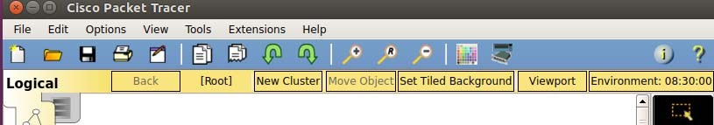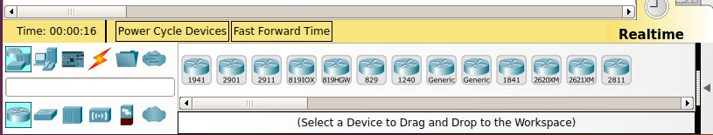 Fig. 1. Cisco Packet Tracer interface
Using Packet Tracer software, we have created and analyzed the following network that we divided in six areas (Figures 2-7). In the first area named Ground floor we inserted a couple of workstations (workstation 11, 12, 13, 14, 15, 16, 17, 18, 19 - ground floor students, Server 3 ground floor) which get their IPs from router 2 by DHCP from network 10.20.30.0/24, a server 3 ground floor and a wireless router that assigns IPs in network 192.169.0.0/29 using the same method. The two smartphones and the tablet are connected to the Wi-Fi router and to network 172.16.1.0/24 using 3G connection as can be seen in Figure 2.
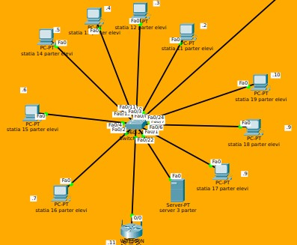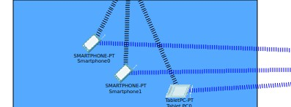

Fig. 2. Ground floor area of the application
In the second area that we named First Floor, we have created 4 VLANs we gave the following VLAN names: Students, Teachers, Voice and Management. The VLANS has defined the following networks: Students - 10.0.1.0/24, Teachers - 10.0.2.0/24, Voice - 10.0.3.0/24 and Management - 10.0.99.0/24 (Figure 3).
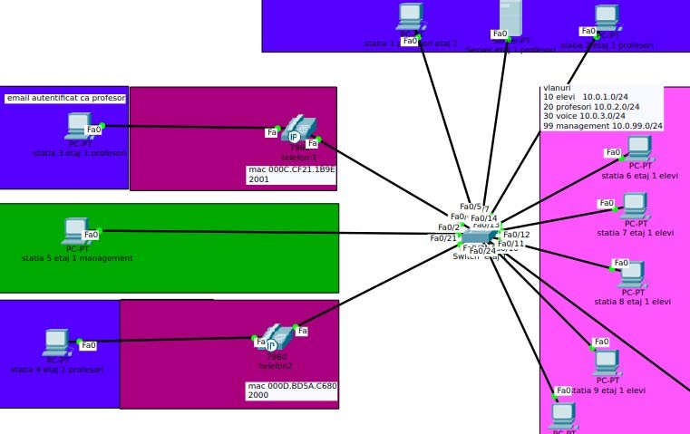 Fig. 3. First Floor Area
In the third area which we named Second Floor we have created 4 VLANs to which we have the following VLAN names: Students, Teachers, Voice and Management and to which we have assigned the following networks: Students -
10.1.1.0/24, Teachers - 10.1.2.0/24, Voice - 10.1.3.0/24 and Management - 10.1.99.0/24. All the devices get IPs using DHCP protocol from router 4 (Figure 4).
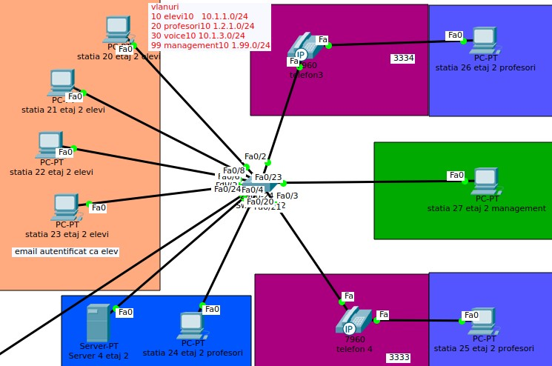
Fig. 4. Second floor Area
In the fourth area (Third Floor) we have 4 VLANs assigned to the following networks: Students - 10.3.1.0, Teachers - 10.3.2.0, Voice - 10.3.3.0 and Management - 10.3.99.0. Besides the workstations, we also find in this area a web server with a static IP 10.3.2.2/24 declared in the server DNS in order that the site www.cezar.ro to be accessed by any device from any network (Figure 5).
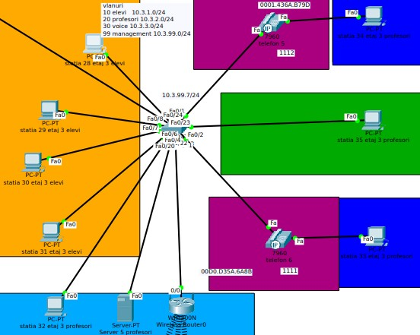
Fig. 5. Third Floor Area
The fifth area was named Home. Here we find a server which offers access to the following devices: Garage, Webcam, Reading lamp, Temperature monitoring device, Central heating and Air Condition. All these devices have assigned static IPs from network 101.217.1.0/24. In order to open the garage door using smartphone 2 from 3G area, we open IOE monitor interface to access management server from home area. The username Cezar and password 2202 will be used. After the link is established, all the devices’ parameters situated in this area can be monitored and changed (Figure 6).
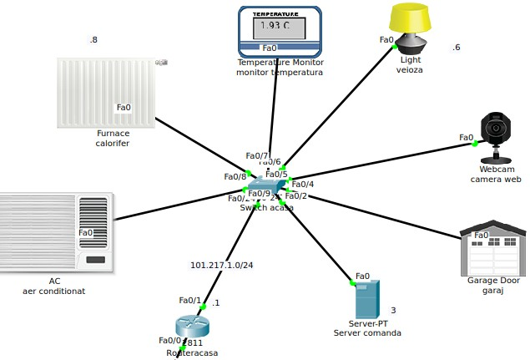
Fig. 6. Home Area
We also have created the Servers room (the Sixth Area) that is very important for all the servers as here we find the following: DNS, EMAIL, NTP and CENTRAL OFFICE
SERVER 3G. All these have fixed IPs assigned from network 10.10.10.0/24 (Figure 7).
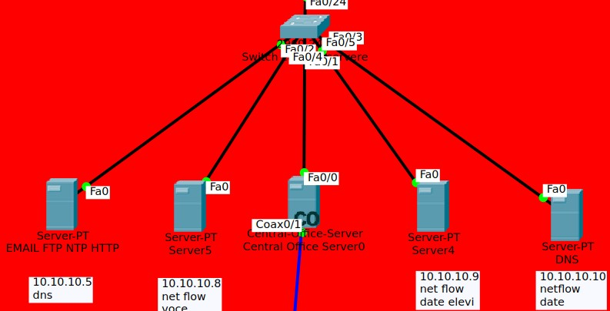
Fig. 7. Servers Area
We also have the 3G Area (the seventh area) where we have 4 smartphones and 2 tablets that have assigned IPs from 3G and Wi-Fi networks. Smartphones 0 and 1 connected to wireless network have assigned IPs from the wireless router situated in Ground Floor Area as they are also connected to the 3G network. Smartphones 2 and 3 are connected to the wireless router situated in the Third Floor Area and 3G network. The same situation holds for the tablets 0 and 1 by means of Wi-Fi from the two routers and 3G from the basic workstation.
A. First Scenario – network analysis using the routing protocol EIGRP
In this scenario we have configured the routers with the routing protocol EIGRP as can be seen in the figure below (Figure 8):
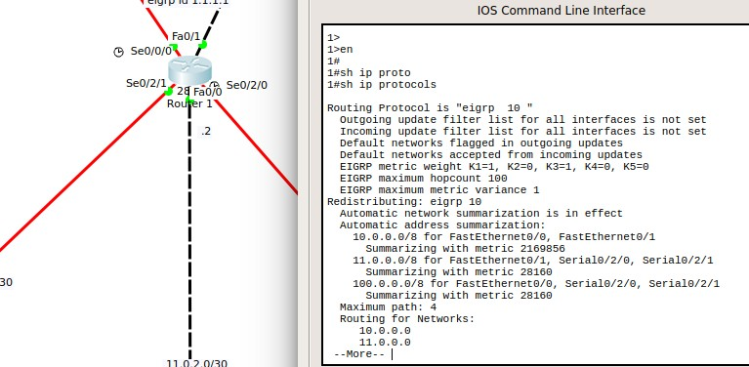
Fig. 8. First Scenario – network analysis using the routing protocol EIGRP
The response time between the devices obtained for this scenario, for the specific cases of DNS and HTTPS services are given in Table II, and for the cases of HTTP and RTP services, are given in Table III.
TABLE II. RESPONSE TIMES IN THE CASE OF THE FIRST SCENARIO -

PROTOCOL EIGRP (DNS, HTTPS)
 | First Scenario – EIGRP Protocol
Time  (s) | DNS Service | Time  (s) | HTTPS Service
0 | Workstation 16 | 0,023 | Workstation 16
0,001 | Switch Ground Floor | 0,024 | Switch Ground Floor
0,002 | Router 2 | 0,025 | Router 2
0,003 | Router 3 | 0,026 | Router 1
0,004 | Switch Servers Room | 0,027 | Router 4
0,005 | DNS Server | 0,028 | Switch Third Floor
0,006 | Switch Servers Room | 0,029 | Server 5 Teachers
0,007 | Router 3 | 0,03 | Switch Third Floor
0,008 | Router 2 | 0,031 | Router 4
0,009 | Switch Ground Floor | 0,032 | Router 1
0,01 | Workstation 16 | 0,033 | Router 2
 |  | 0,034 | Switch Ground Floor
 |  | 0,035 | Workstation 16

TABLE III. RESPONSE TIMES IN THE CASE OF THE FIRST SCENARIO -

EIGRP PROTOCOL (HTTP, RTP)
 | First Scenario –EIGRP Protocol
Time  (s) | HTTP Service | Time  (s) | RTP Service
0 | Smartphone 2 | 0 | Phone 1
0,003 | Wireless router 0 | 0,001 | Switch First Floor
0,004 | Switch Third Floor | 0,002 | Router 2
0,005 | Router 4 | 0,003 | Router 3
0,006 | Router 1 | 0,004 | Router 4
0,007 | Router Home | 0,005 | Switch Second Floor
0,008 | Switch Home | 0,006 | Phone 3
0,009 | Management Server
0,011 | Switch Home
0,012 | Router Home
0,013 | Router 1
0,014 | Router 4
0,015 | Switch Third Floor
0,016 | Wireless Router 0
0,022 | Smartphone 2
From the simulation results which we obtained in Figure 8 and Tables II-III for EIGRP protocol, the following can be observed:
- The access of web server between the workstation 16 Ground Floor Students and Server 5 Teachers have influenced the duration between the moment of the initialization of the browser using https service and the moment of the web page loaded to be of 0,035s.
- For http using the route Smartphone 2 to Management Server and back to Smartphone 2 we have a delay of 0.022s.
- Using the RTP service between Phone 1and Phone 3 we have a delay of 0,006s.
B. Scenario 2 – analysis of the network using the OSPF routing protocol
In the second scenario (Figure 9) we used the OSPF routing protocol and the same services (DNS, HTTPS, HTTP and RTP). The response time is presented in Tables IV - V.
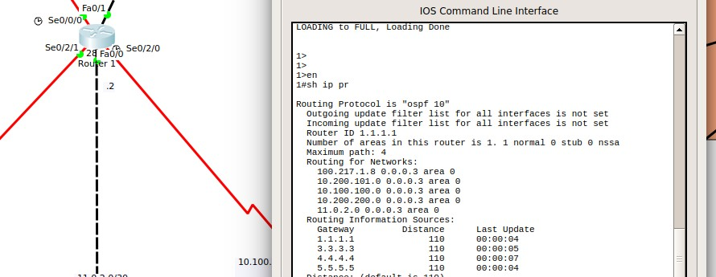
Fig. 9. Scenario 2 – analysis of the network using OSPF routing protocol
TABLE IV. RESPONSE TIMES IN THE CASE OF THE SECOND SCENARIO -

OSPF PROTOCOL (DNS, HTTPS)
 | The Second Scenario –OSPF Protocol
Time  (s) | DNS Service | Time  (s) | HTTPS Service
0 | Workstation 16 | 0,023 | Workstation 16
0,001 | Switch Ground Floor | 0,024 | Switch Ground Floor
0,002 | Router 2 | 0,025 | Router 2
0,003 | Router 3 | 0,026 | Router 1
0,004 | Switch Servers Room | 0,027 | Router 4
0,005 | DNS Server | 0,028 | Switch Third Floor
0,006 | Switch Servers Room | 0,029 | Server 5 Teachers
0,007 | Router 3 | 0,03 | Switch Third Floor
0,008 | Router 2 | 0,031 | Router 4
0,009 | Switch Ground Floor | 0,032 | Router 1
0,01 | Workstation 16 | 0,033 | Router 2
 |  | 0,034 | Switch Ground Floor
 |  | 0,035 | Workstation 16

TABLE V. RESPONSE TIMES IN THE CASE OF THE SECOND SCENARIO -

OSPF PROTOCOL (HTTP, RTP)
 | The Second Scenario –EIGRP Protocol
Time  (s) | HTTP Service | Time  (s) | RTP Service
0 | Smartphone 2 | 0 | Phone 1
0,004 | Wireless router 0 | 0,001 | Switch First Floor
0,005 | Switch Third Floor | 0,002 | Router 2
0,006 | Router 4 | 0,003 | Router 3
0,007 | Router 1 | 0,004 | Router 4
0,008 | Router Home | 0,005 | Switch Second Floor
0,009 | Switch Home | 0,006 | Phone 3
0,01 | Server 1
0,012 | Switch Home
0,013 | Router Home
0,014 | Router 1
0,015 | Router 4
0,016 | Switch Third Floor
0,017 | Wireless Router 0
0,023 | Smartphone 2

From simulation results obtained in Figure 9 and Tables IV-V for OSPF protocol we observe the following:
- While accessing the web server between the workstation 16 Ground Floor Students and Server 5 Teachers, since the moment of the browser initialization using https service to the display of the web page the time that passed was of 0,035s.
- For the http service using the Smartphone 2 – Management Server - Smartphone 2 we have a delay of 0,023s.
- Using RTP service between Phone 1 and Phone 3 we have a delay of 0,006s.
C. Scenario 3 – analysis of the network using the RIPv2 routing protocol
In the third scenario, using the RIPv2 routing protocol (Figure 10) and the same services (DNS, HTTPS, HTTP and RTP) we obtained the following response time presented in in Tables VI – VII.
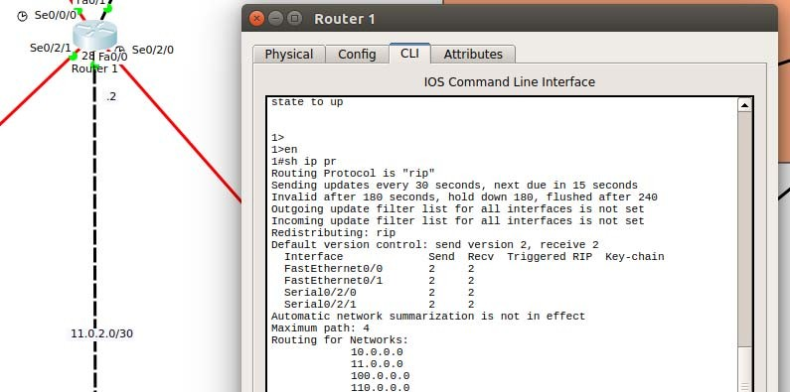
Fig. 10. Scenario 3 – analysis of the network using RIPv2 routing protocol

TABLE VI. RESPONSE TIMES IN THE CASE OF THE THIRD SCENARIO - RIPV2 PROTOCOL (DNS, HTTPS)
 | The Third Scenario – OSPF Protocol
Time  (s) | DNS Service | Time  (s) | HTTPS Service
0,004 | workstation 16 | 0,331 | workstation 16
0,005 | Switch Ground Floor | 0,332 | Switch Ground Floor
0,006 | Router 2 | 0,333 | Router 2
0,007 | Router 3 | 0,334 | Router 1
0,008 | Switch Servers Room | 0,335 | Router 4
0,009 | DNS Server | 0,336 | Switch Third Floor
0,01 | Switch Servers Room | 0,337 | Server 5 Teachers
0,011 | Router 3 | 0,338 | Switch Third Floor
0,012 | Router 2 | 0,339 | Router 4
0,013 | workstation 16 | 0,34 | Router 3
0,014 | workstation 16 | 0,341 | Router 2
 |  | 0,342 | Switch Ground Floor
 |  | 0,343 | workstation 16
TABLE VII. RESPONSE TIMES IN THE CASE OF THE THIRD SCENARIO - RIPV2

PROTOCOL (HTTP, RTP)
 | The Third Scenario – EIGRP Protocol
Time  (s) | HTTP Service | Time  (s) | RTP Service
0,005 | Smartphone 2 | 0,027 | Phone 1
0,006 | Wireless router 0 | 0,028 | Switch First Floor
0,007 | Switch Third Floor | 0,029 | Router 2
0,008 | Router 4 | 0,03 | Router 3
0,009 | Router 1 | 0,031 | Router 4
0,01 | Router Home | 0,032 | Switch Second Floor
0,011 | Switch Home | 0,033 | Phone 3
0,012 | Server 1
0,014 | Switch Home
0,015 | Router Home
0,016 | Router 1
0,017 | Router 4
0,018 | Switch Third Floor
0,019 | Wireless Router 0
0,024 | Smartphone 2

From the simulation results from Figure 10 and Tables VI-VII in the case of RIPv2 protocol we observe the following:
- While accessing the web server between the workstation 16 Ground Floor Students and Server 5 Teachers, from the moment of the browser initialization using https service and the moment of display of the web page the time that passed was of 0,343s.
- for http using the route Smartphone 2 – Management Server - Smartphone 2, we have a
delay of 0,024 s;
- Using RTP service between Phone 1 to Phone 3 we have a delay of 0,033 s;

IV. CONCLUSIONS
Considering the executed simulations and the gained outcomes we can conclude that the most efficient protocol is EIGRP because uses a less complicated algorithm than the one OSPF does; this one is very well scaled on the middle-sized networks and well on the big-sized networks, while OSPF is very well scaled both on the middle-sized and big-sized networks, the latter computing the shortest route. Each router will announce the entire network the routing table and each router using this one will compute the topology of the entire network, requesting very big resources and higher costs compared to EIGRP. The last protocol that could be used for routing a topology is RIP because its time is not very good, therefore it will generate delays in the network.
From the analysis made and the response times obtained, we can conclude that there are differences between the routing protocols used. These differences are generated by the algorithms used that introduce the delays in the execution of some services. We consider that viable software for network simulation is Packet Tracer. This software allows us to design and simulate virtual networks; by using them we can obtain traffic decongestion and at the same time we can strengthen the network security.

REFERENCES

- Ravi Malhotra, IP routing, O’Reilly Media, 2002.
- L.D. Circulares, G. Predusca, N. Angelescu, D. Puchianu, “Comparativ analysis of protocol RIP, OSPF, EIGRP and IGRP for service Video conferencing, E-mail, FTP, HTTP”, CSC20, CSCS20, The 20th International Conference on Control Systems and Computer Science 27-29 May 2015, Faculty of Automatic Control and Computers, University Politehnica of Bucharest, Romania, pp.584-589.
- Uyless Black, IP routing protocols: RIP, OSPF, BGP, PNNI and Cisco routing protocols, Prentice Hall Professional, New Jersey, USA, 2000.
- Ioan Fitigau, Gavril Toderean, “Network performance evaluation for RIP, OSPF and EIGRP routing protocols,” International Conference on Electronics, Computers and Artificial Intelligence (ECAI), 27-29 June 2013, pp.1-4.
- Golap Kanti Dey, Md. Mobasher Ahmed, Kazi Yanvir Ahmmed, “Performance analysis and redistribution among RIPv2, EIGRP & OSPF Routing Protocol,” International Conference on Computer and Information Engineering (ICCIE), 26-27 Nov. 2015, pp.21-24.
- Megha Jayakumar, N. Ramya Shanti Rekha, B. Bharathi, “A comparative study on RIP and OSPF protocols,” International Conference on Innovation in Information, Embedded and Communication Systems (ICIIECS), 19-20 March 2015, pp.1-5.
- Eduard Tetz, Cisco networking all-in-one for dummies, John Wiley & Sons Ltd, 2011.
- Jesin A, Packet Tracer Network Simulator, Packt Publishing, 2014.

- http://www.cisco.com/c/en/us/support.

