mullite-zirconia COMPOSITES: Effect of dispersants on slip and cast properties.

Garrido, L. B.; Aglietti, E.F.
CETMIC (Centro de Tecnología de Recursos Minerales y Cerámica; CONICET-UNLP-CIC). Cno. Centenario y 506. C.C.49 (1897) M.B. Gonnet. Prov. de Buenos Aires. ARGENTINA.
E-mail:garridol@netverk.com.ar

ABSTRACT

Dense mullite-zirconia composites were prepared by reaction sintering of zircon and α-alumina powders. Highly concentrated (57 vol%- 85wt%) aqueous suspensions of the alumina-zircon mixture with different rheological behavior were obtained varying the amount of citric acid and ammonium citrate used as dispersants in a pH range of 7.5 to 9.1. Additionally to study the influence of different stabilization mechanisms on rheological properties, suspensions were dispersed using a polyelectrolyte. The differences between the three studied dispersants were analyzed. Dried compacts prepared from suspensions in the low viscosity range exhibited maximum relative densities of 71, 70.5 and 71.5% of TD for citric acid, with ammonium citrate and with polyacrylate additions, respectively. Green compacts have been subsequently reaction sintered at 1600°C for 2h. Characteristics of sintered compacts prepared from stable and well dispersed suspensions such as density, phase composition and microstructure were determined.

Introduction

Dispersion is a fundamental step in wet ceramic processing where small changes in suspension stability may produce significant variations of density and of microstructure of resulting green and sintered bodies. In order to stabilize ceramic suspensions different kinds and concentrations of dispersants can be used.
Most of anionic dispersants, such as citric acid, ammonium citrate, sodium oxalate, pyrophosphates, and polyphosphates are potential determining, and adsorption on the oxide powder surface decreases the pH of the isoelectric point (iep) with a consequent increase in the negative zeta potential at a given pH ^{(1,2)}. In such a case the stabilizing effect of adsorbed molecules is mainly due to a high zeta potential which results in an increase of the electrostatic repulsion between particles. Since, pH _{iep} reaches a constant value at higher additions of dispersant, the effect of increasing dispersant concentration on electrostatic repulsion is less effective.
Additionally, adsorption may produce a steric barrier that prevents close contact between particles. For the case of a small molecule such as citric acid, the steric contribution is expected to be significant at small interparticle distances or for low surface potentials ⁽³⁾.
According to previous works^{(4,5)}, polyelectrolytes such as polyacrylate and polymethacrylate stabilized alumina suspensions by a combined electrostatic and steric mechanism: adsorption of anionic polyelectrolytes increases the negative surface charge and produces some steric repulsion.
In this work, rheological properties of mixed alumina-zircon suspensions containing citric acid, ammonium citrate and polyacrylate as dispersants were determined, and the possible stabilization mechanisms were analyzed. Using different dispersants, slip properties were optimized in order to improve the characteristics of mullite-zirconia composites obtained after sintering of the pressure filtrated compacts.

2. Materials AND METHODS
Alpha-alumina powder with a mean particle size of 0.4 μm and a BET surface area of 9.5 m²/g was used. Zircon powder was characterized by a larger mean particle size (2 μm) and 4 m²/g BET surface area. The stoichiometric mixture of alumina and zircon (45.5 and 54.5 wt%, respectively) exhibited a broader and bimodal particle size distribution.
For the alumina used, the iep determined using an ESA measurements was about 9 ⁽⁶⁾ which is in agreement with that cited in ⁽⁷⁾. Negative zeta potential slightly increased to -5 mV with increasing of the pH from 9 to 10 ⁽⁶⁾.
Zeta potential vs. pH curve for zircon indicated that the iep was at pH 5 ⁽⁶⁾. A nonsymmetric curve was obtained : in the acidic pH range the magnitude of the zeta potential was lower than that for the basic pHs. The negative zeta potential increased strongly up to -80 mV at pH 9 .
Concentrated aqueous 57 vol% suspensions for rheology measurements and consolidation were prepared by adding the powders to distilled water containing the appropriate amount of dispersant: acid citric (a.r., Anedra), ammonium citrate dibasic (a.r.,Mallinckrodt) and a polyacrylate solution( Dolapix CE64, Zschimmers and Schwartz). NH₄OH was used to adjust the pH. Suspensions were homogenized and dispersed by an ultrasonic process.
Flow curves of the suspensions were obtained using a rotational viscometer Haake vt550 of coaxial cylinders with NV measuring system at 25°C.

Slips were cast by pressure filtration using a metallic sintered filter at 8 MPa, uniaxial pressure was employed. Disks obtained (25 mm in diameter and 12-15 mm in thickness) were dried for 24 h at room temperature and then at 110 °C until a constant weight. Dried density was measured by Hg immersion.
Sintering was carried out in an electric furnace in air. After sintering (1600°C-2h), density was determined by the water absorption method.
Crystalline phases of the fired bodies were characterized by XRD using a Phillips 3020 goniometer with PW3710 controller, Cu-Kα radiation and Ni filter at 40 kV-20 mA.

3. Result and discussion

3.1 Effect of acid citric concentration on rheology of 57 vol% suspensions
Figure 1 shows the apparent viscosity variation vs. shear rate of 57 vol% mixed suspensions with different citric acid additions in a pH range of 7.5 to 9.1.

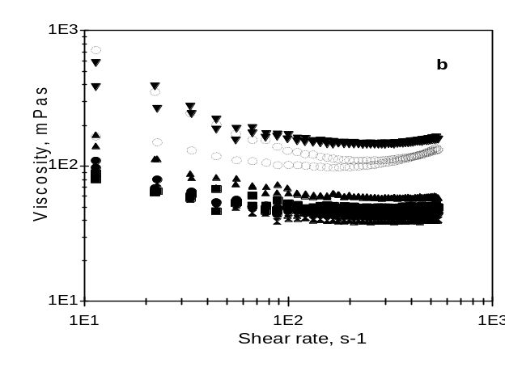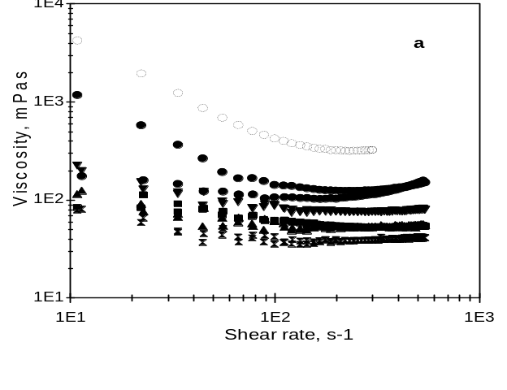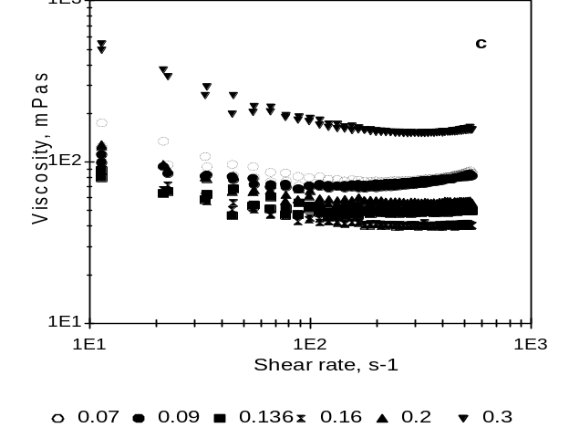
Figure 1: Shear stress vs shear rate curves of 57vol% suspensions for different amounts of citric acid added: (a) pH 7.5, (b) pH 8.5, (c) pH 9.1.
All suspensions exhibited a shear thinning behavior, and apparent viscosity reached a plateau at high shear rates. Although, in some suspensions a shear thickening behavior is observed beyond a critical shear rate.
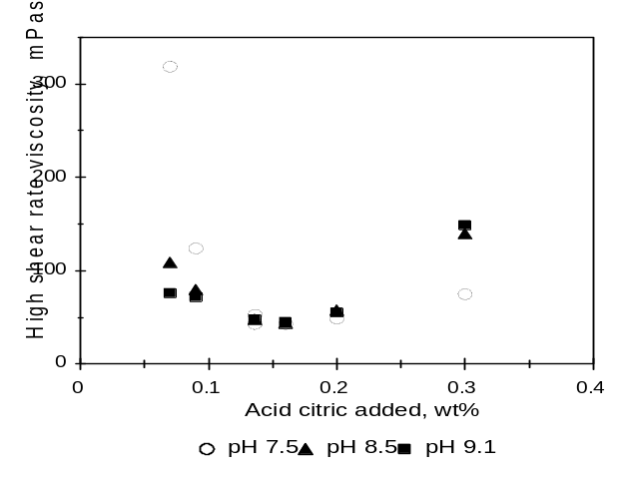Figure 2 shows the Newtonian viscosity at high shear rates (obtained from Figure 1) as a function of the amount of citric acid added for pHs between 7.5 to 9.1.

Figure 2: Newtonian viscosity at the high shear rate region vs citric acid concentrations.

Newtonian viscosity at high shear rates values (Figure 2) indicate that the increasing amount of citric acid added led to an increase of the degree of dispersion of the particles to a maximum, after which further additions caused gradual reduction of the dispersion. Suspensions containing 0.13-0.16 wt% of dispersant at pH 7.5-9.1 exhibited a nearly Newtonian flow behavior with a viscosity of 45 mPa.s. The high degree of dispersion, measured by a minimum viscosity, is a result of citrate anion adsorption on the powder that probably increased the negative surface charge and consequently increased zeta potential. Citric acid shows high affinity for the alumina surface as was determined by Hidber et al. ⁽¹⁾ . At pHs 7.5-9.1, the citric acid molecule has a high negative charge due to dissociation of COOH groups which increases with increasing pH.
At pHs 7.5-9.1, adsorption of citrate anion on alumina used ( pH_{iep} 9) was favorable due to electrostatic attraction between the COO⁻ groups of the molecule and the positive sites on the powder surface, and due to the specific adsorption by a ligand exchange on the Al-OH groups. Considering 1.04 μmol/m² as the adsorbed amount of dispersant effective to stabilize a 70wt% alumina suspension at pH 7-9 ⁽¹⁾ which corresponds to 0.2 wt% of the additive (weight percent with respect to solid content), 0.13-0.16 wt% additions that were required to obtain well dispersed mixed suspensions in our case suggested a low adsorption of citric acid on the zircon surface. In a pH range of 7.5-9.1, far away from pH_{iep}, zircon particles had a very high negative surface charge (few positive surface groups) generating an electrostatic repulsion between the zircon surface and the negatively charged citric acid in solution, which resulted probably in a low amount of dispersant adsorbed. Weak adsorption on the zircon surface was also expected because of the low specific surface area. Thus, citric acid adsorption on the mixed powder may be controlled by the adsorption on the alumina surface.
For citric acid concentrations of 0.2wt%, viscosity of the mixed suspension changed to 60 mPa.s. Since an increase in the equilibrium concentration only produces a small increase in adsorption with more citrate anions remaining in solution ⁽¹⁾, viscosity values higher than the minimum may be attributed to an excess of citric acid in solution, and the corresponding increase in ionic strength.

Effect of pH

At pH 7.5 viscosity increased up to 319 mPa.s for citric acid additions lower than that corresponding to the minimum. With the increase of the suspension pH to 9.1, the degree of dispersion of the particles, measured by the viscosity, improved even though the dispersant content was low. Viscosity values decreased to 76 and 72 mPa.s for 0.07 and 0.09 wt%, respectively. The adsorption isotherm of citric acid on alumina at pH 9 showed a plateau at high equilibrium concentrations in solution ⁽¹⁾. Based on the maximum amount adsorbed (0.52 μmol/m² ), most of 0.1 wt% of dispersant added was adsorbed on its surface. However at pH 7.5, more positive surface groups developed on the powder surfaces, which should increase the citrate adsorption capacity. Then, for mixed suspensions containing less than 0.1 wt% of citric acid, the amount of dispersant added became insufficient, and the net negative charge, mainly on alumina particles, was low resulting in an increase of viscosity. Moreover, viscosity increase may be explained by an electrostatic attraction between the fine and neutral alumina particles (uncovered), and the coarse and negatively charged zircon particles ( heterocoagulation).
As the number of negative surface sites of the powders gradually increased with increasing pH to 9.1, the negative effect of the low adsorbed amount of dispersant on viscosity was less pronounced.
Further increase in dispersant concentration to 0.3 wt% produced an increase in the viscosity values from 75 mPa.s at pH 7.5 to 149 mPa.s at pH 9.1. As the maximum adsorbed amount decreased with increasing pH ⁽¹⁾, more unadsorbed dispersant remained in solution. Also, the concentration of NH₄OH required to adjust the suspension pH to 9.1 increased from 0.05, 0.11 to 0.18 M, for citric acid additions of 0.16, 0.2 and 0.3 wt%, respectively. Thus, for citric acid additions higher than 0.16 wt% at pH 9.1, viscosity increased due to an excess of dispersant and to a high NH₄OH concentration which decreased zeta potential by double layer compression ⁽¹⁻²⁾.

Effect of ammonium citrate concentration
Figure 3 shows that Newtonian viscosity at high shear rates of suspensions containing ammonium citrate (pH 8.5) reached a minimum for additions near to 0.2 wt%. Suspensions stabilized with citric acid at pH 8.5 exhibited a similar minimum viscosity. However, slips prepared with more than 0.2 wt% of citric acid contained also high NH₄OH concentration in solution which increased ionic strength and consequently increased the suspension viscosity.

Effect of polyacrylate concentration
The viscosity behavior as a function of shear rate for different additions of polyacrylate was similar to that shown in Figure 1. Figure 3 shows the constant viscosity in the high shear rate region of 57vol% suspensions (at pH 9) for different amounts of polyacrylate added.
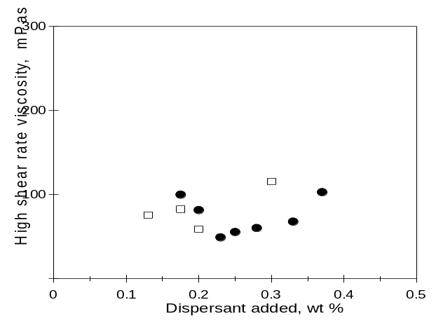For 0.17 wt% of dispersant concentration, suspensions exhibited viscosity values near to 100 mPa.s. Adding 0.23 wt% of polyacrylate, a minimum viscosity of 49 mPa.s was obtained. This value may be related to simultaneous dispersion of both components due to an enhanced electrostatic repulsion as zeta potential values at pH 9 for powders with polyacrylate adsorbed increased to -30 and -100 mV for alumina and zircon ⁽⁶⁾, respectively.

Figure 3: Newtonian viscosity at the high shear rate region vs ammonium citrate (●pH 8.5 )and polyacrylate concentrations (• pH 9 ) .

According to the adsorption isotherm of polyacrylate on the stoichiometric mixture at pH 9 ⁽⁶⁾, the adsorbed amount was constant (0.06 mg/m²) up to an initial concentration of 0.6wt%. Thus, as in the case of citric acid, at higher additions of polyacrylate a decrease in the percentage of the adsorbed amount with respect to added amount was found⁽⁶⁾. Therefore, the estimated concentration of unadsorbed polyelectrolyte in solution increased from 2.2 to 5.6 g/l for 0.23 and 0.4 wt%, respectively. Flocculated suspensions due to an excess of polyelectrolyte exhibited high viscosity (115 mPa.s).

3.2 Green density vs. rheological properties

Figures 4 and 5 show the dried density of compacts prepared by pressure filtration of 57 vol% suspensions with increasing dispersant concentrations. Density increased to a maximum and then gradually decreased.
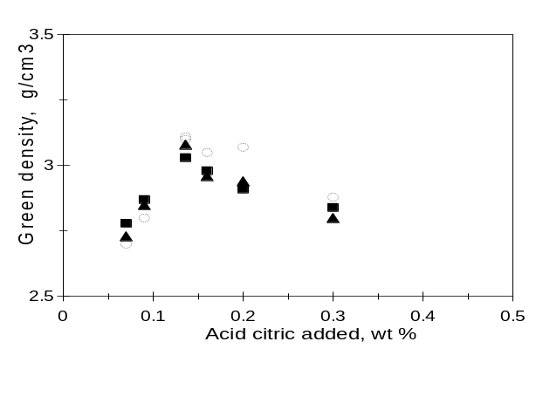
Figure 4: Density of green compacts obtained from 57 vol% suspensions by pressure filtration as a function of the amount of citric acid added for:
○ pH 7.5; ▲ pH 8.5; ■ pH 9.1.

For citric acid used as dispersant, density behavior was dependent on suspension pH. Well dispersed suspension with 0.13–0.16 wt % at pH 7.5 showed the maximum density (mean value of 3.02 g/cm³) due to the presence of electrostatic (long-range) repulsive potentials between particles that facilitated a dense particle packing during consolidation ^{(1,2)}.
With increasing suspension pH, the range of dispersant concentrations resulting in high density values decreased. Excessive concentrations of dispersant and alkali in solution strongly decreased the degree of dispersion as it was shown by viscosity measurements (Figure 2). These flocculated suspensions can not reach close packing. Dispersed suspensions which were further flocculated due to an excess of dispersant and/or NH₄OH showed a significant decreased in density. However, this reduction in density was slightly lower than that obtained from flocculated suspensions due to insufficient amount of dispersant added.
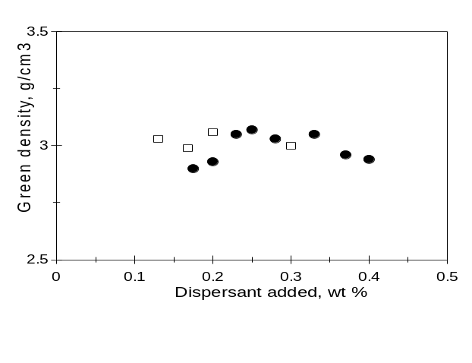
Figure 5: Density of green compacts obtained from 57 vol% suspensions by pressure filtration vs. ammonium citrate (□ pH 8.5) and polyacrylate ( pH 9.1)concentrations.

Figure 5 shows that dispersed suspensions containing 0.22-0.33 wt% of polyacrylate that exhibited a slightly higher viscosity than those prepared with citric acid reached a mean density of 3.05 g/cm³, 71.5 %. Density of compacts prepared from dispersed suspensions further flocculated by excessive additions of polyacrylate showed a similar variation as those with citric acid additions thus suggesting the same effect of the adsorbed dispersant layers at very low interparticle distances. Similar short-range repulsion forces (steric repulsion) between citric acid and polyacrylate was previously attributed to the flat conformation of polyacrylate adsorbed on Al₂O₃ surface in the alkaline pH range ⁽⁸⁾.
Although a high solid concentration of 57 vol% increased the minimum viscosity as compared to that obtained for 48 vol% suspensions ⁽⁶⁾ (from 20 to 45 mPa.s), the density of green bodies increased. However, preparation of highly concentrated suspensions were more complicated because of the triple reduction of the range of dispersant concentration required for optimum stabilization .

3. 3. Sintering of green compacts

Reaction sintering of alumina and zircon powders leads to a mullite-zirconia composite formation at temperatures up to 1600°C depending on sintering time. If reaction is complete, the composite reaches a density of about 3.84 g/cm³ ⁽⁹⁾ depending on the relative content of tetragonal and monoclinic zirconia (t or m-ZrO2 ).
Figure 6: Sintered density vs. dried density of compacts for the different dispersant used (○ citric acid pH 7.5; ▲ citric acid pH 8.5; ■citric acid pH 9.1;  polyacrylate;□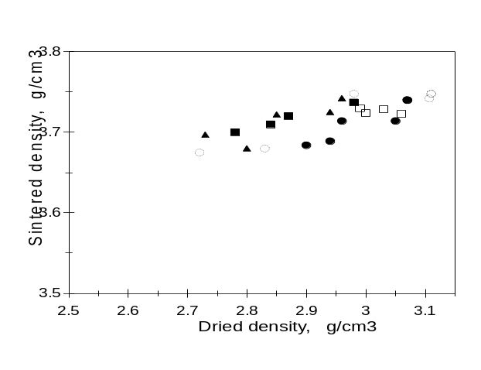 ammonium citrate).

XRD plots of the sintered pressure filtered compacts at 1600°C (2h) showed that mullite and zirconia (t and m) appeared as the principal phases. The presence of minor quantities of zircon indicated that reaction was not complete.
Figure 6 shows the sintered density of compacts prepared by pressure filtration from 57 vol% suspensions containing different dispersants. A nearly linear correlation between green and sintered density values can be noted. Samples with high green density produced compacts with the highest sintered densities.

4. Conclusions

Aqueous 57 vol% suspensions containing a mixture of zircon and α-alumina powders were cast by pressure filtration to produce after sintering a mullite-zirconia composites. Different rheological behavior of the mixed suspensions were obtained by varying the amounts of citric acid, ammonium citrate, and polyacrylate used as dispersants. Maximum relative density of 71, 70.5 and 71.5% TD for citric acid, for ammonium citrate, and for polyacrylate additions respectively, was achieved from well stabilized suspensions.
Density of compacts prepared from dispersed suspensions and dispersed and subsequently flocculated ones due to excessive additions of modifying components exhibit similar short-range repulsion forces (steric repulsion) both for citric acid and polyacrylate which together with the previous zeta potentials measurements indicate that dispersion of zircon-alumina mixtures at pH 9 is mainly achieved by an electrostatic mechanism.
Compacts were reaction sintered at 1600°C–2h showing high densities and fine microstructures.

5. References

- P.H. Hibder, T.J. Graule, L. J. Gauckler, J. Am. Ceram. Soc. 79, 7(1996) 1857.
- E.P. Luther, J.A. Yanez, G.V. Franks, F.F. Lange, D.S. Pearson, J. Am. Ceram. Soc. 78, 6 (1995) 1495.
- Y.K. Leong, P.J. Scales, T.W. Healy, D. V. Boger, J. Chem. Soc. Faraday Trans. 89, 4 (1993) 2473.
- J. Cesarano, I. A. Aksay, A. Bleier, J. Am. Ceram. Soc. 71, 4 (1988) 250.
- L. Guo, Y. Zhang, N. Uchida, K. Uematsu, J. Am. Ceram. Soc. 81,3 (1998) 549.
- L.B. Garrido , E.F. Aglietti, Ceramics International, in press (2000).
- P.A. Smith, R.A. Haber. J. Am. Ceram. Soc.78, 7 (1995) 1737.
- Y.K. Leong, P.J. Scales, T.W. Healy, D. V. Boger, Colloids Surfaces A : Physicochem. Eng. Aspects 95 (1995) 43.
- N. Claussen, J. Jahn, J. Am. Ceram. Soc. (Note) 63, 3-4 (1980) 228.

