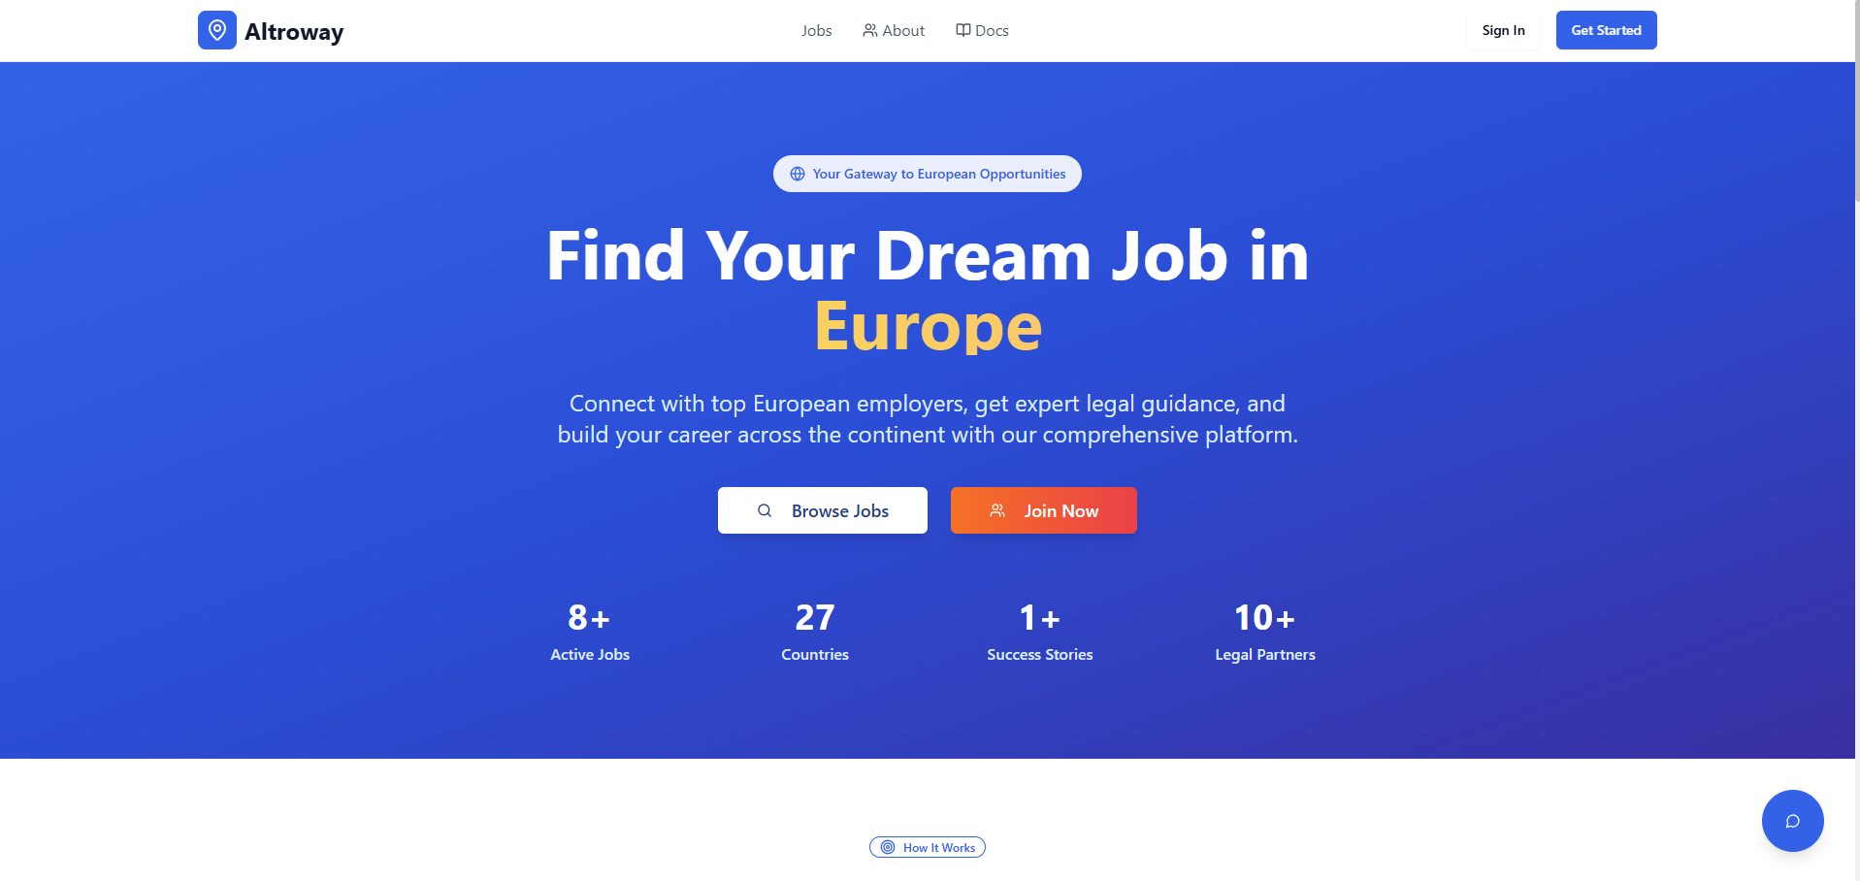
- Logo – ill share what logo to change and collors should be following that theme.
- Content: Guides, Jobs, Legal support, community
Guides: subtopics
- Title and other text - need to change, how to do it ?
- Language ?
- Instead of those two should be - „Let‘s start your journey“ by clicking that it would lead to following:
  - Sign up / account creation. Email, confirmation etc.
  - set your goals;
Mark subtopics: short term work, long term work, full family relocation + citizenship
  - Questionary. Here will be personal information form simmilar to CV but on our template. Let me know what time will need this info
  - English B1 test optional (other languages in the future also)
  - Loading screen - Generating your routes… ->Two options:
short:
Requirements
Documents
Employers
Migration process
Costs
Timeline
Premium:
individual guide based on your qualification and goals
live support from the team
setup of operation
Post arrival tips
Rules and regulations to follow
- Background need to add video. Transition from dark/space to europe map to vilnius old town something like that
- Will chatbot work ?
- Numbers I need to have possibility to edit that text
- Instead of sign in get started language options

