r77 Rootkit

Technical Documentation



|  |  |
| --- | --- |
| r77 Version | 1.1.0 |
| Release date | 11.04.2021 |
|  |  |
| Author | bytecode77 |
| Website | [bytecode77.com/r77-rootkit](https://bytecode77.com/r77-rootkit) |
| GitHub | [github.com/bytecode77/r77-rootkit](https://github.com/bytecode77/r77-rootkit) |

Table of Contents

1 Introduction 4

1.1 Supported Platforms 4

1.2 Compatibility 4

1.3 Tested Applications 4

1.4 Dependencies & Requirements 5

1.4.1 Elevated Privileges 5

2 Rootkit 6

2.1 Rootkit DLL 6

2.2 Installer 6

2.3 Uninstaller 6

2.4 r77 Service 7

2.4.1 Fileless Startup 7

2.5 Hidden Entities 9

2.5.1 File System 9

2.5.2 Processes 10

2.5.3 Registry 11

2.5.4 TCP & UDP Connections 11

2.6 Hide Prefix 12

2.7 Configuration System 12

2.7.1 Process ID’s 13

2.7.2 Process Names 13

2.7.3 Paths 13

2.7.4 Local TCP Ports 13

2.7.5 Remote TCP Ports 13

2.7.6 UDP Ports 13

2.8 Enumeration vs. Access 13

3 Test Environment 15

3.1 Test Console 15

3.2 Example.exe 17

4 Implementation Details 18

4.1 r77 Header 18

4.2 Compile Time Constants 19

4.3 Child Process Hooking 20

4.4 Hooked API’s 21

4.4.1 NtQuerySystemInformation 21

4.4.2 NtResumeThread 21

4.4.3 NtQueryDirectoryFile 21

4.4.4 NtQueryDirectoryFileEx 21

4.4.5 NtEnumerateKey 21

4.4.6 NtEnumerateValueKey 21

4.4.7 NtDeviceIoControlFile 21

5 Integration Best Practices 23

5.1 Include Install.exe 23

5.2 Implement Installation Directly 23

6 Known Issues 24

7 ToDo List 25

8 Bug Reports 26

9 Change Log 27

# Introduction

r77 Rootkit is a fileless ring 3 rootkit. Its primary purpose is to hide certain entities, such as files, directories, processes, etc.

Additionally, the rootkit comes with an out of the box installer that handles injection of processes and persistence. The installation is completely fileless, meaning no files need to be written to the disk. r77 solely relies on in-memory operations and remains on the system after reboot.

For the deployment of r77, only a single executable is required that needs to be executed only once.

This documentation is targeted to integrators of r77 and developers who aim to modify the code of r77.

## Supported Platforms

Windows 10 and Windows 7 are supported, including both x64 and x86 editions. All throughout the product, operating system bitness is taken into consideration. When the documentation mentions x64 and x86 distinction, this only applies to the 64-bit edition. On 32-bit Windows, only 32-bit components are installed.

Supported operating systems are based on market share rather than official support by Microsoft.

|  |  |  |  |
| --- | --- | --- | --- |
| Operating System | x64 | x86 | Market share * |
| Windows 10 | Supported | Supported | 58 % |
| Windows 7 | Supported | Supported | 25 % |
| Windows 8.1 | Not supported | Not supported | 3 % |
| Windows 8 | Not supported | Not supported | < 1 % |

* The market share statistics are taken from netmarketshare on February 2021.

r77 is tested on all supported operating systems prior to release.

## Compatibility

Rootkits, in general, are designed to work for any program, not just specific applications, like Explorer.exe and TaskMgr.exe. r77 hooks functions in ntdll.dll, which is the lowest layer available in ring 3. Therefore, any program is compatible with r77, including programs that will be developed in the future.

## Tested Applications

There is a set of applications that are used to test each module. However, r77 should work for any other application equally.

Applications used in testing:

* Windows Task Manager *
* Process Explorer
* Process Hacker
* Windows Explorer
* Windows Registry Editor
* TCPView
* CurrPorts
* cmd.exe
  + dir
  + netstat.exe *

* See section 6 regarding known issues with the listed applications.

To report bugs regarding applications that behave incorrectly, regardless of whether or not they are in the list of tested applications, go to section 8.

## Dependencies & Requirements

r77 does not have any dependencies, other than the operating system itself and the tools that are already present after the initial installation. The binaries are written in C++ and compiled with /MT.

However, the fileless startup mechanism requires PowerShell and .NET Framework. Both dependencies are present on a clean installation of Windows 7 and Windows 10.

The .NET Framework normally has the issue, where .NET 2.0-3.5 and .NET 4.0-4.8 are two distinct CLR’s. This means that .NET executables targeting .NET 3.5 do not run, when only .NET 4.x is installed – and .NET executables targeting .NET 4.x do not run, when only .NET 3.5 is installed. However, this is **not an issue** for the r77 stager.

On Windows 7, .NET 3.5 is installed by default and on Windows 10, .NET 3.5 is not installed, but 4.x instead. When executing a C# binary in memory from PowerShell as described in section 2.4.1, the target version is irrelevant. The target framework of the fileless stager is set to .NET 3.5 to avoid any code that is incompatible with .NET 4.x. However, the stager will run, if either .NET 3.5 *or* .NET 4.x is installed.

Therefore, this requirement is always met. r77 is **not** a “.NET rootkit”, because only the startup code requires .NET, but the rootkit itself is written in C++ completely.

### Elevated Privileges

The full installation with persistence requires elevated privileges. Escalating privileges using an exploit or a UAC bypass technique is not part of this project.

When using the Test Console running with medium IL, the r77 DLL can be injected into processes with medium IL, but not elevated ones. This is practical enough to do some tests, however a full installation makes no sense, when elevated processes are not injected.

# Rootkit

## Rootkit DLL

The r77 Rootkit is a DLL file (r77-x86.dll and r77-x64.dll) that is compiled separately for 32-bit and 64-bit processes. Once injected into a process, this process will not show hidden entities.

r77 implements reflective DLL injection. The DLL does not need to be written to the disk at any time. Instead, the file is written to the remote process memory and the ReflectiveDllMain export is called to finally load the DLL and invoke DllMain. For this reason, the DLL is not listed in the PEB.

Injecting the DLL into a process that is already injected has no implications. DllMain will detect this and just return FALSE to unload itself.

## Installer

Run Install.exe to inject r77 into every running process and to persist the rootkit on the system. From this point forward, new processes are injected before they run any of their own instructions. This is achieved by hooking process creation. r77 is set up to start after reboot and inject all processes before the first user is logged on.

Install.exe has both r77-x86.dll and r77-x64.dll included in its PE resources. It is not necessary to deploy the DLL’s along with it. This is a **single file deployment**. Install.exe can also be executed using process hollowing to avoid writing the installer to the disk during deployment.

When executing Install.exe a second time after r77 is already installed, the r77 service processes are terminated and recreated. This is supported behavior and the correct way of upgrading r77 to the current version. Already injected processes will **not** be detached and re-injected with the current version of the rootkit DLL. To do that, use Uninstall.exe.

Please review section 5 for details on how to integrate the installer into your own project.

## Uninstaller

To remove r77 from the system completely, run Uninstall.exe. It will uninstall r77 in following steps:

1. Delete the $77stager value from the registry.
2. Delete the scheduled task.
3. Terminate the r77 service.
4. Detach r77 DLL from all injected processes.
5. If the operating system is a 64-bit operating system, all above steps need to be performed again, but from within a 64-bit executable. For this, an executable with a random filename is dropped in the temp directory, executed, and deleted afterwards. This executable is embedded in the PE resources of Uninstall.exe.
6. The configuration system is deleted from the registry.

Executing Uninstall.exe a second time has no effect. However, if any of the above steps failed, it would clean up remaining leftovers.

## r77 Service

When Install.exe is executed, the r77 service is set up and started. The r77 service is fileless, which means the installer does not write any files to the disk.

Two separate r77 service processes are needed to inject both 32-bit and 64-bit processes. The primary purpose of the r77 service is to inject all running processes when the r77 service started, as well as injecting processes that are created later on.

### Fileless Startup

**Stage 1:** The installer creates two scheduled tasks for both the 32-bit and the 64-bit r77 service. A scheduled task does require a file, named $77svc32.job and $77svc64.job to be stored, which is the only exception to the fileless concept. However, scheduled tasks are also hidden by prefix once the rootkit is running.

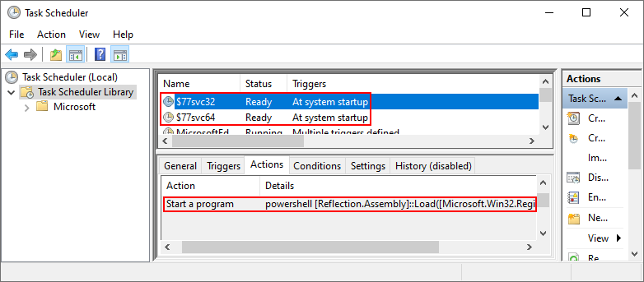

The scheduled task does **not** start the r77 service executable from disk. Instead, it starts powershell.exe at system startup with following command line:

[Reflection.Assembly]::Load([Microsoft.Win32.Registry]::LocalMachine.OpenSubkey('SOFTWARE').GetValue('$77stager')).EntryPoint.Invoke($Null,$Null)

The command is inline and does not require a .ps1 script. Here, the .NET Framework capabilities of PowerShell are utilized in order to load a C# executable from the registry and execute it in memory. Because the command line has a maximum length of 260 (MAX_PATH), there is only enough room to perform a simple Assembly.Load().EntryPoint.Invoke().

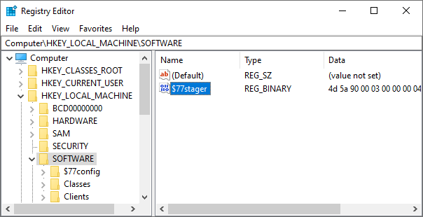

**Stage 2:** The executed C# binary is the stager. It will create the r77 service processes using process hollowing.

The r77 service is a native executable compiled in both 32-bit and 64-bit separately. The parent process is spoofed and set to winlogon.exe for additional obscurity. In addition, the two processes are hidden by ID and not visible in the task manager.

Since the scheduled task starts PowerShell under the SYSTEM account, the r77 service also runs under the SYSTEM account. Therefore, it can inject processes with system IL, except for protected processes, such as services.exe.

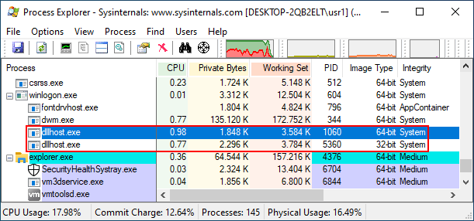

**Important:** The only items written to the file system are the job files ($77svc32.job and $77svc64.job) and the registry value $77stager with the stager executable. No EXE or DLL files are stored in the file system directly. Even Install.exe can be executed using process hollowing to deploy r77 in a completely fileless manner. This is very important, because the rootkit DLL may be detected by AV and deleted.

**Stage 3:** Both r77 service processes are now running. Following operations are performed:

1. The process ID is stored in the configuration system to hide the processes. Because the processes were created using process hollowing, they cannot have the $77 prefix.
2. All running processes are injected.
3. A named pipe is created to handle injection of newly created child processes.
4. In addition to child process hooking, a subroutine checks for newly created processes every 100ms. This is because some processes cannot be injected, but still create child processes. This is particularly the case for services.exe, which is a protected process.

## Hidden Entities

Following entities are hidden, either by prefix, by a specific condition, or by the configuration system:

|  |  |  |  |
| --- | --- | --- | --- |
| Entity | Hidden by prefix | Hidden by condition | Hidden by configuration |
| File | Yes |  | Hidden paths |
| Directory | Yes |  | Hidden paths |
| Named Pipe | Yes |  | Hidden paths |
| Scheduled Task | Yes |  |  |
| Process | Yes |  | Hidden PID’s  Hidden process names |
| CPU Usage |  | CPU usage of hidden processes |  |
| Registry Key | Yes |  |  |
| Registry Value | Yes |  |  |
| TCP Connections |  | TCP connections of hidden processes | Hidden local TCP ports  Hidden remote TCP ports |
| UDP Connections |  | UDP connections of hidden processes | Hidden UDP ports |

### File System

On the file system, all directories and files with the prefix are hidden.

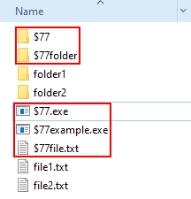

This also includes:

* File & directory junctions
* Named pipes
* Scheduled tasks (.job file with the prefix are hidden; Scheduled tasks are hidden, when r77 is injected in the service that enumerates scheduled tasks, not mmc.exe.)

In addition, individual files, directories and named pipes can be hidden by the configuration system. For this, the full path needs to be written to the configuration system:

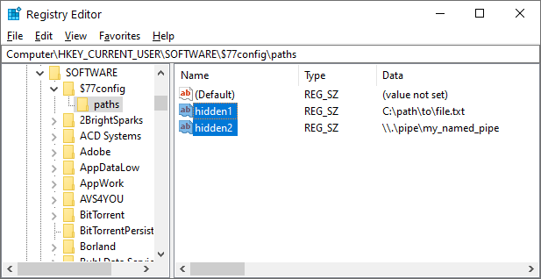

### Processes

Processes of executables where the filename starts with the prefix are hidden.

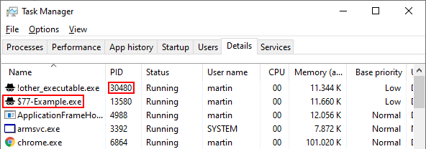

In addition, individual process ID’s can be written to the configuration system. These process ID’s are picked up by r77 and in effect, processes are hidden by ID. For files on the disk, the preferred way is to hide both the process and the executable file by prefix. For processes created in-memory, where the filename cannot be changed, hiding the process by ID is one of two options.

Alternatively, processes can also be hidden by a specific name using the configuration system:

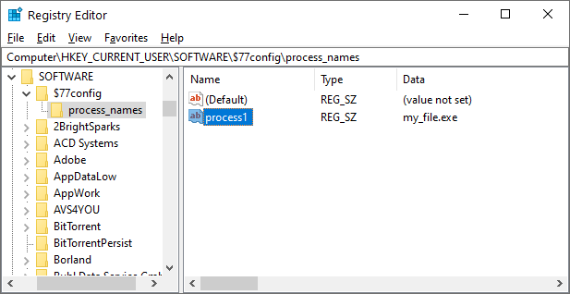

### Registry

Registry keys and values are hidden by prefix.

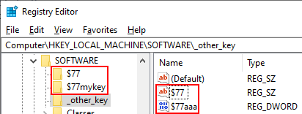

### TCP & UDP Connections

TCP and UDP connections are hidden based on either of the following:

A specific condition:

* The process is hidden by prefix.
* The process is hidden by ID.
* The process is hidden by name.

Or a specific configuration:

* The local or remote port of the TCP or TCPv6 connection is found in the configuration system.
* The port of the UDP or UDPv6 connection is found in the configuration system. UDP connections do not have a remote port.

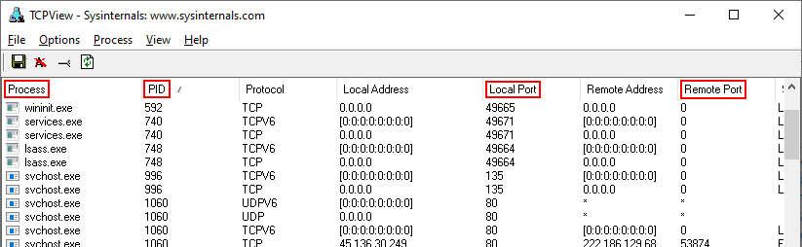

To hide outgoing TCP connections, write the remote port into the configuration system. For example, hiding remote TCP port 443 hides all HTTPS connections created by e.g., web browsers.

To hide TCP listeners, write the local port into the configuration system.

## Hide Prefix

#define HIDE_PREFIX L"$77"

The hide prefix is a compile time variable. It specifies the beginning of a name that is hidden. This applies to the filenames of processes, to files and directories, and all other entities described in section 2.5. If the documentation mentions the string $77, it refers to the compile time variable that is used throughout the code. This is the single place to change the prefix. Additionally, this change must be applied in GlobalAssemblyInfo.cs.

Processes that are hidden by prefix cannot be injected with r77. The DllMain of r77 will return FALSE, if the process starts with the prefix.

## Configuration System

The configuration system is stored in the registry:

* HKEY_LOCAL_MACHINE\$77config
* HKEY_CURRENT_USER\$77config

Because Windows has multiple users, the HKEY_CURRENT_USER key of all users is retrieved by enumerating HKEY_USERS. This way, any of these registry hives can be used to store configuration.

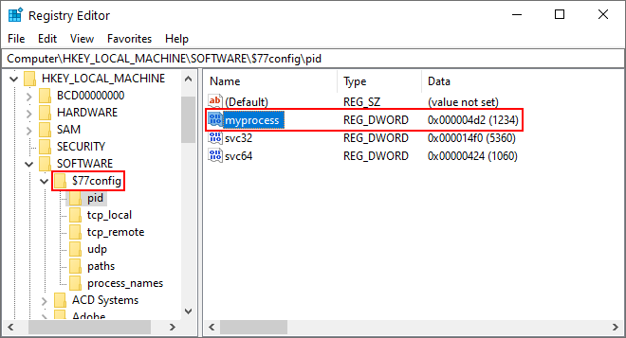

The configuration is read by r77 every 1000ms and the data from all registry keys is merged into a structure that holds following information:

* Array of hidden process ID’s
* Array of hidden process names
* Array of hidden paths
* Array of hidden local TCP ports
* Array of hidden remote TCP ports
* Array of hidden UDP ports

This data is used to hide entities based on custom configuration. Any process can write to the configuration system under any registry hive.

The names of the values are ignored. The values $77config\pid\svc32 and $77config\pid\svc64, however, are reserved to the r77 service and should not be modified. They are created automatically when the r77 service starts.

**Note:** Use **specific** value names – **do not** use randomized value names. Remember, that there is a limit to the number of values. When creating a new value name each time, this limit will eventually be exceeded.

### Process ID’s

The subkey $77config\pid contains DWORD values with process ID’s to be hidden. In addition, network connections from hidden processes are also hidden. This feature can be tested using the Test Console.

### Process Names

The subkey $77config\process_names contains REG_SZ values with filenames of processes to be hidden. In addition, network connections from hidden processes are also hidden.

**Note:** Hiding a process by ID or name instead of by prefix is only recommended, when the filename cannot have the prefix. This is particularly the case with process hollowing. The prefix also prevents the process from being injected with the rootkit.

### Paths

The subkey $77config\paths contains REG_SZ values with full paths to files, directories, junctions, or named pipes to be hidden. Examples:

* C:\path\to\file.txt
* \\.\pipe\my_named_pipe

### Local TCP Ports

The subkey $77config\tcp_local contains DWORD values with local TCP ports to be hidden.

### Remote TCP Ports

The subkey $77config\tcp_remote contains DWORD values with remote TCP ports to be hidden.

### UDP Ports

The subkey $77config\udp contains DWORD values with UDP ports to be hidden.

## Enumeration vs. Access

“Hiding” in r77 means that hidden entities are removed from enumerations. It is still possible to directly access a file, if the filename is known to the user – or to open a process, if the process ID is known.

Functions that open a file/process/etc. are not hooked and they do not return a “not found error” to further masquerade hidden entities. The general assumption is that the name of a prefixed entity will not be guessed.

The main reason is, that there is currently no other way for r77 to maintain itself. For example, r77 could not read from the configuration system, if the hidden key is inaccessible altogether.

This is an issue that may be addressed in future releases of r77.

# Test Environment

The standard, single file to deploy r77, is Install.exe. In addition, the test environment can be used to inject r77 to or detach r77 from individual processes. This is particularly relevant in the development process of r77 to test the DLL prior to installing r77 system wide.

## Test Console

TestConsole.exe can be used to inject r77 to or detach r77 from individual processes. The list of processes is not filtered by r77, because r77 does not inject the Test Console.

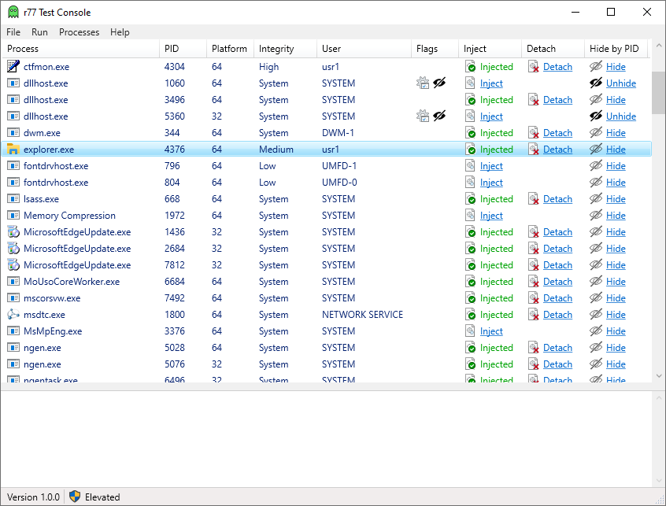

The process list shows, which processes are injected. The “Hide”-Link can be used to write a specific process ID into the configuration system.

The “Flags”-Column shows flags for a specific process.

|  |  |
| --- | --- |
| Flag | Meaning |
|  | The process is the r77 service process. It cannot be injected with r77. |
|  | The process is an r77 helper process. It cannot be injected with r77.  TestConsole.exe is a helper process, as well as ProcessList32.exe and ProcessList64.exe, and other files directly used by the test environment.  Also, Install.exe and Uninstall.exe are helper processes. This is to avoid r77 being injected into them. |
|  | The process ID is found in the configuration system. A task manager does not display this process. This includes the r77 service by default and can be extended to other processes. Uninstall.exe deletes the list of hidden process ID’s. |

The Test Console is written in C#. Lots of operations require an executable to match the bitness of the target process. For this reason, the Test Console uses following native executables as helper files:

|  |  |
| --- | --- |
| File |  |
| BytecodeApi*.dll | Dependencies of TestConsole.exe. |
| ProcessList32.exe  ProcessList64.exe | Because the process list in the Test Console contains r77 related information, the bitness of the executable that enumerates processes needs to match the bitness of the enumerated process.  Each time the process list is refreshed, both executables are run and their output is parsed to populate the process list. |
| Inject32.exe | Executable that is called by TestConsole.exe to inject r77-x86.dll into a 32-bit process.  Inject32.exe 1234 "C:\path\to\r77-x86.dll"  - or –  Inject32.exe -all "C:\path\to\r77-x86.dll" |
| Inject64.exe | Same as Inject32.exe, but used on 64-bit processes with r77-x64.dll. |
| Detach32.exe | Executable that is called by TestConsole.exe to detach r77 from a 32-bit process.  Detach32.exe 1234  - or –  Detach32.exe -all |
| Detach64.exe | Same as Detach32.exe, used on 64-bit processes. |

All above files are used by the Test Console exclusively and are not part of the r77 delivery.

## Example.exe

$77-Example.exe is useful to test task managers and file viewers. To perform a quick test on process hiding, start this executable and then use the Test Console to inject the task manager with r77. The process is no longer visible in the injected task manager. To hide the file, inject Explorer using the Test Console.



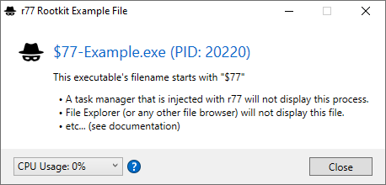

This executable does not implement anything other than a MessageBox. Any executable can be used for testing purposes by renaming its filename to start with the prefix.

To simulate CPU usage, change the value in the “CPU Usage” ComboBox. If this process is hidden in a task manager, the CPU usage is added to the System Idle Process. Additionally, processor usage graphs will be corrected *.

* Please review section 6 regarding issues with processor usage graphs.

# Implementation Details

This section describes implementation details, in addition to those mentioned in the above sections.

## r77 Header

To mark a process as injected, or as the r77 service, etc., the “r77 header” is used.

The most suitable location in the memory of a process to write the r77 header to is the DOS stub. Because it is not used for anything, the process will not malfunction if bytes are overwritten here:

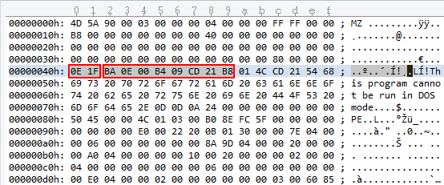

Note, that this is the view of an executable’s memory mapping and **not** the view of the file.

A process may contain either of the following header. The signature is written to the first two bytes of the DOS stub. Any following data is written after the signature.

|  |  |
| --- | --- |
| Signature & default value | Description |
| R77_SIGNATURE  = 0x7277 | When the r77 DLL is injected, R77_SIGNATURE is written to the main module’s DOS stub.  This way, the Test Console can detect, whether or not a process is injected.  If r77 is injected into a process, but the r77 signature is already present, DllMain returns FALSE to avoid double injection.  After R77_SIGNATURE, a function pointer to Rootkit::Detach is stored. Calling it will detach r77 from the process gracefully. This is used by the Test Console and Uninstall.exe.  When detaching r77 from a process, the r77 header is removed by restoring the DOS stub to its original state. |
| R77_SERVICE_SIGNATURE  = 0x7273 | The r77 service processes need to be identifiable to Install.exe and Uninstall.exe. This signature is written to the executable file at **compile time** to avoid injection of r77 into the service process prior to a signature being written.  If r77 is injected into the r77 service process, DllMain also returns FALSE. |
| R77_HELPER_SIGNATURE  = 0x7268 | The helper signature is written to helper files at compile time. These include any executables of the test environment, such as TestConsole.exe.  If r77 is injected into a helper process, DllMain also returns FALSE. |

## Compile Time Constants

Compile time constants are defined in both r77api.h and GlobalAssemblyInfo.cs. Changes must be applied in both files.

The r77 signatures are already mentioned in section 4.1. When changing these, r77 can be customized to be distinct from and be undetectable by the publicly available r77 binaries.

This is a list of additional constants that can be modified:

|  |  |
| --- | --- |
| Constant & default value | Description |
| HIDE_PREFIX  = "$77" | The prefix by which entities are hidden. |
| R77_CONFIG_MAX_HIDDEN_PROCESS_IDS  = 100 | The maximum number of process ID’s that can be stored in the configuration system. |
| R77_CONFIG_MAX_HIDDEN_PROCESS_NAMES  = 100 | The maximum number of process names that can be stored in the configuration system. |
| R77_CONFIG_MAX_HIDDEN_PATHS  = 100 | The maximum number of full paths that can be stored in the configuration system. |
| R77_CONFIG_MAX_HIDDEN_TCP_LOCAL_PORTS  =100 | The maximum number of local TCP ports that can be stored in the configuration system. |
| R77_CONFIG_MAX_HIDDEN_TCP_REMOTE_PORTS  =100 | The maximum number of remote TCP ports that can be stored in the configuration system. |
| R77_CONFIG_MAX_HIDDEN_UDP_PORTS  =100 | The maximum number of UDP ports that can be stored in the configuration system. |
| R77_SERVICE_NAME32  = HIDE_PREFIX + "svc32"  R77_SERVICE_NAME64  = HIDE_PREFIX + "svc64" | The name of the scheduled tasks that launch the r77 service processes. For scheduled tasks, a .job file is created, therefore the prefix is important. |
| CHILD_PROCESS_PIPE_NAME32  = "\\\\.\\pipe\\" + HIDE_PREFIX + "childproc32"  CHILD_PROCESS_PIPE_NAME64  = "\\\\.\\pipe\\" + HIDE_PREFIX + "childproc64" | The name of the named pipe that is used for child process hooking requests. |

## Child Process Hooking

When the r77 service starts, all currently running processes are injected. Processes that spawn later must be injected, too. There are two concepts to achieve this:

**1.) Hooking the creation of processes:** A function that is always called when a process is created is NtResumeThread. When process A creates a process B, this function is called by process A after process B is fully initialized, but still suspended. After this function call, the creation of process B is completed.

Therefore, NtResumeThread is hooked and r77 is injected into the new process **before** actually calling this function. Unfortunately, 32-bit processes can spawn 64-bit child processes and vice versa. As described before, a 32-bit executable cannot inject a 64-bit DLL into a 64-bit process. To solve this, the r77 service provides a named pipe to handle injection requests. When sending the new process ID to the r77 service, the service injects the process and returns a confirmation. After receiving the confirmation from the service, the injection has completed and NtResumeThread can be called. Either the 32-bit, or the 64-bit r77 service must be chosen to send the request to, based on the bitness of the created child process.

This way, a process is injected with r77 before it can execute any of its own instructions. This is very important, because some programs (e.g., RegEdit) initialize fast, then perform enumerations and display the result shortly after starting. The rootkit must be injected at the very beginning!

However, unfortunately, not all processes can be injected. Windows 10 protects certain processes from access, such as services.exe. So, relying on child process hooking alone would result in services spawning without r77 injected, among other processes. This is when **concept 2** comes into play.

**2.) Hooking new processes periodically:** Every 100ms, a list of running processes is retrieved. Any new process in that list will be injected. This way, processes that are missed by the child process routine are still injected. However, there is a delay of up to 100ms, where r77 is not running in that process.

As mentioned previously, double injection of a process has no negative impact. It is supported behavior.

## Hooked API’s

Detours is the hooking library used to hook functions from ntdll.dll. This DLL is loaded into every process on the operating system. It is a wrapper around all syscalls, which makes it the lowest layer available in ring 3. Any WinAPI function from kernel32.dll or other libraries and frameworks will ultimately call ntdll.dll functions. It is not possible to hook syscalls directly. This is a common limitation to ring 3 rootkits.

The following chapters describe each function that is hooked.

### NtQuerySystemInformation

This function is used to enumerate running processes and to retrieve CPU usage.

### NtResumeThread

This function is hooked to inject created child processes, while the new process is still in a suspended state. Only after injection has completed, this function is actually called.

**Note:** Hooking the CreateProcess API is not a good alternative, because it creates and starts a process in one go. Also, it is a high-level API, of which there are several. It is not good design to hook numerous functions that are similar, only to achieve one task.

### NtQueryDirectoryFile

This function enumerates files, directories, junctions and named pipes.

### NtQueryDirectoryFileEx

This function is very similar to NtQueryDirectoryFile and it must be hooked as well. The implementation is mostly the same.

The dir command in cmd.exe uses this function instead of NtQueryDirectoryFile.

### NtEnumerateKey

This function is used to enumerate registry keys. The caller specifies the index of a key to retrieve it. To hide registry keys, the index must be corrected. Therefore, the key must be enumerated again to find the correct “new” index.

### NtEnumerateValueKey

This function is used to enumerate registry values. The implementation of this hook is very similar to NtEnumerateKey.

### NtDeviceIoControlFile

This function is used to access drivers using IOCTL’s.

If the driver is \Device\Nsi and the IOCTL is 0x12001b, a list of all TCP and UDP connections is requested by the caller.

To hide a row, all following rows need to move up by one and the total count needs to be decreased.

# Integration Best Practices

Including r77 into an existing project is simple and can be done in several ways.

## Include Install.exe

Including the installer and executing it upon installation of your project is the preferred way. Executing the installer when r77 is already installed is supported. It will not update already injected processes; however new processes are injected with the new version of the rootkit DLL.

The installer can either be written to disk and executed, or it can be spawned using process hollowing. The process hollowing implementation needs to be written in the language of your project. If your project is written in C#, the process hollowing implementation of the stager can be used. Otherwise, you have to write it yourself. It is required to perform 32-bit process hollowing, because the installer is a native 32-bit executable.

Running the installer using process hollowing is an extra mile worth taking, because it is much less likely to be detected.

## Implement Installation Directly

It is a viable option to implement the installer directly into the code of your project. For this, the behavior of Install.cpp must be replicated:

1. InstallStager.exe needs to be included in your project’s resources.



1. InstallStager.exe must be written to both the 32-bit and the 64-bit registry key.
2. Both scheduled tasks need to be created and started.

Your implementation does not require a native executable. Make sure that your code handles Windows x86/x64 differences properly. For each r77 update, build the solution and take the InstallStager.exe file from the resources of the installer project. Make sure to check for changes in the code of Install.cpp and implement them in your project as needed. The source code of the installer itself is fairly short and commented.

# Known Issues

To ensure quality and compatibility, r77 is tested with several operating system versions and well-known applications. This is a list of all issues that are known and need to be resolved in future releases.

|  |
| --- |
| Issues |
| Sandboxed processes cannot be injected. A sandbox is defined by an integrity level of LOW or UNTRUSTED. Typical applications are sandboxed processes by web browsers and document readers. Injecting a sandboxed process is causing crashes of the process and therefore, r77 does currently not inject into sandboxes. |
| Injecting critical processes, such as smss.exe, csrss.exe, or wininit.exe, has been reportedly causing issues. The exact reason is unknown, therefore processes are only injected, if they are not marked as critical. |
| MSBuild.exe is not working correctly when r77 is injected. |
| Since Windows 8, processes can be in a suspended state. This is particularly relevant for Windows apps. A Windows app is suspended once the main window is minimized.  Injecting those processes result in odd behavior, such as injection does not complete before the process is resumed. Also, detaching such processes does not work while the process is in a suspended state. When uninstalling r77, suspended processes are not detached, and a reboot may be necessary to clean Windows apps from the injected DLL. This needs to be handled properly. However, this is a minor issue that does not cause instability or malfunction. |
| Hiding CPU usage only works partially. The CPU usage of hidden processes is accumulated to the System Idle Process correctly.  However, the graphs of task managers that display CPU usage either remain unchanged, or do not display the correct values.  In detail:   * TaskMgr and perfmon graphs are not corrected, at all. * ProcessHacker: The graph that shows individual CPU cores has spikes in it, because the algorithm currently assumes, that CPU usage is equally distributed across all logical processors. It needs to be calculated per process AND per core at the same time, which is not implemented, yet.   Use $77-Example.exe to test CPU usage hiding. |
| Hiding of TCP and UDP rows does currently not work in the netstat command in cmd.exe. The exact mechanism used by netstat needs to be determined to hook the appropriate function. |

# ToDo List

Following features are on the agenda for upcoming releases:

* Hide loaded DLL’s that have the prefix from the PEB of any process.
* Hide Windows services by prefix and process ID.
* Implement a mechanism to escalate privileges from a process running with medium IL.
* Prohibit querying/opening/deleting/etc. operations on hidden entities (see section 2.8).

# Bug Reports

Please feel free to report any bugs that are not in the list of known issues. Either create an issue in the [GitHub](https://github.com/bytecode77/r77-rootkit) repository or visit [bytecode77.com/contact](https://bytecode77.com/contact) to get in touch.

Bug reports are only considered for supported operating systems (See section 1.1).

**Scope**

* Processes crash or behave abnormally, when r77 is injected.
* Processes cannot be injected for reasons, not stated in the documentation.
* Hidden entities are visible, even though r77 is injected. Any application is in scope, not just the list of explicitly tested applications.
* The r77 service fails to start at system startup.
* The r77 service crashes.
* Installation fails.
* Uninstallation fails or does not remove r77 completely.
* A bug in the Test Console or the test environment in general.
* Anything that is not explicitly mentioned above but constitutes as a bug.

**Out of scope**

* Memory regions that are not zeroed-out. Example: An enumeration is hooked, one item is removed and the count is decreased. Anything that is out of bounds of the new array is not zeroed-out, because it is expected that the caller does not read beyond the buffer to find hidden entities.
* Notoriously crafted parameters of hooked functions that cause the r77 DLL to crash or malfunction in a way that would not happen with normal usage. Penetration and fuzzing of the DLL is not in scope. However, coding errors like missing NULL checks on parameters are in scope.
* Revealing the rootkit by using debuggers is out of scope. Using kernel mode debugging is out of scope completely. r77 is hiding entities from normal to intermediate computer users, not pentesters.
* Kernel code is out of scope, because r77 is a ring 3 rootkit. It does not hide anything from the kernel or from kernel mode drivers.

# Change Log

|  |  |  |
| --- | --- | --- |
| Version | Release | Changes |
| 0.6.0 | 17.12.2017 | **Beta release** |
| 1.0.0 | 21.02.2021 | **Initial release**   * Full rewrite * Resolved all issues of the beta release * Uses Detours instead of MinHook * Implements proper & out of the box installation & persistence * The rootkit is fileless * Testing framework * … And a lot more |
| 1.0.1 | 05.03.2021 | * Bugfix: Crash when injecting critical processes (e.g. smss.exe, csrss.exe, or wininit.exe). Resolution: Do not inject critical processes. |
| 1.1.0 | 11.04.2021 | * Hide processes by name * Hide files, directories, junctions and named pipes by full path |