**Medicare app**



**Team member:**

* Mohammed Abdallah Abd elghani
* Mohammed Ayman said El said
* Sara atef Ahmed Fawzy
* Omnia Ahmed metwally
* Rahma Hussein goniem
* Bassant abdelhamed

Contents

Introduction 2

Abstract 3

Problem statement 4

Objectives of the system 4

Requirement 5

Goals and Activities 5

UI 6

Database 10

# Introduction

In the era of technology, where everything needs to be done efficiently and effectively the existences of Medicare app become necessary. The used of Medicare app can enhance the services and the workflow of all activity that happens in hospitals where it helps in reducing the workload of medical staff, the number of manpower needed, and it also make hospitals management become more manageable and easier to control.

The Medicare app is an android using Katlin programming language- based software designed for registration and management of patient's records and easy access of the records. All these activities are done routinely and would be cumbersome on the employees if done manually hence need of an efficient easy to use management software that will help ease the workload on employees in the clinic / hospital.

Now user can use most of all desktop applications in their smart phones. Even healthcare service providers and patients are feeling comfortable to use mobile devices for patient records and/or patient diagnostic process. The use of mobile phone within the healthcare domain is called m-healthcare, Our Services constitutes of a technology platform that allows users of Medicare Application or Site to search and book appointments with you as an independent healthcare provider Providers subscribed on our platform, including clinics, hospitals, medical professionals, laboratories, and other health services. In another words, we permit users to easily access Providers, such as yourself, to receive medical treatment.

# Abstract

Nowadays, the current Clinic management system that are available had not been widely used. This is because the process of task that occurred in hospitals is quite complex compared to other organization. The other reason is that most of existing system does not full fill the requirements of doctor and other medical staff in our country. Registration in hospitals, the processes of works to be done are vary. Before a patient can received a treatment from doctors, first, they need to register. Patients need to give details about themselves in some cases, patient come to the clinic with if serious injured.

# Problem statement

In our country, most clinics and hospitals have not embraced the new technologies that can improve their management and profits.as a result, most of them use analogue systems to capture and manage data. Large space usage. Use of paper to record data requires large space for storage over time. This can be seen in many places where analogue systems are in use. Inefficient back up methods. Old systems especially that which are analogue do not provide effective ways to back up data and as a result data can be permanently lost in the event data is damaged or misplaced. This may lead to the collapse of the institution.

The application also helps to save time and makes it easier for the patient to reach the nearest doctor. It also helps the patient to find a doctor at the right price for him and facilitates the booking process at the time that suits the patient.

# Objectives of the system

Justification of the computerized system the main aim of a hospital or any clinical organization is to maximize profits. The software product will help in achieving this in the following ways.

**Reduce cost.**

* **Reducing operational cost.** Our project aim is to come up with a software product that will reduce the operational costs of a business. There will be no use of purchasing stationery and hence reduced operational costs.
* **Curbing fraud by the employees**. Our software will enable effective employee supervision and stringent measures that will hinder office fraud. Reducing errors. Our software will provide proper validation techniques that will collectively reduce errors done when recording data.
* Increased efficiency and effectiveness. Enabling ease of access to information concerning each patient and their previous records thus guaranteeing efficiency and effectiveness.

# Requirement

* User properties like name, password
* Provide information about doctor and patient
* At least user of the system should be comfortable with English language.
* Provide doctor in all departments.

# Goals and Activities

The main goal of this project is to develop an m-healthcare application that will provide secure, trustful, and reliable communication for different communities in healthcare area. We have planned to develop an application that will provide interface to both physicians and patients. It will be an application that will be secure from the three important types of threats. As we have discussed above, the three types of major threats are:

* Threats that attack during network communication
* Unauthorized access to data and
* Third persons access to the device storage data

# UI

1. 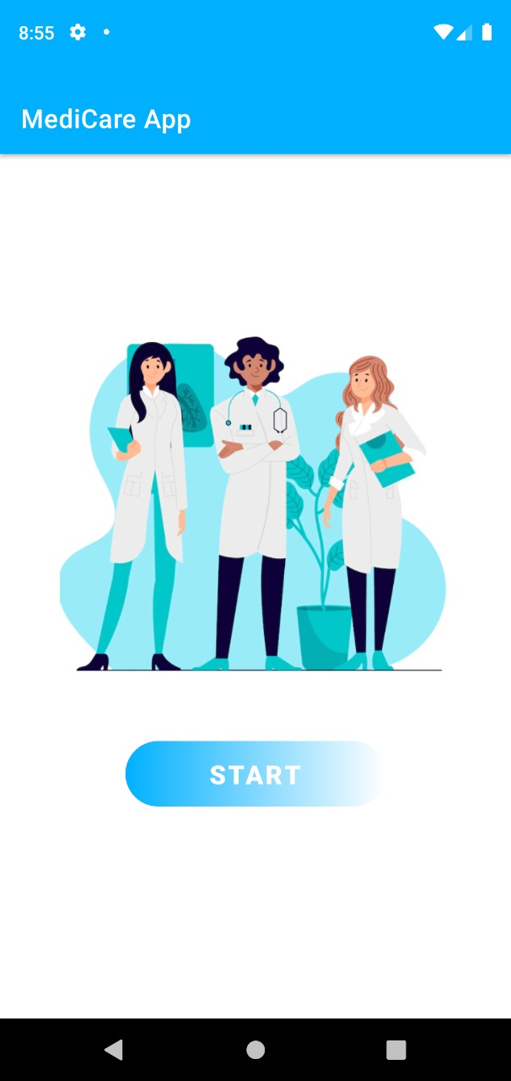The app begin with a start frame that include the starting screen and and a button to move to Login frame

2- In the login fragment the user enter his/her email and password to access his/her data. And you can login as admin to update data or as user to show data and access it and they can sing up if they didn’t have account .

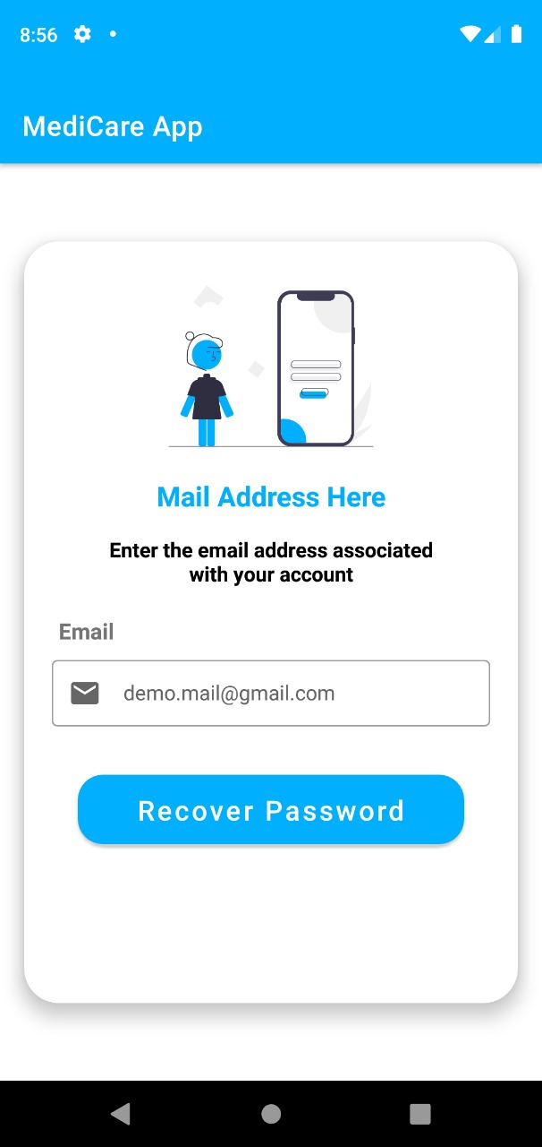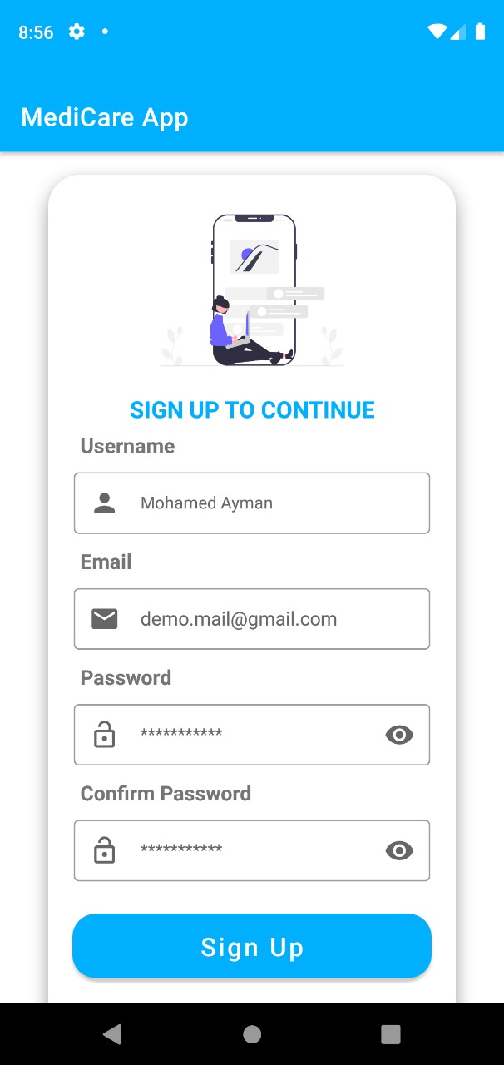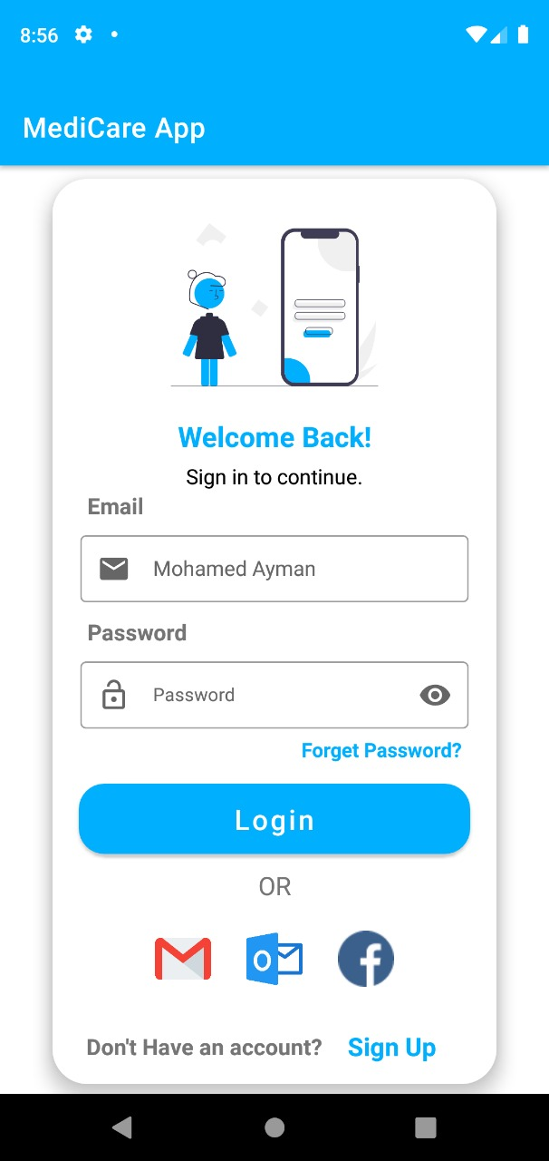

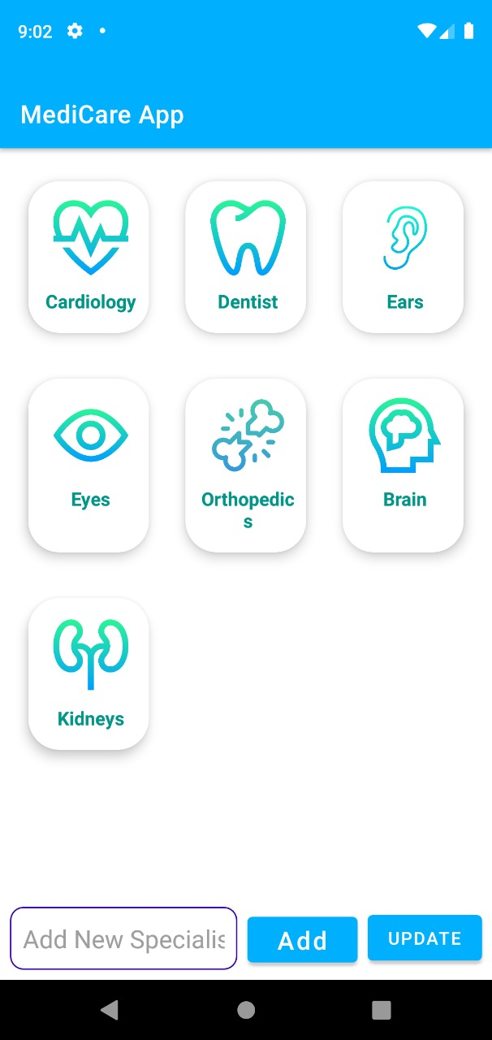3-If the user login as admin they can make many change like they can add or delete or update category and can add Doctor in the list

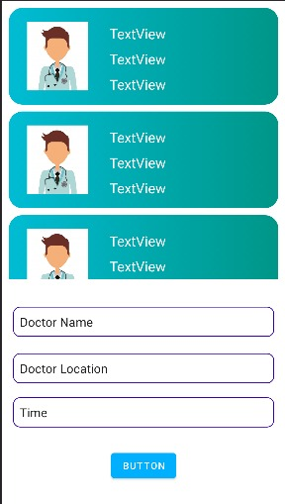

\

4- if they login as User then well go to the category and when he/she chosen the category they can see the Doctor in this category when they chosen the doctor then they can see information about doctor and can reservation with the doctor

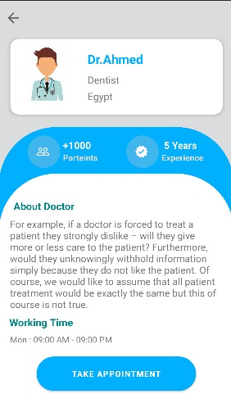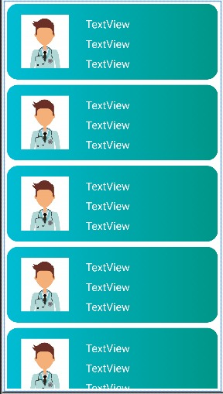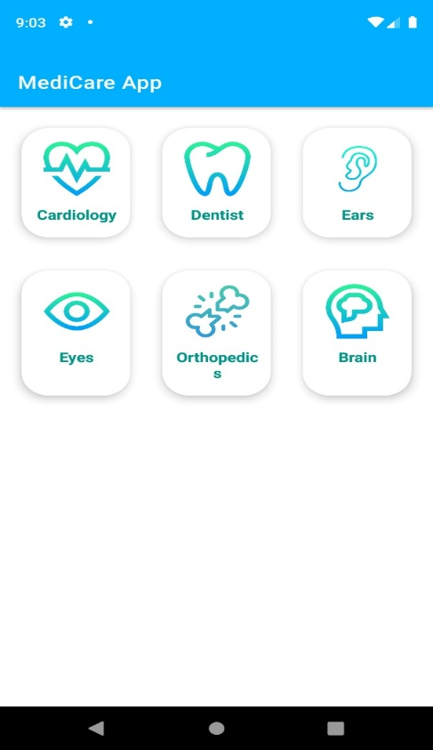

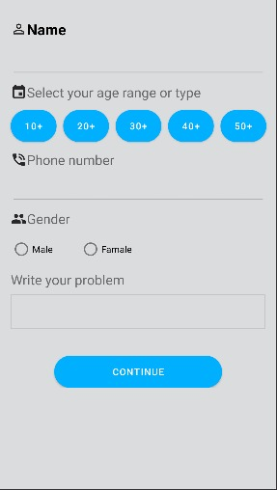

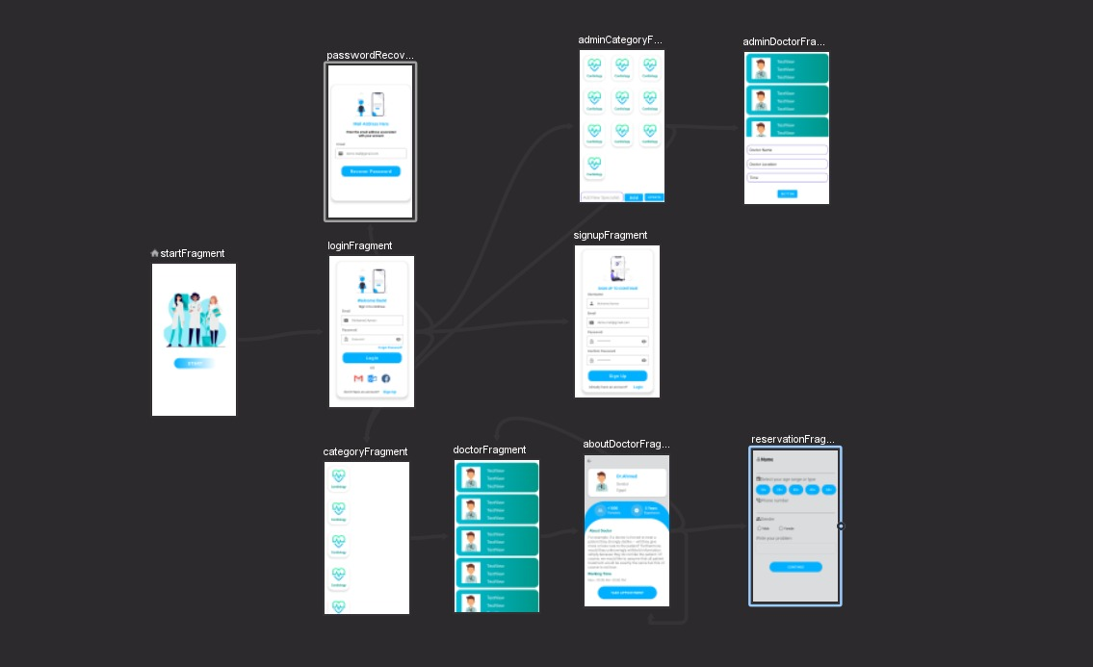

# Database

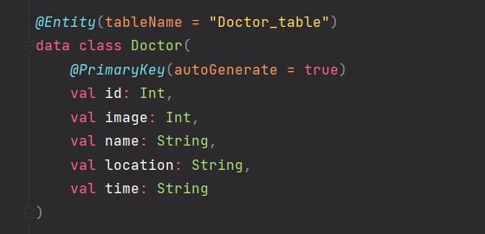The database consistce of two enities ; category and Doctor. The category entity included id and name of category , massege,imageId . Doctor entity have id , Name, location,time,imageId

