VOLATILITY PLUGIN LINUXFIREFOX.PY

DATQUOC<[datquoc93@gmail.com](mailto:datquoc93@gmail.com)>

This plugin show all of URL and Cookies in Firefox browser.

This is result of URL Firefox:

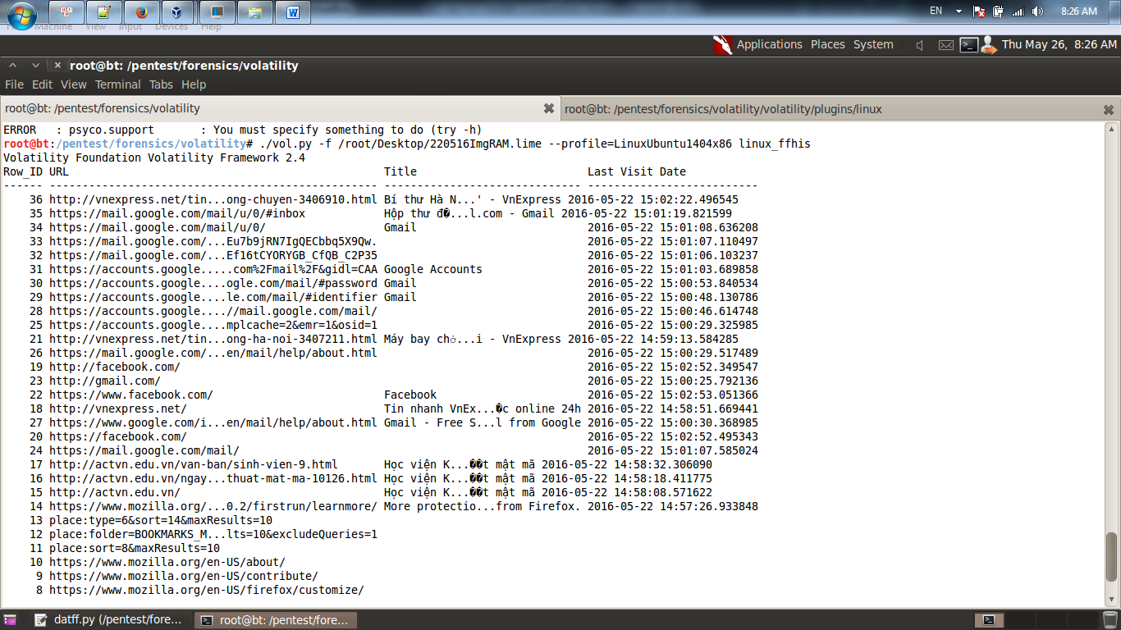

This result of Cookies Firefox:

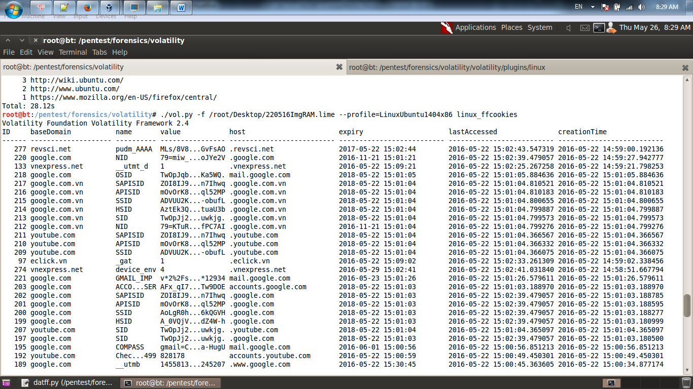

How to use Cookies to access Facebook and Gmail:

|  |  |  |  |  |  |  |
| --- | --- | --- | --- | --- | --- | --- |
| Host | isSecure | Path | isHttpOnly | Expiry | Name | Value |
| .facebook.com | - | / | - | ex:1471705187 | c_user | x |
| .facebook.com | - | / | - | exp | xs | x |
| .google.com | - | / | - | exp | SAPISID | x |
| .google.com | - | / | - | exp | APISID | x |
| .google.com | - | / | - | exp | SSID | x |
| .google.com | - | / | - | exp | HSID | x |
| .google.com | - | / | - | exp | SID | x |
| mail.google.com | - | / | - | exp | OSID | x |