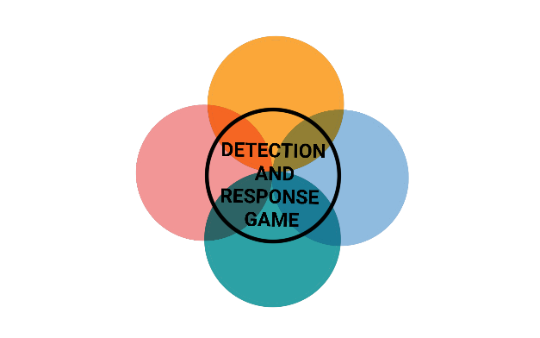

**EVENT**



**EVENT**



**EVENT**



**EVENT**



**INITIAL ACCESS**



**INITIAL ACCESS**



**INITIAL ACCESS**



**INITIAL ACCESS**



**EVENT**



**EVENT**



**EVENT**



**EVENT**

**CHANGE OF EMPLOYEES**

A new employee takes over the detection software, as he has little experience with the product, the maintenance takes longer than expected.

In the next round, the attack is only successfully recognized on a 1.

**CONSULTANT**

During the attack, an IT security advisor happens to be in the company who can help you.

In the next round, the attack is successfully repelled on a 1, 2 or 3.

**VACATION**

You are currently on vacation and cannot be reached during the attack.

The attack is successful in the next round.

**DISEASE**

The employee responsible for the mitigation measures has been sick for a long time, so these have been neglected.

In the next round, the attack is only successfully mitigated on a 1.



**INITIAL ACCESS**



**INITIAL ACCESS**



**INITIAL ACCESS**



**INITIAL ACCESS**

**VACATION**

You are currently on vacation and cannot be reached during the attack.

The attack is successful in the next round.

**CHANGE OF EMPLOYEES**

A new employee takes over the detection software, as he has little experience with the product, the maintenance takes longer than expected.

In the next round, the attack is only successfully recognized on a 1.

**CONSULTANT**

During the attack, an IT security advisor happens to be in the company who can help you.

In the next round, the attack is successfully repelled on a 1, 2 or 3.

**DISEASE**

The employee responsible for the mitigation measures has been sick for a long time, so these have been neglected.

In the next round, the attack is only successfully mitigated on a 1.